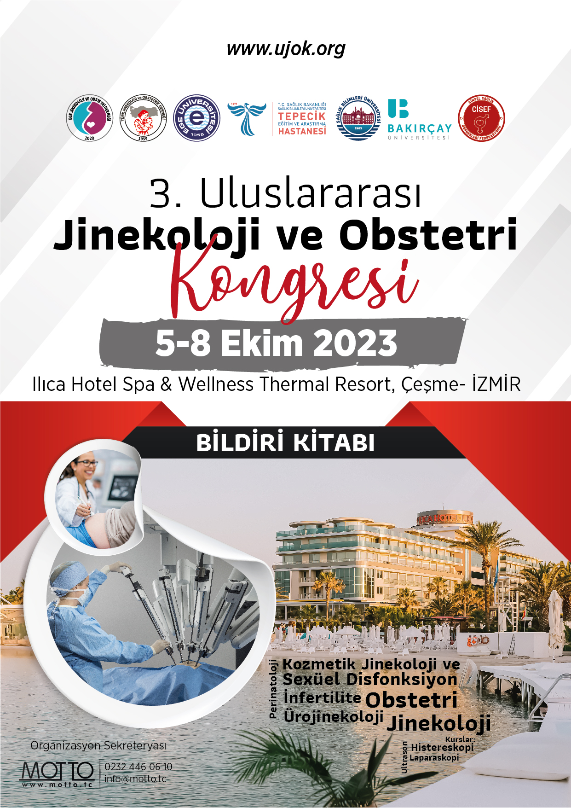

İÇERİKLER;

Sayfa

Davet 3
Kurullar 4 - 5
Ana Konular 6
Bilimsel Program 7 – 14
Sözel Bildiriler 15 -267
Poster Bildiriler 268 - 278

Değerli Meslektaşlarımız;
Ege Jinekoloji ve Obstetri Derneği' nin 3. Kongresi' nin 5-8 Ekim 2023 tarihlerinde llıca Hotel Spa & Wellness Thermal Resort, Çesme’ da düzenleneceğini sizlere iletmek istiyoruz.
Kongremiz Obstetri ve Jinekoloji pratiğinde sıklıkla merak edilen konularda en güncel bilgileri multidisipline bir ekip ile sizlere aktarılacak uluslararası konuşmacıların olduğu oturumlar ile içeriğimiz daha da zenginleşecektir. Ayrıca, önemli çalışmalar ve olguların aktarılacağı sözlü sunum oturumları da kongremizde yer alacaktır. Amacımız her daim birlikte bilgi paylaşımında bulunmak, bütün pozitif enerjimiz ve heyecanımızla keyifle geçen bir kongre sunmaktadır.
Kongremizde sizleri aramızda görmekten mutluluk duyacağız...

KONGRE BAŞKANLARI
Prof. Dr. Mehmet ÖZEREN | Prof. Dr. İsmail Mete İTİL | Prof. Dr. A. Özgür YENİEL

DÜZENLEME KURULU

KONGRE BAŞKANLARI
Prof. Dr. Mehmet ÖZEREN | Prof. Dr. İsmail Mete İTİL | Prof. Dr. A. Özgür YENİEL
KONGRE SEKRETERLERİ
Dr. Alper İLERİ
Dr. Gökay ÖZÇELİK
Dr. Gökhan TOSUN
Dr. İbrahim Karaca
Dr. Volkan Emirdar
* İsme göre alfabetik sıralanmıştır.

BİLİMSEL KURUL
Adnan BUDAK
A. Hamdi İNAN
Ahmet Mete ERGENOĞLU
Ahmet Özgür YENİEL
Ali AKDEMİR
Alpay YILMAZ
Alper BİLER
Alper İLERİ
Atalay EKİN
Aydın ÖZSARAN
Ayşe Rabia ŞENKAYA
Babür KALELİ
Can ATA
Emrah TÖZ
Enver İLHAN
Ertan SARIDOĞAN
Fatih ŞENDAĞ
Fırat ÖKMEN
Fuat AKERCAN
Gökay ÖZÇELTİK
Gökhan TOSUN
H. Gürsoy PALA
İbrahim GÜLHAN
İbrahim KARACA
İbrahim UYAR
İlker ÇAKIR
İsa Aykut ÖZDEMİR
İsmail Mete İTİL
İsmail ÖZDEMİR
Mehmet ÖZEREN
Mehmet Sait YÜCEBİLGİN
Mert KAZANDI
Mine KANAT PEKTAŞ
Murat ULUKUŞ
Mustafa Coşan TEREK
Mustafa KOCAER
Nedim KARADADAŞ
Onur ALDEMİR
Özgür HARMANLI
Sedat AKGÜL
Sercan KANTARCI
Serdar ÖZŞENER
Sermet SAĞOL
Serpil AYDOĞMUŞ
Suna YILDIRIM KARACA
Süleyman Cemil OĞLAK
Şükrü BUDAK
Teksin ÇIRPAN
Tülin ÖZCAN
Volkan EMİRDAR
* İsme göre alfabetik sıralanmıştır.

ANA KONULAR
Kozmetik Jinekoloji
Jineseksoloji
Perinatoloji
Onkoloji
İnfertilite
Tüp Bebek
Obstetri (Gıda Takviyesi, Beslenme)
Obstetrik Kanamalar
Jinekoloji (Vajinit, OKS, HRT …)
Jinekolojik Operasyonlar
- Laparaskopik Histerektomi
- Robotik Histerektomi
- Single Port Histerektomi
- Vajinal Histektomi
Ürojinekoloji
KURSLAR
2.Trimester Ultrasonografi Kursu
Fetal Eko Kursu
Obstetrik Doppler
Laparoskopik Sütur Kursu
V-Notes Kursu
Oasis
Cisef Jineseksoloji Kursu - 2 Saat – CİSEF Sertifikalı
Histereskopi Kursu

5 EKİM 2023
13.30-14.00 | Açılış  Dr. Özgür Yeniel  Dr. Mehmet Özeren  Dr. Bülent Tıraş
 | ÜROJİNEKOLOJİ
 | Oturum Başkanları: Dr. İsmail Mete İtil, Dr. Melike Doğanay
14:00-14:15 | Üriner İnkontinans Cerrahisi  Dr. İsmail Mete İtil
14:15-14:30 | Pelvik Organ Prolapsusu Cerrahisinde En İyi Yaklaşım Abdominal Yol  Dr. Gökay Özçeltik
14:30-14:45 | Pelvik Organ Prolapsusu Cerrahisinde En İyi Yaklaşım Vajinal Yol  Dr. Özgür Yeniel
14:45-15:00 | Pelvik Taban Cerrahisinde Komplikasyonlar ve Yönetimi  Dr. Ömer Lütfi Tapısız
15:00-15:15 | Kahve Molası
 | PANEL
 | Moderatör: Dr. İsmail Mete İtil, Dr. Özgür Harmanlı
15:15-16:15 | 2023 ICS Guideline Değerlendirmesi- Yeni Bir Şey Var mı?
 | Panelistler: Dr. Özgür Harmanlı, Dr. Özgür Yeniel, Dr. Gökay Özçeltik
16:15-16.30 | Kahve Molası
 | VİDEOMARATON
 | Oturum Başkanları: Dr. Özgür Harmanlı, Dr. Ömer Lütfi Tapısız, Dr. Melike Doğanay
16.30-18.30 | Pektopeksi
16.30-18.30 | Sakrokolpopeksi
16.30-18.30 | Kolpoklesis
16.30-18.30 | Midüretral Slingler
16.30-18.30 | Burch
16.30-18.30 | Sakrospinöz Fiksasyon
16.30-18.30 | Uterosakral Ligament Fiksasyonu
18:30 | SÖYLEŞİ  Kadın Beyni Erkek Beyni  Serkan Karaismailoğlu
19.00 | ÇEKİLİŞ
6 EKİM 2023
 | SALON A
 | LAPAROSKOPİ
 | Oturum Başkanları: Dr. Özgür Harmanlı, Dr.Fatih Şendağ, Dr. Selçuk Söylemez
08.30-08.45 | L/S Zor Histerektomi ve Komplikasyon Yönetimi  Dr. Fatih Şendağ
08.45-09.00 | Laparoskopik Myomektomi  Dr. Ali Akdemir
09.00-09.15 | Derin Endometriozis L/S Cerrahisi  Dr. Resul Karakuş
09.15-09.30 | Robotik Histerektomi  Dr. Özgür Harmanlı
09:30-10:00 | Uydu Sempozyumu  Kadın Doğum Pratiğinde Hasta Kan Yönetimi Uygulamaları  Dr. Murat Ekin
10.00-10.15 | Kahve Molası
 | PERİNATOLOJİ
 | Oturum Başkanları: Dr. Sermet Sağol, Dr.Tülin Özcan, Dr. Babür Kaleli
10.15-10.30 | CFFDNA: Güncel Uygulamalar  Dr. Tülin Özcan
10.30-10.45 | 1.Trimester USG Değerlendirmesi  Dr. Fırat Ökmen
10.45-11.00 | 2.Trimester USG Değerlendirmesi  Dr. Mete Ergenoğlu
11.00-11.30 | Uydu Sempozyumu  Oturum Başkanı: Dr. İsmail Mete İtil  Planlamadan Emzirmeye, Hamilelikte Optimal Beslenme ve Mikro Besinlerin Önemi  Dr. Gökhan Tosun
11.30-11.45 | Kahve Molası
 | PERİNATOLOJİ
 | Oturum Başkanları: Dr. Ertürk Levent, Dr. Mete Ergenoğlu
11.45-12.00 | Yüksek Riskli Gebelikler Sonlandırma Zamanlaması  Dr. Atalay Ekin
12.00-12.15 | Temel Fetal Kardiyak Değerlendirme  Dr. İsmail Özdemir
12.15-12.30 | İntrauterin Lazer Uygulaması  Dr. Can Tekin İskender
12.30-13:30 | Yemek Arası
 | ONKOLOJİ
 | Oturum Başkanları: Dr. Levent Yaşar, Dr. K. Erdinç Kamer, Dr. Volkan Kurtaran
13.30-13.45 | Rectovaginal Fistül  Dr. K. Erdinç Kamer
13.45-14.00 | Olgu Bazlı Radikalite, Hangi Vakalar Minimal İnvaziv Cerrahiye Uygun?  Dr. Aykut Özdemir
 | SALON A
14.00-14.30 | Uydu Sempozyumu  Oturum Başkanı: Dr. Adnan Budak  Kontrasepsiyonda Son Nokta  Dr. Ferruh Acet
14:30-14:45 | Kahve Molası
 | Oturum Başkanları: Dr. Levent Yaşar, Dr. Tülin Özcan
14.45-15:15 | Septat Uterusu Nasıl Tedavi Ederim? Plasenta Akreatayı Nasıl Tedavi Ederim? Ovarian Drilling Nasıl Yapılır?  Dr. Margaux Jegaden
15.15-15:30 | Erken Ve İleri Evre Uterin Corpus Tümörlerinin Cerrahi Tedavisi  Dr. Süleyman Salman
15.30-15.45 | Serviks Kanserinin Cerrahi Tedavisi  Dr. Sedat Akgöl
15.45-16:15 | Uydu Sempozyumu  Oturum Başkanı: Dr. Adnan Budak  Gebelikte Beslenme Desteği Neden Önemli?  Dr. Gürsoy Pala
16.15-16:30 | Kahve Molası
 | ENDÜSTRİ PANELİ
 | Oturum Başkanı: Dr. İsmail Özdemir
16.30-17.30 | Dr. Sultan Güç
 | JİNEKOLOJİ
 | Oturum Başkanları: Dr.Veli Mihmanlı, Dr. Yeşim Bayoğlu Tekin, Dr. İbrahim Uyar
17:30-17:45 | Vajinal Myomektomi  Dr. Hanifi Şahin
17:45-18:00 | Zor Vajinal Histerektomi Altın Kuralları  Dr. Çetin Kılıçcı
18:00-18:15 | Labia Minora Plasti ve Hudoplasti  Dr. Hanifi Şahin
7 EKİM 2023
 | SALON A
 | CİSEF
 | Oturum Başkanları: Dr. Kadir Savan, Dr. Almila Suna Nizamoğlu
08.30-08.45 | Jinesexolojik Vajinismus Tedavisi  Dr. Hacer Sadıkoğlu
08.45-09.00 | Disparoni  Dr. Özgü Çelikkol
09.00-09:30 | Uydu Sempozyumu  Oturum Başkanı: Doç. Dr. Hamdi İnan  Jinekolojik Cerrahide Sütür Kullanımı ve Prensipleri  Doç. Dr. Gökhan Tosun
09.30-09.45 | Kahve Molası
 | İNFERTİLİTE BİRİNCİ OTURUM
 | Oturum Başkanları: Dr. Erol Tavmergen, Dr. Abdulkadir Turgut
09.45-10.00 | Fertilite Prezervasyonuna Genel Bakış  Dr. Volkan Emirdar
10.00-10.15 | Fertilite Prezervasyonunda Kullanılan Yöntemler ve KOH Protokolleri  Dr. Özgür Öktem (Online)
10.15-10.30 | Medikal ve Sosyal Nedenlerle Fertilite Prezentasyonu Amacıyla Oosit Dondurmaya Güncel Yaklaşım  Dr. Funda Göde
10.30-10.45 | Over Dokusu Dondurma Teknikleri ve Güncel Durum  Dr. Volkan Turan
10.45-11:00 | IVF de Kök Hücre Tedavileri  Dr. Murat Sönmezer
11.00-11.15 | Tartışma
11.15-13.30 | Yemek Arası
 | SALON A
 | İNFERTİLİTE İKİNCİ OTURUM
 | Oturum Başkanları: Dr. Emre Okyay, Dr. Refik Keleş, Dr. Dilek Arslan
13.30-13.45 | Kime IUI Kime IVF Yapalım  Dr. Burak Yücel
13.45-14.00 | IVF Sikluslarında Hangi Gonodotropin, Hangi Ajan?  Dr. Alper Biler
14.00-14.15 | IVF’te Luteal destek nasıl olmalı?  Dr.Sabri Cavkaytar
14.15-14:30 | Düşük Yanıtlı hastalarda LH: Nasıl Tedavi ediyoruz  Dr. Cem Çelik
14.30-15:00 | Uydu Sempozyumu  Oturum Başkanı: Dr. Sedat Akgöl  Prolapsus Cerrahisinde V-Notes  Dr. Süleyman Salman
15.00-15:15 | Kahve Molası
 | KOZMETİK JİNEKOLOJİDE KOZMETİK UYGULAMALAR
 | Oturum Başkanları: Dr. Özgür Harmanlı, Dr. Deniz Öztekin
15.15-15:30 | Genital Bölge Dolgu İşlemleri  Dr. Ozan Doğan
15.30-15:45 | PRP ve Otolog Yağ Uygulamaları  Dr. Sultan Özkan
15.45-16:00 | İntravajinal COG-İP Uygulamaları  Dr. Murat Yassa
16.00-16:15 | Genital Bölge Lazer Uygulamaları  Dr. Mustafa Behram
16.15-16.30 | Vajinoplasti ve Perineoplasti  Dr. Ozan Doğan
16.30-17.00 | Uydu Sempozyumu  Oturum Başkanı: Dr. İsmail Mete İtil  Vaginit tedavisinde çözüm paketiniz  Dr. Ali Akdemir
17.00-17.15 | Kahve Molası
 | HUKUK PANELİ
 | Moderatör: Dr. İsmail Mete İtil
17.15 | Hekimlerin Hukuki ve Cezai Sorumluluğu  Füsun Erdem, Emrah Sarıkaya
8 EKİM 2023
 | Oturum Başkanları: Dr. Mehmet Osmanağaoğlu, Dr. Numan Çim
09.00-09.15 | Perimenapozal Dönemdeki Kadına Yaklaşım ve Tedavi  Dr. Sezai Şahmay
09.15-09.30 | Menapozda (Vitamin,Mineral) Güncel Yaklaşımlar  Dr. Esra Bahar Gür
09.30-09.45 | Kahve Molası
 | OBSTETRİ
 | Oturum Başkanları:Dr. İsmail Özdemir, Dr. Neşe Yücel
09.45-10.00 | Plasenta Akreata Spektrumunda Uterus Koruyucu Cerrahi  Dr.Ahmet Yalınkaya
10.00-10.15 | Plasenta Perkreata Yönetimi ve Cerrahisi  Dr.Teksin Çırpan
10.15-10.30 | Postpartum Kanamada Medikal, Minimal İnvaziv Uygulamalar  Dr. Ali Acar
10.30-10.45 | İntrauterin Fetal MR mı USG mi?  Dr. Alper Tanrıverdi

SÖZEL BİLDİRİLER

S-01 Retrospective Investigation Of Factors Possible To Affect The Fetal Dna (Cffdna) Fraction Percentage (%) In Maternal Blood In Non-Invasive Prenatal Test (Nipt) Technique
Adil Barut¹, Mahmut Yılmaz², Emre Göksan Pabuçcu²
1 Avcılar Murat Kölük State Hospital
2 Ufuk Üniversitesi Tıp Fakültesi Doktor Rıdvan Ege Hastanesi

Aim: This thesis study aimed to retrospectively investigate the factors that are likely to affect the percentage of fetal DNA fraction in maternal blood in the non-invasive prenatal test (NIPT) technique applied to pregnant women.
Material and methods: This retrospective thesis study included 188 pregnant women who were followed up and screened for chromosomal anomalies from January 2015 to 2022, at the department of obstetrics and Gynaecology of Ufuk University Faculty of Medicine Doctor Rıdvan Ege Hospital. Data on pregnant women were retrieved from hospital and patient records, including body mass index, gestational age, age, fetal gender, NT measurement and anticoagulant use. Data obtained from the analysis of maternal plasma of pregnant women with singleton pregnancies and live births who underwent NIPT were examined. In the evaluation of the data, the significance level with SPSS was accepted as p < 0.05 within the 95% confidence interval.

Results: The sociodemographic, clinical and obstetrics characteristics of the study and control participants are presented in Table 1 and 2. The mean age and gestational age were 35.2±4.7 years and 14.3±2.8 weeks, respectively. The mean fetal DNA fraction level was 8.64%±3.20%. The mean percentage of fetal fraction was 8.56±2.83 in the using anticoagulant and 8.71±3.48 in the no using anticoagulant of participants (p=0.049). In addition, The mean percentage of fetal fraction was 9.41±3.48 in BMI less than 25 and 7.70±2.53 in BMI higher than 25 of participants (p=0.0001). these two differences were statistically significant.
Conclusion: The percentage of fetal DNA fraction measured in maternal serum was found to be statistically significantly and inversely related to maternal weight and body mass index. Increased BMI and anticoagulant use negatively affect the DNA fraction.
Keywords: Fetal DNA fraction, non-invasive prenatal test, fetal cfDNA

Introduction
Screening tests are carried out to identify individuals at risk for a certain disease within presumed healthy societies. When the results of the screening test are positive, individuals can be directed to further diagnostic tests, taking advantage of early diagnosis of the disease. An easily applicable and economical screening test offers the opportunity to screen large populations [1], [2]. Prenatal screening tests are frequently used during pregnancy in line with similar principles [3].
The term "traditional/conventional" tests is used to describe conventional prenatal screening tests, as distinct from cell-free fetal DNA (cffDNA)-based screening tests. In traditional tests, hormone levels in maternal blood are measured, while other types of genetic analysis are performed by analyzing DNA fragments [4]. Traditional prenatal screening tests; It includes the first trimester screening (combined) test (NT+hCG+PAPP-A) and the second trimester screening test (triple-quadruple test) (AFP+hCG+uE3±Inhibin A) [5]. When the Down Syndrome detection rates of prenatal screening tests are compared, it is seen that among traditional prenatal screening tests, the triple test is 69% and the quadruple test is 81%; It was observed that the integrated test, in which the combined test and the quadruple test were combined in a single report, was 96% (with 5% false positivity). Prenatal screening performed with extracellular fetal DNA has been determined to have the highest detection rate for Down Syndrome, with a detection rate of 99% [5].
Although previous studies recommended that NIPT be used only in high-risk pregnancies [6,7], recent studies have stated that NIPT is effective in detecting low risks of aneuploidy such as Trisomy 21, Trisomy 18 and Trisomy 13 [8,9]. NIPT performs significantly better than combined first trimester screening in the low-risk group [8]. Therefore, considering the benefits of NIPT application in low-risk pregnancies, International Organizations have changed their NIPT recommendations towards increasing the preference for NIPT [9,10].
The proportion of fetal cell-free DNA (cffDNA), known as the Fetal Fraction (FF), is thought to be a key factor affecting the performance of NIPT [12]. Studies have shown that an FF rate below 3–4% can increase false negative rates [11,12, 14]. In this thesis study, we aimed to retrospectively investigate the factors that are likely to affect the percentage of fetal DNA fraction in maternal blood in the non-invasive prenatal test technique applied to pregnant women followed in the Department of Gynecology and Obstetrics of Ufuk University Faculty of Medicine Doctor Rıdvan Ege Hospital.
Material and methods
In this thesis study, which retrospectively evaluates the factors expected to affect the percentage of fetal DNA fragments in maternal blood in the non-invasive prenatal test (NIPT) technique, a follow-up chromosomal test was conducted at Ufuk University Faculty of Medicine Doctor Rıdvan Ege Hospital Gynecology and Obstetrics outpatient clinic between December 2015 and February 2022. It is a retrospective analysis in which anomalies are screened.
The study was approved by the Ethics and Research Committee (Ethics Committee Date: 22.02.2023; number: 61351342/ 2023-50)The study was performed in accordance with the principles and guidelines of the Declaration of Helsinki. Analysis and reporting of the results are in compliance with the Strengthening the Reporting of Observational Studies in Epidemiology (STROBE) checklist.
Inclusion criteria were age, NIPT, gestational weeks, singlation pregnancy, BMI, gestational age at which blood was taken for NIPT, fetus gender, whether it was a spontaneous and/or in vitro fertilization pregnancy, anticoagulant use, immunotherapy, antibody treatment, stem cell treatment, organ transplantation, ultrasound anomaly, drug use, abnormal reproductive history, and malignant/benign tumor history. Exclusion criteria were multiple pregnancy and missing data.
Data obtained from the analysis of maternal plasma of pregnant women with singleton pregnancies and who underwent NIPT were examined. The effects of data such as maternal age, racial origin, method of conception (spontaneous or assisted reproduction techniques), maternal characteristics and medical history, smoking during pregnancy (yes or no), weight and height of the pregnant woman on the percentage of cffDNA fraction were investigated.
The presence of a live fetus is confirmed by USG, the gestational age is determined with the help of fetal crown-rump length (CRL) measurement (compared with the gestational week calculated according to the last menstrual date or transfer date), there is no detection of any major fetal abnormality and the fetal neck (NT) Fetuses whose thickness was measured were evaluated.
Demographic characteristics, ultrasonographic measurements, relevant biochemical karyotype (obtained from genetic laboratories) and pregnancy results for amniocentesis for chorionic villus sampling or fetal karyotyping, which is recommended for pregnant women who are thought to have a high risk of aneuploidy, were taken from the records saved in the computer database. It was investigated whether the effect of all obtained parameters on the cffDNA percentage was significant.
Non-Invasive Fetal TrisomY test (NIFTY®) was used by BGI clinical laboratories as the method of obtaining cffDNA. All pregnant women included in the study were subjected to NIPT test at the reference genetics center, informed consent was obtained and samples were taken under appropriate conditions (Genoks Genetic Diseases and Evaluation Center Ankara).
Statistics Data Analysis
Statistical Package For Social Sciences (SPSS) MAC version 21 (IBM, Armonk, NY, USA) software program was used to evaluate the data of our thesis study. Descriptive statistics are presented as numbers and percentages for categorical variables, and as mean±standard deviation (mean±sd), median, minimum, maximum value for numerical variables. Homogeneity was performed according to the Levene test and p>0.05 was considered homogeneous. Whether the distribution of continuous variables was close to normal or not was evaluated by Kolmogorov Smirnov normality and Shapiro-Wilk normality tests, with p > 0.05 being a normal distribution. In cases where the assumption of normal distribution was met for numerical variables, the Independent T test was used for two-group comparisons and the One Way Anova Test was used for three-group comparisons. Nominal variables were examined with Pearson's Chi-square test. Pearson or Spearman correlation analysis was applied between fetal DNA (cffDNA) fraction percentage results and variables. Independent factor analyzes were performed using linner regression analysis. The effects of all parameters on the cffDNA percentage were examined with univariate regression. Statistical significance level was accepted as the p value being 0.05 and less than 0.05 within the 95% confidence interval.

Results: The sociodemographic, clinical and obstetrics characteristics of the study and control participants are presented in Table 1 and 2. The mean age and gestational age were 35.2±4.7 years and 14.3±2.8 weeks, respectively. The mean fetal DNA fraction level was 8.64%±3.20%. The mean percentage of fetal fraction was 8.56±2.83 in the using anticoagulant and 8.71±3.48 in the no using anticoagulant of participants (p=0.049). In addition, The mean percentage of fetal fraction was 9.41±3.48 in BMI less than 25 and 7.70±2.53 in BMI higher than 25 of participants (p=0.0001). these two differences were statistically significant.

Table 1: A comparison of the percentage of foetal DNA respect to maternal and foetal demographic and clinical characteristics
Parameters |  | mean±SD | P
Foetal gender | female | 7,99±2,81 | 0,081 ¹
Foetal gender | male | 9,25±3,42 | 0,081 ¹
Maternal Rh | negative | 8,60±3,19 | 0,988 ¹
Maternal Rh | positive | 8,61±3,14 | 0,988 ¹
The using anticoagulant | no | 8,71±3,48 | 0,049 ¹*
The using anticoagulant | yes | 8,56±2,83 | 0,049 ¹*
Smoking | no | 8,68±3,23 | 0,440 ¹
Smoking | yes | 7,89±2,30 | 0,440 ¹
First-trimester screening test | low risk | 8,74±3,21 | 0,413 ²
 | Maternal age risk | 8,25±2,96 | 0,413 ²
 | High risk | 9,11±2,88 | 0,413 ²
Triple/Quadruple screen | low risk | 8,67±3,35 | 0,393 ²
 | Maternal age risk | 8,30±2,24 | 0,393 ²
 | High risk | 7,18±2,53 | 0,393 ²
foetal anomaly ultrasonography screening | normal | 8,60±3,80 | 0,398 ¹
foetal anomaly ultrasonography screening | anomaly | 9,58±5,46 | 0,398 ¹
OGTT | no | 8,95±3,1 | 0,373 ¹
OGTT | yes | 8,38±3,1 | 0,373 ¹
Maternal age | <35 | 9,1±3,38 | 0,133 ¹
Maternal age | >35 | 8,30±2,99 | 0,133 ¹
BMI | <25 | 9,41±3,48 | 0,0001¹*
BMI | >25 | 7,70±2,53 | 0,0001¹*
SD: Standard deviation; ¹ Independent Sample T Test; ² One-Way ANOVA test (Bonferroni); *p<0.05; GDM: Gestational Diabetes mellitus; BMI: Body Mass Index

Table 2: Correlations of foetal DNA with maternal and foetal demographic and clinical characteristics
Maternal age | r | -,119
 | p | 0,104
Gestational of weeks | r | ,045
 | p | 0,540
Maternal height | r | ,030
 | p | 0,682
Maternal weight | r | -,291
 | p | 0,0001*
Maternal BMI | r | -,362
 | p | 0,0001*
Father age | r | -,109
 | p | 0,136
Delivery of weeks | r | ,108
 | p | 0,142
r: Pearson coefficient; BMI: Body Mass Index; *p<0.05

Discussion
In this retrospective study, which was conducted to investigate the factors that are likely to affect the fetal DNA fraction percentage (%) in pregnant women who were followed up in the Gynecology and Obstetrics outpatient clinic, had live and singleton births, and had cffDNA testing, the percentage of fetal DNA fraction measured in maternal serum, maternal weight and body mass. It was found to be statistically significant (p=0.0001) and inversely related to the index.
Body mass index (BMI) is a measure used to calculate body fat based on a person's height and weight measurements. The percentage of fetal DNA fraction systematically decreases as maternal weight increases. We hypothesize that this inverse relationship is due to the fact that pregnant women with a BMI greater than 25 have a larger maternal plasma volume but a constant amount of fetal cfDNA is obtained, as well as an increased maternal cfDNA concentration as maternal weight increases. We think that the increase in maternal cfDNA obtained from maternal blood in obese pregnant women may be due to chronic inflammation and cell death and, accordingly, affects the low FF percentage. A study supports this hypothesis by reporting that active remodeling of the adipose tissue of obese pregnant women results in increased release of maternally derived cfDNA into the maternal circulation [15]. To obtain a reliable non-invasive prenatal test result, the FF percentage must be sufficient (FF% >3-4). For these reasons, in pregnant women with a BMI greater than 25, a sufficient and/or high FF rate can be achieved by taking the maternal blood sample at a later gestational week, avoiding the inadequate FF rate.
The mean fetal fraction rate of pregnant women who received anticoagulant treatment was found to be lower compared to those who did not receive treatment, and this difference was statistically significant (p = 0.049). When the literature on this subject is examined, there are studies showing that the fetal fraction rate is significantly lower in pregnant women who use anticoagulants, and our study is consistent with these results. In our study, there was the use of low molecular weight heparin (LMWH) as an anticoagulant, but the use of acetylsalicylic acid (ASA) as an anticoagulant was considered nonexistent because the number was too small to be evaluated statistically.
A study showed that the percentage of FF due to anticoagulant use was significantly lower and the inconclusive rate of non-invasive prenatal testing was higher. In this study, the FF percentage was lower in pregnant women using only ASA, but no significant difference was observed in the NIPT failure rate [16]. It has been hypothesized that the use of low molecular weight heparin (LMWH) causes this result by inducing apoptosis in the cell and increasing the amount of maternal cfDNA compared to the amount of fetal cfDNA. However, in another study, low molecular weight heparin was shown to reduce trophoblast cell apoptosis and increase trophoblast cell survival by reducing new cytokeratin epitopes, nucleosome DNA formation, E-cadherin expression and other mechanisms [17]. However, in vitro experiments have shown that autoimmune diseases rather than LMWH are independent predictors of test inconclusiveness in pregnant women. The exact mechanism of the interaction between LMWH and NIPT inconclusiveness has not yet been elucidated [18]. In our study, there is no statistically significant result between autoimmune diseases and the FF rate and NIPT inconclusiveness. As shown in the literature and our study, it is recommended to avoid the use of LMWH before applying NIPT.
In our study, the fetal cfDNA fraction measured in maternal serum was found to be more highly associated with the male gender of the fetus. However, in the literature review, Miltoft C at all. study, FF was found to be higher in pregnancies with female fetuses [19]. More research is needed on this subject.
As is widely known, fetal cfDNA test alternatives, which are marketed under various trade names, are offered by different companies. These tests aim to use a variety of methods to detect fetal cfDNA. The "sequencing" method stands out as the most commonly used approach to determine which chromosome the free DNA fragments belong to. With the advancement of technology, methods such as "whole genome sequencing (WGS)" and "next generation sequencing (NGS)] have become more frequently used approaches today [20]. The "massively parallel sequencing (MPS)" method is also among the new generation sequencing technologies and is a test method used in this study.
The role of fetal fraction in correctly identifying an aneuploid or euploid fetus depends on the analytical method used (e.g., counting or genotyping). When a counting or genotyping algorithm is used, increased fetal fraction is associated with increased detection rate. In our study, the extent to which the fetal cfDNA test, studied with the massively parallel sequencing method, is affected by the fetal fraction ratio is similar to the literature.
Strengths and Limitations
The main limiting factors of our study are the fact that cfDNA testing is not widely used due to its high cost and the resulting limited clinical data. In our study, the limited number and heterogeneity of the patient groups were insufficient to statistically evaluate their relationship with FF.
Conclusıon
It was found that the percentage of fetal DNA fraction examined in maternal serum was statistically significantly and inversely related to maternal weight and body mass index. In pregnant women with a body mass index greater than 25, a sufficient and/or high FF rate can be achieved by moving away from the insufficient fetal fraction (FF) rate by taking a maternal blood sample later in the gestational week.
The average fetal fraction rate of pregnant women using anticoagulants was found to be lower than those who did not use them, and this difference was statistically significant. According to our study, it is recommended to avoid the use of low molecular weight heparin (DMAH) before applying NIPT.
In our study, the fetal cfDNA fraction examined in maternal serum was found to be more highly associated with the male sex of the fetus. However, in a review conducted in the literature, FF was found to be higher in pregnancies with female fetuses. More research needs to be done on this issue
References
[1] M. Hayran, Sağlık Araştırmaları İçin Temel İstatistik. Ankara: Art Ofset Matbaacılık, 2011.
[2] C. P. Price and R. H. Christenson, Kanıta Dayalı Laboratuvar Tıbbı. Ankara: Palme Yayınları, 2010.
[3] I. R. Merkatz, H. M. Nitowsky, J. N. Macri, and W. E. Johnson, “An association between low maternal serum α-fetoprotein and fetal chromosomal abnormalities,” Am J Obstet Gynecol, vol. 148, no. 7, pp. 886–894, Apr. 1984, doi: 10.1016/0002-9378(84)90530-1.
[4] D. Wellesley et al., “Rare chromosome abnormalities, prevalence and prenatal diagnosis rates from population-based congenital anomaly registers in Europe,” European Journal of Human Genetics 2012 20:5, vol. 20, no. 5, pp. 521–526, Jan. 2012, doi: 10.1038/ejhg.2011.246.
[5] B. D. Rink and M. E. Norton, “Screening for fetal aneuploidy,” Semin Perinatol, vol. 40, no. 1, pp. 35–43, Feb. 2016, doi: 10.1053/J.SEMPERI.2015.11.006.
[6] “Committee opinion no. 545: Noninvasive prenatal testing for fetal aneuploidy,” Obstetrics and Gynecology, vol. 120, no. 6, pp. 1532–1534, Dec. 2012, doi: 10.1097/01.AOG.0000423819.85283.F4.
[7] L. J. Salomon, Z. Alfirevic, F. Audibert, K. O. Kagan, G. Yeo, and N. Raine-Fenning, “ISUOG consensus statement on the impact of non-invasive prenatal testing (NIPT) on prenatal ultrasound practice,” Ultrasound in Obstetrics & Gynecology, vol. 44, no. 1, pp. 122–123, Jul. 2014, doi: 10.1002/UOG.13393.
[8] M. E. Norton et al., “Cell-free DNA Analysis for Noninvasive Examination of Trisomy,” New England Journal of Medicine, vol. 372, no. 17, pp. 1589–1597, Apr. 2015, doi: 10.1056/NEJMOA1407349/SUPPL_FILE/NEJMOA1407349_DISCLOSURES.PDF.
[9] H. Zhang et al., “Non-invasive prenatal testing for trisomies 21, 18 and 13: clinical experience from 146 958 pregnancies,” Ultrasound in Obstetrics & Gynecology, vol. 45, no. 5, pp. 530–538, May 2015, doi: 10.1002/UOG.14792.
[10] J. M. M. Van Lith, B. H. W. Faas, and D. W. Bianchi, “Current controversies in prenatal diagnosis 1: NIPT for chromosome abnormalities should be offered to women with low a priori risk,” Prenat Diagn, vol. 35, no. 1, pp. 8–14, Jan. 2015, doi: 10.1002/PD.4530.
[11] M. Ehrich et al., “Noninvasive detection of fetal trisomy 21 by sequencing of DNA in maternal blood: a study in a clinical setting,” Am J Obstet Gynecol, vol. 204, no. 3, pp. 205.e1-205.e11, Mar. 2011, doi: 10.1016/J.AJOG.2010.12.060.
[12] G. E. Palomaki et al., “DNA sequencing of maternal plasma to detect Down syndrome: An international clinical validation study,” Genetics in Medicine, vol. 13, no. 11, pp. 913–920, Nov. 2011, doi: 10.1097/GIM.0B013E3182368A0E.
[13] M. S. Quezada, M. M. Gil, C. Francisco, G. Oròsz, and K. H. Nicolaides, “Screening for trisomies 21, 18 and 13 by cell-free DNA analysis of maternal blood at 10–11 weeks’ gestation and the combined test at 11–13 weeks,” Ultrasound in Obstetrics & Gynecology, vol. 45, no. 1, pp. 36–41, Jan. 2015, doi: 10.1002/UOG.14664.
[14] A. J. Sehnert et al., “Optimal Detection of Fetal Chromosomal Abnormalities by Massively Parallel DNA Sequencing of Cell-Free Fetal DNA from Maternal Blood,” Clin Chem, vol. 57, no. 7, pp. 1042–1049, Jul. 2011, doi: 10.1373/CLINCHEM.2011.165910.
[15] H. M et al., “Increased death of adipose cells, a path to release cell-free DNA into systemic circulation of obese women,” Obesity (Silver Spring), vol. 20, no. 11, 2012, doi: 10.1038/OBY.2012.138.
[16] R. Shree, H. J. MacKinnon, J. Hannan, T. R. Kolarova, J. Reichel, and C. M. Lockwood, “Anticoagulation use is associated with lower fetal fraction and more indeterminate results,” Am J Obstet Gynecol, vol. 0, no. 0, 2023, doi: 10.1016/j.ajog.2023.07.005.
[17] C. Deng and S. Liu, “Factors Affecting the Fetal Fraction in Noninvasive Prenatal Screening: A Review,” Front Pediatr, vol. 10, p. 812781, Jan. 2022, doi: 10.3389/FPED.2022.812781/BIBTEX.
[18] K. H. Nicolaides, R. J. M. Snijders, S. Campbell, C. M. Gosden, and C. Berry, “Ultrasonographically detectable markers of fetal chromosomal abnormalities,” The Lancet, vol. 340, no. 8821, pp. 704–707, Sep. 1992, doi: 10.1016/0140-6736(92)92240-G.
[19] C. B. Miltoft et al., “Contingent first-trimester screening for aneuploidies with cell-free DNA in a Danish clinical setting,” Ultrasound in Obstetrics & Gynecology, vol. 51, no. 4, pp. 470–479, Apr. 2018, doi: 10.1002/UOG.17562.
[20] F. SÖYLEMEZ and D. C. KATLAN, “Prenatal Taramada Serbest Fetal DNA,” Türkiye Klinikleri Sağlık Bilimleri Dergisi, vol. 2, no. 3, pp. 165–173, 2017, doi: 10.5336/HEALTHSCI.2016-51564.

S-02 Analysis Of Orthopedic Complaints Of The Third Trimester Pregnant Women With Bmi>30
Ahmet Şenel¹
1 İstanbul Eğitim ve Araştırma Hastanesi, Ortopedi ve Travmatoloji Kliniği

Objective: Pregnancy is a process that leads to various changes in the musculoskeletal system of women. The most common orthopedic complaint during pregnancy is low back pain. Especially in the third trimester, pregnant individuals who have gained more weight than expected often present with a variety of orthopedic complaints beyond just lower back pain. This study aims to analyze the orthopedic complaints of third-trimester pregnant women with a Body Mass Index (BMI) >30 and share the results. Materials and Methods: Between January 2023 and August 2023, patients who presented to our out-patient clinic were evaluated retrospectively. Pregnant patient with no previous orthopedic diagnosis, no history of trauma, BMI>30 and in the 3rd trimester were included in the study. Twenty-seven pregnant met these criteria. Age, BMI, and orthopedic complaints were analyzed. Age, BMI, and orthopedic complaints were analyzed. Results: The study included 27 pregnant women with an average age of 29.2±3.9 (min-max: 22-37) years. Mean BMI was 32.2±1.4 (min-max:30.1-34.8). Low back pain in 9 (33.3%) patients, calf myalgia in 6 patients (22.2%), foot pain in 5 patients (18.5%), carpal tunnel syndrome in 4 patients (14.8%), hip joint pain in 1 patient (3.7%), neck pain in 1 patient and coccydynia in 1 (3.7%) patient were detected. Accordingly, low back pain was the most common orthopedic complaint, followed by calf myalgia and foot pain, respectively. Conclusion: Excessive weight gain during pregnancy also triggers orthopedic complaints. Existing complaints disrupt the quality of life during pregnancy. Orthopedic complaints can be prevented with a well-structured diet and exercise program for pregnant women.
Keywords: pregnant, third trimester, orthopedic disorder

S-03 Maternal And Neonatal Effects Of Operative Vaginal Births; Tertiary Center Experience
Aleyna Aydın¹, Merve Aldıkaçtıoğlu Talmaç²
1 Özel Rize Şar Hastanesi
2 Başakşehir Çam ve Sakura Şehir Hastanesi Kadın Hastalıkları ve Doğum Kliniği, Jinekolojik Onkoloji Kliniği

GİRİŞ
Operatif ya da müdahaleli vajinal doğum(OVD) yöntemleri olarak bilinen vakum yardımlı ve forseps yardımlı doğum şeklinde annenin ıkınmasıyla eş zamanlı olacak şekilde fetüsün kafasına direk traksiyon uygulanarak doğum eylemi gerçekleştirilmektedir. (1). Doğumların yaklaşık %3.6’sı operatif vajinal doğum ile komplikedir (2).
Forceps rotasyon ve traksiyon için kullanılırken vakum sadece traksiyon için kullanılır. OVD uygulanabilmesi için servikal açıklık tam olmalı, amnion zarı açılmış, fetus verteks prezentasyonunda ve baş angaje olmuş, yeterli anestezi sağlanmış, epizyotomi uygulanmış olmalıdır (3). Deneyimli bir hekim tarafından uygulanmalı ve sezaryen yapılabilecek koşullar hazır tutulmalıdır. Yüz ya da makat prezentasyonu, sefalopelvik uygunsuzluk, konjenital fetal baş anomalileri, 34 haftanın altında gestasyonel yaş, tahmini fetal ağırlığın 2000gr’dan az ya da 4000gr’dan fazla olduğu durumlarda vakum aleti kullanılmamalıdır (4).
Son yıllarda operatif vajinal doğum sayısında azalma gözlenirken sezaryen ile doğum sayısı artmakta, vakum / forseps kullanım oranı da vakum lehine artmaktadır (5). Ülkemizde ise forseps yardımlı doğum neredeyse tamamen terkedilmiş, vakum yardımlı doğum ise sadece bu konuda deneyim sahibi belirli sayıdaki hastane ve hekim tarafından yapılır hale gelmiştir(6). Müdahaleli doğum oranındaki bu azalmadaki temel faktör artmış medikolegal problemler ve hekimlerin bundan kaynaklı çekinceleridir(6). Müdahaleli vajinal doğumların hem anne hem de bebek açısından risk taşıdığı ve özellikle olası bir komplikasyon durumunda sezaryenle doğumun neden tercih edilmediğine dair hekimin dava edilme korkusu bulunmaktadır. Oysa ki, doğru endikasyonlarla tecrübeli hekimler tarafından uygulanan OVD uygulamaları, maternal ve neonatal komplikasyonları arttırmadan, sezaryen ile doğum oranlarını azaltmaya yardımcı olabilir(7). Çalışmamız doğum ekibine operatif doğum yöntemlerinin ne zaman ve nasıl kullanılacağına ikna etme konusunda rehberlik sağlamak, anneler ile bebeklerin potansiyel riskleri azaltmak ve doğum sonuçlarını iyileştirmek amacıyla yapılmıştır.

GEREÇ VE YÖNTEM
Çalışmamız S.B.Ü İstanbul Kanuni Sultan Süleyman Eğitim ve Araştırma Hastanesinde 1 Ocak 2017-30 Nisan 2020 tarihleri arasında yapılmış retrospektif bir çalışmadır. Doğumhanede vakum ya da forseps ile doğum yapan 110 hastanın dosyası arşiv kayıtları incelenerek tarandı. İncelenen gruptaki olgular 18-45 yaş arası, 37-41 hafta aralığındaki gebelerden oluşmaktaydı. 7 olgu kullanılan operatif doğum yöntemi belirtilmediği için çalışma dışı bırakıldı. Çoğul gebelikler, preterm doğum ve ıntrauterin mort fetüsler çalışmaya dahil edilmedi. Operatif vajinal doğumlarda forseps ve vakum uygulamalarının endikasyonları, komplikasyonları, maternal ve neonatal sonuçları, yenidoğan Apgar ve pH değerleri literatür bilgileri dikkate alınarak karşılaştırıldı.
İstatistiksel analiz
Her iki grupta yer alan hastaların bulguları değerlendirilirken, istatiksel analizler için SPSS (Statistical Package for Social Sciences) for MAC-OS 22.0 programı kullanıldı. Kolmogorov Smirnoff ile normal dağılım değerlendirildi. Eşit dağılım olan parametrik değerler için Student-T test, non parametrik veriler için de Mann-Whitney U testi uygulandı. Kategorisel değişkenler için Ki-kare Testi yapıldı. Sonuçlar +/- stLASandart deviasyon olarak verildi. İstatistiksel anlamlılık %95 güven aralığında, p <0,05 düzeyinde değerlendirildi.

BULGULAR
Benzer demografik özelliklere sahip olgular operatif vajinal doğum yöntemlerine göre analiz edildiğinde 103 olgudan 48’inde (% 46.6) forseps ve 55’inde (%53.3) vakum yöntemlerinin kullanıldığı izlendi. Hastaların hiçbirinde zorlu doğum öyküsü yoktu ve yöntem denemeleri % 100 başarı ile sonuçlandı. Tüm hastaların gebelik haftası 34 hafta ve üzeri idi.
Forceps yöntemi kullanılan hastaların yaş ortalaması 25.3±6.83, vakum yöntemi kullanılan hastaların ortalaması ise 23.3±4.33 yıl olarak hesaplandı. Her iki yöntemle doğum yapan hastaların gebelik haftası ortalaması,eğitim seviyesi ve demografik özellikleri benzer idi(Tablo 1,2). Forceps ile doğum yapan hastaların 6 tanesine; vakum yöntemi ile doğum yapan hastaların da 5 tanesine eşlik eden hastalık (gdm, preeklampsi ve ght) olduğu gözlemlenmiştir. Operatif doğum yapan hastaların parite sayısı incelendiğinde nullipar hasta sayısı 83 (%80.6 ), multipar hasta sayısı ise 20 (%19.4 ) olarak izlendi. Nulliparite oranı vakum yöntemi ile doğum yapan hastalarda istatistiksel olarak anlamlı derecede yüksek izlendi (p<0.05).
Tablo 1: Olguların Eğitim Seviyesi

OVD | Okuryazar Değil | İlköğretim | Lise | Lisans | p Değeri
Forceps | 3 | 42 | 2 | 1 | 0.127
Vakum | 5 | 38 | 7 | 5 | 0.127

Tablo 2: Olguların Demografik Özellikleri
Demografik Özellik | Forseps (n-48) | Vakum (n-55) | p Değeri
Yaş | 25.3±6..83 | 23.3±4.33 | 0.275
Gebelik Haftası | 38.08±2.17 | 38.6±1.93 | 1
Nulliparite | 34 | 49 | 0.019
Multiparite | 14 | 6 | 0.019
Eşlik Eden Hastalık | 6 | 5 | 0.572

Hastaların % 6.7 sinde (n=7) evre 3 ve 4. derece perineal laserasyon meydana geldi. Bu olguların 4’ünde forceps, 3’ünde vakum yöntemi kullanıldığı izlendi. Maternal eritrosit süspansiyonu replasmanı gereken 9 olgunun (% 8.7); 3’ünde forceps, 6’sında vakum yöntemi kullanıldığı tespit edildi. Olguların doğum öncesi hemogramları değerlendirildiğinde hastaların %66 sında maternal anemi olduğu izlendi. Maternal komplikasyonlar analiz edildiğinde fark istatistiksel olarak anlamlı izlenmedi.
Doğum sonrası yenidoğanın ağırlığı, Apgar 1 ve Apgar 5. Dakika değerleri ,ph ve baz eksisi karşılaştırıldığında vakum yöntemi ile operatif vajinal doğum yapılan hastalarda Apgar 1 ve 5. Dakika değerleri istatistiksel olarak anlamlı derecede düşük izlendi (Tablo 3,p<0.05).

Tablo 3: Yenidoğan Ağırlığı, pH, Apgar, Ve Baz Eksisi Karşılaştırılması
Yenidoğan Özellikleri | Forseps (n-48) | Vakum (n-55) | p Değeri
Kilo | 3345±410 Gr | 3407±454 Gr | 0.45
pH | 7.23±0.12 | 7.16±0.12 | 0.83
Apgar 1.Dk | 8.13±0.99 | 6.35±1.89 | p<0.05
Apgar 5.Dk | 9.45±0.78 | 8.44±1.48 | p<0.05
Baz Eksisi | -6.81±3.81 | -8.44±3.64 | 0.94

Neonatal komplikasyonlar incelendiğinde hastaların 18’inde sefal hematom , 13’ünde caput succadenum, 12’sinde yüzde ekimoz, 4’ünde kranial ödem, 2’sinde subkonjuktival kanama, 5’inde fraktür, 2’sinde laserasyon, 11’inde sarılık ve 2 hastada da omuz distosisi saptandı. Intrakranial hemoraji ve periferik sinir hasarı izlenmedi. Yenidoğan yoğunbakım ünitesine yatışın operatif vajinal doğum yöntemi kullanılan hastaların 31’inde (% 28) olduğu ve bunun da vakum kullanımında istatistiksel olarak anlamlı derecede yüksek izlendiği tespit edildi (Tablo 4).

Tablo 4: Operatif Vajinal Doğum Hastaları Komplikasyon Verileri
NEONATAL KOMPLİKASYON | Forseps (n-48) | Vakum (n-55) | p Değeri
Sefal Hematom (n-18) | 9(%50) | 9(%50) | 0.75
İntrakranıal Hemoraji (n-0) | 0 | 0
Kranıal Ödem (n-4) | 1(%25) | 3(%75) | 0.37
Caput Succadenum (n-13) | 3(%23.1) | 10(%76.9) | 0.06
Fraktür (n-5) | 2(%40) | 3(%60) | 0.76
Yüzde Ekimoz (n-12) | 9(%75) | 3(%25) | 0.035
Subkonjuktıval Kanama (n-2) | 2(%100) | 0
Periferik Sinir Hasarı (n-0) | 0 | 0
Laserasyon (n-2) | 1(%50) | 1(%50) | 0.92
Sarılık (n-11) | 7(%63.6) | 4(%36.3) | 0.23
Ybü Yatış (n-27) | 8(%29.6) | 19(%70.3) | 0.039
MATERNAL KOMPLİKASYON
3&4.Derece Laserasyon (n-7) | 4(%57.1) | 3(%42.8) | 0.56
Kanama&Es Replasmanı (n-9) | 3(%33.3) | 6(%66.6) | 0.40
Epizyotomi (n-92) | 39(%42.3) | 53(%57.6) | 0.013
OMUZ DİSTOSİSİ (n-2) | 1(%50) | 1(%50) | 0.92

TARTIŞMA
Operatif vajinal doğumların en sık nedeni annenin ileri derecede yorgun düşmesi ve bebeği etkin olarak itememesi ile doğumun ikinci evresinin uzamasıdır. Diğer nedenler arasında maternal medikal durumlar (kardiyak, pulmoner ve nörolojik hastalıklar gibi), doğumun ikinci evresinde güven vermeyen fetal kalp atım trasesinin mevcudiyeti, fetal başın ilerleyişinin ve rotasyonunun durması, doğumun ikinci evresinin uzaması yer almaktadır. Dünyadaki OVD sıklığı klinik uygulamadaki farklılıklar ve bu alanda uzmanlaşmış hekimlerin sayısına bağlı olarak değişim göstermektedir(8).
OVD uygulamalarında maternal anal sfinkter yaralanmaları, geniş laserasyonlar, vulvo-vajinal hematom, uterin rüptür, doğum sonrası kanama, kan transfüzyon ihtiyacı, üriner ve fekal inkontinans; neonatal intrakraniyal hemoraji, sefal hematom, nörolojik yaralanmalar, retinal hemoraji ve hiperbilirubinemi gibi komplikasyonlar izlenebilmektedir (7).
Birçok çalışma operatif vaginal doğumların nullipar gebelerde daha çok görüldüğünü göstermektedir (9). Bunun nedeni primigravid kadınlarda doğumun ikinci evresinin daha uzun olması ve maternal yorgunluğun daha fazla görülmesidir ( 10). Bizim çalışmamızda da forseps doğumların %70,8’i, vakum doğumların ise %89’u nullipar gebelerde gerçekleşmiştir.
Operatif vajinal doğum yöntemlerinde epizyotomi uygulaması doğum uzmanının tercihine göre uygulanmaktadır(9). Çalışmamızda vakum yönteminde epizyotomi uygulanması anlamlı derecede yüksek izlenmiştir. Johnson ve arkadaşlarının yaptığı çalışmada ise forceps yöntemi ile yapılan doğumlarda epizyotomi oranının daha fazla olduğu izlenmiştir (11). Bu farklılığın sebebi çalışmamızda nullipar hasta oranının vakum yöntemi uygulanan grupta daha fazla olmasından kaynaklanıyor olabilir. Evre 3 ve evre 4.derece perineal laserasyon oranları ise Johnson ve arkadaşlarının çalışması ile benzer şekilde forceps yöntemi ile uygulanan doğumlarda daha fazla görülmüştür. Aynı çalışmada neonatal komplikasyonlar arasından sarılık, caput succadenum ve sefal hematom vakum yönteminde daha sık izlenmiştir. Çalışmamızda ise sefal hematom oranları her iki grupta aynı olup caput succadenum oranı vakum yönteminde daha fazla izlense de fark istatistiksel olarak anlamlı izlenmemiştir. Yüzde ekimoz, alet izi ve morarma ise benzer şekilde forceps yönteminde anlamlı derecede yüksek izlenmiştir.(11)
Yenidoğan Apgar 1 ve Apgar 5. Dakika değerleri karşılaştırıldığında vakum yöntemi ile doğum yapan gruptaki apgar skorları anlamlı derecede düşük izlenmiştir. Bu farklılığın sebebi forceps yöntemi seçilen hastaların endikasyonlarında çoğunlukla maternal yorulma ve doğumun 2.evresinin uzaması yer alırken; vakum yöntemi uygulanan grupta fetal distress-güven vermeyen fetal kalp atımı endikasyonlarının daha sık olmasından kaynaklanıyor olabilir.
Çalışmamız hastanemizde üç yıl içerisinde gerçekleştirilen operatif vajinal doğumları incelemiş ve hiçbir doğumda vakum ya da forceps kullanımına bağlı ciddi morbidite saptanmamıştır. Yenidoğan ybü yatış oranları vakum yöntemi kullanımında anlamlı olarak yüksek izlense de yatış endikasyonları incelendiğinde kullanılan yöntem şekli nedenli zor doğum endikasyonu görülmemiş, yatış nedenleri arasında asfiksi, fototerapi gerekliliği ve erken sepsis tanılarının yer aldığı izlenmiştir. Uygulama başarısızlığı nedeni ile acil cs olmaması hasta seçimimizin doğru olduğunu ve gereksiz sezaryen oranlarının uygun endikasyon varlığında operatif vajinal doğum yöntemleri ile azaltılabileceğini göstermektedir.
SONUÇ
Bu çalışmanın sonuçlarına dayanarak, doğum yöntemleri seçiminde hem maternal hem de neonatal komplikasyon risklerinin dikkate alınması gerektiği sonucuna varılabilir. Ayrıca, bu çalışma sonuçları, operatif doğum yöntemlerinin kullanımı konusunda hekimleri bilgilendirmek ve yönlendirmek için de faydalı olabilir. Aynı zamanda, doğum yöntemleri seçimi konusunda yapılacak olan gelecekteki çalışmaların, bu sonuçları destekleyip desteklemediğini ve farklı bir hasta popülasyonunda sonuçların ne olabileceğini de araştırması önemlidir.
Anahtar Kelimeler: Forseps, Maternal ve Neonatal Sonuçlar, Vakum

KAYNAKÇA

1. Vakum Yardımlı Vajinal Doğumun Maternal Ve Neonatal Sonuçları,The Maternal And Neonatal Outcomes Of Vacuum Assısted Vagınal Delıvery.DEU Tıp Derg 2021;35(3): 264 –269 Erol ARSLAN1, Çiğdem AKÇABAY2
2. Martin JA, Hamilton EB, Ventura SJ, Ostermanm M, Wilson E, Mathews TJ. Births: Final Data For 2010. National Vital Statistics Reports 2012; 61: 1-72.
3. ACOG Practice Bulletin No: 17. Operative Vaginal Delivery. Obstetrics & Gynecology 2000; 95: 1-12.
4. Vakum İle Operatif Vajinal Doğumun Perinatal Etkileri …Resul Karakuş1, Doğukan Anğın1, Osman Temizkan1, Mesut Polat1, İlhan Şanverdi1, Seren Karakuş1, Ferhat Ekinci1 Ş.E.E.A.H. Tıp Bülteni 2014;48(3):192-7 DOI: 10.5350/SEMB.20140412070541
5.Demissie K, Rhoads GG, Smulian JC, Balasubramanian BA, Gandhi K, Joseph KS Et. Al. Operative Vagival Delivery And Neonatal And İnfant Adverse Outcomes: Population Based Retrospective Analysis. BML 2004; 329: 24-9.
6.Doğum Travmalarına Medikolegal Yaklaşım.Http://Www.Medikolegalduzlem.Com/U Pload/5be58bfa9985041eb0a6e7f67b0d5c21.Doc Erişim 20.02.2017
7. Retrospectıve Evaluatıon Of Changıng Rates For Operatıve Vagınal Delıvery Over The Decades In A Sıngle Tertıary Health Care Center Atakan TANAÇAN1 , Mehmet Sinan BEKSAÇ İstanbul Tıp Fakültesi Dergisi DOI 10.26650
8.Ameh CA, Weeks AD. The Role Of İnstrumental Vaginal Delivery İn Low Resource Settings. BJOG 2009;116(Suppl. 1): 22-5.
9.Comparison Of Maternal And Neonatal Outcomes Of Operative Vaginal Deliveries: Vacuum Vs.Forceps.Berna Aslan Çetin, Pınar Yalçın Bahat, Nadiye Köroğlu, Merve Konal, Aysu Akça İstanbul Med J 2017; 18: 196-9 DOI: 10.5152/İmj.2017.27122
10.Obuna JA, Ugboma HAA, Ejikeme BN, Umeora OUJ, Agwu UM. Pattern And Outcome Of Higher Order Caesarean Section İn A Secondary Health Facility İn Nigeria. Res Obstet Gynecol 2012; 1: 19-22.
11. Johnson JH, Figueroa R, Garry D, Elimian A, Maulik D. Immediate Maternal And Neonatal Effects Of Forceps And Vacuum-Assisted Deliveries. Obstetr Gynecol 2004; 103: 513-8.

S-04 Myomectomy During Caesarean Section: 22 Case Series
Ali Buhur¹, Çetin Şamiloğlu²
1 İstanbul Kanuni Sultan Süleyman Eğitim ve Araştırma Hastanesiaraştırma Hastanesi
2 Stanbul Kanuni Sultan Süleyman Eğitim ve Araştırma Hastanesiaraştırma Hastanesi

Introduction:
Uterine fibroids are the most common pelvic tumors in reproductive age. The frequency of myoma in pregnancy is 0.05-5%. Although myomectomy operations performed during cesarean section are not recommended due to the risks of intraoperative atony, bleeding and hysterectomy, It has started to be preferred because it has been shown in recent studies that the complication rates are not as high as thought.
Aim
To investigate the effect of myoma size on the clinical outcomes of patients who underwent myomectomy during cesarean section retrospectively.
Material-Method
Our study was conducted in Istanbul Kanuni Training and Research Hospital between 2021-2022; 22 patients who underwent myomectomy during cesarean section were included. The cases were divided into 2 groups according to myoma size; those with fibroid size larger than 4 cm formed group 1 and those with fibroid size smaller than 4 cm formed group 2.Characteristics of the cases (age, parity, body mass index), mean age, number of births, gestational age, fibroid localization, pre- and postoperative hemoglobin values, development of atony, whether transfusion was performed during or after cesarean section. and length of hospital stay were evaluated.. SPSS for Windows 24.0 (SPSS Inc., Chicago, IL, USA) was used for statistical analysis. Independent t-test was performed to compare continuous data between independent groups. 0.05 significance threshold accepted
Results
There was no significant difference between the groups in terms of age, parity, gestational week, pre- and postoperative hemoglobin values, and length of hospital stay. Post op hemoglobin value in group 1 was significantly lower than group 2. (9.20±1.23 g/dl and 10.34±1.45) respectively 2 units of erythrocyte suspension were given in 2 patients in group 1. No significant exceeding in the operation time was detected. No leiomyoma sarcoma was observed in any patient.
Conclusion Our study showed that the amount of bleeding increases with the increase in myoma size. In selected cases, myomectomy can be performed during cesarean section.
Keywords: Myoma Uteri; cesarean sectio; abnormal uterine bleeding

S-05 Epitheloid Trophoblastic Tumours, A Rare Case Report And Review
Alpay Yılmaz¹
1 Izmir Kâtip Celebi Universitesi Ataturk Egitim ve Arastirma Hastanesi Kadin Hastaliklari ve Dogum Anabilim Dali, Jinekolojik Onkoloji

Epitheloid Trophoblastic Tumour (ETT) is originated from Intermediate trophoblasts and is a rare subtype of GTN. The other variant of ITT is called placental site trophoblastic tumour (PSTT). The incidence of these tumours is 1 in 100000 pregnancies. They represent only 1 % of all Gestational Trophoblastic Neoplasia (GTN). Like PSTTs, ETTs follow non-molar pregnancy and present months to years after the antecedent pregnancy. It may also develop after Hydatiform Molar evacuation in rare cases. As It is very rare, its biologic behaviour and optimal treatment modalities are not well established. The interval between antecedent pregnancy and disease onset may be longer for ETT than PSTT, confirmed by a recent study of 62 patients of ITT. There is extensive necrosis macroscopically, but less haemorrhage in comparison with choriocarcinomaBoth ETTs and PSTTs are slow growing tumours and it takes months to years to metastasize after the development of the primary tumour. They often present with abnormal uterine bleeding or amenorrhea. They secrete significantly lower levels of BHCG in comparison to other types of GTN, so HCG is less reliable in these types. Metastases are detected at 30-50% of cases. The most common size of metastasis is Lung. Another important point is both ETT and PSTT have greater tendency for lymphatic spread than the other GTNs.
ETT is far less common than PSST, and confirmative statistical analysis of the risk factors of these tumours cannot be established due to rarity of the disease. The FIGO prognostic scoring system for GTN does not correlate well with outcomes in ETT and PSTT. The interval from the last pregnancy equal of greater than 2 years, and the advanced stage diseases are the most important prognostic factors. Advanced age, deep myometrial invasion, large tumor size, tumor necrosis, and higher mitotic index are the additional risk factors.
As most patients are at young age, fertility preservation may be an option in cases who has strong desire for fertility preservation. Evacuation or resection of the solitary tumor are the options. In high risk group the major problem to determine the prognosis is their chemo-resistant nature. Because of their rarity, no randomized controlled trials have been done. Although there are many experienced centres dealing with GTN in large numbers, they will infrequently manage ETT/PSTT.
Hysterectomy is the primary treatment for the localised disease, that has good prognosis. Unfortunately extra-uterine spread of these tumors occur in about one-third of cases and still cause death in small numbers. Metastatectomy should be perfomed for isolated distant disease, especially in the lungs.
The chemotherapy regimens for metastatic disease is EMA/EP and EP/EMA. The regiments that are effective against treatment- resistant GTN may also have some efficacy in metastatic ETT/PSTT. All of these regimens may also be considered for patients with non-metastatic disease who have one or more adverse prognostic factors (ie, interval from index pregnancy ≥2 years, deep invasion, necrosis, mitotic count >5/10 HPFs).
Even post treatment BHCG is the most impostant indicator for GTNs, it is less reliable marker for ETT/PSTT. Surveillance with PET/CT at the completion of chemotherapy and then every 6-12 months for 2-3 years is therecommended schedule in some centers.

Case Report
29 years old, 2 normal vaginal deliveries (last birth 3 years ago). He applied to our clinic with the complaint of abnormal vaginal bleeding. In the sonographic evaluation, a complex mass formation with intramural localization, compressing the cavity, containing cystic and papilear structures suggestive of molar pregnancy findings was observed. ITT was considered because Bhcg= 26.8 U/L. Comparative MRI of September 25 and October 31: A mass lesion consistent with mole hydatiform was observed in the uterine cavity (a mass lesion compatible with mole hydatiform was observed in the uterine cavity). No significant change was detected in the mass compared to the MRI dated September 25. No signs of metastasis were found in whole abdomen and lung CT. Other tumor markers were normal.
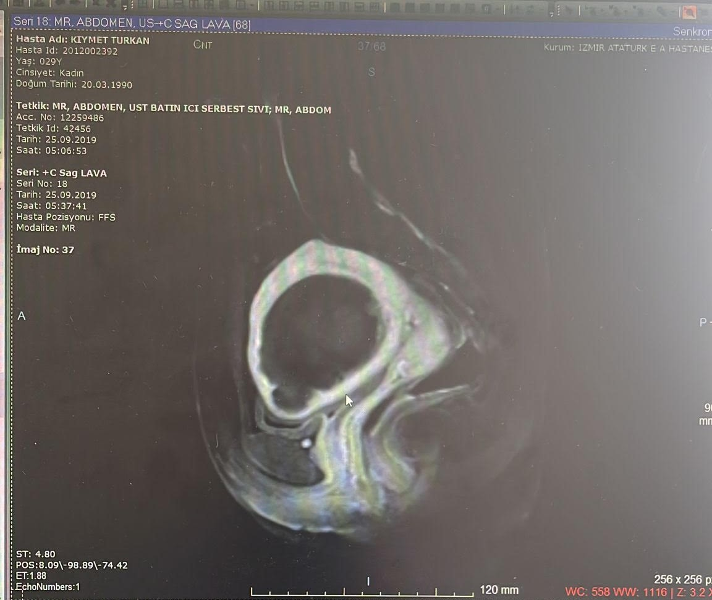

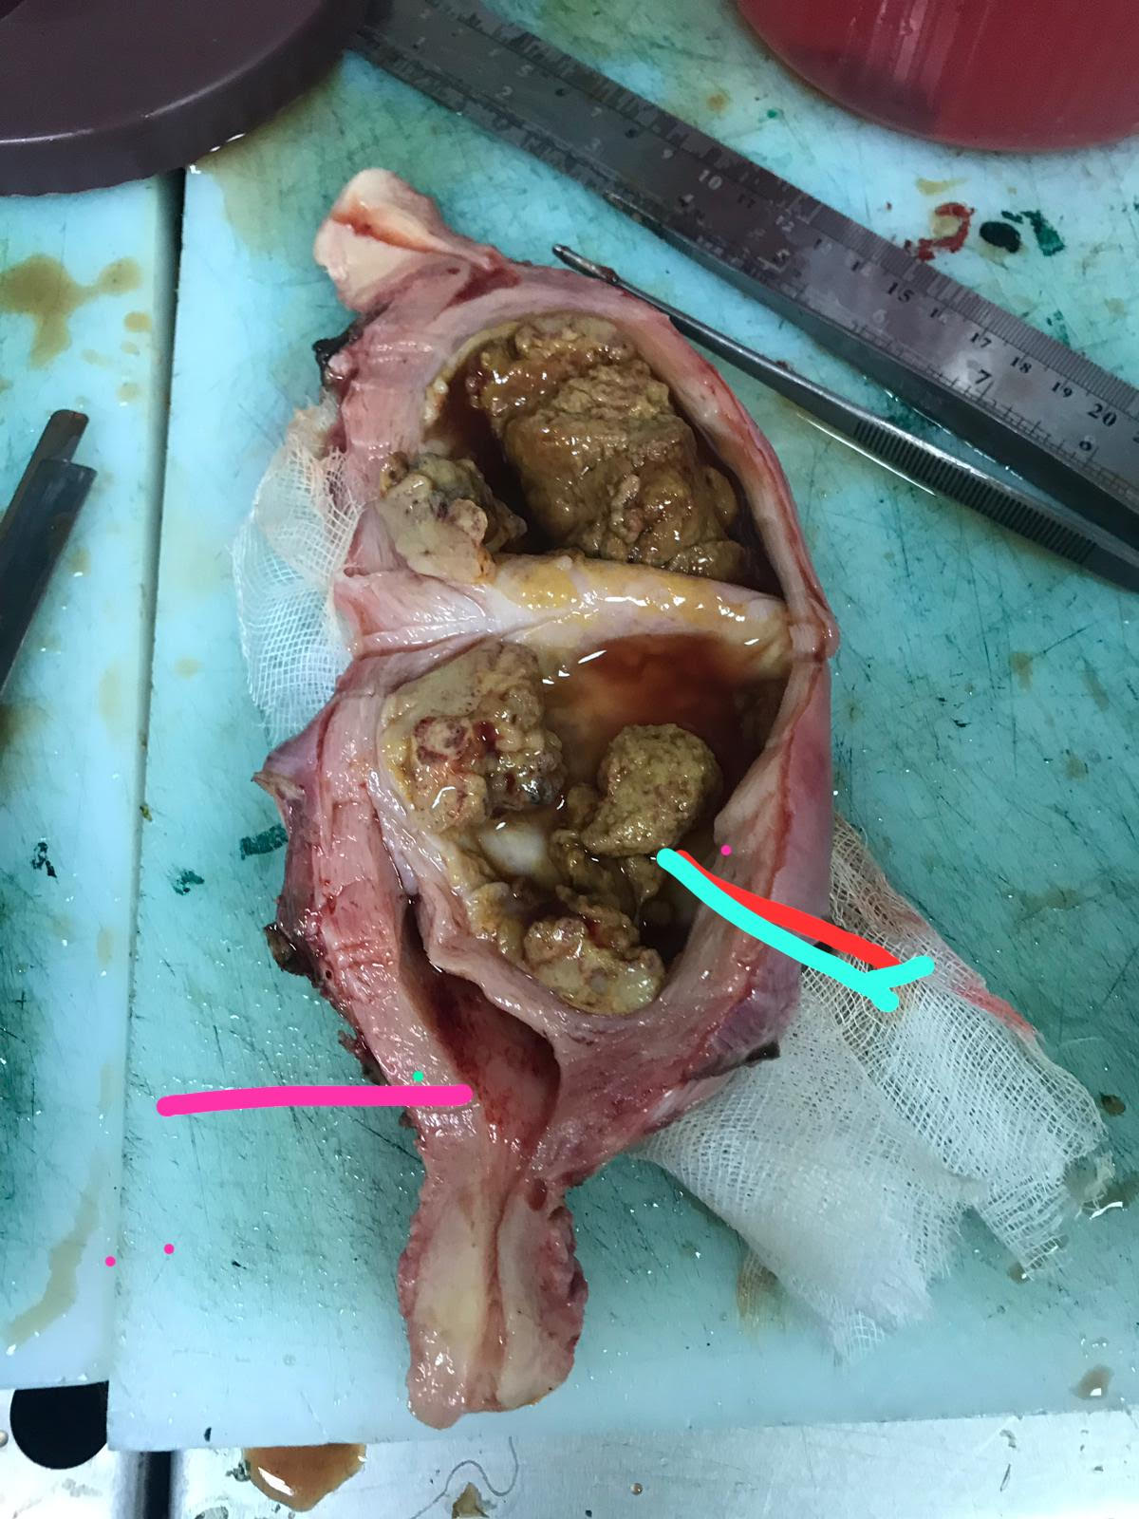

3 December 2019… tah + bs + bilateral palpable pelvic lymph node sampling + abdominal fluid sampling was performed.
Pathology macroscopy: uterine size 15x10x8 cm with intramural localization, 7.5x5.5 cm diameter, a soft tumoral structure with a pinched yellow color was observed. Trample tumoral structure was commonly observed as necrotic. In the cross-sections, 4 lymph nodes on the right and 4 on the left were observed, the largest of which was 2 cm in diameter.
TAH material: epitheloid tophoblastic tumor (7.5 cm in diameter and extensive necrosis was observed).
Lymph nodes reactive lymphoid hyperplasia. Abdominal washing: benign cytology. IHC: Inhibin positive in isolated cells. p63(+)

In tumour board, postoperative follow-up decision was taken for the patient with surgical stage 1.
Clinical course: BHCG: 0.0 u/l at postoperative 2nd week, no increase in subsequent follow-ups. No sign of recurrence was found in the postoperative control MRI at 6 months. The patient, who is still under follow-up, is in remission for 4 years.

References :
1.Kohorn EL. Worldwide survey of the results of treating gestational trophoblastic disease. J Reprod Med 2014;59:145e53. [40] Zhang X, Lu W, Lu B. Epithelioid trophoblastic tumor. Int J Gynecol Canc 2013;23:1334e8.
2.Palmer JE, Macdonald M, Wells M, Hancock BW, Tidy JA. Epithelioid trophoblastic tumor: a review of the literature. J Reprod Med 2008;53:465e75
3.Zhang X, Lu W, Lu B. Epithelioid trophoblastic tumor. Int J Gynecol Canc 2013;23:1334e8
4. Kingdon SJ, Coleman RE, Ellis L, Hancock BW. Deaths from gestational trophoblastic neoplasia: any lessons to be learned? J Reprod Med 2012;57:293e6.
5. Li J, Shi Y, Wan X, Qian H, Zhou C, Chen X. Epithelioid trophoblastic tumor: a clinicopathological and immunohistochemical study of seven cases. Med Oncol 2011;28:294e9.
6.Shen X, Xiang Y, Guo L, Ren T, Feng F, Wan X, et al. Analysis of clinicopathologic prognostic factors in 9 patients with epithelioid trophoblastic tumor. Int J Gynecol Canc 2011;21:1124e30.
7.Hancock BW, Froeling FE, Ramaswami R, Horsman J, Ellis L, Seckl M, et al. The ISSTD global placental site and epithelioid trophoblastic tumour (PSTT/ETT) database e an analysis of 326 patients. ISSTD XVIII World Congress on Gestational Trophoblastic Disease Bali, Indonesia 2015. Abstract 12.
8.Tidy J. The role of surgery in the management of gestational trophoblastic disease. In: Hancock BW, Seckl MJ, Berkowitz RS, Cole LA, editors. Gestational trophoblastic disease. 4th edition. London: ISSTD; 2015
9. Pisal N, North C, Tidy J, Hancock B. Role of hysterectomy in management of gestational trophoblastic disease. Gynecol Oncol 2002;87:190e2.
10.Pfeffer PE, Sebire NJ, Lindsay I, McIndoe A, Lim A, Seckl MJ. Fertility-sparing partial hysterectomy for placental-site trophoblastic tumour. Lancet Oncol 2007;8:744e6.
11.King L, Okagaki T and Twiggs LB Resolution of pulmonary metastases with chemotherapy in a patient with placental site trophoblastic tumour. Int J Gynecol Canc 2: 328-331.
12.Randall TC, Coukos G, Wheeler JE, Rubin SC. Prolonged remission of recurrent, metastatic placental site trophoblastic tumor after chemotherapy. Gynecol Oncol 2000;76:115e7.
13.Dobson LS, Lorigan PC, Coleman RE, Hancock BW. Persistent gestational trophoblastic disease: results of MEA (methotrexate, etoposide, dactinomycin) as first-line chemotherapy in high risk disease and EA (etoposide and dactinomycin) as second line therapy for low risk disease. Br J Canc 2000;82:1547e52.

S-06 Approach To Adnexal Masses Detected During Cesarean Delivery: A Case Presentation
Alper Solmaz¹, Emrah Töz¹
1 Tepecik Eah
ABSTRACT
This report presents a case of an adnexal mass incidentally discovered during a cesarean delivery in the context of pregnancy. The case involves an 18-year-old primigravid patient with no prior abdominal surgeries or underlying medical conditions. A cesarean section was planned due to cephalopelvic disproportion. During the cesarean procedure, a cystic-necrotic mass measuring approximately 4 cm was identified on the left side of the uterus. The mass was surgically excised, and frozen section analysis confirmed it as benign tubal tissue. The patient was discharged on the second postoperative day.
The incidence of adnexal masses during pregnancy is relatively low, and detection of these masses may occur during routine ultrasound or cesarean section. Early pregnancy adnexal masses should be approached with caution for possible malignancies. In cases where surgical intervention is necessary, careful planning and involvement of a gynecologic oncologist are essential. Incidentally discovered masses should be excised and subjected to frozen section analysis for appropriate management. Postpartum care should include referral to a gynecologic oncologist for further evaluation and treatment.
Keywords: adnexal mass, pregnancy, cesarean delivery

INTRODUCTION
The occurrence of adnexal masses during pregnancy is relatively rare, with an incidence ranging between 0.05 and 2.4 percent[1]. These masses may come to light at the time of routine obstetric ultrasonography or during cesarean deliveries. It is noteworthy that the prevalence of adnexal masses has witnessed an upward trend in recent years, largely attributed to the increasing rates of cesarean deliveries. In this report, we present a case of an adnexal mass discovered during a cesarean delivery at our institution.

CASE
An 18-year-old primigravid patient, without a history of prior abdominal surgeries or any underlying medical condition, presented to the emergency department with complaints of labor pain. Due to cephalopelvic disproportion, a cesarean section was planned after obtaining informed consent from both the patient and her family. The abdomen was entered via a Pfannenstiel incision, revealing an approximately 4 cm cystic-necrotic mass located on the left side of the uterus . The right ovary and tube appeared normal, as did the left ovary, while the left uterine tube and salpinx were unremarkable. Following successful fetal delivery and meticulous hemostasis, the mass was cautiously excised with the assistance of a Kocher clamp. The excised tissue was promptly submitted for frozen section analysis, which confirmed it as benign tubal tissue. Subsequently, the abdomen was closed, and the patient was discharged on the second postoperative day.

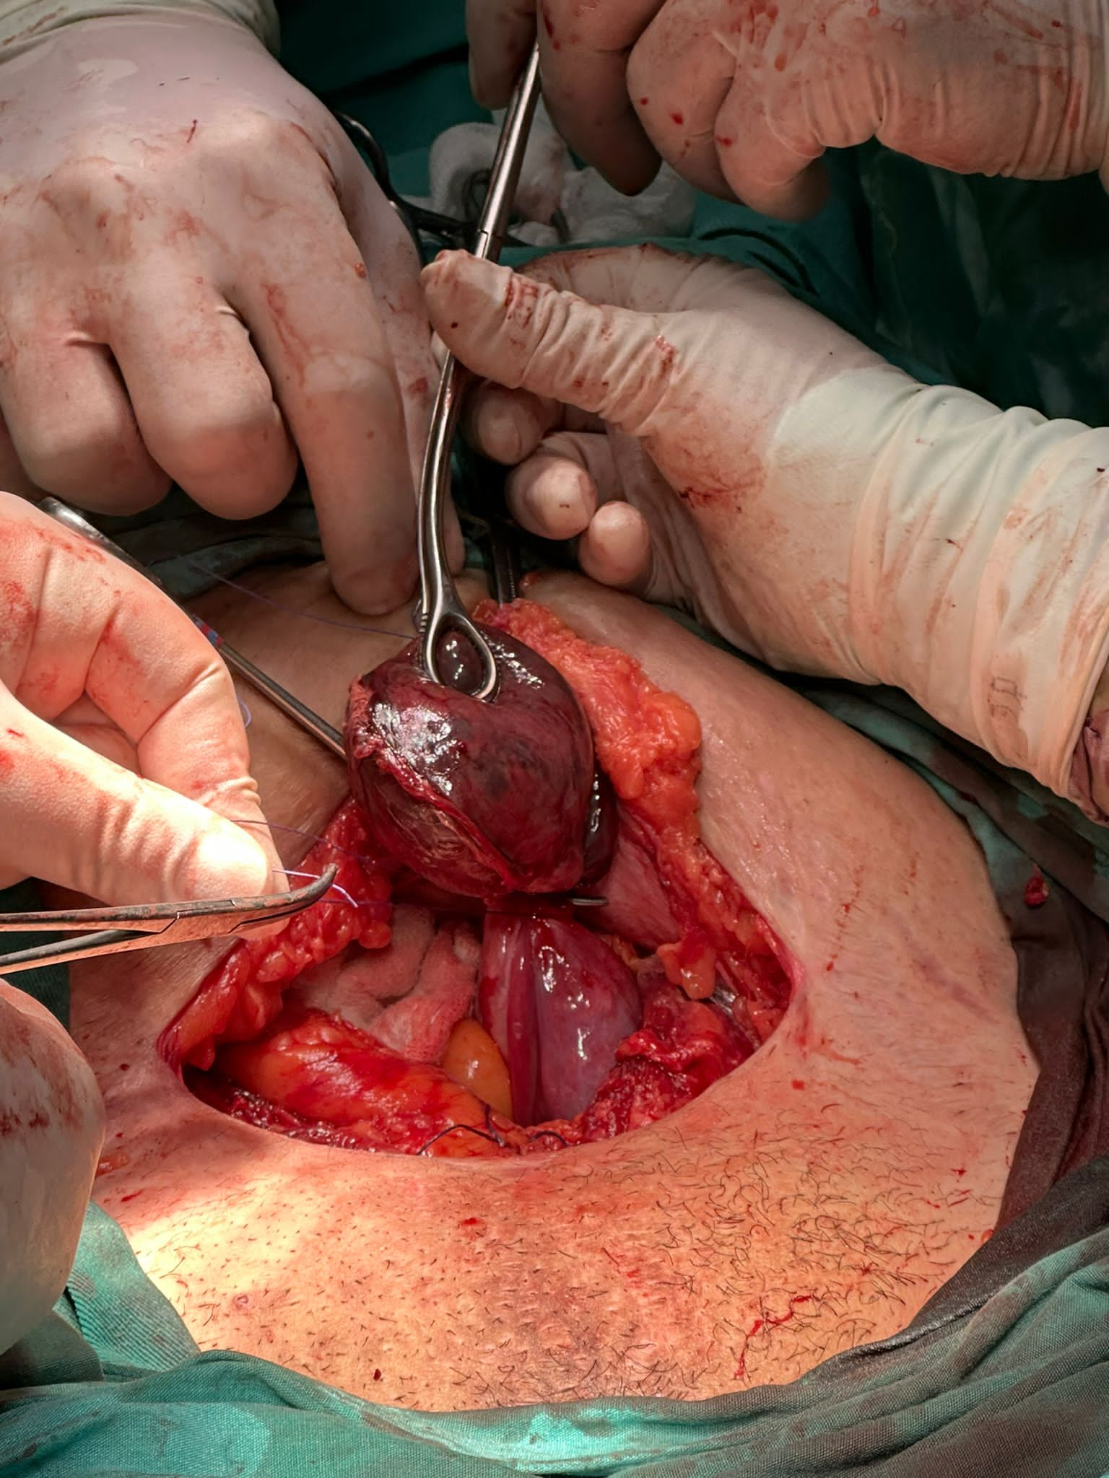

Figure-1

CONCLUSION
The incidence of adnexal masses encountered during pregnancy is relatively low, ranging from 0.05 to 2.4 percent, with approximately 1 to 6 percent of these masses being malignant[1]-[4]. Early pregnancy adnexal masses should be approached with an increased suspicion of possible malignancy. Magnetic resonance imaging (MRI) can serve as a valuable diagnostic tool in cases where suspicion arises. For benign masses lacking acute symptoms, vigilant surveillance represents a reasonable alternative to antepartum surgery[3]. In situations necessitating cesarean section in patients with suspected malignancy, careful consideration should be given to selecting the most appropriate surgical incision, with the involvement of a gynecologic oncologist in the surgical team. In cases where an adnexal mass is incidentally identified during a cesarean section, it should be excised with precision and subjected to frozen section analysis. If the frozen section result indicates malignancy, salpingo-oophorectomy should be considered. Subsequently, postpartum care should include referral to a gynecologic oncologist for further evaluation and management.

REFERENCES
[1] K. E. Webb, K. Sakhel, S. P. Chauhan, and A. Z. Abuhamad, “Adnexal mass during pregnancy: a review,” Am J Perinatol, vol. 32, no. 11, pp. 1010–1016, May 2015, doi: 10.1055/S-0035-1549216.
[2] L. H. Smith, J. L. Dalrymple, G. S. Leiserowitz, B. Danielsen, and W. M. Gilbert, “Obstetrical deliveries associated with maternal malignancy in California, 1992 through 1997,” Am J Obstet Gynecol, vol. 184, no. 7, pp. 1504–1513, 2001, doi: 10.1067/MOB.2001.114867.
[3] K. M. Schmeler, W. W. Mayo-Smith, J. F. Peipert, S. Weitzen, and M. D. Manuel, “Adnexal masses in pregnancy: surgery compared with observation,” Obstetrics and gynecology, vol. 105, no. 5 Pt 1, pp. 1098–1103, 2005, doi: 10.1097/01.AOG.0000157465.99639.E5.
[4] P. Aggarwal and S. Kehoe, “Ovarian tumours in pregnancy: a literature review,” Eur J Obstet Gynecol Reprod Biol, vol. 155, no. 2, pp. 119–124, 2011, doi: 10.1016/J.EJOGRB.2010.11.023.

S-07 Maternal And Neonatal Outcomes In Hellp Syndrome: 10 Years Of Clinical Experience
Ayşegül Bestel¹, Mustafa Göksu¹
1 University Of Health Sciences, Istanbul Kanuni Sultan Suleyman Training And Research Hospital,ıstanbul,turkey

Giriş: HELLP sendromu gebelik veya doğumsonu dönemde görülen hemoliz, karaciğer enzimlerinin yüksekliği ve platelet değerlerinde düşüklük ile karakterizedir. Patogenezi net olmamakla birlikte kompleman düzensizliği ve pıhtılaşma sisteminin aktivasyonu bu duruma yol açabilir. Amacımız HELLP sendromu tanısı konulan hastalarda maternal sonuçları belirlemektir.
Materyal ve metod: 10 yıllık dönemde tersiyer merkez hastanemizde HELLP tanısı alan hastaların verileri retrospektif olarak sistemden incelendi. Anne ve yenidoğan komplikasyonları kaydedildi ve analiz edildi.
Sonuçlar: 10 yıllık dönemde 70 HELLP sendromu vakası vardı. Ortalama anne yaşı 30,15±6,01 yıldı. %88,6 sı sezaryen ile %11,4 ü normal vaginal doğum ile doğurtuldu. Doğum sırasındaki ortalama gebelik süresi 31,8±3,8 haftaydı. Bebeklerin yüzde 40'ı yenidoğan yoğun bakım ünitesine (NICU) yatırıldı. IUGR %52 sinde saptanmıştır. Oligohidroamnios %13 ünde saptanmıştır. Ortalama doğum ağırlığı 1918,10±785,5 idi. Ortalama kalış süresi 6,05±3 gündü. Anne morbiditesi yüksekti, ancak kısa vadeliydi ve tüm vakalarda tam iyileşme sağlandı. AST max 217,35±201,72; ALT max 203,74±234,00. 1 hastada eklampsi meydana gelmiştir.
Tartışma: HELLP sendromu tanısı konduktan sonra maternal morbidite ve mortalite hastanın klinik durumu, laboratuar sonuçlarında anormallik ve gelişen komplikasyonlara bağlıdır.
Anahtar kelimeler: HELLP sendromu, sonuçlar, preeklampsi

Abstract
Maternal and neonatal outcomes in HELLP syndrome: 10 years of clinical experience
Introduction: HELLP syndrome is characterized by hemolysis during pregnancy or postpartum period, elevated liver enzymes and low platelet values. Although the pathogenesis is not clear, complement dysregulation and activation of the coagulation system may lead to this condition. Our aim is to determine maternal outcomes in patients diagnosed with HELLP syndrome.
Material and method: The data of patients diagnosed with HELLP in our tertiary central hospital over a 10-year period were retrospectively analyzed from the system. Maternal and neonatal complications were recorded and analyzed.
Results: There were 70 cases of HELLP syndrome in the 10-year period. Mean maternal age was 30.15±6.01 years. 88.6% were delivered by cesarean section and 11.4% by normal vaginal delivery. The mean gestational age at delivery was 31.8±3.8 weeks.
40% of the babies were admitted to the neonatal intensive care unit (NICU). IUGR was detected in 52%. Oligohydramnios was detected in 13%. The mean birth weight was 1918.10±785.5. The mean length of stay was 6.05±3 days. Maternal morbidity was high, but short-term and full recovery was achieved in all cases. AST max value was 217.35±201.72; ALT max value is 203.74±234.00. Eclampsia occurred in 1 patient.
Conclusion: After the diagnosis of HELLP syndrome, maternal morbidity and mortality depend on the clinical condition of the patient, abnormal laboratory results and developing complications.
Keywords: HELLP Syndrome, Outcomes, Preeclampsia

Introduction
HELLP syndrome is characterized by hemolysis during pregnancy or postpartum period, elevated liver enzymes and low platelet values(1). The prevalence of HELLP syndrome is between 0.5% and 0.9%, and the mortality rate of these patients is up to 24% in the literature(2).
Although the pathogenesis is not clear, complement dysregulation and activation of the coagulation system may lead to this condition.

Endothelial damage in preeclampsia causes microvascular damage and causes liver dysfunction(3). HELLP syndrome develops with multiorgan microvascular damage, hepatic necrosis, increased intravascular coagulation, and thrombocytopenia caused by platelets sticking to the damaged endothelium(1). Renal dysfunction can also be seen in HELLP syndrome, due to periportal hemorrhage with lobular necrosis in the liver and ischemic damage to the kidneys due to microvascular damage(4, 5). Our aim is to determine maternal outcomes in patients diagnosed with HELLP syndrome.
Material and method
The data of patients diagnosed with HELLP in our tertiary central hospital between 2012 and 2022 were retrospectively analyzed from the system. Maternal and neonatal complications were recorded and analyzed.
Results
There were 70 cases of HELLP syndrome in the 10-year period. Mean maternal age was 30.15±6.01 years. 88.6% were delivered by cesarean section and 11.4% by normal vaginal delivery. The mean gestational age at delivery was 31.8±3.8 weeks.
40% of the babies were admitted to the neonatal intensive care unit (NICU). IUGR was detected in 52%. Oligohydramnios was detected in 13%. The mean birth weight was 1918.10±785.5. The mean length of stay was 6.05±3 days. Maternal morbidity was high, but short-term and full recovery was achieved in all cases. AST max value was 217.35±201.72; ALT max value is 203.74±234.00. Eclampsia occurred in 1 patient.

Conclusion

After the diagnosis of HELLP syndrome, maternal morbidity and mortality depend on the clinical condition of the patient, abnormal laboratory results and developing complications.

Table 1: Results of HELLP patients
 | Mean±SD
Age | 30,15±6,01
Gravity | 2,2±1,31
Systolic blood pressure max | 164,01±24,09
Diastolic blood pressure max | 101,36±12,71
AST max | 217,35±201,72
ALT max | 203,74±234,00
Hospitalization (gün) | 6,05±3
Prenatal magnesium time (saat) | 7,66±8,38
Birth weight | 1918,10±785,5
Hb | 11,6±1,46
Hct | 34,07±5,31
Lenfosit | 1,69±0,64
WBC | 15,5±5,36

Table 2: Antenatal information in HELLP patients
Previous form of birth | NSD: 23(60%)  C/S: 15(40%)
IUGR | 32(52%)
Oligohidroamnios | 7(13%)
Type of birth | NSD: 8(11,4%) C/S:62(88,6%)

References

1. Khalid F, Mahendraker N, Tonismae T. HELLP syndrome. 2020.
2. Van Lieshout L, Koek G, Spaanderman M, van Runnard Heimel P. Placenta derived factors involved in the pathogenesis of the liver in the syndrome of haemolysis, elevated liver enzymes and low platelets (HELLP): A review. Pregnancy hypertension. 2019;18:42-8.
3. Stojanovska V, Zenclussen AC. Innate and adaptive immune responses in HELLP syndrome. Frontiers in immunology. 2020;11:667.
4. Barton JR, Riely CA, Adamec TA, Shanklin DR, Khoury AD, Sibai BM. Hepatic histopathologic condition does not correlate with laboratory abnormalities in HELLP syndrome (hemolysis, elevated liver enzymes, and low platelet count). American journal of obstetrics and gynecology. 1992;167(6):1538-43.
5. Ye W, Shu H, Yu Y, Li H, Chen L, Liu J, et al. Acute kidney injury in patients with HELLP syndrome. International urology and nephrology. 2019;51:1199-206.

S-08 Laparoscopic Cervicoisthmic Cerclage: To Who And When?
Barış Sever¹
1 Republic Of Turkey Ministry Of Health, Izmir Provincial Health Directorate, Izmir University Of Health Sciences Tepecik Training And Research Hospital, Department Of Obstetrics And Gynecology, Division Of Perinatalogy

Cervicoistmic cerclage was placed laparoscopically with a transabdominal approach at the 13th gestational week of a patient who had a history of unsuccessful transvaginal cerclages at the Perinatology Clinic of Izmir Tepecik Training and Research Hospital. A 5 mm mersilen suture was used. No complications were encountered after the operation. No abnormality was observed in the patient's follow-up until the 33rd gestational week. Fetal growth begins to slow at the 33rd week of pregnancy . The follow-up of the patient was continued because the abdominal circumference (AC) was 11th percentile (<10th percentile) and the amnion was sufficient in the ultrasonographic examination. The pregnancy was ended by cesarean section when the contractions started at the 36+2 weeks of gestation. A 2450 g baby with Apgar 9-10 was delivered. The cerclage was not removed at the request of the family. No problems were encountered in the intraop and post op period. Placing cerclage in the cervicoistmic region with the transabdominal approach has become a more frequently used method in recent years. It should be well determined in which patients it will be used for and with which methods will be applied. In this article, we evaluated the patient who had a cerclage with a transabdominal approach.
Keywords: Cervical insufficiency, Laparoscopic cervicoisthmic cerclage, Transvaginal cerclage
INTRODUCTION
In selected patients with cervical insufficiency, transabdominal placement of a cerclage at the cervicoisthmic junction rather than transvaginal cerclage is performed to reduce the risk of spontaneous pregnancy loss and/or preterm birth (1). The transabdominal approach is a more morbid procedure than the transvaginal approach, especially if laparotomy rather than laparoscopy is performed for placement, and a cesarean birth is generally required. So it should be the last option. Patients suitable for the transabdominal approach can be listed as follows (2): a) Unable to undergo a transvaginal procedure because an extremely short or absent cervix, amputated cervix, marked cervical scarring, or cervical defect makes it technically impossible to perform b) Failure to deliver a healthy newborn after at least one previous prophylactic transvaginal cerclage (history-indicated or ultrasound-indicated but not a physical examination-indicated cerclage).
The technique (McDonald versus Shirodkar) used for the previous cerclage does not influence decision. No compelling evidence indicates that, before resorting to a transabdominal approach, a Shirodkar cerclage should be attempted in the pregnancy after a failed prophylactic McDonald cerclage. Improvement in birth outcome from transabdominal cerclage may be related to (3): a) More proximal placement of the stitch (at the level of the internal os) b) Decreased risk of caudal suture migration as the uterus enlarges c) Absence of a foreign body in the vagina that could promote infection and inflammation
The laparoscopic approach is equally effective and probably superior to the open approach as long as the provider has the requisite laparoscopic experience to perform the procedure. Due to lower morbidity, the laparoscopic approach is preferable when technically feasible and the requisite surgical expertise is available. Twin pregnancy is not a contraindication to transabdominal cerclage placement (4). The larger uterine size of a twin pregnancy may make access to the lower uterus challenging with open or laparoscopic approach, which is the reason some surgeons perform the procedure earlier in these pregnancies.
In patients who meet criteria for transabdominal cerclage placement, the procedure can be performed either preconception in patients planning to conceive or in early pregnancy after ultrasound assessment of the embryo/fetus. There is no consensus as to the best approach. Advantages of preconception placement include (5): a) The surgeon has optimum exposure b)The risk of injury to the pregnancy is eliminated c) The risk of excessive procedure-related bleeding is reduced compared with procedures performed during pregnancy. Very limited data suggest preconception placement does not impair fertility (6). Still, up to 26 percent of patients in a systematic review underwent the procedure and did not go on to have a pregnancy; the reasons for not conceiving were not provided (7). In patients presenting in early pregnancy, a transabdominal cerclage should be placed in the late first trimester to early second trimester because: a) The risk of spontaneous pregnancy loss is lower than earlier in gestation b) Major structural anomalies can be excluded by ultrasound performed at 11 to 13 weeks c)Information from early aneuploidy screening (if desired) is available d) The uterus is not too large to make it technically challenging. Later placement (≥14 to 15 weeks) is undesirable since the large size of the uterus makes the procedure more difficult, especially if performed laparoscopically, and thus may be associated with a higher risk of complications. However, case reports have described performing the procedure at 18 to 24 weeks (8). The Society for Maternal-Fetal Medicine suggests first-trimester placement but adds that transabdominal cerclage can still be considered before 22 weeks of gestation (2).
In patients who have undergone transabdominal cerclage placement, planned cesarean birth at 36+0 to 37+6 weeks of gestation should be done to avoid the risk of uterine rupture during labor. An advantage of transabdominal cervicoisthmic cerclage over transvaginal cervical cerclage is the ability to leave the suture in place for future pregnancies. The cerclage can be removed at cesarean birth if the patient is not planning additional pregnancies or left in place if future pregnancies are planned.

Case
The patient is 32 years old, has no living children. Since she had 2 early second trimester abortions, transvaginal cerclage was applied at 13 weeks of 3rd pregnancy and at 16 weeks in her 4th pregnancy. Pregnancy with cerclage applied at 13 weeks resulted in abortion at 21 weeks of gestation. 4th pregnancy with cerclage applied at 16 weeks resulted in preterm labor at 24 weeks. The baby died shortly after birth. When the patient applied to our clinic, she has a 9 week pregnancy (CRL: 9+1 weeks, fetal heart rate +, gestational sac regular). Laparoscopic cervicoisthmic cerclage was planned because there was a previous history of recurrent-unsuccessful transvaginal cerclage. The patient was screened for aneuploidy at 11 weeks. The test result was found to be low risk. Aneuploidy markers were checked. No abnormality was observed. Laparoscopic cervicoisthmic cerclage was performed when the patient was 13+0 weeks of gestation. The abdominal cavity was entered with a 10 mm trocar above the umbilicus. Mild adhesions were observed in the omentum. 2 more 5 mm trocars from the left and 1 from the right were placed into the abdominal cavity. In front of the uterus at the level of the isthmus, the bladder was separated with a sharp dissection and the front of the uterus was released. A window was opened in the latum uteri on both sides of the uterus. A 5 mm mercilene suture was passed medial to the uterine vessels (at the level of the uterine cardinal ligament). The sutures passed from the right and left were tied at the isthmic level. The bladder was returned to its former position. The operation was finished after bleeding control.
No problem was observed in the post-operative period. Postoperatively, it was observed that the cerclage was in the cervicoistmic region when examined with ultrasound. Detailed ultrasound and fetal echo were performed at the 20th week of the gestation and found normal. At 33 weeks of the gestation, mild regression was detected in AC measurements (AC 11-17 percentile, EFW 20-22 percentile). No abnormality was observed in the umbilical artery Doppler values. Notch was not observed in the uterine arteries. The patient was followed up to 36+2 weeks with close follow-up. When the patient's contractions started at 36+2 weeks, the patient was taken to cesarean section. A 2450 gr baby was delivered by cesarean section. Apgar was found as 9-10 at the 1st and 5th minutes. No adhesion was observed in the abdomen. The uterus was entered with a transversal incision at the lower uterine segment. The location of the cerclage was determined by palpation before the uterus incision. Since the bladder did not cover the lower uterine segment, the uterus was entered without dissection of the bladder. The uterus was closed as a single layer. Before the operation, the patient and his husband were interviewed, the cerclage was left in place because the parent did not want the cerclage to be removed. There was no problem in the post-operative period.

CONCLUSION
Laparoscopic cervicoisthmic cerclage is an effective method in cases where transvaginal cerclage is insufficient. Patient selection should be done well in terms of morbidity, and the possible risks of the surgery should be shared with the patient in detail. Cerclage placement before conception can make the operation easier and more effective.

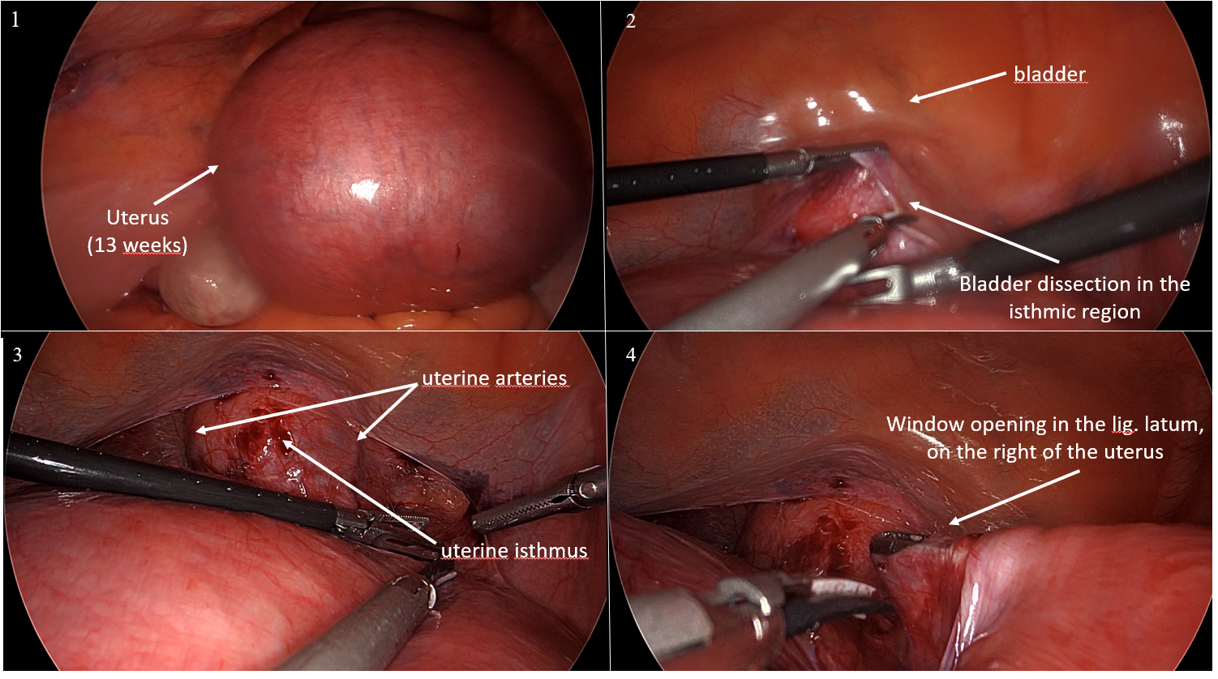
Figure 1: Intraoperative images of laparoscopic cervicoisthmic cerclage-1

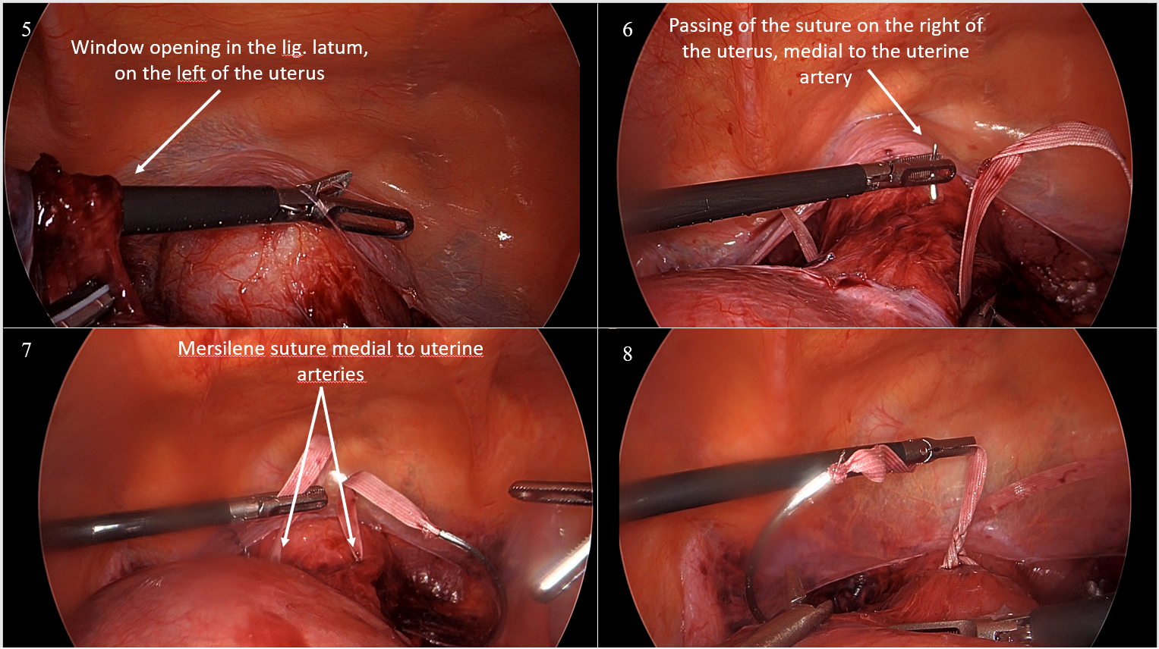
Figure 2: Intraoperative images of laparoscopic cervicoisthmic cerclage-2

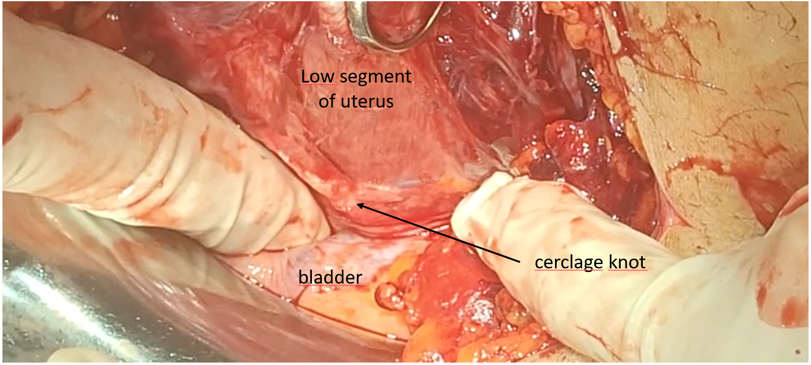
Figure 3: The appearance of the cerclage during cesarean section at 36+2 weeks

References:
- Transabdominal and laparoscopic cervicoisthmic cerclage, Uptodate [Internet] [cited August 2, 2023] . Available at: https://www.uptodate.com/contents/transabdominal-and-laparoscopic-cervicoisthmic-cerclage?search=abdominal%20serklaj&source=search_result&selectedTitle=1~150&usage_type=default&display_rank=1.
- Society for Maternal-Fetal Medicine (SMFM), Temming L, Mikhail E, SMFM Publications Committee. Electronic address: pubs@smfm.org. Society for Maternal-Fetal Medicine Consult Series #65: Transabdominal cerclage. Am J Obstet Gynecol 2023; 228:B2.
- Herron MA, Parer JT. Transabdominal cerclage for fetal wastage due to cervical incompetence. Obstet Gynecol 1988; 71:865.
- Debiève F, Joskin A, Steenhaut P, et al. Transabdominal cerclage for cervical insufficiency in twins: series of seven cases and literature review. J Matern Fetal Neonatal Med 2020; 33:3579.
- Burger NB, Einarsson JI, Brölmann HA, et al. Preconceptional laparoscopic abdominal cerclage: a multicenter cohort study. Am J Obstet Gynecol 2012; 207:273.e1.
- Vousden NJ, Carter J, Seed PT, Shennan AH. What is the impact of preconception abdominal cerclage on fertility: evidence from a randomized controlled trial. Acta Obstet Gynecol Scand 2017; 96:543.
- Moawad GN, Tyan P, Bracke T, et al. Systematic Review of Transabdominal Cerclage Placed via Laparoscopy for the Prevention of Preterm Birth. J Minim Invasive Gynecol 2018; 25:277.
- Joung EJ, Go EB, Kwack JY, Kwon YS. Successful term delivery cases of trans-abdominal cervicoisthmic cerclage performed at more than 18 weeks of gestation. Obstet Gynecol Sci 2016; 59:319.

S-09 Pregnancy Associated Osteoporosis: A Case Report
Benil Nesli Ata¹, Can Ata²
1 Çiğli Eğitim Ve Araştırma Hastanesi, Fiziksel Tıp Ve Rehabilitasyon Kliniği
2 Buca Seyfi Demirsoy Eğitim Ve Araştırma Hastanesi, Kadın Hastalıkları Ve Doğum Kliniği

Pregnancy associated osteoporosis (PAO) is a rare type of premenopausal osteoporosis. It presents with symptoms of severe low back pain and shortening in height seen in the last trimester of pregnancy or in the postpartum period. The primigravid 20 year old patient had a history of cesarean section at 38 weeks of gestation. Severe low back and back pain started one week after birth. The patient's pain was not related to walking or moving. She stated that her pain was continuous and severe enough to limit his activities of daily living. In the thoracic vertebral MRI of the patient, height losses were detected in T10, T11, T12 and L1 vertebraes. The patient, who was diagnosed with pregnancy-related osteoporosis, was treated with teriparatide, an anabolic agent, for six months. In addition, the patient was started on vitamin D and calcium replacement, and breastfeeding was terminated. The bone mineral density of the patient, who applied to the our outpatient clinic for follow-up, was femoral neck Z score -2.6, femoral total Z score -1.9, L1-L4 Z score -4.0. She had no known disease, trauma, smoking or alcohol use in her history. After using lumbosacral orthosis for 8 months, the patient's low back pain decreased and lumbar movements were evaluated as painless in all directions. The treatment was planned considering the patient's re-pregnancy planning and the fact that the drug did not accumulate in the bone matrix. We decided to continue the patient's treatment with the monoclonal antibody denosumab. PAO, it occurs in the first pregnancy and is often seen in the last trimester of pregnancy or in the first 3 months after delivery. Depending on the postural changes during pregnancy and the increase in the relaxin hormone levels, back pain that starts in the last three months of pregnancy and ends in the postpartum period can be seen. This situation causes the diagnosis of PAO to be missed or delayed. PAO should be considered in the differential diagnosis of back pain in pregnant and postpartum patients. It is important to make the diagnosis in the early period in order to prevent morbidity.
Keywords: back pain, pregnancy, premenopausal osteoporosis

S-10 Uterus Didelpyhs With A Spontaneous Pregnancy At Term: A Rare Case Report
Ayşe Demirden¹, Beyzanur Kahyaoğlu¹
1 İstanbul Kartal Dr.lütfi Kırdar Şehir Hastanesi

Uterus didelphys is a rare pathology resulting from the bilateral mullerian ducts absence of fusion. This condition affects 5% of uterine malformations from mullerian ducts and is observed in one woman in 1,000-30,000. A 24-year-old, gravid 2, abortus 1, admitted in obstetric emergency departments for abdominal pain at 36 weeks gestation. The patient past medical history was unremarkable. During examination, the blood pressure was 110/60 mmHg, the heart rate was 60 beats / min. On the vaginal examination of the patient 2 cm cervical dilatation, and breech presentation was determined. Non-stress test (NST) identified bradycardia and fetal distress and she was prepared for emergency cesarean section. The surgical intervention was performed under general anesthesia.A 2730 g, 49 cm, 33 cm head circumference, female infant with breech presentation was born with APGAR scores of 6 and 8 at 1st and 5th min, respectively. At the exteriorization of the uterus outside the peritoneal cavity, we discovered a uterus didelphys (Figure1). The patient and newborn were discharged with good condition on the postoperative 2 th day.The chance of reaching term for pregnancies with didelphys uterus is reported as 20%–30%. The birth rate by cesarean is reported as 82%. Our case was a term pregnancy with a birth by emergency cesarean, due to breech presentation and fetal distress. The delivery route depends on the presentation of the fetus and the occurrence of a previa obstacle by the hemi-uterus during labor.
Keywords: Spontaneous pregnancy,Uterus didelpyhs
Introduction: Uterus didelphys is a rare pathology resulting from the bilateral mullerian ducts' absence of fusion. This condition affects 5% of uterine malformations from mullerian ducts and is observed in one woman in 1,000-30,000. Obstetrical complications are numerous and pregnancies with didelphys uterus have a chance of reaching term of 20%-30%. Herein, we reported a case of pregnancy reaching term on uterus didelphys discovered during an emergency Caesarean section.
Case: A 24-year-old, gravid 2, abortus 1, admitted in obstetric emergency departments for abdominal pain at 36 weeks gestation. The patient past medical history was unremarkable. During examination, the blood pressure was 110/60 mmHg, the heart rate was 60 beats / min. On the vaginal examination of the patient 2 cm cervical dilatation, and breech presentation was determined. Non-stress test (NST) identified bradycardia and fetal distress and she was prepared for emergency cesarean section. The surgical intervention was performed under general anesthesia. A 2730 g, 49 cm, 33 cm head circumference, female infant with breech presentation was born with APGAR scores of 6 and 8 at 1st and 5th min, respectively. At the exteriorization of the uterus outside the peritoneal cavity, we discovered a uterus didelphys (Figure1). The patient and newborn were discharged with good condition on the postoperative 2th day.
Conclusion: The frequency of the uterus didelphys is rare. The incidence of uterine anomalies ranges between 0.1% and 10%, 3.5% in the infertile population and 13% in the population with repeated miscarriages. Of all congenital uterine anomalies, 6% are uterus didelphys. In uterus didelphys cases there is no consensus on birth management. Studies have shown 24.4% preterm birth, 68.6% live birth, 2%–3% ectopic pregnancy and 20.9% abortion rates with increased obstetric complications. The chance of reaching term for pregnancies with didelphys uterus is reported as 20%–30%. The birth rate by cesarean is reported as 82%. Our case was a term pregnancy with a birth by emergency cesarean, due to breech presentation and fetal distress. The delivery route depends on the presentation of the fetus and the occurrence of a previa obstacle by the hemi-uterus during labor.

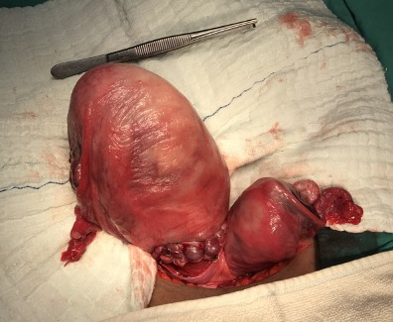

S-11 Rahim İçi Kontraseptif Aracın Tubal Migrasyonu: Olgu Sunumu Tubal Migration Of An Intrauterine Contraceptive Device: A Case Report
Bilgesu Çetinel Kaygun¹, Hüsnü Onur Durmaz¹, Sercan Kantarcı¹
1 Aydın Kadın Doğum ve Çocuk Hastalıkları Hastanesi

ÖZET Rahim içi araç (RİA), kadınlarda geri dönüşümlü en yaygın kontrasepsiyon yöntemlerinden biridir. Uterin perforasyon ve ekstrauterin bölgelere göç gibi ciddi komplikasyonlara neden olabilir. RİA'nın tüplere migrasyonu çok nadirdir ve literatürde kapsamlı bir şekilde tanımlanmamıştır. 32 yaşında gravida 4, parite 3, 1 spontan vajinal doğum 2 sezeryanı olan hasta 1 sene önce, postpartum 4.ayında bakırlı ria takım öyküsü mevcut olup; adet gecikmesi şikayeti ile başvurması üzerine yapılan ultrasonda; ıntrauterin 5 mm gestasyonel sac (gs), yolk sac pozitif fetal pol ayırt edilememiş olup,sol tuba içerisinde RIA izlendi. Hastaya gebeliğin devamı, 2. trimesterda laparoskopi ile RIA çıkarımı önerilmiş olup, tubal ligasyon ve gebelik tahliyesi istemi olan hastaya laparoskopik ria çıkarılması,bilateral tubal ligasyon,tahliye küretaj işlemi gerçekleştirildi. RIA’nın fallop tüpüne olan migrasyonu oldukça nadir görülen ve henüz tam olarak anlaşılamamış bir komplikasyonudur. Bazı hastalarda asemptomatik seyretmesi komplikasyonlara neden olabilir. Özellikle doğum sonrası süreçte yerleştirilen RIA’larda ıntrauterin yerleşim konusunda şüphe mevcutsa görüntüleme yöntemleri ile tespit edilmeli, olası komplikasyonlar gerçekleşmeden mevcut durum çözümlendirilmelidir. ABSTRACT The intrauterine device (IUD) is one of the most common methods of reversible contraception in women. This can cause serious complications such as uterine perforation and migration to extrauterine regions. Migration of the IUD into the tubes is very rare and has not been extensively described in the literature. A 32-year-old patient with gravida 4, parity 3, 1 spontaneous vaginal delivery and 2 cesarean section has a history of copper ria team 1 year ago, in the postpartum 4th month; In the ultrasound performed upon his application with the complaint of delayed menstruation; Intrauterine 5 mm gestational sac (gs), yolk sac positive fetal pole could not be distinguished, and RIA was observed in the left tuba. Continuation of pregnancy, IUD removal by laparoscopy in the 2nd trimester was recommended to the patient. Migration of the IUD into the fallopian tube is an extremely rare and not yet fully understood complication. Asymptomatic course in some patients may cause complications. If there is any doubt about intrauterine placement, especially in IUDs placed in the postpartum period, it should be detected by imaging methods and the current situation should be resolved before possible complications occur.
Anahtar Kelimeler: IUD, Tubal Migration, Pregnancy
ABSTRACT
The intrauterine device (IUD) is one of the most common methods of reversible contraception in women. This can cause serious complications such as uterine perforation and migration to extrauterine regions. Migration of the IUD into the tubes is very rare and has not been extensively described in the literature.

A 32-year-old patient with gravida 4, parity 3, 1 spontaneous vaginal delivery and 2 cesarean section has a history of copper ria team 1 year ago, in the postpartum 4th month; In the ultrasound performed upon his application with the complaint of delayed menstruation; Intrauterine 5 mm gestational sac (gs), yolk sac positive fetal pole could not be distinguished, and RIA was observed in the left tuba. Continuation of pregnancy, IUD removal by laparoscopy in the 2nd trimester was recommended to the patient.

Migration of the IUD into the fallopian tube is an extremely rare and not yet fully understood complication. Asymptomatic course in some patients may cause complications.
If there is any doubt about intrauterine placement, especially in IUDs placed in the postpartum period, it should be detected by imaging methods and the current situation should be resolved before possible complications occur.
Keywords: IUD, Tubal Migration, Pregnancy

INTRODUCTION
The intrauterine device (IUD) is one of the most common methods of reversible contraception in women. It offers a chance of contraception with a failure rate of less than 1% comparable to permanent sterilization [1]. The imaging features of IUDs and their potential complications are crucial to recognize in order to determine adequate positioning and ultimately function of the IUD. Tubal migration of an intrauterine device is not well understood and has not been extensively studied in literature. We report a rare case of a copper IUD embedded in the left fallopian tube and 5 week pregnancy. Only a few such cases have been reported in the literature to date.

CASE REPORT
Gravida 4, parity 3, one spontaneous vaginal delivery 2 cesarean section; she had a history of copper rhinitis 1 year ago. She applied with the complaint of delayed menstruation.
In the vaginal examination, the cervix was multiparous, mobile tenderness, increased temperature, bleeding was not observed, and no riae thread was observed. In the transvaginal ultrasound, intrauterine 5 mm gestational sac, yolk sac positive fetal pole could not be differentiated, and ria was observed in the left adnexal area. (Fig.1-Fig.2)
Her vitals; blood pressure, pulse was within normal limits, and no fever was observed.
In the abdominal examination, it was observed that the abdomen was comfortable, no defense, no rebound.
When laboratory examinations are examined; white blood cell:10030 hemoglobine:11.4 platalet:302000, c-reactive protein-sedimentation-procalcitonin was negative, beta human chorionic gonadotropin:13921.

When the patient's history was questioned, ria kit was provided for contraception in the postpartum 4th month after cesarean section. At the time of insertion, the intrauterine riae was observed in the control ultrasound. The patient did not participate in the follow-up control examination. In this process, pelvic pain, high fever, nausea, vomiting, vaginal discharge are not described.
Continuation of pregnancy and laparoscopic removal of the ria in the second trimester were recommended to the patient, but the patient refused. The patient requested termination of pregnancy and bilateral tubal ligation. Laparoscopic removal of lost ria, tubal ligation and evacuation curettage were performed. In laparoscopy, uterus right adnex and other intra-abdominal organs were observed as normal and free fluid was not observed. In the left tube, the brightness of the ria was observed, ria extraction and bilateral tubal ligation were performed (Fig.4-Fig.5a-Fig.5b). The patient was discharged on the 1st postoperative day.
On the 10th day control, general condition is good, vitals are stable, uterus is normal in size on ultrasound, additional: 7 mm bilateral adnexa is normal, free fluid is not observed.

DISCUSSION
The IUD is an effective and safe method of contraception. This effective method can cause serious complications such as uterine perforation and migration to extrauterine regions [2,3,4]. One of these complications, uterine perforation, is seen with a frequency of 1 in 1000, and besides being generally asymptomatic, it may also present with pelvic pain or bleeding [5,6].
Preferring this contraception method less than 6 months after birth or during breastfeeding increases the risk of perforation. Because this period progresses with accelerated uterine involution and endometrial atrophy, and this whole process increases the risk of perforation [5,7]. In a study by Andersson et. al., at least 80% of patients with perforated IUDs were followed while breastfeeding at the time of insertion [8].
IUD causing uterine perforation; typically occurs at the time of insertion or within 1 year.
The patient had an asymptomatic process in terms of malposition and uterine perforation for almost a year until she applied due to the menstrual delay caused by the current pregnancy [5]. The pathophysiology of IUD migration is not yet clearly understood. Specifically, migration of the IUD into the tubes is very rare and has not been extensively described in the literature. There are 3 cases of tubal migration, of which one of the few cases reported in the literature resulted in a hydrosalpinx and pyosalpenx containing a copper-containing IUD, another located behind the bladder with tubal migration, and another resulted in tubal migration of levonergestrel ria and tubal ectopic pregnancy. In our case, copper-containing IUD was inserted during breastfeeding and 4 months after birth. It has been suggested that tubal migration may be due to part of the IUD penetrating the tubal ostium during insertion, or that the device may have been forced to migrate towards the tubal ostium due to uterine contractions [9,10].
Similarly, migration of the IUD to a neighboring organ may occur through movements of the omentum [5,6].
Another theory is the 2-stage migration where the IUD first pierces the uterine wall and then pierces the fallopian tube wall. After the IUD has pierced the fallopian tube, and especially after it has become embedded in the fallopian tube, copper deposition in the fallopian tube can cause morphological changes and infiltration of inflammatory cells. This may result in hydrosalpinx or pyosalpinx, as reported by Özdemir et al. [10].
Given that the migration of the IUD may be symptom-free for many years, it is thought that the true frequency is probably underreported. Most patients appear apparently asymptomatic, although some patients have signs and symptoms suggestive of IUD perforation, such as pelvic pain, bleeding, and/or infection. However, extrauterine perforation can cause serious complications, including injury to adjacent structures such as the bowel and bladder [5].
The management of the migrating IUD is controversial; It is debatable whether the extrauterine IUD should be removed in an asymptomatic woman [10]. The standard treatment for extrauterine IUDs is surgery and can be performed laparoscopically or via laparotomy [5,11]. The preferred surgical treatment is laparoscopy; however, treatment depends on the degree of perforation and clinical symptoms.
Failure to monitor IUD thread should raise concern for IUD migration, especially if it occurs during insertion in the 6-month postpartum period, as seen in this patient.

CONCLUSION
Migration of the IUD into the fallopian tube is an extremely rare and not yet fully understood complication. Asymptomatic course in some patients may cause complications.
If there is any doubt about intrauterine placement, especially in IUDs placed in the postpartum period, it should be detected by imaging methods and the current situation should be resolved before possible complications occur.

REFERENCES
- Makena D, Gichere I, Warfa K, Levonorgestrel intrauterine system embedded within tubal ectopic pregnancy: a case report. J Med Case Reports (2021) 15:107.
- Inceboz U, Ozcakir H, Uyar Y. Migration of an intrauterine contracep- tive device to the sigmoid colon: a case report. Eur J Contracept Reprod Health Care. 2003;8:229–232.
- Markovitch O, Klein Z, Gidoni Y, Holzinger M, Beyth Y. Extrauterine mislocated IUD: is surgical removal mandatory? Contraception. 2002; 66:105–108.
- Tuncay YA, Tuncay E, Guzin K, Ozturk D, Omurcan C, Yucel N. Tran- suterine migration as a complication of intrauterine contraceptive de- vices: six case reports. Eur J Contracept Reprod Health Care. 2004;9: 194–200.
- Benacerraf BR, Shipp TD, Bromley B. Three-dimensional ultrasound detection of abnormally located intrauterine contraceptive devices which are a source of pelvic pain and abnormal bleeding. Ultrasound Obstet Gynecol. 2009;34(1):110–5.
- Rowlands S, Oloto E, Horwell DH. Intrauterine devices and risk of uterine perforation: current perspectives. Open Access J Contracept. 2016;7:19.
- Braaten KP, Benson CB, Maurer R, Goldberg AB. Malpositioned intrauterine contraceptive devices: risk factors, outcomes, and future pregnancies. Obstet Gynecol. 2011;118(5):1014–20.
- K. Andersson, E. Ryde-Blomqvist, K. Lindell, V. Odlind, I. Milsom Perforations with intrauterine devices: report from a Swedish survey Contraception, 57 (4) (1998), pp. 251-255
- D. Zakin, W.Z. Stern, R. Rosenblatt, Complete and partial uterine perforation and embedding following insertion of intrauterine deives: I. Classification, complications, mechanism, incidence, and missing string ,Obstet Gynecol Surv, 36 (7) (1981), p. 335
- S. Özdemir, S. Özdemir, N. Cihangir, H. Görkemli, D. Emlik Pyosalpinx caused by the tubal migration of an intrauterine device—a case report Eur J Contracept Reprod Health Care, 13 (3) (2008), pp. 320-322
- A. Kriplani, P. Garg, M. Sharma, N. Agarwal, Laparoscopic removal of extrauterine IUCD using fluoroscopy guidance: a case report, J Gynecol Surg, 21 (1) (2005), pp. 29-30.

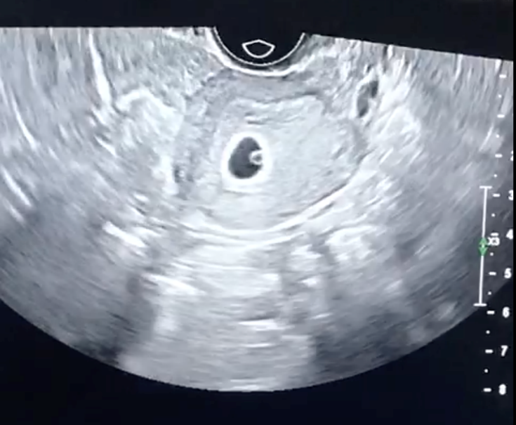
Fig.1. Transvaginal ultrasound; intrauterine 5 mm gestational sac, yolk sac positive
fetal pole could not be differentiated.

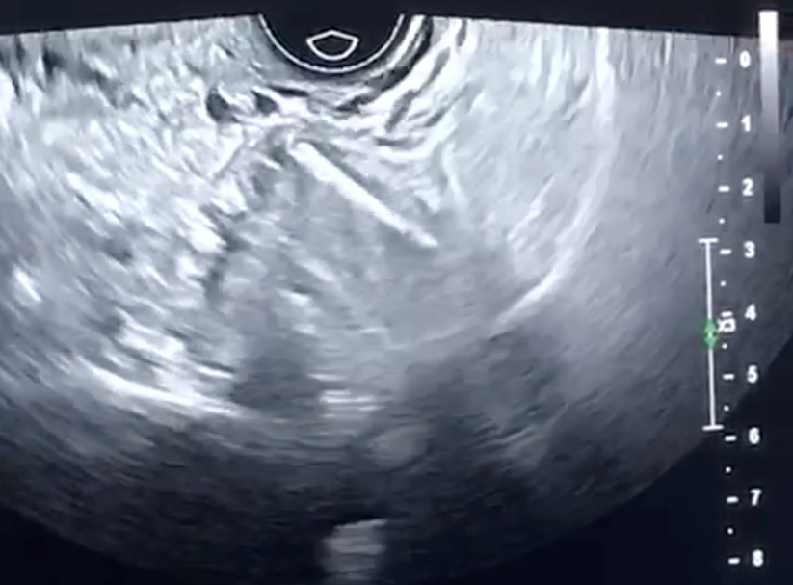
Fig.2. Transvaginal ultrasound; ria was observed in the left adnexal area.

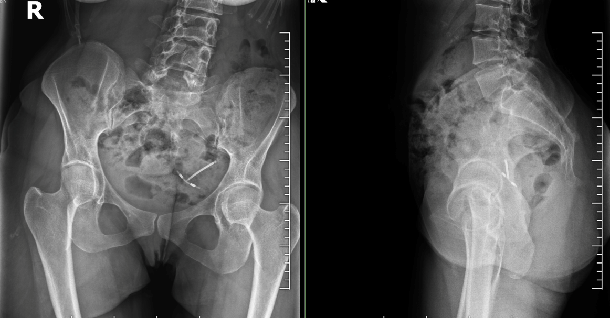
Fig. 3. Abdominal radiograph shows the intrauterine device projecting over the pelvis.
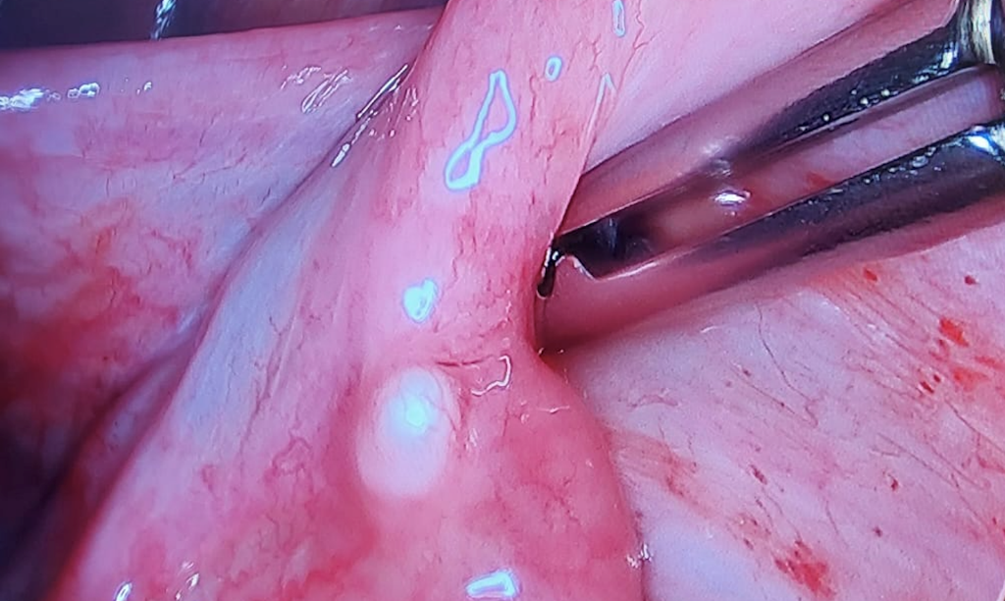
Fig. 4. Monitoring of ria brightness in the left fallopian tube.

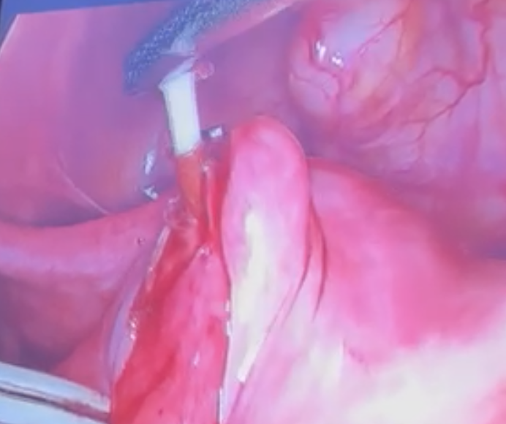
Fig.5a. Gentle traction easily dislodged IUD from left fallopian tube.

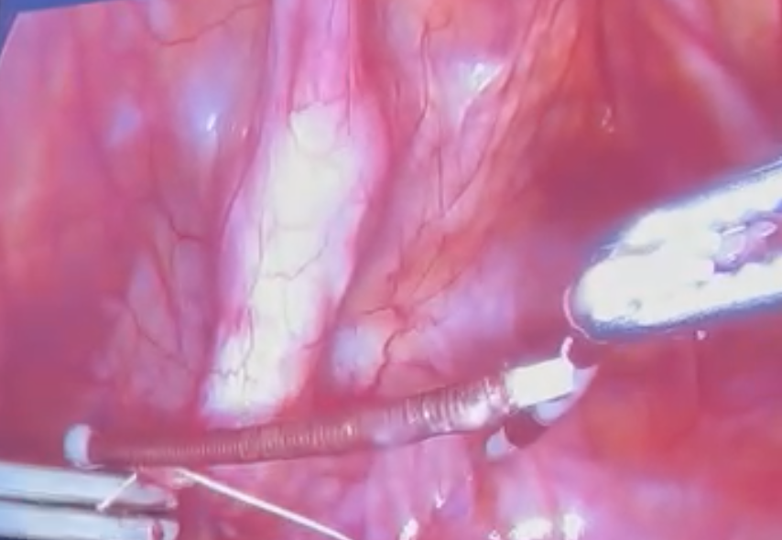
Fig.5b. Gentle traction easily dislodged IUD from left fallopian tube.

S-13 Gebelikte Plasental Görünümü Taklit Eden Myom
Büşra¹, Tayfun²
1 Oflaz
2 Vural

Uterin miyomlar (leiomyomlar) uterusun iyi huylu düz kas tümörleridir. Miyomların hamilelik üzerindeki potansiyel etkileri ve hamileliğin miyomlar üzerindeki potansiyel etkileri, bu tümörlerin üreme çağındaki kadınlarda yaygın olması nedeniyle sık görülen bir klinik endişedir. Miyomlu hastaların çoğunda hamilelik sırasında miyomlara bağlı herhangi bir komplikasyon görülmez. Ağrı en sık görülen sorundur ve özellikle çoklu miyomları, retroplasental miyomları ve boyutları 5 cm’den daha büyük olan hastalarda erken gebelik kaybı, erken doğum ve doğum, fetal malprezentasyon ve plasentanın ayrılması gibi obstetrik komplikasyon riskinde hafif bir artış olabilir. Doğum sonu ise patofizyolojik olarak miyomlar uterus kontraksiyonlarının hem kuvvetini hem de koordinasyonunu azaltarak doğum sonu kanamaya zemin hazırlayabilir, böylece uterus atonisine yol açabilir.
Anahtar Kelimeler: leiomyom , gebelik

S-14 Fetal Multiple Intestinal Atresia: Is It A Component of A Syndrom Accompanied By Pancreatic Hypoplasia?
Ceren Sağlam¹
1 University Of Health Sciences, Izmir Tepecik Training And Research Hospital, Gynecology And Obstetrics Department, Division Of Perinatology

Objective: It’s aimed to emphasize the importance of syndromes or anomalies accompanied by prenatally detected intestinal obstruction findings. Material and Method: The patient referred to Izmir Tepecik Training and Research Hospital Perinatology Department was evaluated and followed-up by ultrasonography. Results: In ultrasonographic evaluation of 23-year-old, gravida-2, parity-1 case at the 17th week, a fetal intraabdominal cyst (17x23 mm) was observed. Differential diagnoses of mesenteric cyst and enteric duplication cyst were considered initially. The patient didn’t accept fetal genetic testing. There was early-onset symmetrical fetal growth restriction. By the third trimester, there were polyhydramnios, minimal ascite and 3 enlarged structures compatible with dilated stomach (48x23x19mm), cystic appearance (44x21mm) and dilated bowel loop (42x19 mm), were thought as malrotation and obstruction secondary to intestinal atresia or cyst compression. 1535 gr girl baby was delivered by cesarean section at 37th week. Neonatal laboratory tests revealed severe hyperglycemia (689mg/dl). The baby was operated on postnatal 2nd day; there was no passage from the stomach to distal, duodenum and gall bladder wasn’t observed, colon, ileum and jejunum were unused, and pancreas was quite hypoplasic. Dilated cystic structures excised. Gastrojejunostomy and portoenterostomy were performed. Severe hyper/hypoglycemia attacks, pancytopenia, metabolic acidosis, and recurrent resistant sepsis attacks developed consecutively. On the postnatal 92nd day she died after cardiac arrest. Karyotype and microarray evaluation was normal. Excised dilated cystic structures were reported had gastric and duodenal epithelium in pathologic examination. Conclusion: The frequency of intestinal atresia, most of which is duodenal atresia, has been reported as 1.3-3.5/10000 live births. However, anomaly combinations accompanied by pancreatic hypoplasia and multiple atresias are very rare, but they have been previously reported in case series and with genetic mutations as Martinez–Frias syndrome and Mitchel–Riley syndrome. Since the majority of these cases are lethal in the postnatal period, it’s very important to provide appropriate genetic counseling and inform family about the prognosis.
Keywords: Fetal intestinal atresia, pancreatic hypoplasia, prenatal diagnosis, Martinez-Frias Syndrome, Mitchel-Riley Syndrome.
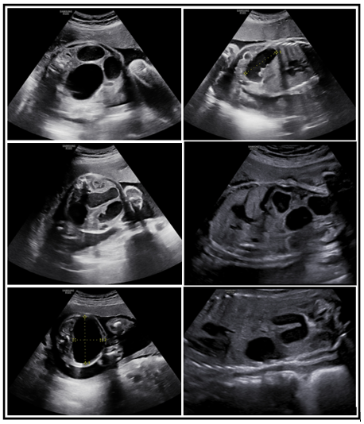
Figure 1. (a,c,d) 3 enlarged gastric, intestinal and cystic structures in the same plane, (d) ascite and (b,e,f)) other views of dilated structures are seen in the ultrasonographic images.

S-15 Heterotopic Pregnancy
Ceyla Ceyhan¹, Mehmet Özeren²
1 Sağlık Bilimleri Üniversitesi İzmir Tepecik Eğitim Araştırma Hastanesi Kadın Hastalıkları ve Doğum Kliniği
2 Sağlık Bilimleri Üniversitesi İzmir Tepecik Eğitim ve Araştırma Hastanesi

HETEROTOPIC PREGNANCY Heterotopic pregnancy is defined as the coexistence of intraauterine and extrauterine gestation. Heterotopic pregnancy is an extremely rare condition if there is no risk factors.The most important risk factor is previous surgery of the fallopian tubes.The incidence of spontaneous heterotopic pregnancy is known as 1/30,000. In reproductive treatment pregnancy frequency is %0.09 - %1.Early diagnosis and treatment of heterotopic pregnancies are important for prevention of mortality, morbidity,and future fertility. CASE PRESENTATION A 23-year- old woman with 10 weeks of amenorrhea and left abdominal pain came policlinic. She has 2 vajinal birth and 2 abortion and no abdominal surgery. And her transvaginal ultrasound has bicornu uterus,7w+5 intrauterin gestation (with negative heart beat )in one of the bicornu and left adnexial gestation (9w+3 with positive heart beat ) in a natural conception and minimal free fluid. Her vital are stabil.The patient underwent emergency laparoscopy.There was nearly ruptured left-sided tubal pregnancy with minimal hemoperitoneum and adhesion from past pelvic infections.and left ovarıan was adherence to left tuba and adnexial mass.So we did laparoscopic tubal and ovarian surgery and for intrauterin missed had termination. The patient is discharged after second day of surgery. CONCLUSION Although spontaneous heterotopic pregnancy is a rare condition, heterotopic pregnancy must be kept in mind and it should be included in the differential diagnosis of pelvic pain in pregnancy. Laparoscopy is a safe option for the treatment of heterotopic pregnancy.
Keywords: Heterotopic Pregnancy,laparoscopy

S-16 A Case Report On Termination Of Cesarean Scar Pregnancy With Truclear Hysteroscopic Mechanical Tissue Morcellation Technique
Cihan Bademkıran¹, Mehmet Yaman¹, Mehmet Salih Algım¹, Emine Akkuş¹
1 Saglık Bilimleri University Gazi Yaşargil Training And Research Hospital

Pregnancy with implantation in a cesarean scar is the rarest form of ectopic pregnancy and is a life-threatening clinical condition. Early diagnosis and treatment is required. Since early diagnosis could not be made in the past, the only treatment; It was to perform an emergency laparotomy to prevent death due to maternal morbidity, massive bleeding, and uterine rupture. However, there are also preventive options in treatment today. Uterine preservating options can be listed as surgical, medical and minimally invasive interventions. Data on cesarean scar pregnancy are mostly based on case reports due to its rarity. Therefore, there is no agreed clinical management on the diagnosis and treatment. In our case report, we wanted to emphasize that scar pregnancy was successfully treated with the truClear mechanical tissue morcellation technique. Cesarean scar pregnancy is a serious obstetric event and early diagnosis is important. Treatment is prone to complications due to the location of the pregnancy. The main aim of treatment should be to minimize damage to the functional layer of the cavity and complications such as rupture. For this purpose, the use of mechanical tissue morcellation technique may be safe, but more cases and data are needed for definitive results.
Keywords: Scar Pregnancy, Complication, Hysteroscopy
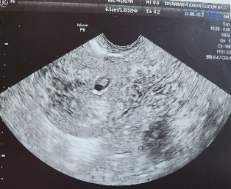
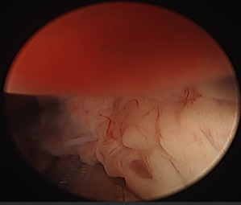
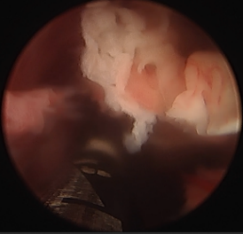

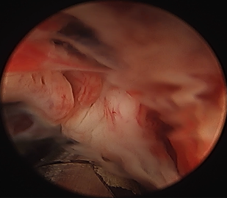
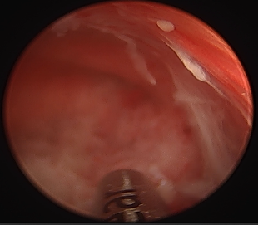
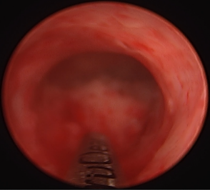

S-18 Hydrocephalus And Acrania In Monochorionic Monoamniotic Twin Pregnancy: A Rare Case Report And Literature Review
Çağlasu Keleş¹, Seçil Karaca Kurtulmuş¹
1 Izmir Kâtip Çelebi Üniversitesi Atatürk Eğitim Araştırma Hastanesi

In the realm of obstetrics, twin pregnancies present a captivating yet intricate subject of study. The phenomenon of two fetuses developing simultaneously within the same maternal environment brings to light a range of physiological and developmental intricacies. A particularly compelling facet of this phenomenon involves the potential anomalies that can affect the central nervous system of these developing fetuses. Craniospinal malformations seem to be the most common disorders in multiple pregnancies. The incidence rate is higher in twin pregnancies with fetal central nervous system malformations .In conclusion, central nervous system malformations in multiple pregnancies have a higher incidence in monochorionic twin pregnancies than in the general population. However, the incidence of two different central nervous system malformations is very low in monochorionic twins. In this case, we present different central nervous system anomalies of fetuses in monochorionic monoamniotic twin pregnancy. In this case, hydrocephalus was found in one fetus and acrania in the other in monochorionic monoamniotic twin pregnancy. Both fetuses were diagnosed with craniospinal malformation, and parents were informed about the negative course of the fetuses. After the completion of the legal procedures, termination was made at the 16th week of pregnancy with the consent and decision of the parents. External images of the fetuses confirmed the diagnosis. The family refused to perform an autopsy. Early detection of anomalies through advanced imaging techniques and genetic testing allows for informed decision-making and the implementation of appropriate management strategies.
Keywords: Twin, Monochorionicity, Hydrocephalus, Acrania

INTRODUCTION

Twin pregnancies are considered as obstetric pathological conditions because of the possible risk of complications. The incidence of multiple pregnancies has increased significantly due to the widespread use of assisted reproductive techniques. About two-thirds of twins are dizygotic. Its prevalence is 7-11/1000 births and increases in parallel with increasing maternal age. Craniospinal malformations seem to be the most common disorders in singleton pregnancies as well as in multiple pregnancies. In twin pregnancies, in addition to neural tube defects, the prevalence of hydrocephalus is three times higher, and the prevalence of other central nervous system malformations is one and a half times higher. Some publications report an even higher - up to 10-15 fold - increase in the prevalence of anencephaly. The incidence of monochorionicity is approximately 25% in all twin pregnancies, but the incidence rate is higher in twin pregnancies with fetal central nervous system malformations. Sebire et al. found that the rate of association between monochorionicity and anencephaly was approximately 46%. However, if we examine the relationship between monochorionicity and all malformations of the central nervous system in our focus, we find the incidence rate just below 53%. In conclusion, central nervous system malformations in multiple pregnancies have a higher incidence in monochorionic twin pregnancies than in the general population. However, the incidence of two different central nervous system malformations is very low in monochorionic twins. In this case, we will present different central nervous system anomalies of fetuses in monochorionic monoamniotic twin pregnancy.

CASE REPORT
A 31-year-old patient with gravida 2 parity and 1 twin pregnancy, who had one previous cesarean section, was referred to the perinatology department from an external center due to comorbidity in her twin. When the patient applied to us, she was in the 16+4th week of her pregnancy. MCMA twin pregnancy was detected in the USG of the patient. 1. Fetal biometry was monitored as BPD:36MM 17W+2D, HC:128MM 12W+4D, AC:93MM 15W+4D, FL:17MM 15W+1D. In addition, the right lateral ventricle was 15mm, the left lateral ventricle was 11.5mm, (Figure 1) tcd was 14mm (<3p). Cisterne Magna obliterated, 3rd ventricle dilated. 2. Fetal calvarium was not observed in fetus. Appearance compatible with Akrania was observed. His biometry was viewed as AC 103MM 16W+2D, FL 18MM 15+4D. Afterwards, the patient was discussed in the Perinatology council of our hospital. It was decided to terminate the pregnancy. The patient was interned and he was dealt with in detail. After obtaining their consent, 300 microgram misoprostol was administered vaginally every 3 hours. At the 3rd dose, the patient had spontaneous abortion. Monochorionic placenta was observed in the abortion material, hydrocephalus in the 1st fetus and acrania in the 2nd fetus. (Figure 3, 4) Then the patient underwent revision curettage. Endometrial thickness was measured as 4mm on control USG. No active bleeding was observed in her vaginal examination. The patient was discharged with recommendations.

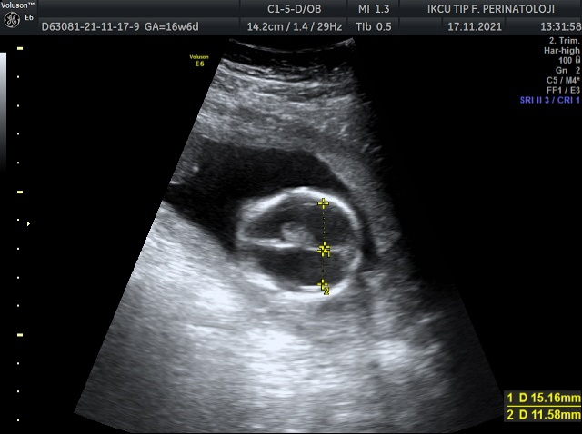

Figure 1 (right lateral ventricle was 15mm, left lateral ventricle was 11.5mm.)

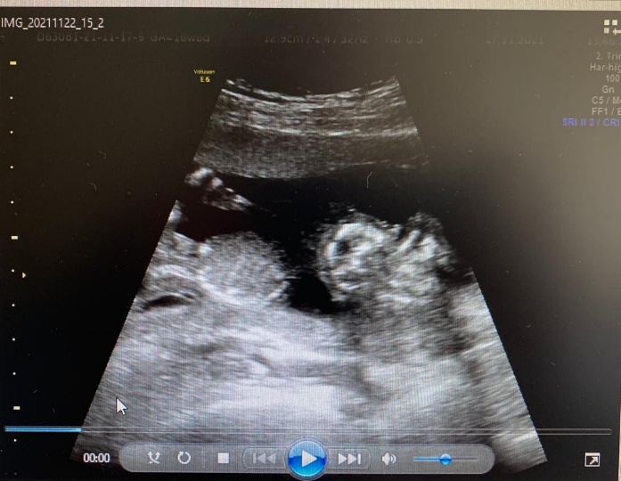
Figure 2 (Fetal calvarium was not observed. Appearance compatible with acrania was observed. )

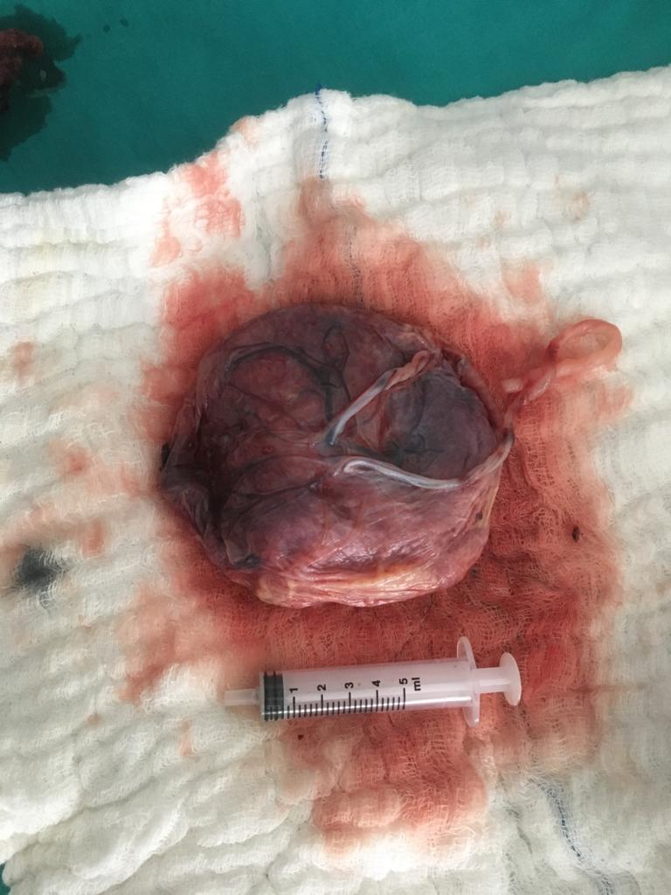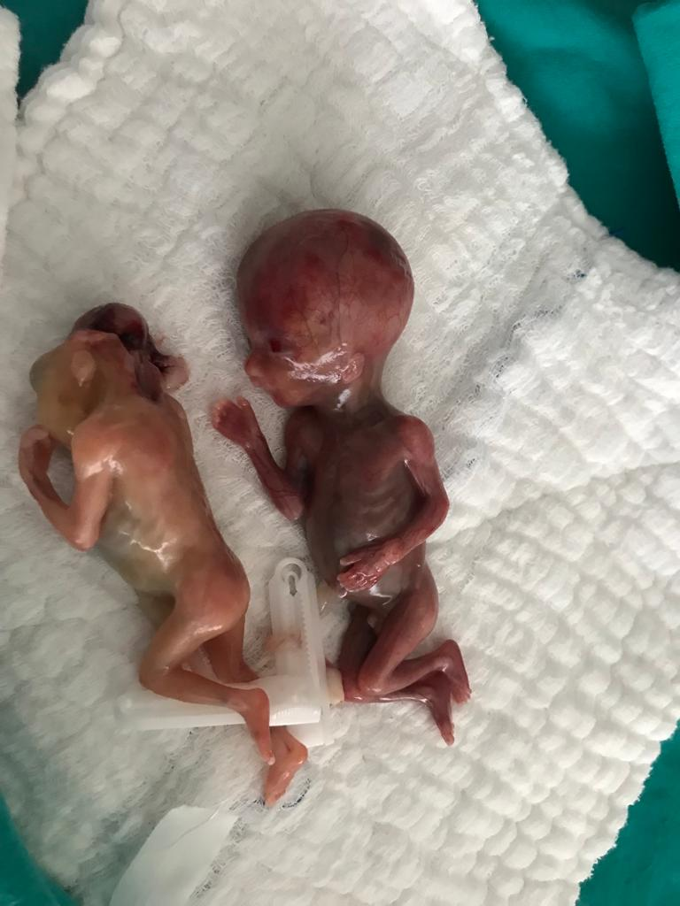

Figure 3: Monochorionic placenta, fetuses

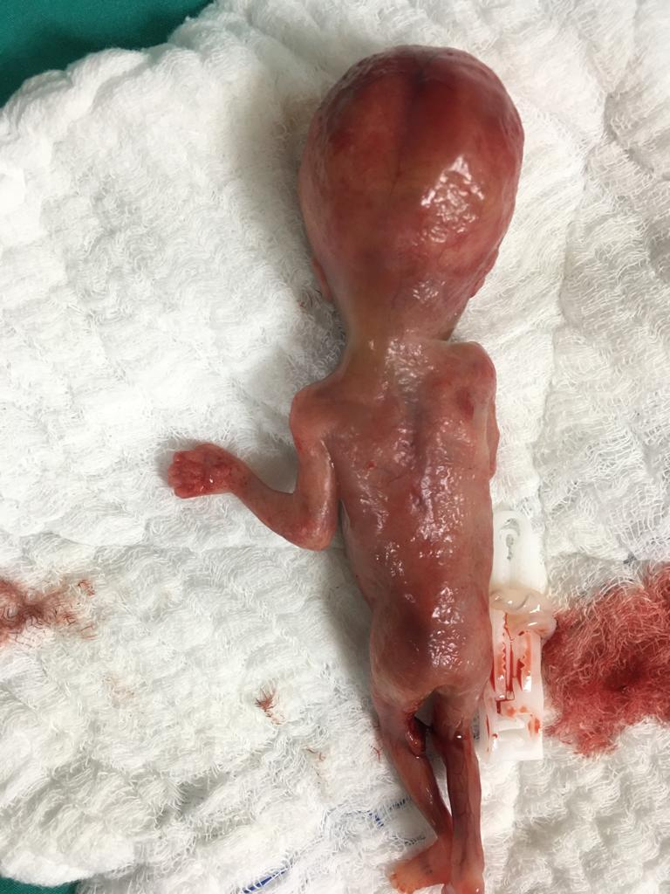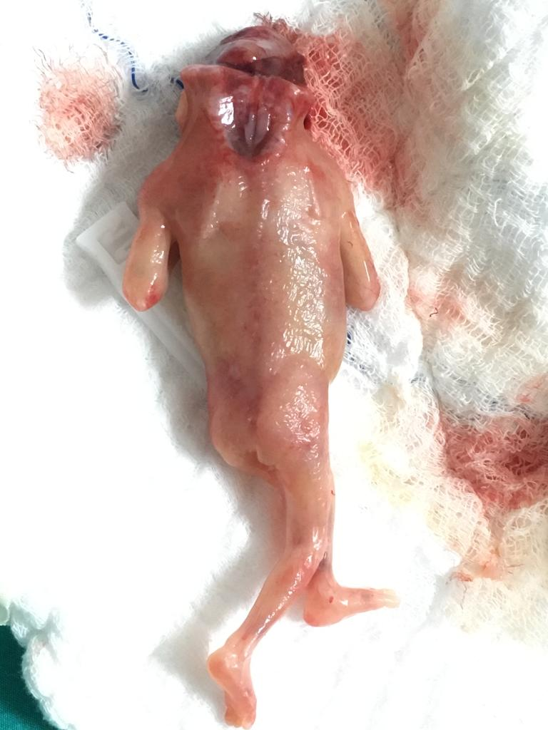

Figure 4.1: Fetus with hydrocephalus Figure 4.2: Fetus with acrania

DISCUSSION
Major structural central nervous system abnormalities can be easily diagnosed by prenatal USG examination. It has been reported that approximately 30% of pregnancies terminated after the 12th week of pregnancy are due to CNS abnormalities. However, since many structures do not become sonographically evident until the second and third trimester, not all abnormalities can be detected by USG. Confirmation of prenatal USG findings with postmortem examination is the gold standard for quality control and evaluation of USG diagnosis. Additional postmortem examination provides clinically relevant information and is a useful tool for a thorough evaluation and optimal genetic counseling, leading to an accurate syndromic diagnosis or further genetic and/or chromosomal investigations. When a decision is made about the outcome of a mismatched twin pregnancy for a particular malformation of the central nervous system after the prenatal diagnosis is made, several questions are taken into account. Chorionicity, amnionity, gestational age, and position of the affected fetus relative to the uterine orifice are essential pieces of information, such as information on the prognosis of the specific malformation, possible treatments, or information on obstetric complications associated with the specific malformation. The aim is to terminate the pregnancy before 16 weeks of gestation if possible, because the risk of invasive curettage increases as time passes.

REFERENCES

- Struksnæs C, Blaas HK, Vogt C. Autopsy Findings of Central Nervous System Anomalies in Intact Fetuses Following Termination of Pregnancy After Prenatal Ultrasound Diagnosis. Pediatr Dev Pathol. 2019 Nov-Dec;22(6):546-557. doi: 10.1177/1093526619860385. Epub 2019 Jun 29. PMID: 31256740.

- E. HrubyTwin pregnancy in evidence-based medicine
- Z. Papp (Ed.), Perinatal dialogue, Golden Book Kiadó, Budapest (2001), pp. 412-419
- Gul A, Cebeci A, Aslan H, Polat I, Sozen I, Ceylan Y. Perinatal outcomes of twin pregnancies discordant for major fetal anomalies. Fetal Diagn Ther. 2005 Jul-Aug;20(4):244-8. doi: 10.1159/000085078. PMID: 15980633.

S-19 Total Laparoskopik Histerektomi Sonrası Dren Yerinden Batın Dışına Omentum Herniasyonu Gelişen Olgunun Yönetimi
Dilara Can¹, Ahkam Göksel Kanmaz¹
1 İzmir Tepecik Eğitim ve Araştırma Hastanesi

Jinekolojik cerrahi işlemler içinde histerektomi en sık uygulanan operasyondur. Histerektomi, cerrahın tecrübesi ve hastaya ait daha önce geçirilmiş cerrahi öykü veya uterus büyüklüğü gibi etkenlere bağlı olarak abdominal, vajinal veya laparoskopik olarak gerçekleştirilebilir. Jinekoloji polikliniğine anormal uterin kanama ve sık idrara çıkma şikayeti ile başvuran 55 yaşında olgu değerlendirildi. Mevcut bulgularla olguya total laparoskopik histerektomi + unilateral salpingo-ooferektomi + tanısal sistoskopi operasyonu önerildi ve yapıldı. Batın sol alt kadranda bulunan 5 mm’lik port yerinden Douglas boşluğuna 1 adet 3 delikli silikon dren yerleştirildi. Yapılan dren takibinde postoperatif 20. Saatte drenden 100 cc serohemorajik mayi izlendi. Dren sıfırlanarak takibe devam edildi. Postoperatif 24. Saatte drenin spontan olarak ayrılarak batın dışına çıktığı görüldü. Batın port insizyonundan dren ile beraber omentum herniasyonu olduğu görüldü. Tanısal laparoskopi planlandı. Yapılan laparoskopik gözlemde batın sol alt kadranda bulunan 5 mm’lik port insizyonundan omentumun protrüze olduğu görüldü. Bipolar koter ve soğuk makas ile makroskobik normal görünen omentum hattından parsiyel omentum rezeksiyonu yapıldı. Kanama kontrolü sonrası Douglas’a 1 adet nelaton dren yerleştirilerek operasyona son verildi. Postoperatif 1. Günde taburcu edildi. Hastanın patoloji sonucu histerektomi materyali leiomiyom ile uyumlu, omentum materyali fokal nekroz ve kanama alanları içeren lipomatöz doku(omentum) olarak raporlandı. Laparoskopik cer¬ra¬hide operasyon bitirilirken 10 mm port yer¬le¬ri ve çok kul¬la¬nı¬lan ya da ge¬niş¬le¬yen 5 mm port yer¬le¬ri¬nin fas¬ya de¬fekt¬le¬ri ka¬pa¬tıl¬ma¬lı¬dır.
Anahtar Kelimeler: Laparoskopik Histerektomi, Fasya Defekti, Omentum
ABSTRACT
Among gynecological surgical procedures, hysterectomy is the most frequently performed operation. Hysterectomy can be performed abdominal , vaginal or laparoscopic way , depending on factors such as the surgeon's experience and the patient's previous surgical history or uterine size .
A 55 years old case who applied to the gynecology clinic with complaints of abnormal uterine bleeding and frequent urination was evaluated. With the current findings, total laparoscopic surgery was performed on the case. Hysterectomy + unilateral salpingo-oophorectomy + diagnostic cystoscopy operation was recommended and performed. A 3-hole silicone drain was placed into the Douglas space through the 5 mm port in the left lower quadrant of the abdomen . During the drain follow-up, 100 cc of serohemorrhagic fluid was observed from the drain at the 20th postoperative hour . The drain was reset and follow-up continued. At the 24th postoperative hour, it was observed that the drain spontaneously separated and went out of the abdomen through to the port incision. Omentum with drain through abdominal port incision it was observed that there was a herniation . Diagnostic laparoscopy was planned. In the laparoscopic observation, it was observed that the omentum was protruded through the 5 mm port incision in the left lower quadrant of the abdomen. Partial resection of the omentum was performed from the macroscopically normal-appearing omentum line with bipolar cautery and cold scissors. After bleeding control, a nelaton drain was placed in Douglas and the operation was completed. She was discharged on postoperative day 1. The patient's pathology result was reported as hysterectomy material compatible with leiomyoma , and omentum material as lipomatous tissue ( omentum ) containing focal necrosis and bleeding areas .
In laparoscopic surgery operations, fascia incisions in 10 mm port areas and frequently used or expanded 5 mm port areas should be closed when completing the case.
Keywords: Laparoscopic Hysterectomy, Fasia Defect, Omentum

GİRİŞ
Giriş
Jinekolojik cerrahi işlemler içinde histerektomi en sık uygulanan operasyondur(1). Histerektomi, cerrahın tecrübesi ve hastaya ait daha önce geçirilmiş cerrahi öykü veya uterus büyüklüğü gibi etkenlere bağlı olarak abdominal, vajinal veya laparoskopik olarak gerçekleştirilebilir(2). Laparoskopik olarak gerçekleştirilen histerektomi; postoperatif ağrı, morbidite, kan kaybı, normal aktivitelere dönme süresi, yara enfeksiyonu ve hastanede kalış süresi bakımından abdominal histerektomiye üstündür(3). Bu avantajlarına rağmen komplikasyon oranı, öğrenme eğrisinin uzun sürmesi, operasyon süresinin uzaması dezavantaj olarak karşımıza çıkmaktadır(4). Laparoskopik histerektomi genellikle 2 adet 5 mm ve 2 adet 10 mm port kullanılarak yapılır.
Yöntem
Jinekoloji polikliniğine anormal uterin kanama ve sık idrara çıkma şikayeti ile başvuran 55 yaşında olgu değerlendirildi. Olgunun bilinen hipertansiyon ve diyabet tanısı mevcuttu.
Üç vajinal doğumu ve dış merkezde over kisti nedeniyle laparatomi ile sağ ooferektomi operasyonu öyküsü mevcuttu.
Bulgular
Hasta transvajinal ultrason ile değerlendirildi ve uterus korpus anteriorda endometriuma bası yapan 57x60 mm intramural miyom nüvesi izlendi. Sol over yaş ile uyumlu atrofik olarak değerlendirildi. Ardından yapılan endometrial örnekleme sonucu düzensiz proliferatif endometrium olarak raporlandı.
Hasta mevcut bulgular ile değerlendirildi ve laparoskopik histerektomi unilateral salpingo-ooferektomi şeklinde operasyon seçeneği sunuldu. Hastanın kabul etmesi üzerine operasyon öncesi hazırlık tamamlandı. Olguya total laparoskopik histerektomi + unilateral salpingo-ooferektomi + tanısal sistoskopi operasyonu yapıldı. Batın sol alt kadranda bulunan 5 mm’lik port yerinden Douglas boşluğuna 1 adet 3 delikli silikon dren yerleştirildi. Dren ipek sütur ile tespit edildi. Yapılan dren takibinde postoperatif 20. Saatte drenden 100 cc serohemorajik mayi izlendi. Dren sıfırlanarak takibe devam edildi. Postoperatif 24. Saatte drenin spontan olarak ayrılarak batın dışına çıktığı görüldü. Yapılan muayenede drenin 3 deliği intakt olarak izlendi. Batın port insizyonundan dren ile beraber omentum herniasyonu olduğu görüldü. Hastaya bilgi verildi. Tanısal laparoskopi planlandı. Yapılan laparoskopik gözlemde batın sol alt kadranda bulunan 5 mm’lik port insizyonundan omentumun protrüze olduğu görüldü. Bipolar koter ve soğuk makas ile makroskobik normal görünen omentum hattından parsiyel omentum rezeksiyonu yapıldı. Kanama kontrolü sonrası Douglas’a 1 adet nelaton dren yerleştirilerek operasyona son verildi. Postoperatif takibi yapılan olgu ek yakınma gelişmemesi üzerine postoperatif 1. Günde taburcu edildi. Hastanın patoloji sonucu histerektomi materyali leiomiyom ile uyumlu, omentum materyali fokal nekroz ve kanama alanları içeren lipomatöz doku(omentum) olarak raporlandı.

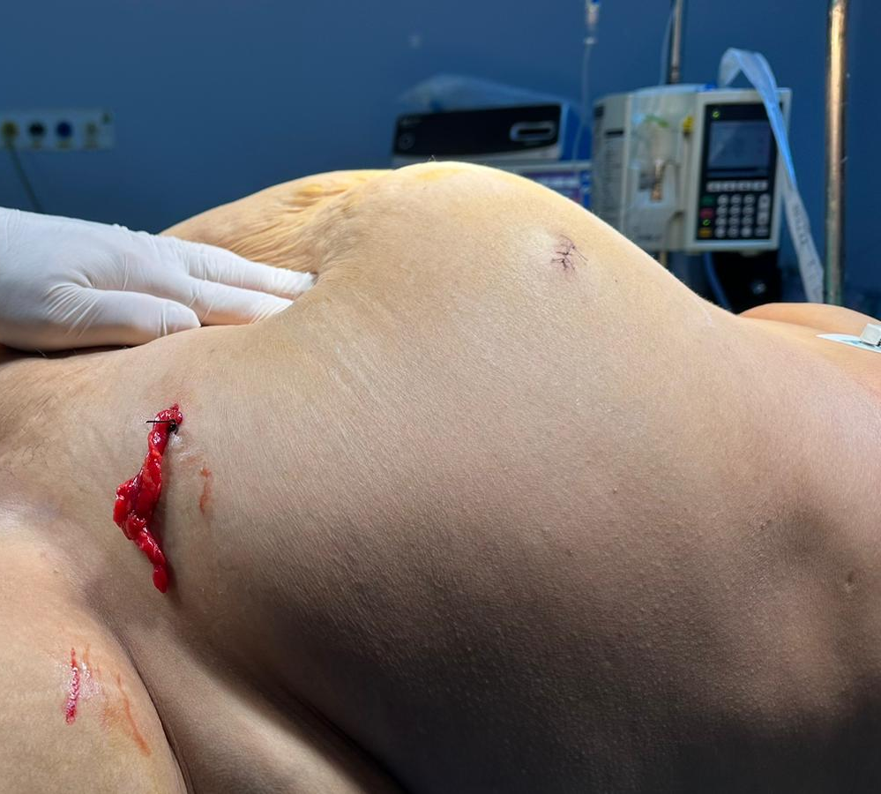

Şekil 1: Hasta operasyon masasında iken görünen omentum herniasyonu

SONUÇ VE TARTIŞMA
Laparoskopik cerrahi operasyonlarında vaka bitirilirken 10 mm port yerleri ve çok kullanılan ya da genişleyen 5 mm port yerlerinde oluşan fasya insizyonları kapatılmalıdır.Port insizyonundan herni riskini arttıran faktörler port deliğinin çok fazla manipülasyonu, materyal çıkartılırken fasyanın gerilmesi ve fasya defektinin kapatılmamasıdır. Bu tür durumlarda omentum, barsak ve her ikisinin herniasyonu görülebilir. Komplikasyon oranını düşürmek için fasya defektleri mutlaka onarılmalıdır.

KAYNAKÇA
AMA (American Medical Association) yazım kuralı
- Wright JD, Herzog TJ, Tsui J, et al. Nationwide trends in the performance of inpatient hysterectomy in the United States. Obstet Gynecol 2013;122:233-241.
- Nieboer TE, Johnson N, Lethaby A, et al. Surgical approach to hysterectomy for benign gynaecological disease. Cochrane Database Syst Rev 2009;8:CD003677.
- Reich H, De Caprio J, McGlynn F. Laparoscopic hysterectomy. J Gynecol Surg 1989;5:213-216.
- Wang CJ, Yen CF, Lee CL, Tashi T, Soong YK. Laparoscopically assisted vaginal hysterectomy for large uterus: a comparative study. Eur J Obstet Gynecol Reprod Biol 2004;115:219-223.

S-20 Servikal Elongasyonun Eşlik Ettiği Pelvik Organ Prolapsusu Olgularinda Vaginal Histerektomi Sonrasi Nüks Oranlarimiz
Dilek Uysal¹, Mustafa Şengül¹
1 İzmir Kâtip Çelebi Üniversitesi Atatürk Eğitim ve Araştırma Hastanesi

Giriş: Servikal kollum elangasyonu pelvik organ prolapsus(POP) olgularının %40'ında saptanan yaygın görülen bir bulgudur. Bu olgularda vaginal histerektomi(VH) en sık uygulanan cerrahi prosedür olmaktadır. Cerrahi sonrası bu olgularda POP rekürens sıklığı ile ilgili literatürde çok fazla çalışma yoktur. Çalışmamızda 2010-2020 yılları arasında Vaginal Histerektomi yapılan hastalarda servikal uzunluğun nüks oranlarına etkisini karşılaştırmayı hedefledik. Materyal Metod: Bu tek merkezli retrospektif çalışmada, 2010-2020 yılları arasında POP nedeniyle VH uygulanan kadınlar toplanmıştır. Vakalar, Pelvik Organ Prolapsusu Nicelik(POP-Q) sisteminin C noktası ≥0 ve tahmini servikal uzunluğun ≥5 cm olması temelinde servikal kollum elangasyonu varlığı yokluğu açısından iki gruba ayrıldı. Primer sonuç, POP-Q sistemi tarafından değerlendirilen pelvik organ prolapsusunun (POP) nüksetmesiydi. İki grubun sonuçları eğilim skoru eşleşmesi sonrası yaş, parite ve preoperatif POP-Q evreleri açısından karşılaştırıldı. Hastalar operasyon sonrası takip süreçlerinde nüks POP açısından incelendi. Pre operatif ve post operatif C noktaları kayıt altına alındı. Eş zamanlı hasta özellikleri, operasyon kayıtları ve postoperatif komplikasyon verileri değerlendirmeye alındı. İstatistiksel analiz Sürekli değişken dağılımının normalliği Shaphiro wilk testi ile test edilmiştir. Normal olmayan sayısal verileri 2 grup arasında karşılaştırmak için Mann whitney u testi kullanıldı. Ameliyat öncesi ve sonrası ölçümleri karşılaştırmak için Wilcoxon testi yapıldı. Kategorik değişkenler için grupları karşılaştırmak için ki-kare testi uygulandı. Windows sürüm 24.0 için SPSS ile istatistiksel analiz yapıldı ve p <0.05 değeri istatistiksel olarak anlamlı kabul edildi. Bulgular: Grup eşleştirme, her iki grupta da benzer demografi sağladı. Preoperatif C noktaları açısından karşılaştırıldığında servikal elongasyonun eşlik ettiği POP olgularında 3 (2 -4 ) (n=33), diğer grupta 2.5 (1.5 -4) (n=40) olarak ölçülmüştür (p:0.782). Postoperatif C noktaları açısından karşılaştırıldığında servikal elongasyonun eşlik ettiği POP olgularında -3 (-4 /-3 ) (n=33), diğer grupta -2 (-3 /-2 ) (n=40) olarak ölçülmüştür (p:0.011). Operasyon süreleri karşılaştırıldığında servikal elongasyonun eşlik ettiği POP olgularında operasyon süresi/dk 98 (79 -138.5 ), diğer grupta 83 (60 -116 ) olarak saptanmıştır(p:0.013). Sonuç: Serviksin elangasyonu pelvik organ prolapsusu olan kadınlarda yaygın bir bulgudur. Altta yatan patofizyolojik mekanizmalar ve servikal uzamanın gelişimi şu anda tam olarak anlaşılmamıştır. Servikal kollum uzunluğunun eşlik ettiği POP'lu kadınlarda vaginal histerektomi sonrası POP rekürensi normal servikal uzunluğu olan POP hastalarına göre daha az saptanmıştır.
Anahtar Kelimeler: Servikal kollum uzunluğu, Vaginal histerektomi, Pelvik Organ Prolapsusu
ABSTRACT
Introduction: Cervical collum elangation is a common finding found in 40% of pelvic organ prolapse(POP) cases. In our study, we aimed to compare the effect of cervical length on recurrence rates in patients who underwent Vaginal Hysterectomy between Dec 2010 and Dec 2020. Method: In this single-centered retrospective study, women who underwent VH due to POP between 2010 and 2020 were collected. Dec. The cases were divided into two groups in terms of absence of presence of cervical collum elangation on the basis of point C of Pelvic Organ Prolapse Quantity(POP-Q) system ≥0 and estimated cervical length ≥5 cm. The primary outcome was recurrence of pelvic organ prolapse (POP) evaluated by the POP-Q system. The results of the two groups were compared in terms of age, parity and preoperative POP-Q stages after matching the propensity score. Patients were examined in terms of recurrence POP during the postoperative follow-up processes. Pre operative and post operative C points were recorded. Simultaneous patient characteristics, operation records and postoperative complication data were evaluated Statistical analysis The normality of the continuous variable distribution was tested with the Shaphiro wilk test. Mann whitney u test was used to compare abnormal numerical data between 2 groups. Dec. Wilcoxon test was performed to compare preoperative and postoperative measurements. The chi-square test was applied to compare the groups for categorical variables. Statistical analysis was performed with SPSS for Windows version 24.0 and a value of p <0.05 was considered statistically significant. Results: Group matching provided similar demographics in both groups. Compared to the preoperative C points, it was measured as 3 (2 -4) (n=33) in POP cases accompanied by cervical elongation, 2.5 (1.5 -4) (n=40) in the other group (p:0.782 ). When compared in terms of postoperative C points, it was measured as -3 (-4 / -3) (n=33) in POP cases accompanied by cervical elongation, -2 (-3 / -2 ) (n=40) in the other group (p:0.011 ). Compared to the operation times, the operation time/min was found to be 98 (79 -138.5 ) in POP cases accompanied by cervical elongation, and 83 (60 -116 ) in the other group(p:0.013 ). Conclusion: Cervical elangation is a common finding in women with pelvic organ prolapse. The underlying pathophysiological mechanisms and the development of cervical elongation are currently not fully understood. In women with POP accompanied by cervical collum length, POP recurrence after vaginal hysterectomy was found to be less than in POP patients with normal cervical length.
Keywords: Cervical collum length, Vaginal hysterectomy, Pelvic Organ Prolapse

GİRİŞ
Servikal kollum elangasyonu pelvik organ prolapsus(POP) olgularının %40'ında saptanan yaygın görülen bir bulgudur. Bu olgularda vaginal histerektomi(VH) en sık uygulanan cerrahi prosedür olmaktadır. Cerrahi sonrası bu olgularda POP rekürens sıklığı ile ilgili literatürde çok fazla çalışma yoktur. Çalışmamızda 2010-2020 yılları arasında Vaginal Histerektomi yapılan hastalarda servikal uzunluğun nüks oranlarına etkisini karşılaştırmayı hedefledik.

YÖNTEM
Bu tek merkezli retrospektif çalışmada, 2010-2020 yılları arasında POP nedeniyle VH uygulanan kadınlar toplanmıştır. Vakalar, Pelvik Organ Prolapsusu Nicelik(POP-Q) sisteminin C noktası ≥0 ve tahmini servikal uzunluğun ≥5 cm olması temelinde servikal kollum elangasyonu varlığı yokluğu açısından iki gruba ayrıldı. Primer sonuç, POP-Q sistemi tarafından değerlendirilen pelvik organ prolapsusunun (POP) nüksetmesiydi. İki grubun sonuçları eğilim skoru eşleşmesi sonrası yaş, parite ve preoperatif POP-Q evreleri açısından karşılaştırıldı. Hastalar operasyon sonrası takip süreçlerinde nüks POP açısından incelendi. Pre operatif ve post operatif C noktaları kayıt altına alındı. Eş zamanlı hasta özellikleri, operasyon kayıtları ve postoperatif komplikasyon verileri değerlendirmeye alındı. İstatistiksel analiz Sürekli değişken dağılımının normalliği Shaphiro wilk testi ile test edilmiştir. Normal olmayan sayısal verileri 2 grup arasında karşılaştırmak için Mann whitney u testi kullanıldı. Ameliyat öncesi ve sonrası ölçümleri karşılaştırmak için Wilcoxon testi yapıldı. Kategorik değişkenler için grupları karşılaştırmak için ki-kare testi uygulandı. Windows sürüm 24.0 için SPSS ile istatistiksel analiz yapıldı ve p <0.05 değeri istatistiksel olarak anlamlı kabul edildi.

BULGULAR
Grup eşleştirme, her iki grupta da benzer demografi sağladı(Tablo-1). Preoperatif C noktaları açısından karşılaştırıldığında servikal elongasyonun eşlik ettiği POP olgularında 3 (2 -4 ) (n=33), diğer grupta 2.5 (1.5 -4) (n=40) olarak ölçülmüştür (p:0.782). Postoperatif C noktaları açısından karşılaştırıldığında servikal elongasyonun eşlik ettiği POP olgularında -3 (-4 /-3 ) (n=33), diğer grupta -2 (-3 /-2 ) (n=40) olarak ölçülmüştür (p:0.011) (Tablo-2). Operasyon süreleri karşılaştırıldığında servikal elongasyonun eşlik ettiği POP olgularında operasyon süresi/dk 98 (79 -138.5 ), diğer grupta 83 (60 -116 ) olarak saptanmıştır(p:0.013).

 | VH+SE (n=33) | VH(n=40) | P
Variables | Median [25%-75%] | Median [25%-75%]
Yaş | 57 [38 -67 ] | 61.5 [54 -68.5 ] | 0.110
BMI | 29.36 [26.05 -32.03 ] | 30.27 [25.16 -32.22 ] | 0.978
Parite | 3 [2 -3 ] | 3 [2 -4 ] | 0.162
izlem süresi ay | 74 [65 -91 ] | 76 [58.5 -95 ] | 0.859
HASTANEDE KALIŞ(gün) | 2 [2 -3 ] | 3 [2 -3 ] | 0.098
PREOP D | -5 [-5 --4 ] | -4 [-5 --3 ] | 0.002*
OP SÜRESİ(dk) | 83 [60 -116 ] | 98 [79 -138.5 ] | 0.013*
Tablo 1.

 |  | VH+SE (n=33) | VH(n=40)
 |  | Median [25%-75%] | Median [25%-75%] | P
Post menapoz | PREOP C NOKTASI | 3 [2 -4 ] | 2 [1,5 -3 ] | 0,441
Post menapoz | POSTOP C NOKTASI | -3 [-4 --3 ] | -2,5 [-3 --2 ] | 0,004*
Post menapoz | Within group | P=0.001* | P=0.001*
Pre menapoz | PREOP C NOKTASI | 2,5 [1 -4 ] | 3,5 [1,5 -4,5 ] | 0,616
Pre menapoz | POSTOP C NOKTASI | -3 [-4 --2 ] | -2 [-3 --2 ] | 0,110
Pre menapoz | Within group | P=0.001* | P=0.001*
Tablo 2.

SONUÇ VE TARTIŞMA
Serviksin elangasyonu pelvik organ prolapsusu olan kadınlarda yaygın bir bulgudur. Altta yatan patofizyolojik mekanizmalar ve servikal uzamanın gelişimi şu anda tam olarak anlaşılmamıştır. Servikal kollum uzunluğunun eşlik ettiği POP'lu kadınlarda vaginal histerektomi sonrası POP rekürensi normal servikal uzunluğu olan POP hastalarına göre daha az saptanmıştır.

KAYNAKÇA

- Liu YY, Wang CL, Loo ZX, Lin KL, Long CY. Clinical Risk Factors for Uterine Cervical Elongation among Women with Pelvic Organ Prolapse. Int J Environ Res Public Health. 2021 Sep 2;18(17):9255.
- Berger MB, Ramanah R, Guire KE, DeLancey JO. Is cervical elongation associated with pelvic organ prolapse? Int Urogynecol J. 2012 Aug;23(8):1095-103. doi: 10.1007/s00192-012-1747-6.
- Mothes AR, Mothes H, Fröber R, Radosa MP, Runnebaum IB Systematic classification of uterine cervical elongation in patients with pelvic organ prolapse.
Eur J Obstet Gynecol Reprod Biol. 2016 May;200:40-4.

S-21 A Tertiary Hospital Experience Of Applicability Of Hysteroscopic Tıssue Morcellation In Myom And Polyps
Cihan Bademkıran¹
1 Saglık Bilimleri University Gazi Yaşargil Training And Research Hospital

Hysteroscopy is the standard modality of diagnosis and treatment of endometrial pathologies. Patient selection for this procedure is usually based on preoperative ultrasound scan results. By means of hysteroscopy, procedures such as polyp and fibroid resection, synechiolysis, sterilization, septum resection and removal of residual pregnancy products are performed. In addition to being an organ preservating surgery, being a minimally invasive procedure is one of its biggest advantages. The hysteroscopy procedure is prone to complications and may cause adverse changes in the endometrial cavity. In order to minimize these disadvantages and complications, mechanical tissue morcellator systems are used in addition to the variety of energy modalities in the hysteroscopy technique. We aimed to reveal the applicability, advantages and disadvantages of hysteroscopic tissue morcellation, which is called the 'truClear' method, carried out in our clinic in pathologies in various patient groups. Hysteroscopic procedure with truClear method was applied to patients with abnormal uterine bleeding who were diagnosed with intracavitary polyp or myoma in Diyarbakır Gazi Yaşargil Training and Research Hospital Gynecology and Obstetrics Clinic between January 2023 and August 2023. In these procedures, patient demographics, characteristics of the intracavitary lesion, size of the lesion, duration of the procedure, amount of fluid used and pressure were evaluated. We experienced that the truClear mechanical tissue morcellation technique, which we used in our study, resulted in success without intraoperative complications in myoms and polyps, and in a minimally invasive manner even in relatively large fibroids and polyps. The small number of patients is the limitation of our study, and studies with large series are needed on this subject.
Keywords: Hysteroscopy, Mechanical tissue morcelation, Abnormal uterine bleeding

S-22 A Case Of A Patıent Wıth Chronıc Ablatıo Olıgo Sequence Detected In The Second Trımester
Emre Yalçın¹, Ceren Sağlam¹, Alkım Gülşah Şahingöz Yıldırım¹
1 University Of Health Sciences, Izmir Tepecik Training And Research Hospital Department Of Obstetrics And Gynecology, Department Of Perinatology

Objective: Chronic ablatio oligo sequence (CAOS) is a prediagnosis that should be kept in mind in patients presenting to the clinic with intrauterine growth retardation and oligohydramnios. These patients may have a history of first trimester vaginal bleeding. Therefore, the importance of ultrasonographic evaluation of the placenta was aimed. Method: The patient who was referred to the Perinatology Department of Izmir Tepecik Training and Research Hospital with a prediagnosis of early-onset intrauterin growth restriction was diagnosed with CAOS. Results: A 26-week pregnant 26-year-old G1PO patient was referred to our clinic from an external center with early-onset IUGR and placentomegaly. In the ultrasonography of the patient, fetal measurements were compatible with 20 weeks, amniotic fluid volume oligohydramnios, end diastolic flow loss , placentomegaly and a 96x68 mm hematoma area were observed in umbilical artery doppler, and a wave a was positive in the ductus venosus (Figure 1,2,3). Coagulation parameters were normal. Fetal karyotyping was normal. The patient had a history of vaginal bleeding in the first trimester. She was taking progesterone as treatment. The patient was hospitalized in the ward and was taken under observation. At the 27th week, the patient was diagnosed with severe preeclampsia and delivery was decided upon the detection of high blood pressure, elevated liver enzymes, proteinuria and prodromal symptoms, and the baby was taken to the neonatal intensive care unit after delivery. Conclusion: Detachment placenta is a partial or complete separation of the normally located placenta before fetal delivery. It occurs in 0.4% to 1% of pregnancies. Although the cause of detached placenta is unknown, many predisposing factors have been demonstrated. These include advanced maternal age, increased gravida or parity, gestational hypertension, intrauterine growth retardation, non-vertex presentation, polyhydramnios, premature rupture of membranes, history of pregnancy with detached placenta, smoking and trauma. Detached placenta has been associated with maternal and neonatal morbidity and mortality. In conclusion, evaluation of patients presenting with IUGR and oligohydramnios in terms of CAOS is important for patient management.
Keywords: CAOS,ultrasound,ablation,oligohydramnios
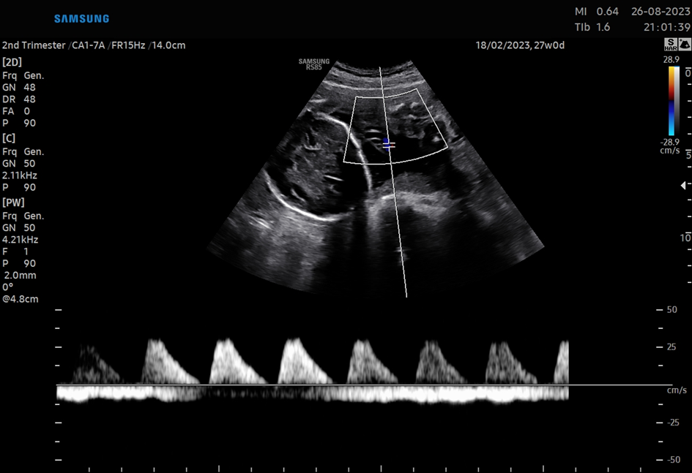
Figure 1: End diastolic blood flow in umblical artery

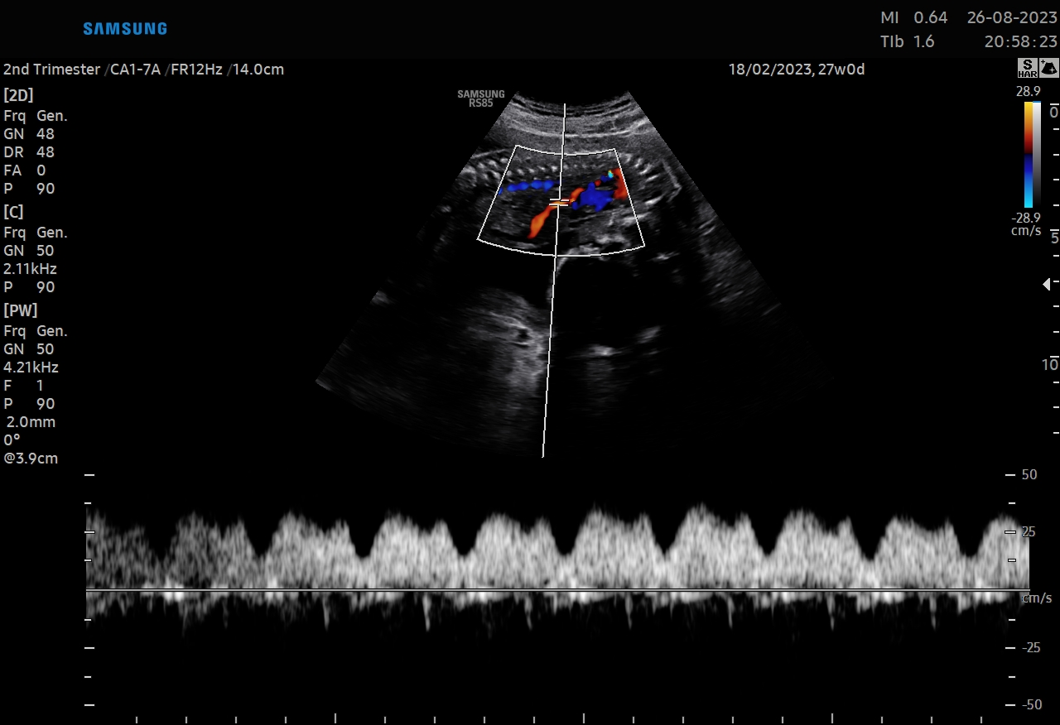
Figure 2: Positive a-wave in the ductus venosus

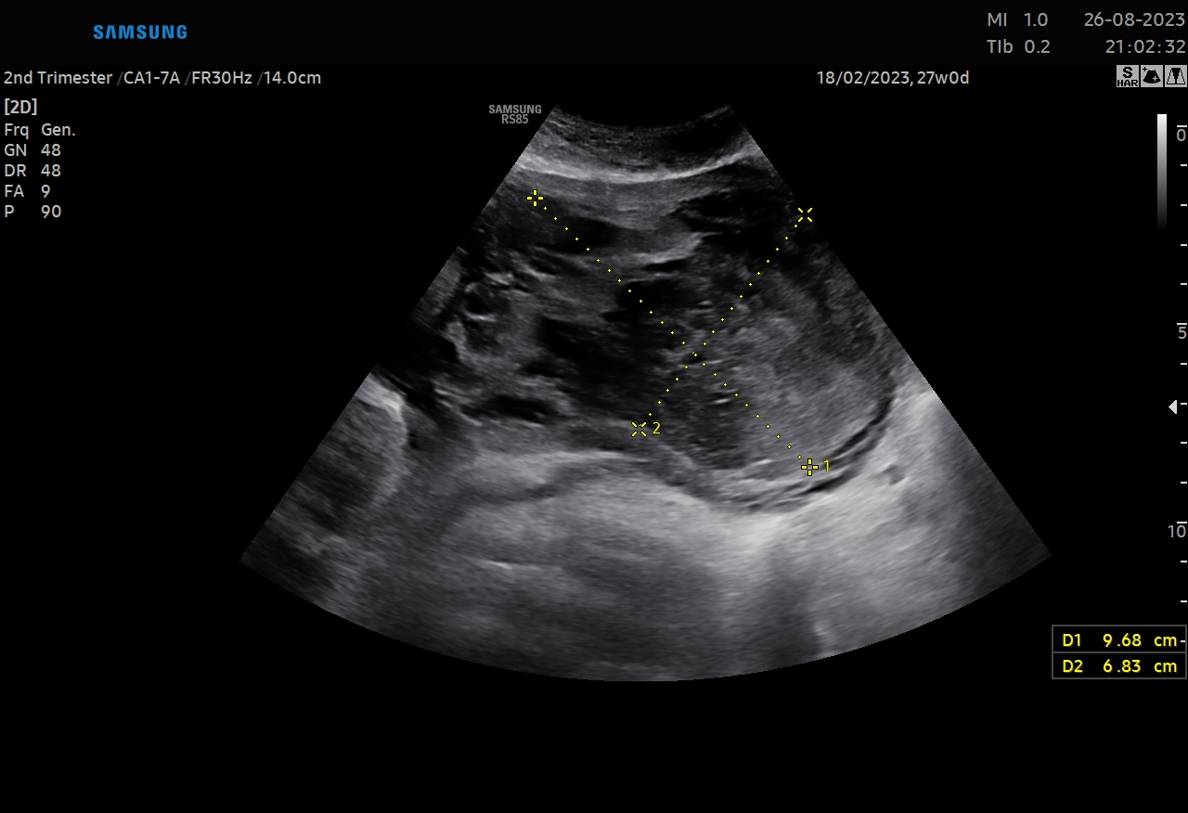
Figure3: Hematoma area in the placenta

S-23 Delayed Diagnosis Of Placenta Previa Percreata And Postoperative Outcomes
Erhan Okuyan*¹, İlyas Turan ¹
1 Batman Eğitim ve Araştırma Hastanesi

Placenta previa perforata is one of the most difficult cases for obstetricians to manage with a serious mortality rate. In this case report, we describe the case of placenta previa perforata in a 29-year-old woman who had 2 previous cesarean sections and its postoperative outcome
Keywords: Placenta previa percreata , Obstetric emergency
GİRİŞ

At the age of 29, the patient, who came to regular follow-ups and gave birth by cesarean section twice before, was admitted to the emergency room with the complaint of labor and water retention at 38 weeks of gestation and an emergency operation decision was made.

YÖNTEM

A case report of placenta previa perkreata with missed diagnosis

BULGULAR

The patient is taken into operation under emergency conditions based on her system notes as she had previous follow-ups. The gynecologist and obstetrician, who is in the 10th month of his specialization, diagnoses placenta previa percreata when he observes the uterus after entering the abdomen with pfannenstiel incision and immediately calls the 2nd surgeon for help. After increasing the abdominal incision with sub-umbilical median and supra-umbilical median incision, the uterus is passed through a transverse incision at the fundus level and a single live meconium stained Apgar3-5 male baby is removed. Subsequently, the placenta cord is ligated and kept in the cavity and the uterus is quickly sutured with full-thickness continuous 1.0 vicryl and intra-abdominal exploration of the uterus is started. Upon observation of dense adhesions on the posterior wall of the uterus and dense adhesions on bilateral adnexa, a gynecologic oncologist is invited to the case. Uterine posterior wall, paracolic areas, vesicouterine area, bilateral obturatuar fossae were dissected. Perioperative total abdominal hysterectomy was performed with 6 units of erythrocyte suppression and 2 units of fresh frozen plasma transfusion ( Figure 1-3). After the bladder methylene blue control, bladder trigone perforation with a length of approximately 6 cm was observed and the bladder was double sutured by the urologist. After being followed up in the intensive care unit for 3 days in the postoperative period, the patient was discharged with healing after the general well-being of the patient was followed up in the ward conditions.

Figure-1 : Placenta previa percreata
Figure-2 : Periopeative Hysterectomy material
Figure-3 : Postoperative period

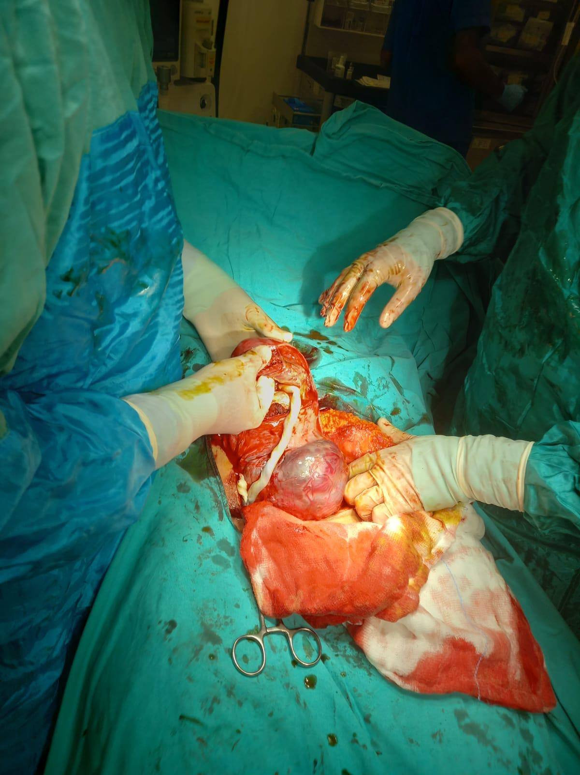
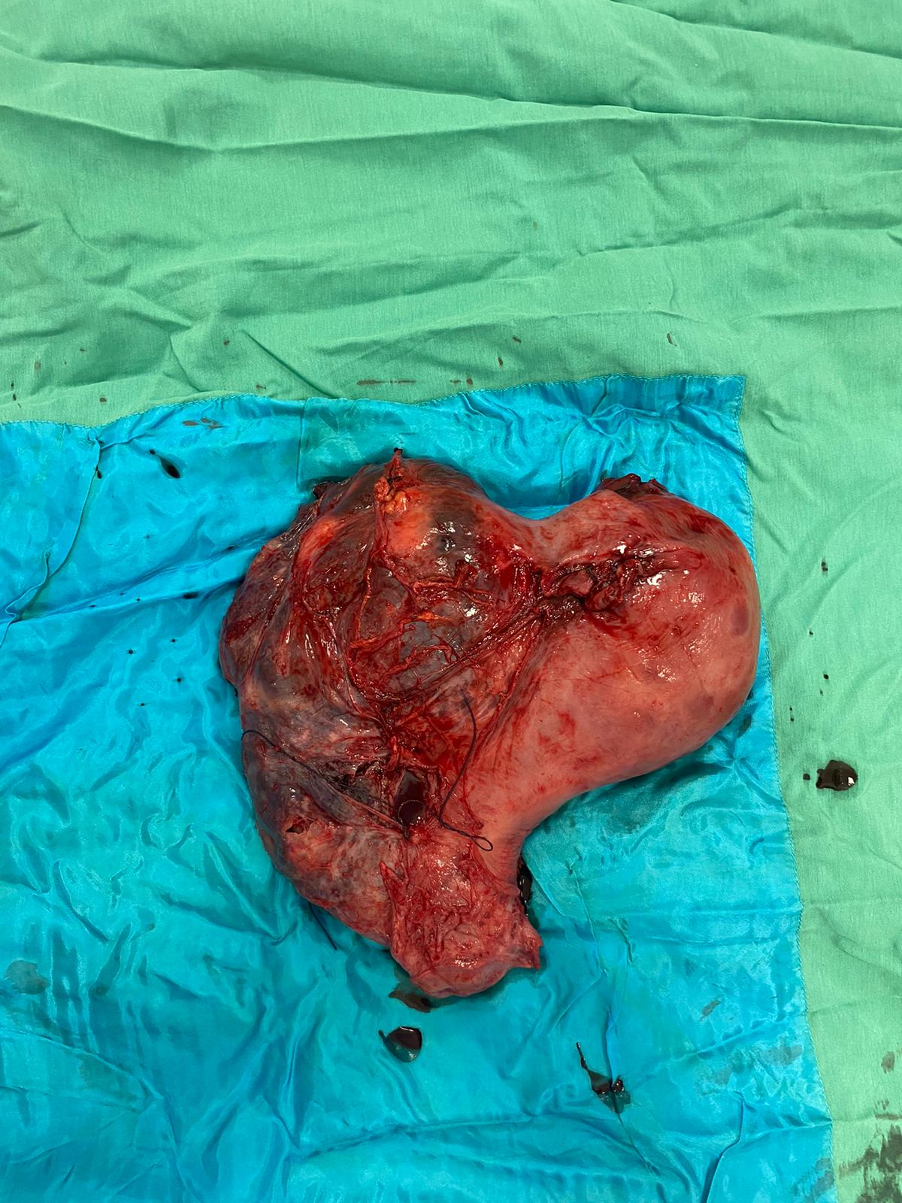
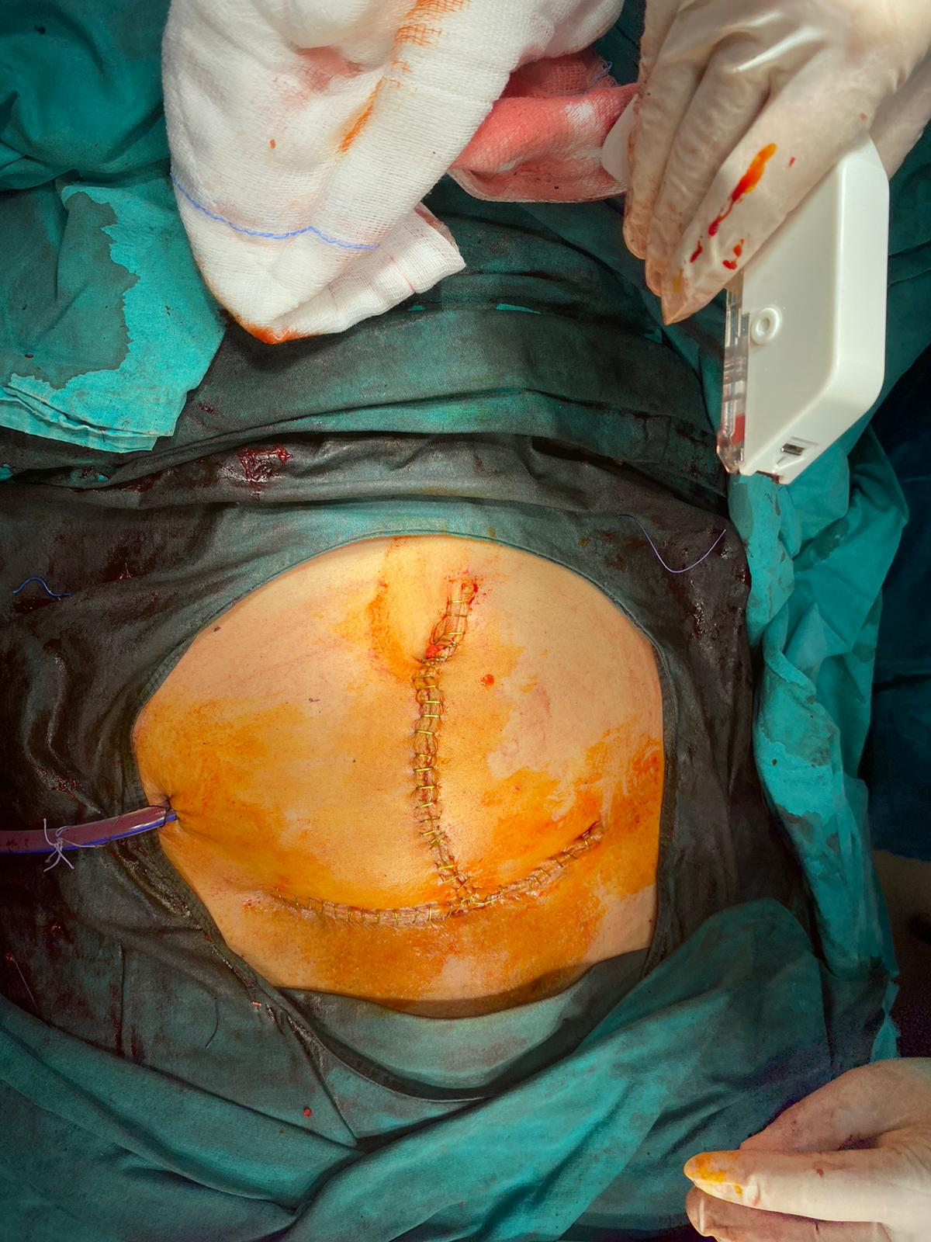

SONUÇ VE TARTIŞMA

Placenta previa percreata is a life-threatening condition requiring serious teamwork and

management, and delays in diagnosis increase mortality and morbidity.

S-24 Gebelikte Adneksiyel Kitlelere Yaklaşım
Zeynep Acar¹, Esra Can¹
1 İstanbul Kanuni Sultan Süleyman Eah

OLGU SUNUMU: 22 yaşında, gravida 3 parite 2 olan 14 haftalık gebede, muayenesi sırasında sağ adneksiyel alanda 70x75 mm boyutlarında ölçülen multiseptalı kistik kitle izlendi. Laboratuvar tetkiklerinde; tümör markerları normal tesbit edildi. Manyetik Rezonans görüntülemede sağ adnekste septalı yaklaşık 9*6 cm çapında septalı kistik kitle görüldü (Şekil-1a) Hastaya kitle boyut ve lokalizasyonu nedenli gebeliğin ilerleyen dönemlerinde ağrısının daha da artabileceği, rüptür ve malignite ihtimalleri hakkında bilgi verildi. Ön planda malignite düşünülmeyen hasta takibe alındı. Gebeliğin 34. Haftasına kadar USG takiplerinde kist boyutlarında artış izlenmedi. 38. Hafta takibinde 4 hafta öncesine göre kist boyutlarında iki kat artış izlendi. C/S ile beraber kistektomi uygulanması planlandı. 38h+2 d Umblikus altından yapılan midline kesi ile laparotomi yapıldı. Batın yıkama sitolojisi alındıktan sonra, uterustan kerr insizyon ile Apgar 6-8 3610 gr erkek bebek doğurtuldu. Kerr insizyon kapatıldıktan sonra sağ overden kaynaklanan ve karşı pelvis duvarına kadar uzanan, tüm douglası dolduran 20 cm boyutlarında, kistik kitle izlendi. Sağ kistektomi yapıldı, frozena gönderildi. Diğer intraabdominal organlar ve periton yüzeyleri doğal görünümde izlendi. Pelvik ve paraaortik lenf nodu palpasyonunda patolojik büyüklükte kitle hissi alınmadı. Kistektomi materyalinin frozen sonucunun “müsinoz kist adenom” gelmesi üzerine, kalan over dokusunun kanama kontrolünü takiben , apendektomi ve omentektomi yapıdı. Postoperatif komplikasyon gelişmedi. Postoperatif patoloji sonucu musinöz kist adenom ile uyumlu geldi. TARTIŞMA: Müsinöz kistadenom ön tanısıyla tanısıyla gebelik süresince izlediğimiz olguda ayrıca USG’de malignite kriterlerinin (asit, bilateralite, vaskülarizasyon artışı) bulunmayışı da konservatif yaklaşım kararının alınmasında etkili olmuştur. Gebelik sırasında olası komplikasyonlar gelişmemiş, hastanın kitlesi sezaryen sırasında çıkartılmıştır. Zanetta ve ark. ve Rodriguez ve ark. gebelikte malignite şüphesi olan ovaryen kitlelerin %80’ni borderline yapıda ve erken evre tümörlerin oluşturduğunu ve bu tür kitlelerin gebelik sırasında yayılma eğiliminin çok zayıf olduğunu, bu nedenle cerrahi girişimin gebelik bitimine kadar ertelenebileceğini belirtmişlerdir .Gebelikte borderline bir tümöre yapılacak cerrahi girişimin, büyümüş uterus ve artan pelvik vaskülarite nedeniyle evreleme açısından yetersiz cerrahiyle sonuçlanabileceği, bu nedenle borderline tümör şüphesinde cerrahi girişimin gebelik sonuna ertelenmesinin daha uygun olacağı bildirilmiştir .
Anahtar Kelimeler: Gebelik ,adneksiyel kitle
GİRİŞ
Antenatal gebelik takibinde Usg' nin hayatımızda rutin kullanıma girmesiyle semptomatik ve palpe edilemeyen adneksiyel kitlelerin de saptanma sıklığı da artmıştır.
Gebeliğin ilk 16-18. Haftalarında tespit edilen basit adneksiyel kitlelerin %90’ı fonksiyonel kistler olup genellikle spontan gerilerler. Adneksiyel kitlelerin takibinde genellikle gözlem yeterliyken komplike olanlar için cerrahi gerekebilir.
Takip esnasında persiste büyük kitlelerde torsiyon, rüptür, malignite tanısında gecikme gibi riskler mevcut iken cerrahide ise fetal kayıp, preterm eylem ve artmış emboli riski gibi komplikasyonlar görülebilir.
Malignite şüphesi olan ve klinik olarak semptomatik adneksiyel kitleye cerrahi müdahale için en uygun dönem gebeliğin orta dönemi olan 12-27. haftalar arasıdır
II. trimesterde hala persiste eden kitleler muhtemelen gerilemeyecek olup, C/S esnasında veya postpartum dönemde cerrahi gerektirecektir.
Gebeliğin 14. Haftasında saptanan adneksiyel kitle nedeniyle opere ettiğimiz olguda sergilenen klinik yaklaşım tarzı, histopatolojik bulgular, anne ve fetus açısından gebelik prognozları sunularak, konu güncel literatürün ışığında değerlendirildi.
OLGU SUNUMU:
22 yaşında, gravida 3 parite 2 olan 14 haftalık gebede, muayenesi sırasında sağ adneksiyel alanda 70x75 mm boyutlarında ölçülen multiseptalı kistik kitle izlendi. Laboratuvar tetkiklerinde; tümör markerları normal tesbit edildi. Manyetik Rezonans görüntülemede sağ adnekste septalı yaklaşık 9*6 cm çapında septalı kistik kitle görüldü (Şekil-1a) Hastaya kitle boyut ve lokalizasyonu nedenli gebeliğin ilerleyen dönemlerinde ağrısının daha da artabileceği, rüptür ve malignite ihtimalleri hakkında bilgi verildi. Ön planda malignite düşünülmeyen hasta takibe alındı. Gebeliğin 34. Haftasına kadar USG takiplerinde kist boyutlarında artış izlenmedi. 38. Hafta takibinde 4 hafta öncesine göre kist boyutlarında iki kat artış izlendi. C/S ile beraber kistektomi uygulanması planlandı. 38h+2 d Umblikus altından yapılan midline kesi ile laparotomi yapıldı. Batın yıkama sitolojisi alındıktan sonra, uterustan kerr insizyon ile Apgar 6-8 3610 gr erkek bebek doğurtuldu. Kerr insizyon kapatıldıktan sonra sağ overden kaynaklanan ve karşı pelvis duvarına kadar uzanan, tüm douglası dolduran 20 cm boyutlarında, kistik kitle izlendi. Sağ kistektomi yapıldı, frozena gönderildi. Diğer intraabdominal organlar ve periton yüzeyleri doğal görünümde izlendi. Pelvik ve paraaortik lenf nodu palpasyonunda patolojik büyüklükte kitle hissi alınmadı. Kistektomi materyalinin frozen sonucunun “müsinoz kist adenom” gelmesi üzerine, kalan over dokusunun kanama kontrolünü takiben , apendektomi ve omentektomi yapıdı. Postoperatif komplikasyon gelişmedi. Postoperatif patoloji sonucu musinöz kist adenom ile uyumlu geldi.
TARTIŞMA: Müsinöz kistadenom ön tanısıyla tanısıyla gebelik süresince izlediğimiz olguda ayrıca USG’de malignite kriterlerinin (asit, bilateralite, vaskülarizasyon artışı) bulunmayışı da konservatif yaklaşım kararının alınmasında etkili olmuştur. Gebelik sırasında olası komplikasyonlar gelişmemiş, hastanın kitlesi sezaryen sırasında çıkartılmıştır. Zanetta ve ark. ve Rodriguez ve ark. gebelikte malignite şüphesi olan ovaryen kitlelerin %80’ni borderline yapıda ve erken evre tümörlerin oluşturduğunu ve bu tür kitlelerin gebelik sırasında yayılma eğiliminin çok zayıf olduğunu, bu nedenle cerrahi girişimin gebelik bitimine kadar ertelenebileceğini belirtmişlerdir .Gebelikte borderline bir tümöre yapılacak cerrahi girişimin, büyümüş uterus ve artan pelvik vaskülarite nedeniyle evreleme açısından yetersiz cerrahiyle sonuçlanabileceği, bu nedenle borderline tümör şüphesinde cerrahi girişimin gebelik sonuna ertelenmesinin daha uygun olacağı bildirilmiştir.
KAYNAKÇA

- Ferrazzi E, Lissoni AA, Dordoni D, Trio D, Redaelli L, Rusconi C. Differentiation of small adnexal masses based on morphologic characteristics of transvaginal sonographic imaging: a multicenter study. J Ultrasound Med. 2005 ;24(11):1467-73; quiz 1475-6.
- Brito ME, Borges A, Rodrigues S, Ambrósio P, Condeço R, Lacerda A. Conservative Management of Asymptomatic Adnexal Masses Classified as Benign by the IOTA ADNEX Model: A Prospective Multicenter Portuguese Study. Diagnostics (Basel). 2021;11(11):1992.

S-25 Histeroskopi Ile Anterior Uterin Duvardan Posterior Uterin Duvara Uzanan Myomun Çıkarılması
Fatma Gizem Demirci Pangal¹, Sabahattin Anıl Arı¹
1 İzmir Bakırçay Üniversitesi Kadın Hastalıkları ve Doğum Anabilim Dalı

Objective: Demonstration of intramural myoma adhered to the anterior and posterior uterine walls within the uterine cavity through hysteroscopy. Method: Our case was 51 years old women who is presented with abnormal uterine bleeding. Ultrasonogrophic evaluation revealed that 27 mm anterior intramural myoma, 35 mm posterior intramural myoma and 18 mm fundal intramural myoma within the uterus. The endometrium measures 9 mm, and no pathological findings are observed in the bilateral adnexal regions. Operative hysteroscopy was planned. After preparation and analgesia performed, tenaculum was placed to external cervix. Semicircle loop was used in the 7 mm bipolar resectoscope. The hysteroscope was inserted to the cavity. Distension medium was normal saline. Bilateral tubal ostia were identified. The intramural myoma is adhered to the anterior and posterior uterine walls. Following the excision of the initial myoma, an additional myoma was identified along the right uterine wall. Upon realizing that the case would be prolonged, a practice we routinely undertake, we specifically prioritized the monitoring of fluid dynamics. All three fibroids were resected during surgery. Results: After being monitored for postoperative bleeding, the patient was discharged in a healthy condition without any complications on the first post-operative day. Conclusion: Hysteroscopy can be safely utilized for the treatment of type 0 and type 1 myomas.
Keywords: abnormal uterine bleeding, hysteroscopy, minimal invasive surgery, myoma

S-26 Uni veya Bilateral Hidrosalpinksin Salpenjektomi Ile Uzaklaştırılması Antiadezif Prodocalyxin Düzeylerini Azaltarak Implantasyon Oranlarını Arttırabilir.
Fatma Tanılır Çağıran¹
1 Özel Kadın Hastalıkları ve Doğum Kliniği

İmplantasyon penceresindeki endometrıumda tüm reseptivite genlerinin ekspresyonu artarken antiadeziv podocalyxin (PODXL)'nin ekspresyonu azalır.Hidrosalpinx(HX) varlığında alkali ve toksik kimyasal tubal sıvı ostıumlar aracılğıyla endometrıuma ulaşarak reseptivite genlerinin ekspresyonunu bozar. Ancak HX'in endometrıal PODXL ekspresyonu üzerine etkisi bilinmemektedir.Bu çalışma HX nedeni ile salpenjektomi yapılan hastaların endometrial PODXL seviyelerini saptamak için dizayn edildi.
Anahtar Kelimeler: hidrosalpinks, salpenjektomi, PODXL, implantasyon

S-27 Hyperechoic Amniotic Fluid In A Term Pregnancy
Fırat Ökmen¹
1 Buca Seyfi Demirsoy Eğitim ve Araştırma Hastanesi

Introduction :Amniotic fluid is a liquid that surrounds a developing fetus within the amniotic sac and is usually clear or slightly yellowish in color. Echogenic amniotic fluid results from the presence of echogenic particles within the amniotic fluid, appearing homogeneous. The presence of echogenic amniotic fluid is rare in full-term pregnancies during ultrasound examinations. Echogenicity can arise due to the presence of meconium, blood, or vernix caseosa in the amniotic fluid. The presence of meconium in the amniotic fluid raises concerns about the fetus's health, tolerance during birth, and most importantly, the risk of fetal or neonatal death. Consequently, specialists in obstetrics and gynecology tend to increase antenatal monitoring and even consider initiating the birthing process when the amniotic fluid becomes echogenic, all in an effort to assess fetal well-being. Findings: A 35-year-old case was referred to our clinic due to hyperechogenic amniotic fluid during the 38-39 weeks of pregnancy. Upon examination, the patient was identified as gravida 2, para 1. It was learned that her previous delivery had occurred vaginally at term. An ultrasonographic examination of the case revealed a single, viable fetus within the uterine cavity. The placenta was located fundally, and fetal biometric measurements were consistent with the gestational age. The amniotic fluid was noted to be adequate and hyperechogenic. No major fetal anomalies were detected. The nonstress test yielded a reactive result. The biophysical profile was determined to be 10 points. When uterine contractions and cervical dilation were observed between the 39th and 40th weeks of gestation, the case was admitted to the hospital. Following 6 hours of oxytocin induction, a healthy male baby weighing 3640g was delivered vaginally. The amniotic fluid was found to be clear at the time of delivery. Conclusion: Echogenic amniotic fluid can be observed in normal pregnancies as well as in conjunction with different conditions. In the third trimester, hyperechogenic amniotic fluid is most commonly due to vernix and rarely due to meconium. This sonographic finding is not a reliable indicator of meconium or blood in the amniotic fluid and typically should not alter antenatal management.
Keywords: Amniotic fluid, hyperechoic, liquor, meconium, term pregnancy

S-28 A Heterotopic Pregnancy Case Presenting With Acute Abdomen Findings
Funda Genç¹, Adnan Budak¹
1 Sbü Tepecik Eğitim ve Araştırma Hastanesi Kadın Hastalıkları ve Doğum

Heterotopic pregnancy, a combination of intrauterine and ectopic pregnancy, can present with acute abdominal symptoms, especially in the first trimester. In this case report, we describe a 41-year-old patient with a known 5-week pregnancy who presented with nausea, vomiting, and diffuse abdominal pain. Emergency ultrasonography revealed a 5-week intrauterine pregnancy with no fetal heartbeat and a 3 cm paraovarian ectopic gestational sac, along with diffuse abdominal fluid. Due to deteriorating hemodynamic parameters, the patient underwent urgent surgery, revealing approximately 1 liter of partially coagulated blood and a ruptured right tubal ectopic sac in the abdomen. Subsequently, a right partial salpingectomy was performed, and the procedure concluded with curettage as the patient did not wish to continue the pregnancy. This case highlights the occurrence of heterotopic pregnancy following spontaneous conception and its potential to manifest as acute abdominal symptoms in the first trimester, emphasizing the importance of early diagnosis.
Anahtar Kelimeler: Heterotopic pregnancy; acute abdomen
INTRODUCTION

Heterotopic pregnancy is a rare occurrence, defined as the simultaneous presence of an intrauterine pregnancy and an ectopic pregnancy. Historically, it was a rare condition (estimated to occur in 1 in 30,000 pregnancies), but with the rise of assisted reproductive technology (ART), its overall incidence has been increasing. In a retrospective study of over 97,000 patients undergoing IVF between 2005 and 2018, the incidence of heterotopic pregnancy was reported as 0.2 percent.

CASE

A 41-year-old patient, gravida 1, parity 0, with a 5-week pregnancy, presented to the emergency department of gynecology and obstetrics with complaints of nausea, vomiting, and abdominal pain. On abdominal examination, diffuse tenderness and rebound tenderness were noted. Transvaginal ultrasonography (TV-USG) revealed diffuse free fluid, suggestive of intra-abdominal bleeding, along with a 5-week intrauterine pregnancy lacking fetal heartbeat. Emergency abdominal USG indicated diffuse fluid in the abdomen, raising suspicion of ovarian cyst rupture with concurrent pregnancy. The patient's hemoglobin level was 13.5 g/dl, and beta-human chorionic gonadotropin (b-hCG) level was 9639 U/L. The patient was monitored and admitted for observation.

After 4 hours, the patient's hemoglobin level dropped to 11.4 g/dl, and due to tachycardia and worsening general condition, exploratory laparotomy was performed. Intraoperatively, approximately 1000 cc of defibrinated blood was found in the abdomen, with no evidence of intra-abdominal organ perforation. Examination revealed a structure in the right tubal region consistent with a ruptured ectopic pregnancy sac. The patient underwent right salpingectomy. Postoperative hemoglobin was 11.1 g/dl, and there were no postoperative complications. The patient was discharged on the 2nd postoperative day.

DISCUSSION

While assisted reproductive techniques have significantly increased the incidence of heterotopic pregnancy, it remains exceptionally rare following spontaneous conception. Predisposing factors, similar to those for ectopic pregnancy, include pelvic adhesions, prior tubal injury or surgery, and sexually transmitted diseases. Early diagnosis of these pregnancies is crucial for the patient's well-being and future fertility, as heterotopic pregnancies can carry high maternal and fetal mortality rates.

In such cases, maternal mortality is reported at 1%, and intrauterine fetal mortality ranges from 45-65%. Diagnosis and follow-up rely on beta-hCG levels, progesterone levels, and ultrasound (USG) imaging. Serial progesterone determinations can indicate a poor prognosis, whereas serial beta-hCG monitoring is less useful due to the presence of concomitant intrauterine pregnancy. Although intrauterine pregnancies are easily diagnosed by USG, it is rare to visualize a gestational sac or fetal heartbeat in the adnexal region for ectopic pregnancies. Moreover, an intrauterine pregnancy can mask an accompanying ectopic pregnancy.

Therefore, in first-trimester pregnancies following ART, thorough evaluation of potential extrauterine pregnancy sites using vaginal USG is crucial. However, in a review of heterotopic pregnancy cases after ART, less than half were diagnosed by USG, with most cases diagnosed during emergency laparotomy when symptoms emerged. In our patient, diagnosis occurred upon the onset of clinical symptoms, and the preoperative diagnosis rate remains at 50%. Typically, patients present with acute abdominal symptoms due to delayed diagnosis, resulting in increased mortality, significant blood loss, and a decreased ability to perform conservative tubal surgery.

While TV-USG can enhance diagnosis, laparoscopy has replaced laparotomy as the primary diagnostic and treatment approach for symptomatic heterotopic pregnancies. In cases necessitating laparotomy due to acute symptoms, surgical interventions should aim to minimize trauma to the uterus and reduce anesthesia exposure, with the ultimate goal of preserving the intrauterine pregnancy.

In conclusion, clinicians should consider heterotopic pregnancy in the differential diagnosis for patients presenting with bleeding and pain in the first 12 weeks of pregnancy, especially when acute abdominal findings are present.

REFERENCES
- Heterotopic pregnancy after ovulation induction and assisted reproductive technologies: a literature review from 1971 to 1993 J Tal 1, S Haddad, N Gordon, I Timor-Tritsch
- Heterotopic pregnancy in a natural conception cycle presenting as hematometra Po-Jen Cheng 1, Ho-Yen Chueh, Jian-Tai Qiu
- Suspected ectopic pregnancy Beata E Seeber 1, Kurt T Barnhart
- Combined intrauterine and extrauterine gestations: a review E A Reece, R H Petrie, M F Sirmans, M Finster, W D Todd

A comparison of heterotopic and intrauterine-only pregnancy outcomes after assisted reproductive technologies in the United States from 1999 to 2002 Heather B Clayton 1, Laura A Schieve, Herbert B Peterson, Denise J Jamieson, Meredith A Reynolds, Victoria C Wright

S-29 Atipik Bir Lokalizasyonda Ciltalti Endometriosis Örneği: Kalçada İmplante Olmuş Doku
Yusuf Başkıran¹, Gamze Karababa¹, Gökhan Güler¹
1 Van Yyü Dursun Odabaşı Tıp Merkezi

Endometriosis is a gynecological pathology characterized by the location of functional endometrial tissue outside the uterus and presenting with clinical symptoms such as pelvic pain, dysmenerea and infertility. What is known about its etiology and pathology is limited. . Although it is mostly seen in the pelvic region (ovaries, tuba uterina, broad ligament), it can also be seen in the pelvic extragenital organs (colon, rectum, bladder, appendix) and extrapelvic organs (eye, kidneys, adrenal glands, lungs, umbilicus, central nervous system, diaphragm, gallbladder, heart, liver, bone, peripheral nerves and skin). Histopathological sampling of the tissue is required for diagnosis. Treatment may include surgical excision and/or medical treatment. In this case, we aimed to discuss the management and etiopathology of a case of cutaneous endometriosis located extraperitoneally and extraepelvicly.
Keywords: Endometriosis, yüzeyel, gluteal bölge

S-30 Nadir Görülen Bir Olgu: 16. Gebelik Haftasinda Tani Konulan Hellp Sendromu
Yusuf Başkıran¹, Gamze Karababa¹, Gökhan Güler¹
1 Van Yyü Dursun Odabaşı Tıp Merkezi Kadın Hast ve Doğum

ABSTRACT HELLP syndrome is a pregnancy-specific condition characterized by hemolysis, elevated liver enzymes and low platelets. It is more common in pregnancies complicated by preeclampsia. It is an important cause of maternal and fetal mortality. According to the GeneralL rule, the diagnosis is made after the 20th week of gestation, but there are cases diagnosed in the literature at earlier weeks. It should be kept in mind that in cases diagnosed in the early weeks, underlying systemic diseases may be present. In this case, we aimed to discuss the management and etiopathogenesis of HELLP syndrome diagnosed at 16th gestational week.
Keywords: ANAHTAR KELİMELER: HELLP sendromu, gebelik, hipertansiyon
GİRİŞ
HELLP sendromu, gebeliklerin yaklaşık %0.1-0.8’ini komplike eden, hemoliz(mikroanjiopatik hemolitik anemi), yüksek karaciğer enzimleri ve platellet düşüklüğü ile karakterize semptomlar topluluğudur. Bu oran ağır preeklampside %20, eklampside %10’a kadar çıkmaktadır. Preeklempsi tanılı gebelerin ise yaklaşık %10-20’si Hellp sendromu ile komplike olur. HELLP sendromunun %70’i antepartum %30’u postpartum tanı alır. Önemli bir fetal ve maternal mortalite sebebi olmasından dolayı(%4) yüksek klinik öneme sahip olan Hellp sendromu 1982 de ilk olarak tanımlanmış olmasına rağmen tedavi ve yönetimi hala netlik kazanmamıştır. Bu nedenle kadın doğum kliniğinde halen önemini korumaktadır(1).
Hellp sendromu ve preeklempsi tanısı genel itibariyle 20. gebelik haftası ve sonrasında konulabilmekte, ancak nadir de olsa 20. haftadan önce bu vakalara rastlanabilmektedir. Erken haftalarda tanı alan olgularda genelde antifosfolipid antikor sendromu ve triploid kromozom anomalileri tespit edilmiştir. Literatürde şimdiye kadar bildirilen en erken haftadaki olgu 17. gestasyonel haftasındadır(2).
Biz bu olgu bildirimimizde 16. Gestasyonel haftada HELLP sendromu tanısı ile takip ve tedavi ettiğimiz olguyu sunmayı amaçladık. Şimdiye kadar bildirilen olgularda en erken 17. gestasyonel haftada HELLP tanısı konulmuş olup daha erken haftada da görülebileceği, bu hastaların tanı almasıyla beraber AFAS sendromu gibi altta yatan sebeplerin araştırılması gerektiğini ve tedavi yönetiminin nasıl olacağı üzerine tartışmayı ve 20. gestasyonel haftadan önce tanı alan hastaları gözden geçirmeyi hedefledik.
OLGU
41 yaş kadın hasta kliniğimize birinci basamak hekimi tarafından HELLP sendromu ön tanısı ile sevkedildi. Hastanın yakınlarından alınan öyküye göre 5. gebeliği olup 1yaşayanı ve 3 doğup ölen(prematürite nedeniyle) öyküsü olduğu öğrenildi. Son adet tarihini bilmeyen hastanın ultrasonografiye göre 16 hafta ile uyumlu, fetal kalp atımı mevcut gebeliği izlendi. Hastanın anamnezi derinleştirildiğinde önceki gebeliklerde preeklempsi öyküsünün mevcut olduğu fakat HELLP ile komplike olmadığı öğrenildi. . Hastanın gelişinde sistolik kan basıncı 190 mmHg diastolik kan basıncı 110 mmHg olarak ölçüldü. Laboratuarda karaciğer transaminazları yüksek, platellet değerleri düşük idi. Yapılan periferik yayma incelemesinde hemolize ait bulgular izlendi.
Hastanın yoğun bakım ünitesine yatışı yapıldı. Acil antihipertansif tedavi başlandı. Magnezyum sülfat nöroprotektif amaçla başlandı. Hastanın yaklaşık 2 günlük yoğun bakım yatışı süresince antihipertansif tedaviye rağmen tansiyonlarının düşmemesi üzerine kardiyoloji konsültasyonu yapıldı.Hastaya ekokardiyografik inceleme yapıldı, patoloji saptanmadı. Hastanın karaciğer ultrasonunda karaciğer ve safra yolları olağan idi, hepatosteatoz izlenmedi. SLE ve karaciğer otoantikor taraması, hepatit markerları, TORCH paneli çalışıldı negatif görüldü. Akut yağlı karaciğer tablosunun hipoglisemi gibi spesifik klinik bulgularına rastlanılmadı. Karaciğer toksik maddeler ve ilaçlar sorgulandı, özellik bulunamadı. Hastanın AFAS taraması amacıyla yapılan tetkikleri negatif geldi.
Takibinin 2. gününde yapılan ultrasonografik incelemede fetal kalp atımı negatif olarak değerlendirildi. Hastanın transaminazlarının gerilememesi, genel durumunun orta olması, tansiyonlarının agresif antihipertansif tedaviye rağmen yüksek seyrediyor oluşu nedeniyle histerotomi tercih edildi. Hastada intraoperatif herhangi bir komplikasyon gelişmedi. Postoperatif 4 gün yoğun bakım ve sonrasında 3 gün serviste takibi yapılan hastanın transaminazları doğum sonrası tedrici olarak düşüp tansiyonları normal değer aralıklarına gelmeye başladı. Hastanın mevcutm klinik ve laboratuar tablosu, doğum sonrası hızla düzelme gösterdi. Postoperatif 2. hafta ve 1. aydaki takiplerinde herhangi bir jinekolojik patoloji izlenmedi, mevcut klinik tablodan dolayı sekel oluşmadı. Hastanın AFAS taraması için yapılan tetkikleri negatif geldi.
TARTIŞMA
HELLP sendromu, maternal ve fetal mortalite riski yüksek, tanı ve tedavisi büyük önem arz eden bir klinik durumdur.
Bilinen risk faktörleri arasında genetik yatkınlık, multiparite, önceki gebelikte mevcut öykü, yaş, diyabet ve böbrek hastalıkları sayılabilir. Klinik prezentasyon değişken olup en sık epigastrik ve sağ üst kadran ağrısı(%90), bulantı ve kusma(%50), baş ağrısı(%31) görülür. Hastaların çoğunda bu bulgular ortaya çıkmadan 1-2 gün önce halsizlik başlar(3).
Patofizyolojide temel neden preeklempside de olduğu gibi vazospazm sonucunda karaciğer, plasental yatak gibi birçok organ ve sistemde vasküler lezyonlar ve koagüsyon sistemi aşırı aktivasyonudur. Bunlara ilave olarak endotel hücre hasarı, artmış trombosit aktivasyonu, mikrovasküler yatakta trombosit tüketimi ve pıhtılaşma aktivitesinde artış görülür. (2) Ayrıca bu klinik tablo plasenta varlığı ve plasentasyona verilen maternal yanıtla karakterize olduğu için temelde insan gebeliğine özgüdür. Ancak molar gebelikte de preeklempsi tanısı konulabilmesi; fetüs gelişiminin gerekli olmadığı, bu olayın yalnız plasenta varlığıyla ilişkili olduğunu göstermektedir. Hellp sendromunda temel mekanizma benzer olup koagülasyon sistemi aktivasyonu ve endotel hasarı biraz daha fazla olmaktadır(3).
Patofizyolojide özellikli 2 teori ön plana çıkmaktadır. İlk teoriye göre hasar plasentasyon kaynaklı olup aşırı immun yanıt ile ilişkilidir(4). İkinci teori ise sinsityal yüzeydeki kontrollü hücre yıkımının yerine bu yüzeyde gerçekleşen apoptozis ile ilişkilidir. Ayrıca bu sinsityotrofoblastik dökülme maternal immun yanıtı da tetikleyebilir(5).
Tanıda sıklıkla kullanılan laboratuar tetkikleri tam kan sayımı ve karaciğer fonksiyon testleridir. Hemoliz tanısı, kanda artmış indirekt biluribin seviyesi, azalmış haptoglobulin düzeyi ve periferik yaymada hemoliz göstergesi olan şistozit, anizositoz, burr hücre görülmesiyle konulur. Azalmış haptoglobulin seviyesi hematokrit düşmeden hemolizin habercisi olabilir. Serum transaminaz değerleri 4000 seviyesine kadar çıkabilmekle beraber tipik olarak daha ılımlı bir yükseliş mevcuttur. Sibai AST için eşik değeri 70 U/l olarak belirlemiştir. Düşük trombosit sayısı için genel yaklaşım 100.000/mm³’ten küçük ölçümlerin tesbit edilmesidir(1,6). DİK mevcut değilse protrombin zamanı, parsiyel tromboplastin zamanı ve fibrinojen seviyeleri normaldir. Yükselmiş ürik asit düzeyi preeklampsi tanısında yararlıdır fakat HELLP sendromunda görülmeyebilir. Sonuç olarak HELLP sendromu tanısında en önemli kriterin platelet sayısı olduğu söylenebilir(6).
Fizik muayene tamamen normal olabilir. Fakat sağ üst kadran ağrısı %90 hastada mevcuttur. Ödem iyi bir bulgu değildir. Çünkü normal gebeliklerin %30’unda ödem görülebilir. Hipertansiyon ve proteinüri hafif şiddette olabilir veya hiç olmayabilir(7).
HELLP sendromu tanısı almış hastaların klinik tablosu genellikle hızla bozulma eğilimindedir. Bu sendromun varlığı yüksek maternal mortalite ve morbiditeyle bağlantılı olduğundan bazı otörler acil doğum önermektedirler(6). Başka bir yaklaşım da acil doğumun sadece 34 hafta ve ilerisindeki gebelik haftalarında HELLP sendromu teşhisi konulması durumunda veya multiorgan disfonksiyonu, DİK, renal yetmezlik, ablasyo plasenta şüphesi ve fetal distres gibi durumlarda söz konusu olması gerektiğini vurgulamaktadır(8). HELLP sendromu tanısı alan gebede ilk amaç maternal durumu stabilize etmek olmalıdır. Gelişebilecek konvülziyonlara karşı önlem olarak nöroprotektif magnezyum sülfat infüzyonu verilmelidir.. Magnezyum sülfat infüzyonu hasta hastaneye yatar yatmaz başlamalıdır ve doğumdan sonra en az 24 saat süresince devam etmelidir. Arteryal kan basıncını düşürmede tercih edilecek ajanlar hidralazin, labetolol ve nifedipidir(9).
Yine bu hastalar ek klinik tablolar ile komplike olabilir. HELLP sendromu tanısı almış hastalar artmış maternal ölüm (%1), pulmoner ödem (%8), akut renal yetmezlik (%3), dissemine intravasküler koagülopati (%15), ablasyo plasenta (%9), karaciğer hemorajisi veya yetmezliği (%1), yetişkin respiratuar distres sendromu (ARDS), sepsis ve stroke(%1) açısından artmış riske sahiptir(10). HELLP sendromuyla komplike olmuş gebeliklerde ayrıca artmış yara hematomu oranı ve kan ve kan ürünlerinin artmış transfüzyonu söz konusudur(11).
HELLP sendromu ile ilgili literatür gözden geçirildiğinde ortak kanaat, 34 hafta ve üzeri gebeliklerde doğum kararı alınması yönündedir. 34 haftanın altındaki gebeliklerde ise ilk amaç maternal stabiliteyi sağlamak olmak üzere bekleme veya doğum kararı verilebilir. Doğum sonrası periyotta ilk 48 saatte hasta çok yakından takip edilmeli ve magnezyum sülfat infüzyonu en az 24 saat tercihen 48 saat devam etmelidir. Hastaların büyük çoğunluğu doğumdan 48 saat sonra düzelmeye başlar (10). Yapılan bazı çalısmalarda yüksek doz deksametazon ve betametazonun postpartum HELLP sendromlu hastalarda iyileşmeyi hızlandırdığı, hastanede kalış süresini kısalttığı vurgulanmaktadır. Fakat bazı otörler bu uygulamanın yararlılığı kanıtlanmadığı için hastalarında henüz kullanmamaktadırlar (9).
20. gestasyonel haftadan önce HELLP sendromu nadir olarak görülmekle beraber ekseriyetle risk faktörü olan gebelerde görülebilmektedir. Risk faktörleri arasında AFAS, triploid kromozoma sahip fetüs, molar gebelik, çoğul gebelik, yardımcı üreme teknikleri ve taşıyıcı annelik sayılabilir. Yardımcı üreme teknikleri bazı otörlere göre risk sayılmazken bazılarına göre ise risk grubudur(12,13,14). Yine raporlanmıış bir 20 hafta öncesi taşıyıcı anne olgusu mevcuttur(15). Son dönem vaka bildirimlerinin artması nedeniyle bu olguların daha detaylı incelenmesi ve yönetiminde yeni görüşlerin tartışılması gerekliliği aşikardır.
Biz bu olgu bildirimimizde 16. Gestasyonel haftada HELLP sendromu tanısı ile takip ve tedavi ettiğimiz olguyu sunmayı amaçladık. Şimdiye kadar bildirilen olgularda en erken 17. Gestasyonel haftada HELLP tanısı konulmuş olup daha erken haftada da görülebileceği, bu hastaların tanı almasıyla beraber AFAS sendromu gibi altta yatan sebeplerin araştırılması gerektiğini ve tedavi yönetiminin nasıl olacağı üzerine tartışmayı hedefledik. Biz olgumuzda yoğun bakım şartlarında yatışından sonra belli bir süre gözlemsel yaklaşım sonrası hastanın laboratuar parametrelerinin bozulması ve fetal kalp atımının negatifleşmesi üzerine histerotomi ile gebeliğin sonlandırılmasını tercih ettik. Yine bu hastalarda tedavi prosedürünün gözlemsel veya gebelik sonlandırılması açısından protokolleştirilmesi için daha fazla bildirilmiş olguya ve daha geniş yaklaşım deneyimine ihtiyaç gerekliliği mevcuttur.

KAYNAKÇA
1-Morton A. Imitators of preeclampsia: A review. Pregnancy Hypertension: An International Journal of Women's Cardiovascular Health. 2016 Jan;6(1):1-9.
2-Berry EL, Iqbal SN. HELLP Syndrome at 17 Weeks Gestation: A Rare and Catastrophic Phenomenon. J Clin Gynecol Obstet. 2014 Dec;3(4):147-50.
3- Brown MA, Magee LA, Kenny LC, Karumanchi SA, McCarthy FP, Saito S, et al. The hypertensive disorders of pregnancy: ISSHP classification, diagnosis & management recommendations for international practice. Pregnancy Hypertension. 2018 Jul;13:291-310.
4- Jebbink J, Wolters A, Fernando F, Afink G, van der Post J, Ris-Stalpers C. Molecular genetics of preeclampsia and HELLP syndrome — A review. Biochimica et Biophysica Acta (BBA) - Molecular Basis of Disease. 2012 Dec;1822(12):1960-9.
5-Jena MK, Sharma NR, Petitt M, Maulik D, Nayak NR. Pathogenesis of Preeclampsia and Therapeutic Approaches Targeting the Placenta. Biomolecules. 2020 Jun 24;10(6):953.
6- Barnhart L. HELLP Syndrome and the Effects on the Neonate. Neonatal Network. 2015;34(5):269-73.
7- Dusse LM, Alpoim PN, Silva JT, Rios DRA, Brandão AH, Cabral ACV. Revisiting HELLP syndrome. Clinica Chimica Acta. 2015 Dec;451:117-20.
8- Adorno M, Maher-Griffiths C, Grush Abadie HR. HELLP Syndrome. Critical Care Nursing Clinics of North America. 2022 Sep;34(3):277-88.
9- Alavifard S, Chase R, Janoudi G, Chaumont A, Lanes A, Walker M, et al. First-line antihypertensive treatment for severe hypertension in pregnancy: A systematic review and network meta-analysis. Pregnancy Hypertension. 2019 Oct;18:179-87.
10- Steegers EA, von Dadelszen P, Duvekot JJ, Pijnenborg R. Pre-eclampsia. The Lancet. 2010 Aug;376(9741):631-44.
11- Dusse LM, Alpoim PN, Silva JT, Rios DRA, Brandão AH, Cabral ACV. Revisiting HELLP syndrome. Clinica Chimica Acta. 2015 Dec;451:117-20.
12- Calhoun K C, Barnhart K T, Elovitz M A, Srinivas S K. Evaluating the Association between Assisted Conception and the Severity of Preeclampsia. ISRN Obstet Gynecol. 2011;2011:928592.
13- Masturzo B, Di Martino D, Prefumo F, Cavoretto P, Germano C, Gennarelli G, et al. Higher rate of early-onset preeclampsia in pregnancies following oocyte donation according to increasing maternal age. Arch Gynecol Obstet. 2019 Oct;300(4):861-7.
14- Shanis L, Jessmon P, Sinaii N, Armant D N, Stratton P. IVF and increased risk for preeclampsia revisited: a meta-analysis. Fertil Steril. 2011;96(3):S181.
15- Myer E, Hill J. First Trimester Hemolysis, Elevated Liver Enzymes, Low Platelets Syndrome in a Surrogate Pregnancy. AJP Rep. 2015 Sep 7;05(02):e212-e214.

S-31 Primer Dismenoreli Hastaların Visual Analog Skala Skorları Ile Uterin Arter Doppler Ölçümleri Arasındaki Ilişki
Gamze Yılmaz¹, Hatice Akkaya¹
1 Ankara Bilkent Şehir Hastanesi

Amaç: Primer dismenoreli hastaların Visual analog skala(VAS) skorları ile uterın arter doppler ölçümleri arasındaki ilişkinin incelenmesi Materyal&Metod: Çalışma Ankara Bilkent Şehir hastanesine başvuran 18-24 yaş arasında daha önceden hiç gebelik yaşamamış 80 primer dismenoresi(PD) olan hasta ile yapılmıştır. Adet döngüsünün ilk gününde hastalara 0 (ağrı yok) ile 10 (maksimum ağrı, 'hissettiğim en kötü ağrı') arasında bir VAS skoru uygulanarak hastalar iki gruba ayrılmıştır. VAS skoru ≥7 olan 40 kadın Grup 1 iken VAS skoru<7 olan 40 kadın grub 2 olarak belirlenmiştir. Hastaların yaşları (yıl), vücut kitle indeksleri (kg/m2), adet süreleri (gün), kanama süreleri (gün), VAS skorları ve doppler parametreleri kaydedilmiştir. Doppler ölçümleri menstrual siklusun ilk günü transabdominal olarak yapılmıştır. Uterin arter kan akışı, her iki tarafta (sağ ve sol) servikokorporeal bileşkeye komşu olan uterin arterin lateral seviyesinde ölçülmüştür. Her iki uterin arterde(sağ/sol); sistol/diyastol (S/D) oranları, pulsatilite indeksi (PI) ve rezistans indeksleri (RI) kaydedilmiştir. Sonuç: Hastaların yaşı, BMI’leri, siklus uzunlukları,menstrual gün sayısı arasında istatistiki olarak anlamlı bir fark bulunmamıştır. Hastaların VAS skorları arasında anlamlı farklılık olup sırasıyla 8.52±1.15 ve 4.40±1.29 olarak belirlenmiştir(p<0.05). İki grubun doppler incelemesinde sağ ve sol uterin arter için S/D ve pulsatilite indeksleri arasında fark bulunmaz iken; rezistans indeksleri arasında istatistiksel olarak anlamlı fark izlenmiştir(sağ uterin arter için p=0,029, sol uterin arter içinp=0.001). VAS skoru ile Sol uterin arter rezistans indeksi arasında pozitif yönde %24.5 ‘lik korelasyon saptanmıştır(p=0.029) Tartışma: Dismenore adet dönemi öncesi veya sırasında ortaya çıkan bir tür pelvik ağrı olmakla beraber pelvik patolojinin yokluğunda ortaya çıktığında primer dismenore olarak adlandırılır. PD prevelansı %16-91 arasında bildirilmiş olup, genç kadınlarda daha yaygındır. Çalışmamızda özellikle VAS skoru ile sol uterin arter rezistans indeksi arasında pozitif yönde korelasyon bulunmuş olup , dismenore tedevisinde spefisik olarak sol uterin arter rezistans indeksine yönelik tedavi protokollerinin faydalı olabileceği kanısına varılmıştır.
Anahtar Kelimeler: Anahtar kelimeler: Dismenore, Visual analog skalası, Uterin arter doppler

S-32 Homeobox A Cluster 7 (Hoxa7) Protein Expression Significantly Increases In Pregnancies Complicated With Preterm Delivery
Gizem Güzel¹,Fırat Aşır², Cemil Oğlak³
1 S.b.ü. Gazi Yaşargil Eğitim ve Araştırma Hastanesi
2 Dicle Üniversitesi, Histoloji ve Embryoloji Anabilim Dalı
3 SBÜ Gazi Yaşargil Eğitim ve Araştırma Hastanesi

ABSTRACT OBJECTIVE This investigation was sought to determine Homeobox A Cluster 7 (HOXA7) protein expression in the placentas of pregnancies complicated with preterm delivery using immunohistochemical analysis. MATERIALS AND METHODS Placentas of 25 uncomplicated pregnancies with term delivery and placentas of 25 women with preterm delivery were included in this research. We fixed the placental specimens in zinc-formalin and then processed for paraffin wax tissue embedding. We analyzed the HOXA7 immune activity using immunohistochemical metjod in placental sections. RESULTS Placentas in the term birth group showed normal histology without placental lesions. Degenerated villi, fibrin deposition, vascular congestion with cytotrophoblast delamination were noted in placentas from the preterm delivery group. HOXA7 protein expression was very high in preterm placentas than term placentas. Expression was particularly prominent in cytotrophoblast cells and villous connective tissue. CONCLUSION HOXA gene family is needed for appropriate placental formation. HOXA7 protein expression might be differentially regulated in placentas of preterm delivery and might play a role in the pathogenesis of preterm labor.
Keywords: HOX genes,placenta,preterm delivery

S-33 Ovarian Ectopic Rupture Of Pregnancy And Corpus Luteum Cyst With Simultaneous Hemorrhage
Gül Çavuşoğlu¹
1 Diyarbakir Gazi Yasargil Training And Research Hospital

Introduction
Primary ovarian pregnancy is one of the rare forms of ectopic pregnancy. It occurs once in 7000-40000 live births. It constitutes 0.15% of all pregnancies and 1-3% of all ectopic pregnancies. There are risk factors such as intrauterine device use, salpingitis, previous pelvic surgery, previous PID, infertility and use of assisted reproductive techniques. Although the exact cause of ovarian ectopic pregnancies is not known exactly, it is thought to be due to reflux of the fertilized ovum. The signs and symptoms of the disease are similar to those in tubal ectopic pregnancy. However, preoperative diagnosis is difficult due to insufficient clinical and ultrasonographic findings. Definitive diagnosis is made by surgical exploration and histopathological evaluation. Approximately 75% of them are terminated in the first trimester and the diagnosis can often be confused with corpus luteum hemorrhage and tubal ectopic pregnancy. It should be diagnosed in early pregnancy with ultrasonography and appropriate treatment should be planned. Despite advances in medical treatment, surgical treatment is still the gold standard.
A case
The patient, who applied to our emergency clinic with the complaint of inguinal pain, was 35 years old, had a G2 p1 Y1 normal delivery history, and had no known additional disease or previous operation history. The general condition of the patient was deteriorated, hypotensive, abdominal rebound and defense were positive. In the gynecological examination and transvaginal ultrasonography performed after the beta HCG value of the patient with a hemoglobin value of 5.1 mg/dl was 6152 mIU/ml, the uterus was normal in size, the endometrium was 11 mm, the left adnexal area was 4.3x3.6 cm, and the image compatible with an ectopic pregnancy was 1.8 cm in the right ovary. Corpus luteum cyst and free fluid reaching from the Douglas to the fundus and an image compatible with the coagulum were observed. With these findings, she was admitted to the obstetrics and gynecology service with the diagnosis of ruptured ectopic pregnancy. Emergency laparotomy was planned. In the operation, extensive coagulum was observed and aspirated. The uterus and bilateral tubes were found to be intact. A focus compatible with a ruptured ovarian ectopic pregnancy was observed in the left ovary, and there was active bleeding in the form of leakage. A ruptured corpus luteum cyst was also observed in the right ovary. Ectopic pregnancy material and ruptured corpus luteum cyst were removed and sent to pathology. Bleeding areas in the ovary were cauterized with bipolar cautery and sutured accordingly. The operation was terminated after bleeding control. Endometrial curettage was also performed on the patient. Postoperatively, a total of 4 units of erythrocyte suspension and 2 units of fresh frozen plasma were given to the patient due to low hemoglobin. He was discharged on the second postoperative day. Histopathology left ovarian biopsy material showed dispersed cyto-syncytiotrophoblastic cells on the hemorrhagic ovarian surface and surface stroma. The right ovary recorded sample was reported as hemorrhagic corpus luteum. In the literature, ovarian ectopic pregnancies developed especially with the use of intrauterine device and after tubal ligation were presented. There are also rare cases of ovarian ectopic pregnancy in cases who underwent in vitro fertilization after salpingectomy. We think that this rare ectopic pregnancy form is remarkable because our patient had no previous genital tract infection, no history of intrauterine device use, and simultaneous rupture of corpus luteum cyst.

Figure 1: ruptured ovarian pregnancy of the left ovary and ruptured corpus luteum cyst of the right ovary
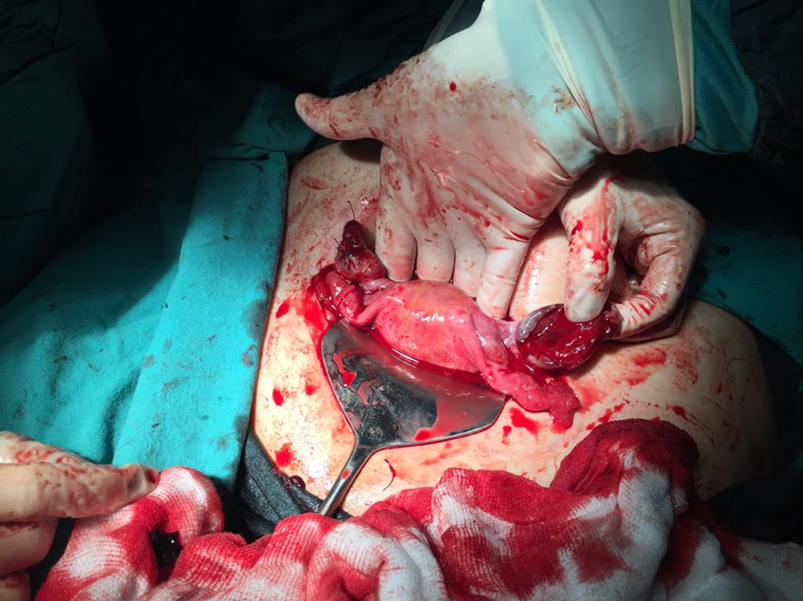

Results
Although the mechanism of occurrence cannot be fully explained, early diagnosis should be made with a good pelvic sonography in ectopic pregnancies and conservative medical/surgical treatment should be planned by early intervention before the patient's stability is impaired.
Keywords: ectopic pregnancy, hemorrhagic corpusluteum cyst, ovarian ectopic pregnancy

S-34 Could The Use Of Isotretinoin Lead To A Suppression Of The Ovarian Reserve In Patients With Pcos? A Case Control Study
Halime Şen Selim¹
1 İzmir Atatürk Eğitim ve Araştırma Hastanesi

Introduction: It is discussed in the literature that Isotretinoin, the most effective treatment agent of acne vulgaris, may be associated with inflammatory bowel disease, rheumatological diseases, especially depression, as well as proven mucocutaneous side effects. The most important question in the minds of these young women, who are still in their adolescence and many of whom are diagnosed with Polycystic Ovary Syndrome (PCOS), is whether the use of Isotretinoin will cause infertility. We aimed to determine whether the use of isotretinoin decreases the ovarian reserve and thus, whether it will cause infertility in the future.

Methods: Patients who applied to the gynecology outpatient clinic between January 2021 and February 2023 and were diagnosed with PCOS were retrospectively screened.

Among these patients, 22 patients who applied for isotretinoin use and whose AMH values were checked were included in the study group. Eight of these patients were excluded from the study because they did not come for their 3rd-month follow-up.

A control group of 18 patients with similar demographic characteristics, who did not use isotretinoin, did not receive any infertility treatment, and were diagnosed with primary infertility, who underwent initial infertility evaluation, were formed. AMH levels were compared in both groups at the beginning of the treatment and at the 3rd month.

Results: The mean age of the patients was 22.0±3.0 years. When the patients were compared in terms of study start (T0) and third-month AMH values, no statistical difference was found between T0 and T3 in the control group (2.10 ng/mL vs. 2.14 ng/mL, p=0.389); AMH values were found to be statistically different between T0 and T1 in the PCOS+treatment group (11.27 ng/mL vs. 5.39 ng/mL ; p<0.001). (Table 1) When both groups are compared regarding the level of change in AMH values at 0. months and 3rd month, it was statistically significantly higher in the study group (-0.03 ng/mL vs -3.66; p<0.001). (Table-2)
 | Control group |  |  | PCOS+ isotretinoin group
Değişkenler | T0 | T3 | p value | T0 | T3 | p value
AMH,(ng/mL) median (IQR) | 2.10 (1.65) | 2.14 (1.69) | 0.389 | 11.27 (4.98) | 5.39 (5.75) | <0.001

Table-1: Comparison of AMH level between PCOS+ isotretinoin group and control groups at the start of the study (T0) and 3rd month (T3)

Variables | Control  group | PCOS+ isotretinoin group | p value
AMH level variation , (ng/mL) median (IQR) | -0.03 (0.29) | -3.66 (7.98) | <0.001

Table-2: The comparison of AMH level variation at the start of the study (T0) and 3rd month (T3) between the PCOS+ isotretinoin group and control groups

Conclusion: The retrospective nature of our study and the evaluation of ovarian reserve only with AMH levels are the limitations of our study, but the use of Isotretinoin seems to have a negative effect on ovarian reserve.

Keywords: Anti-Mullerian Hormone; İzotretinoin; Infertility; Ovarian reserve, Polycystic Ovary Syndrome

S-35 Resolution Of Fetal Atrio-Ventricular Block By Use Of Maternal Oral Methylprednisolone In Pregnancy Without Lupus Antibodies
Havva Güleli¹, Osman Akdeniz¹, Mehmet Obut¹
1 Diyarbakır Sağlık Bilimleri Üniversitesi Gazi Yaşargil Eğitim Araştırma Hastanesi

Resolution of fetal atrio-ventricular block by use of maternal oral methylprednisolone in pregnancy without lupus antibodies Havva Güleli1, Osman Akdeniz2, Mehmet Obut1 1 Health Sciences University, Department of Perinatology, Diayarbakır Gazi Yaşargil Training and Research Hospital, Diyarbakır, Turkey 2 Health Sciences University, Department of Pediatric Cardiology, Diayarbakır Gazi Yaşargil Training and Research Hospital, Diyarbakır, Turkey Aim: Fetal atrio-ventricular (A-V) block is a rare but life-threatening condition for fetuses. In most fetuses with structurally normal hearts, fetal AV block is caused by maternal lupus antibodies. Although there is no complete consensus in the literature, transplacental treatment with fluorinated steroids is one option to prevent progression of complete A-V block in pregnancies with lupus antibodies. However, the usefulness of steroids in pregnancies with fetuses with A-V block and without lupus antibodies has not been demonstrated. Case: The patient, 36 years old, gravidity: 3, parity: 1, was referred to our health center at 19 weeks of gestation because of fetal bradyarrhythmia. The patient had no chronic or acute illness. The patient’s routine laboratory values were normal. An obstetric ultrasound and detailed fetal anatomic examination were performed by a maternal fetal medicine specialist. No fetal structural or cardiac abnormalities were noted. On obstetric Doppler, the ventricular beat rate was 80. On M-mode ultrasound, the atrial rhythm was 140 beats per minute and the ventricular rhythm was 78. The patient was evaluated for possible causes of fetal atrioventricular block, including lupus antibodies, medications, etc. The level of lupus antibodies was normal and there was no other precipitating factor for the fetal atrioventricular block. The patient was advised to undergo ultrasound examination every two weeks. At 25 weeks' gestation, the fetal heart rhythm was similar to the first ultrasound examination. At 26 weeks' gestation, the patient turned to an outside fetal medicine specialist, who started 4 mg/day of oral methylprednisolone. At 28 weeks' gestation, the fetal atrioventricular block had resolved, and both atrial and ventricular rhythms were 147 beats per minute. The patient took oral methylprednisolone 4 mg/day until delivery. No fetal atrioventricular block was detected at the patient's routine follow-up, even on day 27.
Keywords: Antenatal Steroid, Atrioventricular Block, Lupus Antibodies

S-36 The Relationship Between Serum 25-Hydroxyvitamin D Level And Herpes Simplex Virus Type-2 Prevalence
Hüseyin Aytuğ Avşar¹, Ufuk Atlıhan ²
1 Buca Seyfi Demirsoy Eğitim ve Araştırma Hastanesi
2 Özel Karataş Hastanesi

Vitamin D has an important immunomodulatory role and is associated with various infectious diseases. Since vitamin D receptors are present in various human tissues, especially immune cells, its immunomodulatory potential is very important. Studies investigating the relationship between vitamin D level and Herpes Simplex Virus (HSV) infection are very limited. Therefore, our study aimed to determine the relationship between Serum 25-Hydroxy Vitamin-D and HSV type 2 (HSV-2) infection. Patients who applied to our hospital between January 2018 and February 2022 with HSV type-2 detected and whose serum 25-Hydroxyvitamin-D value was checked in the hospital database in the last 3 months were compared with those who did not have an infection and whose serum 25-Hydroxyvitamin-D value was checked in the last 3 months. The diagnosis of HSV Type-2 was made by physical examination and no biochemical test was applied. Patients actively taking vitamin D replacement, pregnant women, patients using immunomodulators due to autoimmune diseases, patients with malnutrition disorders, women with other diagnosed sexually transmitted infections were excluded from the study. 932 participants were included in the analysis. In total, 864 patients were HSV negative (92.8%) and 68 patients (7.2%) were HSV-2 positive. Serum 25-Hydroxyvitamin-D levels of HSV-2 patients were found to be significantly lower than the control group (p<0.05). Serum 25-hydroxyvitamin D3 levels in the control group were 23.22±13.09 on average. In the HSV -2 positive group, mean serum 25-hydroxyvitamin D3 levels were 17.73±10.32. Severe vitamin D deficiency was found in the population studied, regardless of the presence of HSV. Vitamin D levels were found below the normal value in approximately 93% of the population. There was no significant age difference between the groups after propensity score matching (p>0.05). Logistic regression analysis showed that Serum 25-Hydroxyvitamin-D was negatively associated with HSV-2 infection ([OR]=0.691, p<0.001). Vitamin D deficiency was seen as an independent risk factor for HSV-2 (Adjusted OR 2.704, p<0.001). Low serum Serum 25-Hydroxyvitamin-D was found to be significantly associated with increased risk of HSV-2 infection. In this direction, future interventional and pathophysiological studies should aim to clarify the nature and mechanism of the relationship.
Keywords: herpes simplex type 2, vitamin D, immunity

S-37 Evaluation Of Pregnancy Outcomes In Women With A History Of Hysterescopic Myomectomy
Ufuk Atlıhan¹, Hüseyin Aytuğ Avşar²
1 Özel Karataş Hastanesi
2 Buca Seyfi Demirsoy Eğitim ve Araştırma Hastanesi

In our study, we aimed to evaluate pregnancy outcomes in women with a history of hysterescopic myomectomy.The data of the pregnancy outcomes of 48women who had a history of myomectomy and who performed their pregnancy follow-up and delivery in our hospital between 2015-2023 after myomectomy were collected retrospectively.Patients who underwent myomectomy for submucous-myoma were included in the study.The mean age of the 48patients included in the study was 32.56±5.19years,and the mean body-mass-index was 29.5±4.56kg/m2,10(20.8%) never delivered,9(18.7%) normal-spontaneous-delivery(NSPD),27(56.2%) cesarean section(C/S),and 2(4.1%) both NSPD,C/S there was.The mean operation time was 34.16±12.7minutes,and the mean hospital stay was 1.09±0.11days.Gestational-week in which the delivery took place was found to be 37weeks,3days±3days on average.The need for neonatal intensive care after delivery was determined in 7patients(14.5%),and the need for blood transfusion was determined in 8(16.6%) patients.Considering the obstetric complications, there were no complications in 23(47.9%)patients;The most common complications were premature rupture of membranes in 6 patients(12.5%),threat of premature birth in 10(20.8%)patients,and intrauterine-growth-retardation in 9(18.7%)patients,respectively.When postoperative complications were evaluated,no complication developed in 38(79.1%)patients.The most common postoperative-complication was rest-placenta in 7(14.3%)patients.In 3patients,wound-infection developed with a rate of 6.2%.Myoma was detected again during pregnancy in 8(16.6%) of the patients. 1-fibroid was detected in 6(12.5%)patients and >2-fibroids in 2(4.1%)patients.Mean week of birth and birth weight were found to be lower in the patient group with fibroids during pregnancy,and a statistically significant difference was found.The operation time was found to be higher in the patient group with fibroids.There was no statistical difference between the groups in terms of neonatal intensive care need,need for blood transfusion,amount of blood loss,postoperative and obstetric complications.According to myoma size, there were 5(62.5%) patients with fibroids smaller than 3cm,and 3(37.5%)patients with fibroids >3cm.When the patients were grouped according to myoma size,the amount of blood loss was found to be higher in those with myomas of >3cm(p<0.05).There was no statistical difference between the groups in terms of neonatal intensive care need,need for blood transfusion,postoperative,obstetric complications.It has been observed that when fibroids are detected during pregnancy in patients who have undergone myomectomy,delivery occurs earlier in the week,causes lower birth weight and increases the duration of the operation.
Keywords: hysterescopy, myomectomy, pregnacy

S-38 Acquired Hematologic Factors Inhibitors In Unexpected Postpartum Hemorrhage: Surgical Treatment Duration 11 Month
İbrahim Buğra Bahadır¹, Ayşe Filiz Yavuz², Gamze Yılmaz³
1 Ankara Sincan Eğitim Araştırma Hastanesi
2 Ankara Bilkent Şehir Hastanesi
3 Ankara Bilkent Şehir Hastanesi

Unexplained postpartum hemorrhage (PPH) refractory to hemostatic and surgical procedures should raise suspicion of hematological disease.When hemostatic medical and surgical procedures fail to control bleeding, increased morbidity, fertility loss, and death can occur.A 36-year-old patient with G4P1Y1A1D/C2 applies to our clinic with the diagnosis of intrauterine hematoma and massive bleeding on the 7th day after cesarean section.The patient had a history of pulmonary thromboembolism and FactorV Leiden mutation before pregnancy, used enoxaparin and acetylsalicylic acid during pregnancy.The patient's hemoglobin level decreased from 10.6 g/dl to 5.1 g/dl.The patient, who did not respond to medical treatment, underwent surgical intervention and endometrial curettage and uterotonic balloon were applied.The patient was consulted with hematology, and appropriate investigations, blood product replacement, and treatment were planned.The patient, who had massive intra-abdominal bleeding on the 2nd day of follow-up, total abdominal hysterectomy and right salpingectomy were performed, and bleeding was controlled surgically.The patient was definitively diagnosed with Factor5 Leiden mutation, protein C/S resistance, and acquired factor8 deficiency (bethesda 6 ) by the hematology clinic.The patient took factor 7a replacement.Immunosuppressive therapy was recommended to the patient, but she was not accepted because she was breastfeeding. Immunoglobulin (IVIG) therapy was given.The patient, who was followed up in the intensive care unit, was taken to re-laparotomy due to the development of acute abdomen 10 days later.4500 cc hematoma was extracted from the abdomen and hemostatic agents such as Floseal© and Tisseel© were applied.The fascia was left open, and the skin was closed with retention sutures.The patient, who suffered from skin and subcutaneous necrosis during follow-up, was left to secondary healing.Totally, the patient replaced by 51 units of erythrocyte suspension, 36 units of fresh frozen plasma, 14 units of cryospitate, 6 units of fibrinogen and 1 human platelet in the first 20 days.Appropriate debridement and treatment took approximately 11 months.The patient was discharged in wellness.The patient is still being followed in the hematology clinic with acquired factor8 deficiency Bethesda 2 levels.The aim of this case report is to emphasize that the treatment of patients with PPH due to an acquired factor inhibitor is lifesaving in this disease with high mortality.
Keywords: Postpartum Hemorrhage, Acquired Factor8 inhibitor, Massive Transfusion
INTRODUCTION
Standart hemostatik prosedürlere dirençli, açıklanamayan postpartum hemoraji (PPH), edinilmiş kanama bozukluğuna ilişkin klinik şüphenin artmasına neden olmalıdır. Hemostatik tıbbi müdahaleler ve cerrahi prosedürler kanamayı kontrol edemediğinde, ameliyat sonrası masif kan kaybı, artmış morbidite, doğurganlık kaybı ve ölüm meydana gelebilir. Pıhtılaşma faktörlerine karşı bir otoantikor inhibitörü bulunduğunda, hayatı tehdit eden doğum sonu kanamanın kontrolü ve sonraki kanama ataklarının önlenmesi, zamanında ve doğru tanıya, hızlı hemostatik tedavi ve faktör inhibitörlerinin ortadan kaldırılmasına ve uygun uzun süreli hasta bakımına bağlıdır. Faktör inhibitörüne bağlı edinilmiş doğum sonrası hemofili, PPH'nin nadir bir nedenidir; ancak gecikmiş tedavi annede morbidite ve mortalitenin artmasına neden olabilir. Bu vaka takdiminin amacı hematologlar ve kadın hastalıkları ve doğum uzmanları/jinekologlar arasında, PPH'nin bir nedeni olarak Faktör8 nötralize edici otoantikorların ortaya çıkışı konusunda farkındalığı artırmak ve tanısal değerlendirme, tedavi ve tedaviyi optimize etmek için kadın doğum uzmanları/jinekologlar ile hematoloji uzmanları arasındaki iş birliğinin önemini vurgulamaktır. Edinilmiş bir faktör inhibitörüne bağlı olarak doğum sonu kanama yaşayan kadınların uzun vadeli tedavisinin mortalitesi yüksek olan bu hastalıkta hayat kurtarıcı olduğu unutulmamalıdır.
CASE
36 yaşında g4p1y1a1d/c2 olan hasta sezaryen ameliyatı sonrası 7. günde kavite içinde hematom ve masif kanama tanısı ile tarafımıza başvuruyor. Dış merkezde fetal distress tanısıyla acil sezaryen olan hasta postoperatif 7. gününde evde ani senkop ve evde abondan kanama öyküsüyle acil servise başvurdu. Hastanın gebelik öncesi pulmoner tromboemboli öyküsü ve Faktör5 Leiden mutasyonu olduğu, gebelik boyunca enoksaparin 6000 ünite 1x1 ve asetilsalisilikasit 100 mg 1x1(35.haftaya kadar) kullandığı, postoperatif 3.gününde cilt altı hematom olması nedeniyle enoksaparin 6000 ünite 1x1 4 gün önce kesildiği ve hematom takibi yapıldığı öğrenildi. Kabulünde tansiyon:80/50 mm/hg nabız: 70 atım/dk idi. Ultrasonda kavite içinde yoğun koagülüm izlenmiş olup vajinal muayenede abondan kanama mevcuttu. Acil şartlarda hastaya elle halas yöntemiyle kanama kontrolü sağlanmaya çalışıldı. Vajinal kanaması devam eden hastaya 1 ampul metilergonovin, 4 ampul traneksamik asit, 2 adet rektal mizoprostol uygulandı. Elle halas yapıldıktan sonra kavitede endometriyum çift duvar kalınlığı 20 mm olarak izlendi. 500 cc ringer laktat içerisine 10 ünite oksitosin uygulandı. Vajinal kanaması devam eden hastaya kan merkezi aranarak 4 ünite ES, 4 ünite TDP , 2 adet kriyopresipitat hazırlandı. Hastanın hg:10.6-8.6-5,1 mg/dl plt:484.000-469.000 ınr:0.94-1.00 fibrinojen:3.0 d-dimer:30.72 olarak görüldü. Hasta acil şartlarda probe küretaj ve intrauterin hemostatik balon uygulanması için ameliyathaneye alındı. Hastaya ultrason eşliğinde probe küretaj işlemi uygulandı. Ardından hastaya 350 cc şişirilerek intrauterin balon yerleştirildi. Hastaya 1 adet dren yerleştirildi. 2 g fibrinojen uygulandı. Hematolojiye danışıldı, gerekli tetkikler istenildi. Takiplerinde major kanaması devam eden hasta yoğun bakım şartlarında takibe alındı ve 2 gün içinde 10 ünite ES, 8 ünite TDP ve 2 ünite fibrinojen replasmanı yapıldı. Dreninden masif kanama bulgusu gelmesi üzerine 2 gün sonra hastaya re-laparatomi planlandı. Hastaya total abdominal histerektomi ve sağ salpenjektomi operasyonu uygulandı, kanama kontrolü sağlandı. Cerrahi tedaviler boyunca enfeksiyon hastalıkları ile birlikte gerekli ve uygun antibiyotik tedavisi verilmiştir. Hematoloji kliniği tarafından hastaya Faktör5 Leiden mutasyonu, protein C/S rezistansı ve edinsel faktör 8 eksikliği tanısı konuldu. Hastaya 2 defa faktör 7a replasmanı yapıldı. İmmünsüpresif tedavi önerildi. Hasta emzirdiği için kabul etmedi. Immünoglobulin (IVIG) tedavisi verildi. Yoğun bakım takibine alınan hasta 10 gün sonra tekrar batında yaygın hematom görülmesi ve akut batın gelişmesi sebebiyle genel cerrahi kliniğiyle birlikte re-laparatomiye alındı. Batından 4500 cc hematom boşaltılıp Floseal, Tisseel gibi gibi hemostatik ajanlar uygulandı. Fasya açık bırakıldı, GAM insizyon hattı, cilt ve cilt altı katları retansiyon süturleriyle usulüne ve anatomiye uygun kapatıldı. Eski pfannenstiel insizyon hattının altında, cilt altına Surgicel ve Spongostan uygulanarak Jackson dren yerleştirildi ve prolen süturla matris şeklinde kapatıldı. Erken komplikasyon olmadı. Takiplerinde retansiyon süturleri nekroza giden hasta sekonder iyileşmeye bırakıldı. Hematoloji testleri sonucunda hastanın kesin tanısı Bethesda 6 olarak edinsel faktör 8 inhibitörü ve protein C/S rezistansı olarak belirlendi. Batın ön duvarı total olarak nekroza uğrayan hastaya toplamda ilk 20 gün içinde 51 ünite eritrosit süspansiyonu 36 ünite taze donmuş plazma 14 ünite kriyospitat 6 ünite fibrinojen 1 human platelet verildi. Uygun debridman ve tedavi yaklaşık 11 ay sürdü. Hasta sağlıklı bir şekilde taburcu edildi. Hasta halen hematoloji kliniğinde edinsel faktör 8 inhibitörü tanısı ile Bethesda 2 seviyelerinde takip edilmektedir.

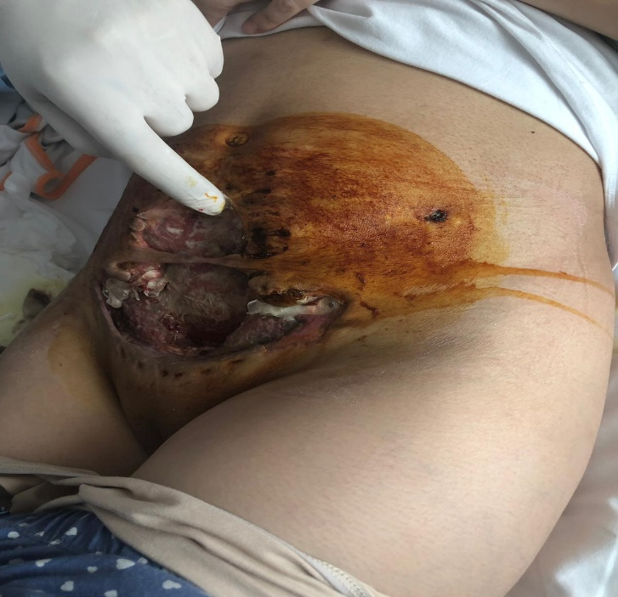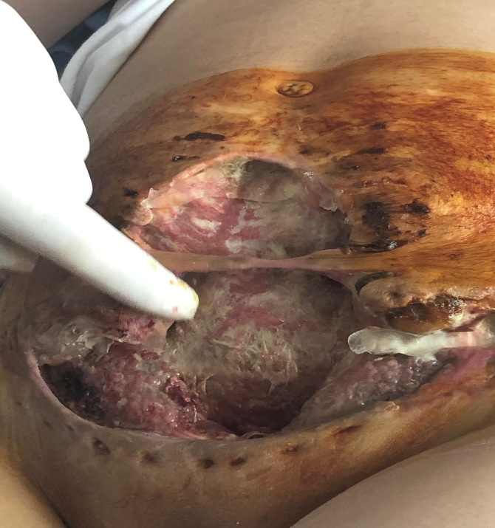
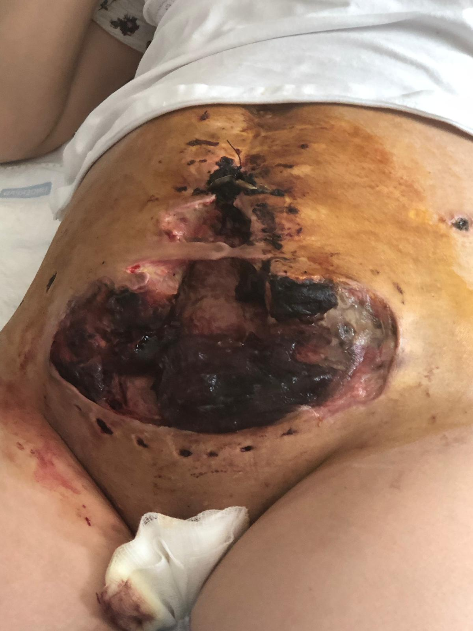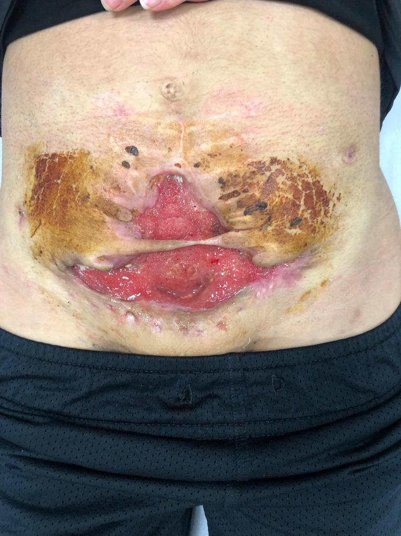

CONCLUSION
Bu vaka takdiminin amacı hematologlar ve kadın hastalıkları ve doğum uzmanları arasında, postpartum hemorajinin bir nedeni olarak Faktör 8 nötralize edici otoantikorların ortaya çıkışı konusunda farkındalığı artırmak ve tanısal değerlendirme, tedavi ve tedaviyi optimize etmek için kadın hastalıkları ve doğum uzmanları ile hematologlar arasındaki işbirliğinin önemini vurgulamaktır. Edinilmiş bir faktör inhibitörüne bağlı olarak postpartum hemoraji yaşayan kadınların uzun vadeli tedavisinin mortalitesi yüksek olan bu hastalıkta hayat kurtarıcı olduğu unutulmamalıdır.

KAYNAKÇA

1. Cohen AJ, Kessler CM. Acquired inhibitors. Baillieres Clin Haematol. 1996;9(2):331-354. doi:10.1016/s0950-3536(96)80067-9
2. Lurie S, Sadan O, Golan A. Re-laparotomy after cesarean section. Eur J Obstet Gynecol Reprod Biol. 2007;134(2):184-187. doi:10.1016/j.ejogrb.2006.10.017
3. Paidas MJ, Hossain N. Unexpected postpartum hemorrhage due to an acquired factor VIII inhibitor. Am J Perinatol. 2014;31(8):645-654. doi:10.1055/s-0033-1358768

S-39 İzole Fetal Asitte Abdomino-Amniyotik Şant Uygulaması
Raziye Torun¹, Atalay Ekin¹, İlker Uçar¹
1 Tepecik Eğitim ve Araştırma Hastanesi

25 yaşında, ilk gebeliği olan hasta 21. Gebelik haftasında izole fetal batında asit nedenli başvurdu. Yapılan değerlendirmede kardiyak, gastrointestinal ve üriner sistemlere ait başka anomali saptanmadı. Yapılan tetkiklerde hastanın kan grubu A Rh pozitif, parvovirüs, sitomegalovirüs, rubella, toxoplazma testi negatif olarak saptandı. Kordosentez yapıldı, normal karyotip olarak raporlandı. Hastaya 23. Gebelik haftasında ultrason eşliğinde fetal peritoneal kavite ve amniyotik sıvı arasına kateter yerleştirildi.
Anahtar Kelimeler: Abdomino-amniyotik şant, fetal anomali, fetal asit
OBJECTİVES
To determine the effectivenes of abdomino-amniotic shunt method applied in the treatment of isolated fetal ascites.

METHODS
25-year-old patient with her first pregnancy presented at 21 weeks of gestation due to isolated fetal ascites. No other anomalies related to the cardiac, gastrointestinal, and urinary systems were detected in the assessment. In the laboratory tests; blood group was identified as A Rh positive, and the tests for parvovirus, cytomegalovirus, rubella, and toxoplasma resulted negative. Cordocentesis was performed for fetal karyotype analysis, and it was reported as a normal karyotype. At the 23rd week of pregnancy, a pigtail catheter was placed under ultrasound guidance between the fetal peritoneal cavity and the amniotic fluid.
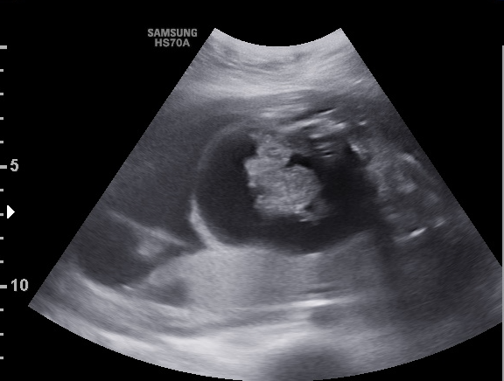
Image 1: Fetal ascites before shunting

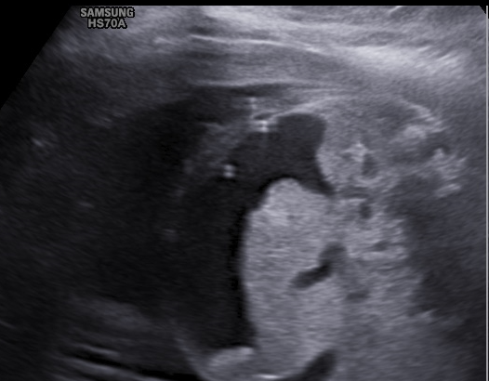
Image 2: Shunt in the fetal abdominal wall after the procedure

RESULTS
After the procedure, a dramatic reduction in the amount of fetal ascites was observed in the ultrasound performed at the 12th hour. The amount of ascites, which was measured as 22 mm (Anterior-posterior) before the procedure, was measured as 3 mm after the procedure. The patient's pregnancy follow-ups are ongoing at our clinic, and in the evaluation performed at the 29th week, no fetal ascites findings were detected. The shunt has been observed in its place.
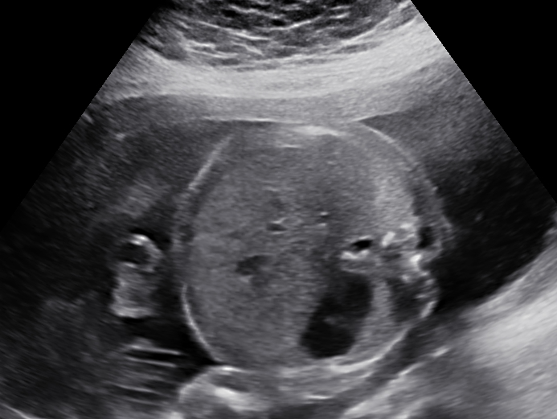
Image 3: Image taken during follow up, there is minimal fetal ascites after shunting procedure

CONCLUSION
Although isolated fetal ascites generally leads to favorable neonatal outcomes, the prognosis varies significantly depending on the underlying etiology. (1) There are studies in the literature indicating that the week of detecting fetal ascites is significant in terms of prognosis and perinatal mortality rates. It is noted that fetal ascites detected before the 24th week of gestation is associated with a higher frequency of perinatal mortality. (2) Prenatal diagnosis is important both for dystocia and neonatal resuscitation. Lethal complications, including pulmonary hypoplasia and fetal hydrops, related to ascites can also emerge. Particularly, fetal ascites appearing in early pregnancy weeks increases the likelihood of encountering these complications. In order to prevent these complications, prenatal interventional procedures are carried out. Abdomino-amniotic shunting has first been reported in 1984. (3) While it's generally not recommended to apply shunt procedures for uncomplicated fetal ascites according to the general consensus, its significant advantage lies in eliminating the need for repetitive prenatal paracentesis. It has been demonstrated that prenatal drainage of fetal ascites extends the duration of pregnancy and improves neonatal resuscitation outcomes. (4) In cases where isolated fetal ascites is detected, shunt procedure can be considered as an option to prevent lethal complications and prolong the duration of pregnancy.

REFERENCES
1. El Bishry G. The outcome of isolated fetal ascites. European Journal of Obstetrics & Gynecology and Reproductive Biology. 2008;137(1):43-6.
2. Catania VD, Muru A, Pellegrino M, De Marco EA, Paradiso FV, Manzoni C, et al. Isolated fetal ascites, neonatal outcome in 51 cases observed in a tertiary referral center. European Journal of Pediatric Surgery. 2017;27(01):102-8.
3. SEEDS JW, HERBERT WN, BOWES Jr WA, CEFALO RC. Recurrent idiopathic fetal hydrops: results of prenatal therapy. Obstetrics & Gynecology. 1984;64(3):30S-3S.
4. Bernaschek G, Deutinger J, Hansmann M, Bald R, Holzgreve W, Bollmann R. Feto‐amniotic shunting—report of the experience of four european centres. Prenatal diagnosis. 1994;14(9):821-33.

S-40 Unilateral Primary Ovarian Leiomyoma In Postmenopausal Period: Case Report
Ilkin Seda Can Çağlayan¹
1 Sivas Cumhuriyet Üniversitesi Tıp Fakültesi

Objective:Leiomyomas are rare benign smooth muscle tumors of the ovary. Ovarian leiomyomas constitute approximately 0.5-1% of benign tumors of the ovary. They usually occur in reproductive age and asymptomatically. About 16% of cases occur after menopause. They are usually unilateral, with no left or right side preference. Most bilateral cases have been reported in young women aged 16-25 years. They are usually small in size and detected incidentally, but cases reaching giant sizes have been reported in the literature. Ovarian leiomyomas are primary or parasitic in origin. Primary ovarian leiomyomas are defined as lesions arising from the ovary. From ovarian tissue, including blood vessels within the ovary, smooth muscle fibers, or similar tissues within the ovarian stroma and tunica albuginea. In contrast, parasitic ovarian leiomyomas are extraovarian in origin and adherent to the ovary. Rarely, such tumors twist around their pedicle, followed by bleeding and necrosis. Although ultrasound, which we use in the diagnosis of gynecologic pelvic pathologies, is a good diagnostic method, it is not sufficient for the specific diagnosis of ovarian leiomyomas. Case report: We present a postmenopausal patient who presented to our outpatient clinic with abdominal pain and abdominal swelling that started in the last six months. Our 54-year-old patient, who had been in menopause for 13 years, had a 5-6 cm solid lesion with borders not clearly separated from the ovary, which was thought to be associated with the right adnexal area. Total abdominal hysterectomy + bilateral salpingo-oophorectomy (frozen) was planned for the patient with no abnormalities in tumor markers and other laboratory tests. The frozen examination result was ovarian leiomyoma. No extra pelvic pathology was observed. The patient was discharged without any postoperative problems. Conclusion: Diagnosis of ovarian fibroids is difficult because they are usually not associated with ant specific clinical symptoms. Misdiagnosis causes problems in teratment, especially in women reproductive age. Therefore, keeping leiomyomas in mind especially in solid masses observed in the ovary may prevent surgeons from performing more surgery than necessary for the patient. Young patients and are bening lesions, ovarian sparing surgery should be preferred after excluding the possibility of malignancy.
Keywords: Ovarian leiomyoma, solid tumour, extrauterine fibroma

INTRODUCTION
Leiomyoma, with its variants, is the most common benign mesenchymal tumor of the uterus ¹. It can also be seen in extrauterine sites. The broad ligament is the most common extrauterine site with an incidence of less than 1%.². Other unusual sites are the round ligament, ovarian ligament, vulva, ovaries, bladder and urethra.³. Ovarian leiomyoma is rare, accounting for approximately 0.5-1% of benign tumors of the ovary⁴. They are benign in nature but definitive diagnosis requires histopathological evaluation and differentiation from other solitary tumors of the ovary such as fibroma, tectoma and sclerosing stromal tumor. The most likely theory is that they take their origin from the smooth muscle of the ovarian ligaments through which they enter the ovary or from the smooth muscle of the ovarian blood vessels. ⁵⁶. Most cases are asymptomatic and 85% occur in pre-menopausal women. Most common in women aged 20-65 years ⁴⁷. Although their presentation and treatment are often simple, they can undergo various forms of asymptomatic degeneration that greatly alter their appearance and blur the diagnostic process. Most of these tumors are unilateral, small in size and usually occur in pre-menopausal women⁸.

CASE REPORT
We present a case of primary ovarian leiomyoma in the postmenopausal period. A 54-year-old patient presented to our gynecology outpatient clinic with complaints of abdominal pain and abdominal distension for 6 months. She went through menopause 13 years ago (gravida:5 parity:5). On gynecologic examination, a mobile mass was palpated in the douglas. Ultrasound examination revealed a heterogeneous, smoothly circumscribed, hypoechoic, nodular lesion of approximately 5-6 cm in size, which was thought to be originating from the right adnexa, posterior to the uterus. There was a moderate amount of free fluid in the abdomen. No abnormality was detected in laboratory blood values and tumor markers [Ca 125, Ca 15-3, Ca19-9, carcinoembryonic antigen (CEA), and alpha-fetoprotein (AFP)]. The patient was decided to operate. During laparotomy under general anesthesia, the solid mass in the right ovary was sent for frozen examination (Figure 1). Frozen result was reported as ovarian leiomyoma. Uterus, left tuba and ovary were atrophic. Total abdominal hysterectomy and bilateral salpingo-oophorectomy were performed. The patient was discharged without any postoperative problems.

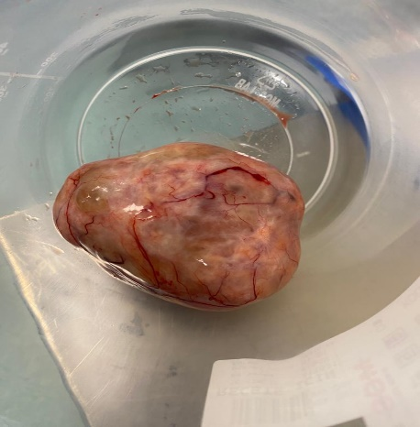

Figure 1: Right oophorectomy material

DISCUSSION

We present a case of ovarian leiomyoma in a postmenopausal woman who presented with abdominal pain. Most ovarian leiomyomas described in the literature are asymptomatic and discovered incidentally⁵. Clinical findings are variable in symptomatic cases; abdominal pain, palpable mass, hydronephrosis, elevated CA-125, hydrothorax and ascites may be detected.⁸. It can also be Meigs' syndrome.⁹¹⁰. Meigs syndrome is characterized by the presence of ascites and pleural effusion in the presence of solid ovarian tumors such as fibroma, tectoma and granulosa cell tumors ¹⁰. Ovarian leiomyoma associated with Meigs syndrome is extremely rare and only two cases have been reported¹¹. Our patient had minimal abdominal fluid and no pelvic effusion on chest radiography. Most of the cases are diagnosed by routine gynecologic examination and pathologic examination of the materials in the peroperative or postoperative period. Histologic examination is the gold standard for definitive diagnosis.

Since ovarian leiomyomas present as solid adnexal masses, they are often confused with the more common ovarian fibromas in the preoperative period. In some cases, elevated tumor markers and abdominal free fluid may raise suspicion of ovarian malignancy. A good preoperative evaluation and the addition of MR imaging may partially help in the differential diagnosis. This is important for us in terms of the type of operation (laparoscopy/ laparotomy), incision type and preoperative preparation. We should always keep ovarian leiomyomas in mind in adnexal masses, even if they are very rare. This is especially important for ovarian sparing surgery in young and reproductive age patients. In the literature, there is a 17-year-old patient who underwent bilateral salpingoooferectomy for bilateral ovarian leiomyomas. ¹². Leiomyomas are benign lesions that should always be kept in mind when approaching ovarian masses, especially in young women. Ovarian sparing surgery and wedge resection (especially if a minimally invasive surgical procedure is performed) can be very difficult, especially in primary ovarian leiomyomas because they are integrated with the ovary. Since our case was a postmenopausal patient, we chose oophorectomy as the treatment option.

KAYNAKÇA

1. El-Naggar AK, Chan JKC, Rubin Grandis J, Takata T, Slootweg PJ. International Agency for Research on Cancer WHO classification of head and neck tumours. Lyon Int Agency Res Cancer. Published online 2017.
2. Song JY. Laparoscopic resection of a rare, large broad ligament myoma. J Minim Invasive Gynecol. 2015;22(4):530-531.
3. Sehgal R, Maghrabi A. Benign metastasizing leiomyoma:‘a sheep in wolf’s clothing.’ Community Oncol. 2013;10(4):122-124.
4. Agrawal R, Kumar M, Agrawal L, Agrawal KK. A huge primary ovarian leiomyoma with degenerative changes-an unusual. J Clin diagnostic Res JCDR. 2013;7(6):1152.
5. Tomas D, Leniček T, Tučkar N, Puljiz Z, Ledinsky M, Krušlin B. Primary ovarian leiomyoma associated with endometriotic cyst presenting with symptoms of acute appendicitis: a case report. Diagn Pathol. 2009;4(1):1-4.
6. Tsalacopoulos AJ G& T. Leiomyoma of the ovary-a report of 3 cases. South African Med J. 1981;59(16):574-575.
7. Blue NR, Felix JC, Jaque J. Primary ovarian leiomyoma in a premenarchal adolescent: first reported case. J Pediatr Adolesc Gynecol. 2014;27(4):e87-e88.
8. Wei C, Lilic N, Shorter N, Garrow E. Primary ovarian leiomyoma: a rare cause of ovarian tumor in adolescence. J Pediatr Adolesc Gynecol. 2008;21(1):33-36.
9. Kelekci S, Eris S, Demirel E, Aydogmus S, Ekinci N. Lipoleiomyoma of the uterus and primary ovarian leiomyoma in a postmenopausal woman: two rare entities in the same individual. Case Rep Pathol. 2015;2015.
10. Kurai M, Shiozawa T, Noguchi H, Konishi I. Leiomyoma of the ovary presenting with Meigs’ syndrome. J Obstet Gynaecol Res. 2005;31(3):257-262.
11. Tsuchiya H. A case of Meigs’ syndrome with ovarian leiomyoma. Iryo. 1994;48:1066-1069.
12. Lim S, Jeon H. Bilateral primary ovarian leiomyoma in a young woman: case report and literature review. Gynecol Oncol. 2004;95(3):733-735.

S-41 Primary Ovarian Leiomyosarcoma With Isolated Para-Aorta-Caval Metastas: A Rare Case Report
Hatice Kübra Can¹, İsmail Bağlar¹, Esra Keleş¹, Murat Api¹
1 Kartal Dr. Lütfi Kırdar Şehir Hastanesi

Introduction: Primary ovarian sarcomas are an uncommon occurrence, accounting for less than 2% of all ovarian malignancies, with primary ovarian leiomyosarcoma, a rare smooth muscle neoplasm, making up less than 0.1% of these malignancies. Initial stages of this condition often present with no symptoms, while disease progression is rapid, and symptoms become non-specific in advanced stages with a high degree of malignancy. Unfortunately, most patients are diagnosed with advanced disease at the time of presentation. Herein, we present a rare case of paraaortacaval recurrence of ovarian leiomyosarcoma. Case: A 60-year-old female, gravida 0, was referred to the Department of Gynecologic Oncology. In 2007, she had undergone a hysterectomy and bilateral salpingo-oophorectomy due to an adnexal mass, which was later confirmed as leiomyosarcoma. The patient underwent chemotherapy and radiotherapy treatment, and in 2016, a simple nephrectomy was performed due to recurrence in the right kidney. In 2018, an excision of the left retroperitoneal mass was done due to the recurrence of localized inferior of the left kidney, which revealed a malignant mesenchymal tumor and leiomyosarcoma infiltration. During follow-ups, a fistula developed in the retroperitoneal area, and a laparotomy was performed, which led to mass excision and twelfth rib excision. Magnetic Resonance Imaging (MRI) revealed a solid mass lesion with a diameter of approximately 6 x 5 cm in the paraaortacaval area. Gastrointestinal endoscopy and colonoscopy were normal. The decision for surgical debulking was made, and during abdominal exploration, a 6 cm in diameter mass lesion was detected over the aorta and vena cava inferior (Figure 1). A 6*5 cm heterogeneous mass excision in the para aortocaval region and vena cava repair was performed with the cardiovascular surgery team, and tumors in the bowel mesentery were excised. Para-aortic lymph node dissection was performed, and R0 resection was achieved. The surgical specimens were submitted for histopathologic examination, and the postoperative course was uneventful. Discussion: Ovarian leiomyosarcoma is a rare malignancy that poses significant management challenges and has poor survival rates. There is a critical need for an international registry for this disease to collect comprehensive and reliable data that can help identify the
Keywords: ovarian leiomyosarcoma, malignant neoplasm; ovarian neoplasm

S-42 Fearful Dream: Pregnancy And Fetal/neonatal Management In Anaphylaxis
İlke Özer Aslan¹, Mustafa Törehan Aslan²
1 Tekirdağ Namık Kemal Üniversitesi Tıp Fakültesi, Kadın Hastalıkları ve Doğum Anabilim Dalı
2 Tekirdağ Namık Kemal Üniversitesi Tıp Fakültesi, Çocuk Sağlığı Ve Hastalıkları Anabilim Dalı, Neonatoloji Bilim Dalı

Giriş: Gebelikte anafilaksi geçirme olguları oldukça nadir görülmekle birlikte maternal hipotansiyon ve fetal hipoksik iskemik ensefalopati gibi olumsuz sonuçlara yol açarak ciddi morbidite ve mortalitelere sebep olabilmektedir. Ek olarak anafilaksi gelişen gebelerde yüksek sezaryen oranları da dikkat çekmektedir.Biz de nadir görülen bu olgumuzdaki yönetimimizden ve neonatal sonuçlardan bahsederek oldukça nadir görülen bu olguların doğru yönetiminin ne kadar önemli olduğunu vurgulayarak literatüre katkı sağlamak istedik. Gebelik ve Fetal/Neonatal Yönetim: 25 yaş G4P3C1Y2 son adet tarihine göre 32+0/7 haftalık gebeliği olan olgumuzun gebelik öncesinde de iki defa arı sokması sonrasında anafilaksi geçirme öyküsü bulunmaktadır. Tarafımıza başvurusunun öncesinde yine arı sokması sonrasında bilinç kaybı, ağır hipotansiyon ve nefes darlığı gibi semptomlarla anafilaksi tablosu gelişmesi üzerine dış merkeze başvurmuş intramusküler 0,5 mg adrenalin uygulanması sonrasında anafilaksi tablosu gerilemiştir. Acil serviste çekilen kontrol non-stres testlerde (NST) fetal taşikardi saptanması üzerine tarafımıza yönlendirilmiştir. Tarafımızca yapılan kontrollerde fetal kalp atımı 170 atım/dakika saptanması üzerine akciğer maturasyonu açısından betametazon uygulamasını takiben yatarak izleme alınmış ve yakın NST takibine başlanmıştır.Maternal İV hidrasyon ve oksijen desteği uygulanarak resüte edilmesine rağmen NST takiplerinde fetal taşikardisi devam eden non-reaktif bir NST paterni olan(Resim 1) fetal kalp atımları 185 atım/dakika ulaşan olguya acil sezaryen kararı alınmıştır. 1745 gram ağırlığında Apgar skorları 1.dakika: 4, 5.dakika 7 (entübe) olan, canlı kız bebek doğurtulmuştur. Doğum sonrasında ciddi solunum sıkıntısı ve taşikardisi saptanan yenidoğan entübe edilerek yenidoğan yoğun bakım ünitesine yatırılmıştır.Yenidoğan yoğun bakım ünitesi takiplerinde hipertansiyonu olan olguya antenatal adrenalin uygulaması sonucu devam eden beta-mimetik etki açısından propanolol tedavisi başlanarak yakın tansiyon takibi yapılmıştır.Tansiyon takiplerine göre antihipertansif tedavi azaltılarak postnatal 16. günde kademeli olarak kesilen olgu sonrasında normotansif seyretmiştir, fetal ekokardiyografisinde ek bir patoloji saptanmamıştır.Yenidoğanda intrakraniyal kanama ve neonatal ensefalopati bulgularının olması oldukça dikkat çekicidir. Tartışma: Olgumuzdaki gibi maternal hayatı tehlikeye sokabilecek düzeyde anafilaksiyle gebelik döneminde de karşılaşılması durumunda adrenalin uygulaması birçok kılavuzda desteklenmektedir.Ancak oluşacak neonatal sonuçlar açısından dikkatli olup, doğru yönetimi benimsemek mutlaka hastaların yatışını yapıp yakın NST takibine almak ve multidisipliner yaklaşım olumsuz fetal ve neonatal sonuçlar açısından oldukça önemlidir.Literatürü taradığımızda bizim olgumuz dışında maternal arı sokması sonrası gebeliğinde anafilaksi gelişen sadece bir olgu bulunmakla birlikte onda da benzer şekilde neonatal ensefalopati bulguları gelişmiştir
Anahtar Kelimeler: Gebelik, arı sokması, anafilaksi, fetal taşikardi, neonatal hipertansiyon
Introduction: Although cases of anaphylaxis during pregnancy are rare, they can lead to negative consequences such as maternal hypotension and fetal hypoxic-ischemic encephalopathy, causing severe morbidity and mortality. High cesarean section rates in pregnant women who develop anaphylaxis are also noteworthy. These rare cases can be managed safely thanks to timely and correct interventions. We wanted to contribute to the literature by discussing our management and neonatal outcomes in this rare case and emphasizing the importance of adequately administering these rare cases.

Pregnancy and Fetal/Neonatal Management: A 25-year-old G4P3C1Y2 patient, who was 32+0/7 weeks pregnant according to her last menstrual period, had a history of anaphylaxis after being stung by bees twice before pregnancy. Before applying to us, she went to an external center after developing anaphylaxis with symptoms such as loss of consciousness, severe hypotension, and shortness of breath after a bee sting. The anaphylaxis situation subsided after the intramuscular administration of 0.5 mg adrenaline. She was referred to us after fetal tachycardia was detected in the non-stress tests (NST) taken in the emergency department. In the controls performed by us, the fetal heart rate was seen as 165 beats/minute, and following betamethasone administration, inpatient monitoring was started in terms of lung maturation, and close NST monitoring was started. An emergency cesarean section was decided for the case, whose fetal heart rate reached 175 beats/minute, a non-reactive NST pattern (Figure 1), and whose fetal tachycardia continued in the NST follow-ups despite being resuscitated with maternal IV hydration and oxygen support. A live female baby weighing 1745 grams, with Apgar scores of 4 at the 1st minute and seven at the 5th minute (intubated), was delivered. The newborn, found to have severe respiratory distress and tachycardia after birth, was intubated and admitted to the neonatal intensive care unit. During the neonatal intensive care unit follow-ups, propranolol treatment was started, and close blood pressure monitoring was carried out in the case of the patient with hypertension, given the ongoing beta-mimetic effect resulting from antenatal adrenaline administration. According to blood pressure follow-ups, the patient remained normotensive after reducing the antihypertensive treatment and gradually discontinued on the 16th postnatal day. No additional pathology was detected in the fetal echocardiography. The presence of intracranial hemorrhage and neonatal encephalopathy findings in the newborn is quite remarkable.

Discussion: In our case, adrenaline administration is supported by many guidelines if anaphylaxis that could endanger maternal life is encountered during pregnancy. However, being careful regarding neonatal outcomes, adopting the correct management, hospitalizing the patients, and keeping them under close NST follow-up and a multidisciplinary approach is critical regarding adverse fetal and neonatal outcomes. When we scanned the literature, there was only one case other than ours who developed anaphylaxis during pregnancy after a maternal bee sting, and she also developed similar neonatal encephalopathy findings.

Keywords: Pregnancy, bee sting, anaphylaxis, fetal tachycardia, neonatal hypertension.

Kaynaklar
- Jeon HJ, Ryu A, Min J, Kim NS. Maternal anaphylactic shock in pregnancy: A case report. Medicine (Baltimore). 2018 Sep;97(37):e12351. doi: 10.1097/MD.0000000000012351. PMID: 30212990; PMCID: PMC6156050.
- Simons FE, Schatz M. Anaphylaxis during pregnancy. J Allergy Clin Immunol. 2012 Sep;130(3):597-606. doi: 10.1016/j.jaci.2012.06.035. Epub 2012 Aug 4. PMID: 22871389.
- Simionescu AA, Danciu BM, Stanescu AMA. Severe Anaphylaxis in Pregnancy: A Systematic Review of Clinical Presentation to Determine Outcomes. J Pers Med. 2021 Oct 22;11(11):1060. doi: 10.3390/jpm11111060. PMID: 34834412; PMCID: PMC8623240.
- Tan E, O'Sullivan M, Crozier T, Kolawole H, Mantas S, Said M, Rueter K, Frith K, Barnes S. Acute management of anaphylaxis in pregnancy. Aust J Gen Pract. 2022 Jun;51(6):405-408. doi: 10.31128/AJGP-03-21-5918. PMID: 35637583.

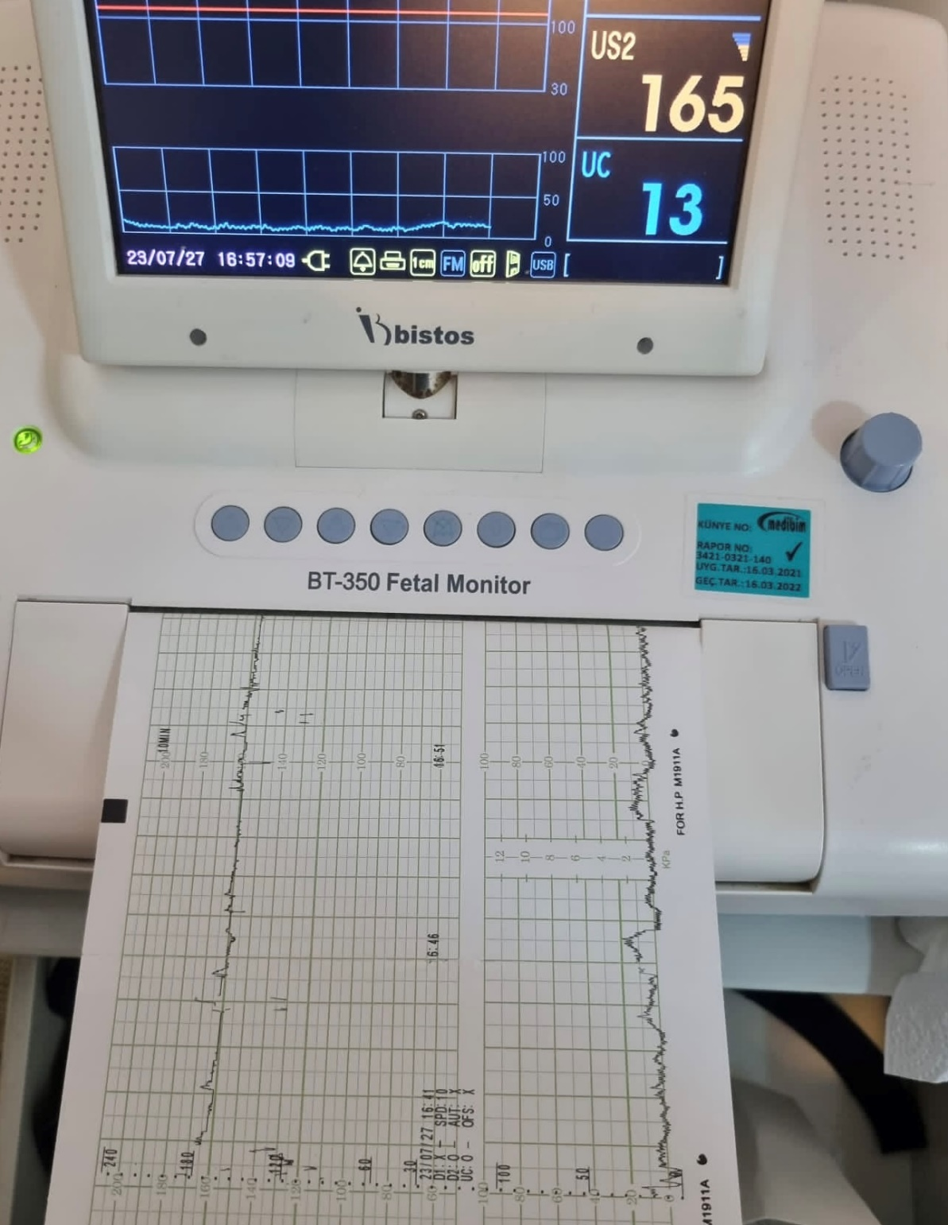

Resim 1: Olgunun NST Takibi / Figure 1: NST Follow-up of the Case

S-43 The Relationship Between Placental Location And Histopathologic Findings Of The Placenta And Umbilical Cord
İrem Şenyuva¹, Şirin Küçük²
1 Uşak Üniversitesi Tıp Fakültesi
2 Uşak Eğitim ve Araştırma Hastanesi

Plasenta Lokalizasyonu ile Plasenta ve Umblikal Kord Histopatolojik Bulguları Arasındaki İlişki The Relationship Between Placental Location and Histopathologic Findings of the Placenta and Umbilical Cord İrem Şenyuva1, Uşak Üniversitesi Tıp Fakültesi, iremsenyuva@yahoo.com Şirin Küçük2, Uşak Eğitim ve Araştırma Hastanesi,ata2012irin53@yahoo.com Özet Plasenta lokalizasyonu ile plasenta ve umblikal kord histopatolojik bulguları arasındaki ilişkiyi araştırmak amaçlandı. 2019 yılı Ocak-Aralık tarihleri arasında Uşak Eğitim ve Araştırma Hastanesi Kadın Hastalıkları ve Doğum bölümüne müracaat eden hastalar retrospektif olarak incelendi. Düşük riskli ve term de doğum yapan 52 hasta analiz edildi. Anterior ve posterior plasental lokalizasyona göre hastalar plasenta ve umbilikal kord makroskobik bulguları açısından karşılaştırıldı ve gruplar arasında anlamlı bir fark bulunmadı. Histopatolojik incelemede; umbilikal kord da hipoksi bulgusu saptanmadı(p>0.05). Anterior plasental lokalizasyonlu dört, posterior lokalizasyonlu altı olguda koranjiozis ile uyumlu hipoksi bulgusu gözlendi fakat, istatistiksel olarak anlamlı saptanmadı (p=0.09). Bu olgularda koranjiozise eşlik eden hipoksi ile ilişkili farklı lezyonlar tanımlanmadı. Anterior ve posterior plasental lokalizasyonda histopatolojik açıdan anlamlı hipoksi bulgularının gözlenmemesi uterin arterlere yakınlık ve diyabet, hipertansiyon gibi pre uterin vasküler bir patolojinin olmaması ile açıklanabilir. Anahtar Kelimeler: Hipoksi, lokalizasyon, plasenta Abstract The aim of this study was to examine the link between placental location and histopathologic findings in the umbilical cord and placenta. Retrospective research was done on patients who attended the Obstetrics and Gynecology Department at Usak Training and Research Hospital between January and December of 2019. 52 women, term and low-risk pregnancy, were included in this study. There was not any statistical significant between placenta location and macroscopic histopathologic findings(p>0.05). Four women with anterior placental location and six women with posterior placental location both had chorangiosis, however it was not statistically significant. ( p=0.09). Furthermore, there were no other hypoxia-overlapping lesions seen with the chorangiosis in these cases. Hypoxia was not observed in the anterior or posterior placenta, which could be attributed to low risk pregnancy, the absence of pre uterin vascular pathology such diabetes, hypertension, etc., and the proximity of the uterine arteries. Key words: Hypoxia, location, placenta Intraductıon: Given that uterine blood flow is irregular, intrauterine localization of the placenta may be impacted. The aim of this study was to examine the link between placental location and histopathologic findings in the umbilical cord and placenta. Material-Method: Retrospective research was done on patients who attended the Obstetrics and Gynecology Department at Usak Training and Research Hospital between January and December of 2019. Ultrasonographic placenta location and demographic findings were examined. Patients were divided into two groups according to placenta location, and their histopathologic results were compared. Results: 52 women, term and low-risk pregnancy, were included in this study. The mean age was 28.6±6.45, the mode of delivery was vaginal 53.8% and 46.2% caserean, 28.8% of vaginal deliveries were primiparous, and 72.2% were multiparous. The mean weight of babies were 3323,08±45.6 gr and none of them required intensive care. The location of the placenta was found to be anterior in 33 women (63%) and posterior in 19 women (36%). There was not any statistical significant between placenta location and macroscopic histopathologic findings (Table-1). There was no evidence of hypoxia in the umbilical cord. Four women with anterior placental location and six women with posterior placental location both had chorangiosis, however it was not statistically significant. ( p=0.09). Furthermore, there were no other hypoxia-overlapping lesions seen with the chorangiosis in these cases. (Figure-1). Discussion and Conclusion: Chorangiosis is determined as hyper vascularity of terminal villus of placenta and it is related to hypoxia. According to Altshuler criteria: > 10 capillaries in at least 10 terminal villi in ≥ 10 non infarcted areas in at least 3 low power fields of the placenta. On the other hand, it might be allowed to combine with other hypoxia-overlapping lesions, such as intravillous hemorrhage, villous infarct, ateriosclerosis of spiral arteriol etc. The uterine arteries and their anastomos are close to the anterior and posterior placentas, providing efficient placental perfusion. Hypoxia was not observed in the anterior or posterior placenta, which could be attributed to low risk pregnancy, the absence of pre uterin vascular pathology such diabetes, hypertension, etc., and the proximity of the uterine arteries. References 1- Altshuler G. Chorangiosis. An important placental sign of neonatal morbidity and mortality. Arch Pathol Lab Med. 1984 ;108(1):71-4. 2- Stanek J. Placental hypoxic overlap lesions: a clinicoplacental correlation. J Obstet Gynaecol Res. 2015 ;41(3):358-69. 3-Duran Erdolu M, Köşüş A, Köşüş N, Dilmen G, Kafali H. Relationship between placental localisation, birth weight, umbilical Doppler parameters, and foetal sex. Turk J Med Sci. 2014;44(6):1114-7. Table-1.Placenta location and histopathologic findings Histopathologic findings Placenta location n Mean±sd Min-Max (Median) p Placenta (gr) Anterior 33 639,18±130,17 455-1017 (625) 0,419 Posterior 19 657,63±123,72 417-817 (661) Placenta size(cm) Anterior 33 17,45±1,3 15-20 (17) 0,653 Posterior 19 17,32±1,29 15-20 (17) Placenta thickness(cm) Anterior 33 3,2±0,66 2-5 (3) 0,483 Posterior 19 3,08±0,34 2,5-4 (3) Umblical cord lenght(cm) Anterior 33 38,36±9,57 21-59 (38) 0,494 Posterior 19 37,37±11,56 23-62 (34) Umblical cord size(cm) Anterior 33 1,44±0,27 1-2 (1,5) 0,465 Posterior 19 1,42±0,36 1-2,5 (1,5) Figure-1: Capiller hypervascularity in terminal villus ,chorangiosis ( arrow) (HE x 40)
Anahtar Kelimeler: histopathology, location ,placenta
Intraductıon: Given that uterine blood flow is irregular, intrauterine localization of the placenta may be impacted. The aim of this study was to examine the link between placental location and histopathologic findings in the umbilical cord and placenta.
Material-Method: Retrospective research was done on patients who attended the Obstetrics and Gynecology Department at Usak Training and Research Hospital between January and December of 2019. Ultrasonographic placenta location and demographic findings were examined. Patients were divided into two groups according to placenta location, and their histopathologic results were compared.
Results: 52 women, term and low-risk pregnancy, were included in this study. The mean age was 28.6±6.45, the mode of delivery was vaginal 53.8% and 46.2% caserean, 28.8% of vaginal deliveries were primiparous, and 72.2% were multiparous. The mean weight of babies were 3323,08±45.6 gr and none of them required intensive care. The location of the placenta was found to be anterior in 33 women (63%) and posterior in 19 women (36%). There was not any statistical significant between placenta location and macroscopic histopathologic findings (Table-1). There was no evidence of hypoxia in the umbilical cord. Four women with anterior placental location and six women with posterior placental location both had chorangiosis, however it was not statistically significant. ( p=0.09). Furthermore, there were no other hypoxia-overlapping lesions seen with the chorangiosis in these cases. (Figure-1).
Discussion and Conclusion:
Chorangiosis is determined as hyper vascularity of terminal villus of placenta and it is related to hypoxia. According to Altshuler criteria: > 10 capillaries in at least 10 terminal villi in ≥ 10 non infarcted areas in at least 3 low power fields of the placenta. On the other hand, it might be allowed to combine with other hypoxia-overlapping lesions, such as intravillous hemorrhage, villous infarct, ateriosclerosis of spiral arteriol etc.
The uterine arteries and their anastomos are close to the anterior and posterior placentas, providing efficient placental perfusion. Hypoxia was not observed in the anterior or posterior placenta, which could be attributed to low risk pregnancy, the absence of pre uterin vascular pathology such diabetes, hypertension, etc., and the proximity of the uterine arteries.
References
1- Altshuler G. Chorangiosis. An important placental sign of neonatal morbidity and mortality. Arch Pathol Lab Med. 1984 ;108(1):71-4.
2- Stanek J. Placental hypoxic overlap lesions: a clinicoplacental correlation. J Obstet Gynaecol Res. 2015 ;41(3):358-69.
3-Duran Erdolu M, Köşüş A, Köşüş N, Dilmen G, Kafali H. Relationship between placental localisation, birth weight, umbilical Doppler parameters, and foetal sex. Turk J Med Sci. 2014;44(6):1114-7.

Table-1.Placenta location and histopathologic findings
Histopathologic findings | Placenta location | n | Mean±sd | Min-Max (Median) | p
Placenta (gr) | Anterior | 33 | 639,18±130,17 | 455-1017 (625) | 0,419
Placenta (gr) | Posterior | 19 | 657,63±123,72 | 417-817 (661) | 0,419
Placenta size(cm) | Anterior | 33 | 17,45±1,3 | 15-20 (17) | 0,653
Placenta size(cm) | Posterior | 19 | 17,32±1,29 | 15-20 (17) | 0,653
Placenta thickness(cm) | Anterior | 33 | 3,2±0,66 | 2-5 (3) | 0,483
Placenta thickness(cm) | Posterior | 19 | 3,08±0,34 | 2,5-4 (3) | 0,483
Umblical cord lenght(cm) | Anterior | 33 | 38,36±9,57 | 21-59 (38) | 0,494
Umblical cord lenght(cm) | Posterior | 19 | 37,37±11,56 | 23-62 (34) | 0,494
Umblical cord size(cm) | Anterior | 33 | 1,44±0,27 | 1-2 (1,5) | 0,465
Umblical cord size(cm) | Posterior | 19 | 1,42±0,36 | 1-2,5 (1,5) | 0,465

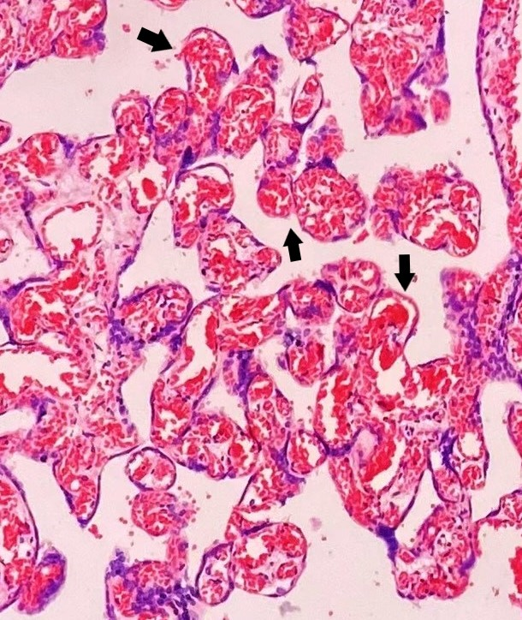

Figure-1: Capiller hypervascularity in terminal villus ,chorangiosis ( arrow) (HE x 40)

S-44 Case Presentation: Preeclampsia Developing In The Context Of Chronic Abruption-Oligohydramnios Sequence (Caos)
İsmail Aykut¹, Uğur Şen¹, Mehmet Özer¹
1 İzmir Tepecik Eah Kadın Hastalıkları ve Doğum

Abruptio placentae is defined as the separation of the placenta from the decidua before delivery. The incidence of abruptio placentae is approximately 3 to 10 per 1000 births. In cases of chronic abruption, the presence of oligohydramnios is referred to as 'Chronic Abruption-Oligohydramnios Sequence (CAOS)'. In patients with CAOS, there is an increased risk of developing preeclampsia, preterm birth, chorioamnionitis, low birth weight, chronic lung disease, and the need for mechanical ventilation. To increase awareness of chronic abruption-oligohydramnios sequence, we present a case in which a patient presented with vaginal bleeding, and preeclampsia developed in the setting of chronic abruption placenta, oligohydramnios, and abnormal Doppler findings.
Keywords: chronic abruption , oligohyroamnios , preeclampsia
INTRODUCTION
Abruptio placenta, defined as the separation of the placenta from the decidua before birth. The incidence of abruptio placenta is approximately 3 to 10 per 1000 births (1,2). The early detachment of the placenta is due to bleeding in the basal decidua. Bleeding can start with the rupture of arterial vessels in the decidua and progress to hematoma formation. In cases of arterial bleeding, the placenta can detach almost completely, leading to serious maternal and fetal adverse outcomes. In chronic abruption, poorly developed early spiral arteries lead to decidua necrosis, placental inflammation, infarction, and consequently, venous bleeding in the placenta. In chronic abruption, bleeding usually self-limits. Intermittent, mild bleeding, oligohydramnios, and intrauterine growth restriction can be observed. Oligohydramnios accompanying chronic abruption cases is referred to as 'Chronic Abruption-Oligohydramnios Sequence (CAOS)' (3). CAOS increases the risks of intrauterine growth restriction, preeclampsia, and early membrane rupture (4). As a result, it has a poor prognosis due to serious neonatal morbidity and mortality caused by preterm birth (3,5).

CASE
A 26-year-old, G1P0 (Gravida 1, Para 0) patient at 27+0 weeks gestation according to her last menstrual period presented to our center with vaginal bleeding in the form of spotting. The patient's pregnancy follow-ups have not been regular, and there is no known medical history or surgical history.

On initial evaluation, the patient's general condition is good, blood pressure is 140/75 mmHg, heart rate is 78 beats per minute, and temperature is 36.4°C. Her abdomen is comfortable, with no signs of guarding or rebound tenderness. There is no fundal tenderness. Obstetric ultrasound revealed a single intrauterine fetus with positive fetal cardiac activity. Fetal measurements indicate a gestational age of BPD: 23+0, HC: 23+2, AC: 22+6, FL: 30+0, and an estimated fetal weight of 450 grams. Amniotic fluid index (AFI) measures 50 mm. The placenta is noted to be larger than normal and fundally located, with an area that could be consistent with a retroplacental hematoma, but no evidence of placenta previa. Doppler examination showed end-diastolic flow reversal in the umbilical artery and a positive A wave in the ductus venosus. Vaginal examination revealed a 1 cm cervical dilation, and there were coagulated clots consistent with prior bleeding upon speculum examination.

Laboratory findings show hemoglobin (HGB) at 11.3 g/dL, white blood cell count (WBC) at 11.1 x10³/uL, platelet count (PLT) at 308 x10³/uL, alanine aminotransferase (ALT) at 10 U/L, aspartate aminotransferase (AST) at 16 U/L, C-reactive protein (CRP) at 3 mg/L, and fibrinogen at 280 mg/dL. No drainage was observed. The patient was admitted to our service for monitoring purposes.

The patient was started on betamethasone 6 mg 2x2 therapy, with vital sign and pediatric follow-up every 6 hours, and a planned 24-hour urine collection. Due to blood pressure readings of 155/80, 140/80, and 140/90 on the second day of hospitalization, alpha-methyldopa 250 mg 3x1 therapy was initiated. On the second day of hospitalization, blood pressure readings were 160/90 and 150/90, and laboratory findings showed HGB: 10.6 g/dL, WBC: 14.1 x10³/uL, PLT: 238 x10³/uL, ALT: 82 U/L, AST: 142 U/L, CRP: 5.5 mg/L, and fibrinogen: 225 mg/dL. A control ultrasound revealed a retroplacental hematoma measuring 50x35 mm, with Doppler examination showing end-diastolic flow reversal and a positive A wave in the ductus venosus. The patient received 4 grams of magnesium sulfate (MgSO4) as a loading dose, and then a continuous infusion of 1.5 grams per hour was started, while the alpha-methyldopa dose was changed to 3x2.

On the fourth hour of monitoring, the patient reported an increase in bleeding. A follow-up examination revealed active leakage from the cervix. Blood pressure readings were 140/90, 150/85, 140/95, and 160/90, with normal respiratory rate and pulse rate. The patient exhibited bilateral positive deep tendon reflexes. Control laboratory results showed HGB: 9.3 g/dL, WBC: 16.3 x10³/uL, PLT: 145 x10³/uL, ALT: 134 U/L, AST: 263 U/L, CRP: 12 mg/L, and fibrinogen: 118 mg/dL. Control ultrasound showed progression of the retroplacental hematoma to 90x65 mm, with intermittent retrograde flow observed in the umbilical artery on Doppler examination. The family was informed about the situation, and a decision was made to proceed with a cesarean section due to severe preeclampsia and abnormal Doppler findings. It was planned to administer 2 grams of fibrinogen during the cesarean section. A 412-gram male infant was delivered with a head presentation. Brownish amniotic fluid was observed, and the placenta had areas of necrosis. The placenta was sent for pathology examination. The infant was evaluated with an Apgar score of 2 at 1 minute and subsequently intubated. Postoperatively, MgSO4 maintenance therapy was continued. Postoperative laboratory evaluation showed HGB: 8.6 g/dL, WBC: 17.1 x10³/uL, PLT: 150 x10³/uL, ALT: 114 U/L, AST: 215 U/L, CRP: 20 mg/L, magnesium (Mg): 5.5 mg/dL, and fibrinogen: 225 mg/dL. Blood pressure readings ranged from 125-140/70-80 during follow-up. On the first postoperative day, the patient's general condition was stable, vital signs were normal, uterine involution was appropriate, and bowel movements were present. Laboratory results showed HGB: 9.1 g/dL, WBC: 14.1 x10³/uL, PLT: 178 x10³/uL, ALT: 63 U/L, AST: 70 U/L, CRP: 18 mg/L, magnesium (Mg): 2.8 mg/dL, and fibrinogen: 320 mg/dL. On the third postoperative day, vital signs remained stable, blood pressure readings were within the normal range, and laboratory findings showed an improving AST/ALT trend, returning to normal limits. As a result, the patient was discharged in good health.
CONCLUSIONS
Similar to our case, Chronic Abruption-Oligohydramnios Sequence (CAOS) is generally a condition seen in the second trimester and carries a poor prognosis. Prolonged venous bleeding results in the development of subchorionic hematoma, separating the amnion and chorion from the decidua, disrupting blood flow to the amnion and chorion. Insufficient perfusion of the amnion and chorion can lead to chorioamnionitis and early membrane rupture (6). Pathological examination of the placenta may reveal chronic deciduitis, decidual necrosis, placental infarcts, thrombosis, and hemosiderin accumulation (7). Inadequate placental function can result in impaired fetal renal perfusion, leading to oligohydramnios (8). In patients with CAOS, the average gestational age at birth has been found to be 28.1 +/- 4.5 weeks (3). Patients with CAOS are at increased risk of developing preeclampsia, preterm birth, chorioamnionitis, low birth weight, chronic lung disease, and the need for mechanical ventilation (4,5). Patients presenting with recurrent vaginal bleeding, as in our case, should be carefully evaluated, associated pathologies should be identified, and vigilant and careful management should be provided during follow-up.

REFERENCES
- Maeland KS, Morken NH, Schytt E, et al. Placental abruption in immigrant women in Norway: A population-based study. Acta Obstet Gynecol Scand 2021; 100:658.
- Lueth A, Blue N, Silver RM, et al. Prospective evaluation of placental abruption in nulliparous women. J Matern Fetal Neonatal Med 2022; 35:8603.
- Elliott JP, Gilpin B, Strong TH Jr, Finberg HJ. Chronic abruption-oligohydramnios sequence. J Reprod Med 1998; 43:418.
- Rasmussen S, Irgens LM, Dalaker K. A history of placental dysfunction and risk of placental abruption. Paediatr Perinat Epidemiol 1999; 13:9.
- Kobayashi A, Minami S, Tanizaki Y, et al. Adverse perinatal and neonatal outcomes in patients with chronic abruption-oligohydramnios sequence. J Obstet Gynaecol Res 2014; 40:1618.
- Harris BA Jr. Peripheral placental separation: A review. Obstet Gynecol Surv 1988; 43: 577–581.
- Elsasser DA, Ananth CV, Prasad V, et al. Diagnosis of placental abruption: relationship between clinical and histopathological findings. Eur J Obstet Gynecol Reprod Biol 2010; 148:125.
- Shenker L, Reed KL, Anderson CF, Borjon NA. Significance of oligohydramnios complicating pregnancy. Am J Obstet Gynecol 1991; 164: 1597–1599.

S-45 Sol Over Torsiyonu ve Sağ Over Dermoid Kisti Bulunan Olgunun Yönetimi
Feden Kübra Özdilek Kırçiçeği¹,Kaan Öztürk¹, Oktay Akgün¹
1 İzmir Tepecik Eğitim ve Araştırma Hastanesi

Acil servise başvuran ve yapılan fiziki muayenede akut karın bulguları saptanan kadınlarda, her yaş grubu için ayırıcı tanıda over torsiyonu düşünülmelidir. Ancak kesin tanıyı koymak, over torsiyonunun belirtilerinin özgün olmaması nedeniyle her zaman çok kolay olmamaktadır. Doğru ve erken tanı koymak, özellikle genç yaştaki hastalarda overin kurtarılması ve ilerleyen yıllarda fertilitenin korunması açısından önemlidir. Kliniğimiz acil servisine yaklaşık 3 gün önce başlayan karın ağrısı şikayetiyle başvuran 22 yaşındaki virgo hasta değerlendirildi. Hasta ağrının 3 gün önce başladığını, ara ara gerilediğini ancak başvuru gününde şiddetlendiğini belirtti. Bilinen ek hastalık ve operasyon öyküsü bulunmayan hastanın yapılan fizik muayenesinde batında yaygın hassasiyet, sol alt kadranda istemli defansı mevcuttu. Yapılan suprapubik ultrasonda sol over boyutları artmış 109x94x110 mm, içerisinde 55x42x44 mm hemorajik kist ile uyumlu alan izlendi. Korteks ve medulla ayrımı yapılamamış olup vasküler akım kodlanmadı. Sağ over 78x65x85mm içerisinde yaklaşık 54x40mm dermoid kist ile uyumlu heterojen hiperekojen kitle lezyonu izlendi. Douglas’ta serbest mai izlenmedi. Hastaya tanısal laparotomi planlandı. Yapılan batın gözleminde sol tuba ve sol over normalden iri yaklaşık 8cm büyüklükte ve 3 tur torsiyone izlendi. Sağ overde yaklaşık 5cm dermoid kist ile uyumlu görünüm izlendi. Sol over ve tuba detorsiyone edildi. Sol over kanlanmasının tekrar başladığı görüldü. Sol overdeki hemorajik kist wedge rezeksiyon ile eksize edildi. Sağ overde kist lojuna girilerek kistektomi yapıldı. 1 hafta sonra kontrol pelvik ultrasonda sol over boyutları 50x40x40 mm, sağ over boyutları 30x32x35 mm boyutlarında ve her iki over vasküler kodlanma olağan izlendi.Nihai Patoloji sonucunda sağ over kistetektomi materyali matür kistik teratom, sol over materyali torsiyona bağlı hemorajik infarktüs olarak raporlandı. Hastanın aylık ultrason kontrollerine devam edildi. Kontrollerde patolojik bulgu saptanmadı. Over ve adneks torsiyonlarının acil müdahalesi özellikle üreme çağındaki kadınlarda önemlidir. Klinik bulgular nonspesifik olmakla beraber cerrahi öngörü ve klinik şüphe tanı için en önemli birinci basamaktır. Cerrahi tedavide organ koruyucu yaklaşımlar olabildiğince ilk seçenek olmalıdır.
Anahtar Kelimeler: Over Torsiyonu, Dermoid Kist, Abdominal Ağrı
GİRİŞ
Acil servise başvuran ve yapılan fiziki muayenede akut karın bulguları saptanan kadınlarda, her yaş grubu için ayırıcı tanıda over torsiyonu düşünülmelidir. Ancak kesin tanıyı koymak, over torsiyonunun belirtilerinin özgün olmaması nedeniyle her zaman çok kolay olmamaktadır. Doğru ve erken tanı koymak, özellikle genç yaştaki hastalarda overin kurtarılması ve ilerleyen yıllarda fertilitenin korunması açısından önemlidir (1). Overin destek aldığı ligamentlerin etrafında dönmesi ile ortaya çıkan over torsiyonu her yaş grubunda karşılaşılabilecek jinekolojik acil bir durumdur. İnfundibulopelvik ligamentin kendi etrafında dönmesi sonucu arterial, venöz ve lenfatik akım engellenir. Engellenen venöz ve lenfatik akım sonucu overde ödem gelişir ve gelişen ödem zaten azalmış olan arterial akım üzerine daha da azaltır. Arterial akımdaki azalma iskemiye yol açar ve iskemi sonucu nekroz, infarkt ve lokal hemoraji oluşur. Nekroza giden over dokusu fonksiyonunu kaybeder ve zaman içerisinde involüsyona uğrar. Erişkinlerde, over torsiyonu görülen vakaların % 50-80’inde fonksiyonel kist ya da neoplastik kist ile karşılaşılmaktadır.(2, 3)

Yöntem

Kliniğimiz acil servisine yaklaşık 3 gün önce başlayan karın ağrısı şikayetiyle başvuran 22 yaşındaki virgo hasta değerlendirildi. Hasta ağrının 3 gün önce başladığını, ara ara gerilediğini ancak başvuru gününde şiddetlendiğini belirtti. Bilinen ek hastalık ve operasyon öyküsü bulunmayan hastanın yapılan fizik muayenesinde batında yaygın hassasiyet, sağ alt kadranda istemli defansı mevcuttu.

Bulgular
Yapılan laboratuvar tetkiklerinde Hemoglobin 11.7 g/dl Beyaz Küre 6.000 , CRP 122 mg/L, karaciğer fonksiyon testleri ve böbrek fonksiyon testleri olağan, CA-125 42.6, Beta Hcg değeri negatifti. Vital bulguları stabil olarak değerlendirildi.
Yapılan suprapubik ultrasonda sol over boyutları artmış 109x94x110 mm, içerisinde 55x42x44 mm hemorajik kist ile uyumlu alan izlendi. Korteks ve medulla ayrımı yapılamamış olup vasküler akım kodlanmadı. Sağ over 78x65x85mm içerisinde yaklaşık 54x40mm dermoid kist ile uyumlu heterojen hiperekojen kitle lezyonu izlendi. Douglas’ta serbest mai izlenmedi.
Hastaya mevcut bulgular ile operasyon önerildi. Hastaya tanısal laparotomi planlandı. Pfannenstiel insizyon ile yapılan batın gözleminde sol tuba ve sol over normalden iri yaklaşık 8cm büyüklükte ve 3 tur torsiyone izlendi. Sağ overde yaklaşık 5cm dermoid kist ile uyumlu görünüm izlendi. Sol over ve tuba detorsiyone edildi. Sol over kanlanmasının tekrar başladığı görüldü. Sol overdeki hemorajik kist wedge rezeksiyon ile eksize edildi. Sağ overde kist lojuna girilerek kistektomi yapıldı. Kist materyali frozena gönderildi. Frozen sonucu dermoid kist ile uyumlu olarak bildirildi. Operasyona son verildi.

Hastanın post-operatif 2. Gün suprapubik ultrasonunda sol over boyutu 70x50x50 mm boyutlarında, parankimde parsiyel vasküler akım izlendi. Sağ 40x30x45 mm boyutlarında izlendi.Douglas’ta serbest mai izlenmedi. Genel durumu iyi, ek şikayeti olmayan hasta post operatif 2.günde taburcu edildi. 1 hafta sonra kontrol pelvik ultrasonda sol over boyutları 50x40x40 mm, sağ over boyutları 30x32x35 mm boyutlarında ve her iki over vasküler kodlanma olağan izlendi.Nihai Patoloji sonucunda sağ over kistetektomi materyali matür kistik teratom, sol over materyali torsiyona bağlı hemorajik infarktüs olarak raporlandı. Hastanın aylık ultrason kontrollerine devam edildi. Kontrollerde patolojik bulgu saptanmadı.
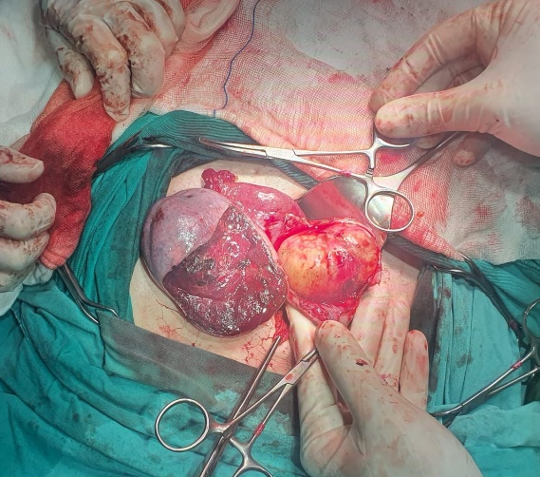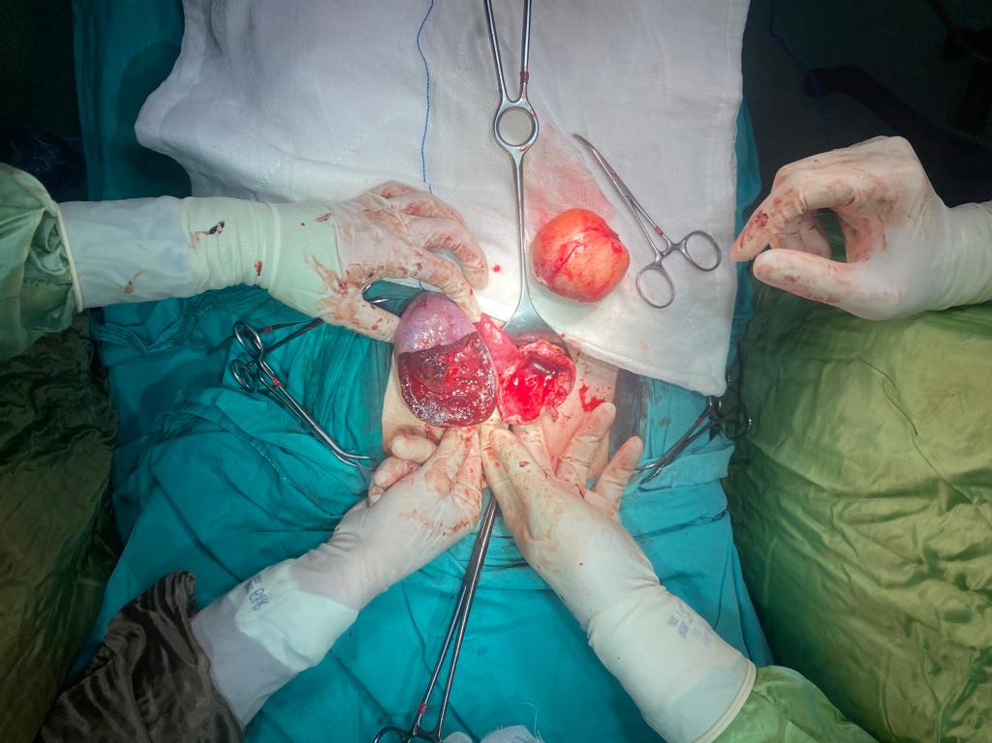
Şekil 1 : Torsiyone sol over ve sağ over dermoid kist Şekil 2 : Kistektomi sonrası sol ve sağ over

.

SONUÇ VE TARTIŞMA
Over ve adneks torsiyonlarının acil müdahalesi özellikle üreme çağındaki kadınlarda önemlidir. Klinik bulgular nonspesifik olmakla beraber cerrahi öngörü ve klinik şüphe tanı için en önemli birinci basamaktır. Cerrahi tedavide organ koruyucu yaklaşımlar olabildiğince ilk seçenek olmalıdır.

KAYNAKÇA
AMA (American Medical Association) yazım kuralı
- Bayer AI, Wiskind AK. Adnexal torsion: can the adnexa be saved. Am J Obstet Gynecol 1994;171(16):1506–11.
- 2. Nichols DH, Julian PJ. Torsion of the adnexa. Clin Obstet Gynecol 1985;282(2):375-80.
- Warner MA, Fleischer AC, Edell SL, et al. Uterine adnexal torsion: sonographic findings. Radiology 1985;154(3):773-5.

S-46 Hpv Frequency, Types And Cytology Results In Women Between 2017 And 2021 In Kahramanmaras
Kemal Hansu¹
1 Kahramanmaraş Sütçü İmam Üniversitesi Tıp Fakültesi Kadın Hastalıkları ve Doğum Anabilim Dalı

Objective: Evaluation with cervical cytology results by determining the distribution of high-risk HPV types after HPV screenings performed in Kahramanmaraş Province Cancer Early Diagnosis and Screening Training Center Methods: The study included 36420 women between the ages of 30-65, who applied to Cancer Early Diagnosis and Screening Education Centers (KETEM) between January 2017 and December 2021 in Kahramanmaraş and had HPV DNA test done. HPV typing was performed on women with positive HPV test, and patients with high risk HPV type were referred to secondary and tertiary healthcare institutions and smear test was performed. Results: HPV screening test result was positive in 1420 of 36420 women who were screened for HPV (3.89%). 74 sample results were reported as insufficient material (0.2%). HPV typing of the patients with positive results was performed; The most frequently isolated HPV type was 16 (21.9%). When the results of HPV positive women were examined; Cervical cytology was normal in 701 (49%) cases, cervical infection was reported in 378 (26.6%) cases, and the results of 212 (15%) patients were reported as insufficient material. Cervical cytology result of 81 (5.7%) patients is ASC-US, 7 (0.49%) patients are ASCH, 36 (2.5%) patients are LSIL, 2 (0.14%) patients are HSIL, and 3 (0%) ,21) patients had AGC. AIS was not observed in any patient. Conclusion: HPV prevalence and genotype distribution seem to be regionally variable. Cervical cancer is a disease that can be prevented with appropriate screening programs, vaccination and early treatment. Participation in screening programs should also be increased in our region and the rate of vaccination should be increased.
Keywords: pap smear, cervical cytology, human papillomavirus,HPV screening program

S-47 34 Weeks Gestation With Unicornuate Uterus And Associated Ectopic Kidney Case Report
Mehmet Bölükbaşı¹, Pınar Tuğçe Özer², Ozan Odabaş¹
1 Sbü Tepecik Eğitim ve Araştırma Hastanesi Kadın Hastalıkları Ve Doğum
2 Kemalpaşa Devlet Hastanesi Kadın Hastaları ve Doğum Kliniği

Patients with congenital uterine anomalies are at an increased risk of having renal, skeletal, or abdominal wall abnormalities, or a history of inguinal hernias. Renal anomalies are found in 20 to 30 percent of patients with Müllerian defects. The three primary mechanisms for abnormal uterine development are agenesis/hypoplasia, defective lateral fusion, and defective vertical fusion. Ultrasonography, hysterosalpingography, and magnetic resonance imaging can be used in the diagnosis of congenital uterine anomalies, with magnetic resonance imaging being the gold standard. Our patient, a 33-year-old woman, gravida 4, parity 1, with a history of 2 abortions, and her last menstrual period occurring 34 weeks and 2 days prior, presented to our hospital with complaints of labor pains. During NST follow-up, the patient exhibited 60 Montevideo units with 2 contractions in 10 minutes. When the patient's contractions did not subside and recurrent decelerations were observed during follow-up, a cesarean section was performed based on indications of oligohydramnios, previous cesarean section with pain, and cerclage pregnancy. During the cesarean section, a right unicornuate uterus, a left ovary adherent to the lateral abdominal wall, and a left kidney ectopic in the left lower quadrant were observed. The right ovary and right salpinges appeared normal, while no left salpinges were observed. Additionally, there was no cavity associated with the left rudimentary horn of the uterus. Unicornuate uterus patients are at higher risk for endometriosis, preterm labor, and breech presentation, and particularly, renal anomalies with a 40 percent incidence rate. In our case, the left kidney was ectopic in the left lower quadrant. In conclusion, patients with a unicornuate uterus have an increased risk of preterm delivery, ectopic pregnancy, and endometriosis, and it is recommended to investigate for ectopic renal locations. In patients with a unicornuate uterus associated with a rudimentary horn, removal of the rudimentary horn is recommended.
Keywords: unicornuate uterus, pregnancy, ectopically located kidney
INTRODUCTION

Congenital uterine anomalies can lead to symptoms such as pelvic pain, abnormal bleeding at menarche, recurrent pregnancy loss, or preterm birth. These anomalies can be identified in patients, including adolescents, presenting with these disorders. Some may be suspected due to findings on physical examination, such as a longitudinal vaginal septum, while others may be detected during imaging studies for infertility, nonreproductive organ symptoms, or trauma. The American Society for Reproductive Medicine's classification system for Müllerian defects, adopted in 2021, emphasizes congenital uterine anomalies and associated anomalies of the vagina, cervix, fallopian tubes, and renal system. It utilizes descriptive terminology instead of the previous numerical system. This terminology includes müllerian agenesis, cervical agenesis, unicornuate uterus, uterus didelphys, bicornuate uterus, septate uterus, longitudinal vaginal septum, transverse vaginal septum, and other complex anomalies.

Patients with congenital uterine anomalies are at an increased risk of having renal, skeletal, or abdominal wall abnormalities, or a history of inguinal hernias, and vice versa. Renal anomalies are found in 20 to 30 percent of patients with Müllerian defects. For instance, duplex collecting systems, horseshoe kidneys, pelvic kidneys, and unilateral renal agenesis have been associated with obstructed hemiuteri, obstructed hemivaginas, and transverse vaginal septa. Typically, a renal anomaly is ipsilateral to the congenital uterine anomaly. The prevalence of congenital uterine anomalies was 5.5 percent in an unselected population, 8 percent in infertile patients, 12.3 percent in patients with a history of miscarriage, and 24.5 percent in patients with miscarriage and infertility.

The underlying etiology for abnormal uterine development is not well understood but is likely related to polygenic and multifactorial causes. Patients with uterine anomalies usually have a normal karyotype (46,XX). The three main mechanisms for abnormal uterine development are agenesis/hypoplasia, defective lateral fusion, and defective vertical fusion. Ultrasonography, hysterosalpingography, and magnetic resonance imaging can be used for diagnosing congenital uterine anomalies, with magnetic resonance imaging being the gold standard.

CASE

Our patient, a 33-year-old woman, gravida 4, parity 1, with a history of 2 abortions, and her last menstrual period occurring 34 weeks and 2 days prior, presented to our hospital with complaints of labor pains. An obstetric ultrasonographic evaluation revealed an intrauterine single fetus with fetal heartbeat, head presentation, anterior placenta, and an amniotic fluid index (AFI) of 46 mm. Antenatal measurements were as follows: BiParietal Diameter (BPD): 34+4 weeks, AC 34+2 weeks, FL 34+3 weeks, Umbilical arterial s/d ratio: 2.68, and pulsatile index: 0.77. In a speculum examination, a cerclage rope was observed, and there was no active vaginal bleeding. Vaginal examination indicated dilatation with no cervical effacement. The patient had previously been under perinatology care and had undergone a cerclage procedure at 16 weeks of pregnancy due to cervical insufficiency.

During NST follow-up, the patient exhibited 60 Montevideo units with 2 contractions in 10 minutes. Her blood pressure was 123/75 mmHg, pulse rate was 78/minute, and her temperature was 36.20°C. Laboratory findings included Hb 12.9, leukocyte 11300, platelet 205000, and fibrinogen 596. The patient was then transferred to our delivery room service, where hydration treatment and continuous NST monitoring were initiated. However, the patient's labor did not regress, and recurrent decelerations were observed, leading to a decision for a cesarean section based on indications of oligohydramnios, painful previous cesarean section, and cerclage pregnancy.

During the cesarean section, a right unicornuate uterus, a left ovary adherent to the lateral abdominal wall, and a left kidney ectopic in the left lower quadrant were observed. The right ovary and right salpinges appeared normal, while no left salpinges were observed, and there was no cavity associated with the left rudimentary horn of the uterus. A 2144-gram live baby girl was delivered through a transverse incision in the lower segment with a basal 1-minute Apgar score of 7. Following the cesarean section, the cerclage rope was appropriately managed. Postoperative laboratory values showed Hb 12.4, leukocyte 16700, and platelet 157000.

On postoperative day 2, our patient became hemodynamically and clinically stable. She was informed about her unicornuate uterus and ectopic kidney placement and discharged with recommendations for urology and gynecologic follow-up after 6 weeks.

DISCUSSION

In the unicornuate uterus, a cavity is usually normally associated with the fallopian tube and cervix, while the failed Müllerian duct may have various configurations. It may not develop at all or only partially develop as a primitive horn or an anlage (a cluster of embryonic cells) on the uterus. This horn (or anlage) may or may not communicate with the uterus. In our case, the affected Müllerian duct did not develop at all. Diagnosis is typically made by ultrasound showing a uterus deviated to one side of the pelvis; 3-D reconstructed images are particularly useful. Care should be taken to assess the presence of a non-communicating or rudimentary horn. In complicated cases where surgical removal of the rudimentary horn is considered, MRI may help in surgical planning.

Patients with a unicornuate uterus are at higher risk for endometriosis, preterm labor, and breech presentation. A review of pregnancy outcomes in patients with unicornuate uteri reported rates of obstetric complications: 2.7 percent ectopic pregnancy, 24.3 percent first-trimester abortion, 9.7 percent second-trimester abortion, 20.1 percent preterm birth, 3.8 percent fetal demise, and 51.5 percent live births. Unicornuate uterus is associated with renal anomalies, particularly at a high rate of 40 percent. In our case, the left kidney was ectopic in the left lower quadrant. Patients with unicornuate uteri are not usually candidates for reconstructive procedures to improve pregnancy outcomes, as this anomaly is typically associated with favorable pregnancy outcomes. However, rudimentary horns that do not communicate with the endometrium are sometimes surgically removed to prevent ectopic pregnancies.

In conclusion, patients with a unicornuate uterus have an increased risk of preterm delivery, ectopic pregnancy, and endometriosis. Investigating ectopic renal locations is recommended in these cases. For patients with a unicornuate uterus associated with a rudimentary horn, removal of the rudimentary horn is recommended.

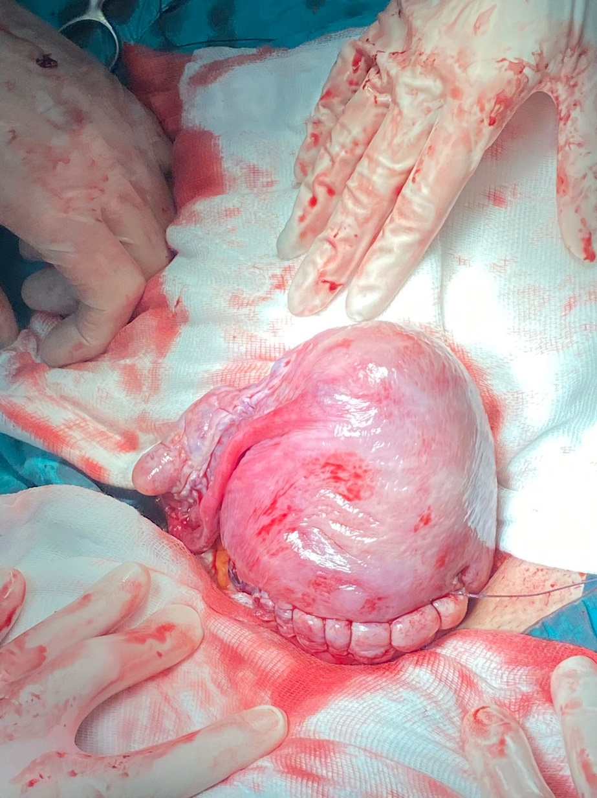
Sağ unicornuat uterus
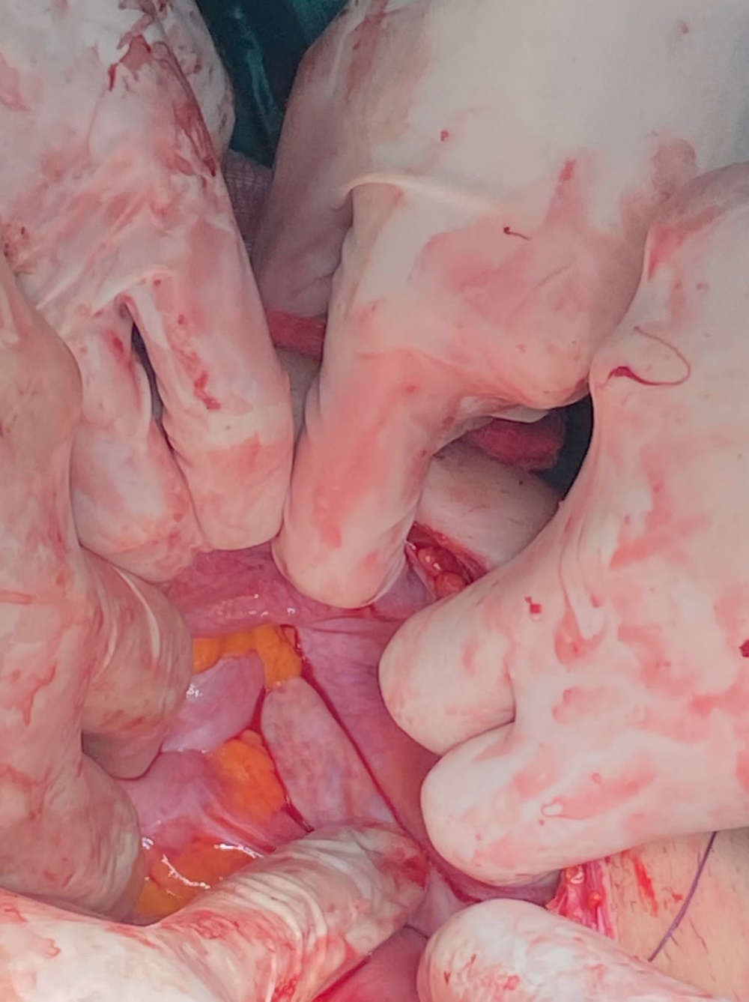
Sol batın yan duvarına yapışık over

REFERENCES
1. Crowther ME. Unicornuate uterus. Int J Gynaecol Obstet. 1991;34(3):281-284. doi:10.1016/0020-7292(91)90365-c
2. Passos IMPE, Britto RL. Diagnosis and treatment of müllerian malformations. Taiwan J Obstet Gynecol. 2020;59(2):183-188. doi:10.1016/j.tjog.2020.01.003
3. Khati NJ, Frazier AA, Brindle KA. The unicornuate uterus and its variants: clinical presentation, imaging findings, and associated complications. J Ultrasound Med. 2012;31(2):319-331. doi:10.7863/jum.2012.31.2.319

S-48 Differentiation Of Healthy Blood, Diseased Blood, Bloody Jaw Cysts And Urine By Line Widths Of High Field Nmr Peaks
Mehmet Nafi Sakar¹, Mehmet Zafer Koylu², Utku Nezih Yılmaz³
1 Department Of Obstetrics And Gynecology, Faculty Of Medicine, Istanbul, Turkey
2 Faculty Of Science, Dicle University, Diyarbakir, Turkey
3 Department Of Oral-Maxillofacial Surgery, Faculty Of Dentistry, Dicle University, Diyarbakir, Turkey

Purpose: Line width studies of high field Nuclear Magnetic Resonance (NMR) peaks have been seen more frequently in the recent literature. The aim of this study was to compare NMR line-widths of HOD peaks in healthy blood, cancerous blood, diabetic blood and bloody jaw cysts. The line widths of urine samples from the same individuals were also compared. Methods: In this study, the blood and urine of 29 cancer patients, 17 diabetic patients, 28 healthy volunteers and 20 bloody jaw cysts were collected. Mixtures were prepared by adding 0.02 mL sample to 0.98 mL D2O. Single pulse proton NMR measurements were performed at 400 MHz and line widths were obtained from half-height of the HOD (semi water) peak. Results: Statistical evaluations show that the mean line width of cancerous blood is different from normal blood (P=0,032) but the mean line width of diabetic blood is not different from normal blood (p=0.072). Other groups are completely different (p<0.05). Similar results were found for urine groups. Line widths exhibit poor correlation width each of albumin and total protein (the coefficient of determination, R2, around 0.3). Poor correlation was also found between some biochemical parameters and line widths of diseased samples. The HOD molecules reducing spin-spin relaxation (T2) distribution range of each group is responsible from the reduced overlap between groups. Conclusion: Present data suggest that comparison of healthy and diseased body fluids can be made by line width measurements of the HOD NMR peak in the high Field. These results may lead to new research in MRI.
Keywords: NMR, line width, blood, urine, cyst

S-49 Successful Microwave Ablation In The Treatment Of Twin Reversed Arterial Perfusion (Trap) Sequence
Mehmet Özer¹
1 Sağlık Bilimleri Üniversitesi, Tepecik Eğitim ve Araştırma Hastanesi, Kadın Hastalıkları ve Doğum Perinatoloji Kliniği

ABSTRACT The Twin Reversed Arterial Perfusion (TRAP) sequence is found in roughly 2.6% of monochorionic twin pregnancies and 0.01% of all pregnancies. Historically, rates reported were 0.003% for all pregnancies and 1% for monochorionic twins. With modern advances in obstetric ultrasound and assisted reproductive technologies, these figures are thought to be higher. Contrary to its name, the TRAP sequence is seldom observed in monochorionic triplets or other higher-order gestations. In TRAP scenarios, the pump twin retains standard fetal circulation, but retrograde deoxygenated blood flow is established to its co-twin through arterio-arterial anastomoses. A 23-year-old G5P2Y2A2 (NSD) patient was referred to the Tepecik Training and Research Hospital's perinatology clinic. Without any known comorbidities and no regular medications, the patient's diagnosis was made via ultrasonographic evaluation. At the 18th week of gestation, a microwave ablation technique was applied to impede blood flow to the acardiac fetus. Initial ultrasonographic findings revealed a positive heartbeat in the primary fetus (CRL:60 mm, 12 weeks + 4 days) and an absence of cardiac activity in the secondary fetus, which displayed only a torso and lower extremities. An assessment at the 18th gestation week showed unchanged characteristics for the second fetus, while the primary fetus continued regular development. Following an abdominal microwave ablation intervention on the umbilical vein of the acardiac fetus at this same gestation week, halted blood flow to the acardiac fetus was verified via ultrasound. In pregnancies, techniques such as microwave ablation are employed for the occlusion of vascular anastomoses and selective fetal reduction. Following a diagnosis of the TRAP sequence, due to the evidence suggesting superior outcomes with the occlusion of the acardiac twin's cord compared to passive observation, patient referral to specialized centers is recommended.
Keywords: acardiac fetus, microwave ablation, TRAP sequence, twin pregnancy
INTRODUCTION
The Twin Reversed Arterial Perfusion (TRAP) sequence is a rare monochorionic twin pregnancy complication where one fetus, termed "acardiac twin", lacks a functional heart and is retrogradely perfused by its sibling. TRAP sequence is observed in approximately 2.6% of monochorionic twin pregnancies and 0.01% of all pregnancies ¹. The pump twin, bearing the perfusion load for itself and its acardiac co-twin, is at risk for high-output heart failure, evidenced by cardiomegaly, polyhydramnios, and possible hydrops fetalis ^{2,3}. Despite its name implying twins, the TRAP sequence is rarely seen in monochorionic triplets or higher-order multiple pregnancies. In TRAP, while the pump twin maintains the regular fetal circulatory pattern, retrograde deoxygenated blood flow to its co-twin is facilitated through arterio-arterial anastomoses ^{3–5}. In this study, we present the treatment of a patient diagnosed with the TRAP sequence.

METHOD
The patient was referred from an external center to Tepecik Training and Research Hospital's perinatology clinic. The patient, a 23-year-old woman, came with a medical history denoted as G5P2Y2A2 (NSD), highlighting her previous obstetric experiences and outcomes.
On initial assessment, the patient's overall health status appeared stable. She had no reported additional illnesses or comorbidities, which is essential in determining the possible risk factors and intervention strategies. Furthermore, her medication history was reviewed, revealing that she was not on any regular medications, eliminating potential drug-related influences on the fetal conditions.
For diagnostic clarity, a comprehensive ultrasonographic assessment was conducted. This advanced imaging technique provided detailed insights into the intrauterine environment, enabling the medical team to understand the condition of both fetuses. It was through this ultrasonographic evaluation that the presence of the Twin Reversed Arterial Perfusion (TRAP) sequence became evident, underscoring the need for specialized intervention.
Based on the diagnosis and the associated risks of the TRAP sequence, a decision was made to intervene at the crucial juncture of the 18th week of pregnancy. A microwave ablation technique was selected as the preferred method of intervention. This invasive procedure was aimed specifically at halting the blood flow to the acardiac fetus, thus aiming to prevent further complications for both the healthy twin and the mother.

RESULTS
In the initial ultrasound assessment, the examination provided vital insight into the condition of both fetuses. The first fetus exhibited positive heartbeats, suggesting a healthy circulatory and cardiac function (CRL:60 mm, 12 weeks + 4 days) (Figure 1). The second fetus was observed as acardiac (Figure 2). Additionally, only its torso and lower extremities were present. We confirmed the diagnosis by demonstrating through the umbilical artery color and spectral Doppler interrogation that the blood in the acardiac fetus flows toward its body rather than away from it.
By the 18th week of pregnancy, a subsequent evaluation was conducted. The first fetus continued on its path of normal development, manifesting all typical features expected at this gestational age. The second fetus was observed to increase in size between the 12th and 18th weeks.
To address the condition, an innovative approach was adopted. At the 18th week, a microwave ablation procedure was performed. This intervention, targeted abdominally on the umbilical vein, aimed to interrupt the blood supply leading to the acardiac fetus. Following this procedure, a follow-up ultrasound was immediately performed. In the umbilical vessels of the acardiac twin, absence of blood flow was confirmed post-procedure and in subsequent ultrasound examinations via Doppler studies, indicating the procedure's success.
No complications related to the procedure occurred during or after the intervention. The patient was discharged after a one-day hospital stay.
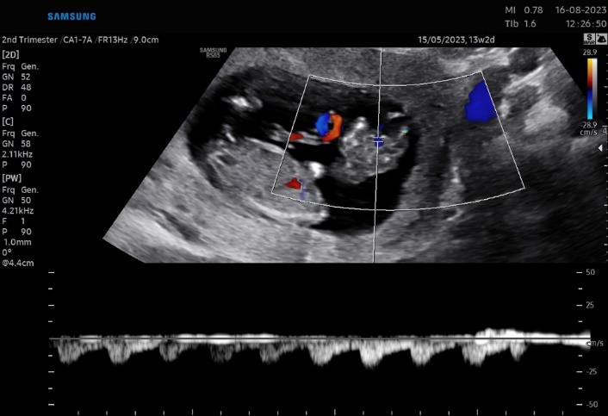
Figure 1: Doppler ultrasound imaging of the acardiac fetus and the healthy fetus.

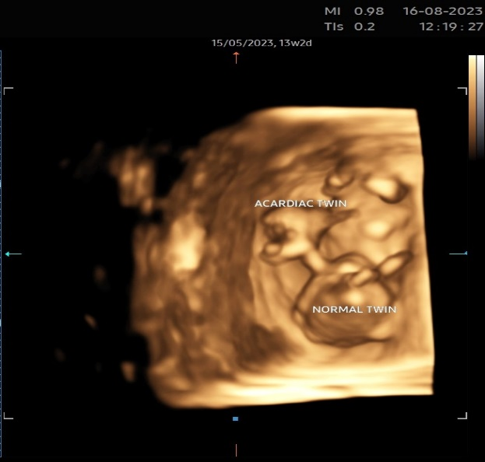
Figure 2: 3D ultrasound imaging of the acardiac fetus and the healthy fetus.

CONCLUSION AND DISCUSSION
Due to the presence of vascular anastomoses in these pregnancies, various techniques including fetoscopic ligation, laser coagulation, bipolar cord coagulation, radiofrequency ablation, and microwave ablation are employed in selective fetal reduction procedures ⁶⁻⁸. The use of microwave ablation has been determined to potentially be a viable approach in addressing the TRAP sequence by halting the blood supply to the acardiac fetus. After being diagnosed with the TRAP sequence, guiding patients to specialized centers with expertise in fetal diagnosis and intervention is advisable. Particularly in high-risk pregnancies, research indicates that blocking the acardiac twin's cord leads to more favorable results than adopting a passive observational strategy ⁹.

REFERENCES:
1. van Gemert MJC, van den Wijngaard JPHM, Vandenbussche FPHA. Twin reversed arterial perfusion sequence is more common than generally accepted. Birth Defects Res A Clin Mol Teratol. 2015;103(7):641-643. doi:10.1002/bdra.23405
2. Dhanju G, Breddam A. Twin reversed arterial perfusion (TRAP) sequence: A case report and a brief literature review. Radiol Case Rep. 2022;17(5):1682-1691. doi:10.1016/j.radcr.2022.02.057
3. Steffensen TS, Gilbert-Barness E, Spellacy W, Quintero RA. Placental pathology in trap sequence: Clinical and pathogenetic implications. Fetal Pediatr Pathol. 2008;27(1):13-29. doi:10.1080/15513810801893389
4. Pan P, Luo G, Tang L, et al. Monochorionic-Triamniotic Triplet Pregnancy Complicated by Twin Reversed Arterial Perfusion Sequence: Case Report and Literature Review. American Journal of Perinatology Reports. 2017;07(02):e106-e110. doi:10.1055/s-0037-1603917
5. van Gemert MJC, Ross MG, Nikkels PGJ, Wijngaard JPHM van den. Acardiac twin pregnancies part III: Model simulations. Birth Defects Res A Clin Mol Teratol. 2016;106(12):1008-1015. doi:10.1002/bdra.23559
6. j.1469-0705.1994.04050396.x.
7. Lee H, Wagner AJ, Sy E, et al. Efficacy of radiofrequency ablation for twin-reversed arterial perfusion sequence. Am J Obstet Gynecol. 2007;196(5):459.e1-459.e4. doi:10.1016/j.ajog.2006.11.039
8. Xie J, Cheng Z, Wu T, Wei Y, Wang X. Microwave ablation versus radiofrequency ablation for the treatment of severe complicated monochorionic pregnancies in China: Protocol for a pilot randomised controlled trial. BMJ Open. 2020;10(8). doi:10.1136/bmjopen-2019-034995
9. Mone F, Devaseelan P, Ong S. Intervention versus a conservative approach in the management of TRAP sequence: A systematic review. J Perinat Med. 2016;44(6):619-629. doi:10.1515/jpm-2015-0165

S-50 Metastatic Breast Signet Ring Cell Carcinoma Mimicking Peritonitis Carcinomatosa
Melis Özbilen¹, Hatice Kübra Can¹, Esra Keleş¹, Murat Api¹, Emre Mat¹
1 Kartal Dr Lütfi Kırdar Şehir Hastanesi

Signet-ring cell carcinoma is one of the rarest forms of adenocarcinoma that can arise from breast. Given their similar presentations and the extreme rarity of this unusual malignancy, it can be difficult to differentiate between peritonitisis carcinomatosa and SRCC.
Keywords: signet ring cell carcinoma, peritonitisis carcinomatosa, metastasis
Introduction: Signet ring cell carcinoma (SRCC) of the breast is very rare. Until 2003, SRCC was placed under ‘mucin-producing carcinomas’ and separated from other carcinomas by the World Health Organization (WHO). To date, only a few cases have been reported. Signet ring cell carcinoma of the breast despite advances in imaging methods is challenging to recognize preoperatively. We describe a rare case of metastatic breast signet ring cell carcinoma mimicking peritonitis carcinomatosis.

Case: A 42-year-old female, gravida 0, was referred to the department of gynecologic oncology. Transabdominal ultrasonography revealed an approximately 34mm left adnexal complicated cyst. A massive ascites was noted. Endoscopic ultrasound-guided fine needle aspiration of ascites showed acute and chronic inflammation with suspicious of malignancy She had an elevated cancer antigen (CA) 125 level of 228.0 U/mL and CA 15-3 level of 46.0 U/mL with normal complete blood count values. Gastrointestinal endoscopy and colonoscopy were normal. After obtaining written consent from the patient, exploratory laparoscopy was planned with a preliminary diagnosis of peritonitis carsinomatosa. There was a widespread miliary appearance intraperitoneally in the laparoscopic evaluation. The extensive pelvic peritoneal thickening, with multiple miliary peritoneal implants on the anterior abdominal wall were also present. Massive ascites was present. Laparoscopy-guided peritoneal biopsies and ascites sampling were performed. The definitive pathology resulted in signet ring cell carsinoma of breast.

Discussion: Signet-ring cell carcinoma is one of the rarest forms of adenocarcinoma that can arise from breast. Given their similar presentations and the extreme rarity of this unusual malignancy, it can be difficult to differentiate between peritonitisis carcinomatosa and SRCC.
Key Words: signet ring cell carcinoma, peritonitisis carcinomatosa, metastasis
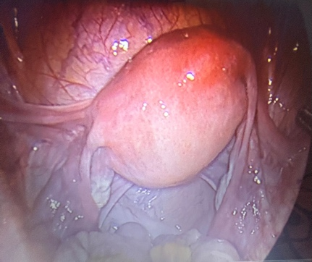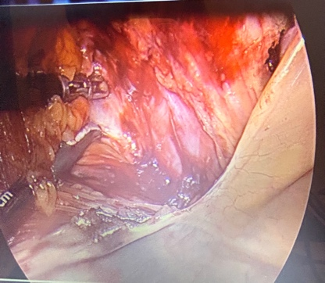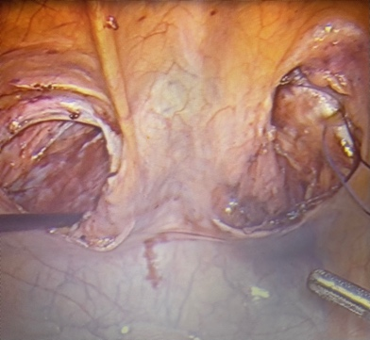

- https://actaoncologicaturcica.com/jvi.aspx?pdir=aot&plng=tur&un=AOT-64326
- https://dergipark.org.tr/tr/download/article-file/511893

S-51 Gerçek Doğal Siklus ile Yapılan Donma Çözme Embriyo Transferin Başarısını Araştırmak
Meltem Sönmezer¹
1 Özel Muayenehane, Ankara Ticaret Merkezi

Amaç: Donma çözme embriyo transfer sikluslarında gerçek doğal siklusun başarısını araştırmak amaçlanmıştır Materyal ve Yöntem : Bu retrospektif kohort analizde Ocak 2022 ile Temmuz 2023 tarihleri arasında gerçek doğal siklus ile yapılan donma çözme embriyo transferi yapılan 23 vaka değerlendirilmiştir. Gerçek doğal siklus embriyo transferinde hCG tetikleme ve luteal faz desteği kullanılmamıştır. Çalışmadaki ana amaçalar, implantasyon ve klinik gebelik oranları olarak belirlenmiştir. Ortalama transfer edilen embriyo sayısı, ortalama transfer edilen menstrüel siklus günü, LH pik günü (>17iu/ml) ortalama en yüksek estradiol düzeyi, ve embriyo transferi günü ortalama serum progesteron düzeyleri değerlendirilmiştir. Sonuçlar: Ortalama transfer edilen embriyo sayısı 1.7, ortalana imlantasyon ve klinik gebelik oranları sırası ile %55.8 ve % 69,5 olarak saptanmıştır. Hastalardan 12’sine tek embriyo, 11’ine ise 2 embriyo transferi yapılmıştır. Preimplantasyon genetik analiz yapılan 8 hastaya tek euploid embriyo transferi yapılmıştır, ve bu hastalardan 7’si (%87.5) gebe kalmıştır. Ortalama transfer edilen mestrüel siklus günü 19,38±1.67 (17-23), LH pik günü ortalama serum estradiol 307,5±102,5 pg/ml (78-492 pg/ml), ve embriyo transfer günü ortalama serum progesteron düzeyi ise 24,33±16,4 (14.5-41) olarak saptanmıştır. Karar: Gerçek doğal siklus ile yapılan donma çözme embriyo transferi umut vaat eden başarılı bir alternatif olarak karşımıza çıkmaktadır. Vaka sayıları az olmakla birlikte euploid embriyo transferi yapılan hastalarda gebelik oranları artmış gözükmektedir
Anahtar Kelimeler: IVF, donmuş embriyo transferi, doğal siklus, gebelik oranı, implantasyon oranı

Table 1. Gerçek doğal siklus donmuş embriyo transferi yapılan hastalarda IVF sonuçları

Değişken | Değer  (n=23)
Transfer edilen embriyo (n, mean±SD) | 1.7±0.7
LH pik günü serum estradiol (pg/ml, mean±SD) | 307,5±102,5
Embriyo transferi günü serum progesteron (ng/ml, mean±SD) | 24,33±16,4
Embriyo transfer günü (mean±SD) | 19,38±1.67
İmplantasyon oranı (%) | 55.8
Klinik gebelik oranı (%) | 69,5

S-52 A Retrospective Analysis Of Patient Characteristics And Ivf Outcome Of Breast Cancer Patients Undergoing Oocyte Cryopreservation
Meltem Sönmezer¹
1 Ankara Ticaret Merkezi, Özel Muayenehane

Objective: To assess patient characteristics and IVF outcome of breast cancer patients undergoing oocyte cryopreservation for the purpose of fertility preservation Material and Method: Patient datasheets of hormone receptor positive 8 single breast cancer patients with a newly diagnosed tumor were reviewed. Tumor types, chemotherapy regimens, age, antral follicle counts, serum AMH levels were recorded. IVF outcome parameters included duration of stimulation, cumulative gonadotropin consumption, peak serum estradiol, number of oocytes retrieved and number of mature oocytes frozen. Any relapse during follow up was noted. Results: The mean age of the patients was 32,14+/-5.2 years, the mean serum AMH was 3.37+/-1.67 ng/ml, and mean AFC was 13.6+/-3.3. All of the patients were single and underwent letrozole-gonadotropin controlled ovarian stimulation followed by transabdominal oocyte retrieval. Excluding one patient with a diagnosis of mixed ductal and serous tumor, all others were diagnosed with infiltrative ductal cancer. Regarding the chemotherapy regimens 5 patients received 6 cycles of Adriamycin + Cyclophosphamide, 2 received 4 cycles of Adriamycin + Cyclophosphamide and the last one received only Tamoxifen + GnRH analog suppression without chemotherapy. The mean duration of stimulation was 10.25+/-1.9 days, the mean cumulative gonadotropin consumption was 2109.3+/-348 IU/ml, mean serum peak estradiol was 613+/-211 ng/ml, mean number of oocytes retrieved was 13.75+/-8.31 and mean number of oocytes frozen was 10.8+/-7.62. One of the patients returned 8 years following the initial procedure and conceived with frozen oocytes. No cancer relapse was detected in any of the patients during a follow up of 41.8+/-23.6 months. Conclusion: Single patients with a newly diagnosed hormone sensitive breast cancer should not be refrained from ovarian stimulation and oocyte cryopreservation. Transabdominal approach can be utilized safely in experienced hands.
Keywords: Oocyte cryopreservation, breast cancer, abdominal oocyte retrieval

S-53 Youtube'daki Üriner İnkontinansa Yönelik Cerrahi Videolarının Kalitesi ve Güvenilirliğinin Analizi
Merve Biçer¹
1 Özel Muayenehane

Amaç: Bu çalışmanın amacı, YouTube'daki üriner inkontinans cerrahi videolarının kalitesini, güvenilirliğini ve yararlılığını değerlendirmektir. Yöntemler: "Üriner inkontinans cerrahisi , anahtar kelimesi kullanılarak YouTube'da bir arama yapıldı. Arama sonuçları ilk 400 video ile sınırlı tutuldu. Dahil etme kriterlerini karşılayan 350 video incelendi. Operasyon videoları Transobturator Tape (TOT), Tension free Vaginal Tape (TVT) ve Burch operasyonlarını içermekteydi. Beğeniler, beğenmeme, toplam izlenme, yorumlar ve kaynaklar gibi izleyici parametreleri değerlendirildi. Videoların eğitim içeriği, Global Kalite Puanı kullanılarak değerlendirildi. Ayrıca videoların popülerliği Video Güç İndeksi kullanılarak değerlendirildi. Yükleme kaynakları akademik kurumlar ve bireysel kullanıcılar olarak kategorize edildi. Bulgular: Grup 1 (düşük ve orta kalite videolar) 286 (%81.7) video içerirken, grup 2 (iyi ve mükemmel kalite videolar) 64 (%18.2) video içeriyordu. Grup 1'deki ortalama izlenme, beğenme ve yorumlar sırasıyla 20233±21342, 112±102 ve 41±31 iken, grup 2'de bu değerler sırasıyla 26521±22531, 214±168 ve 61±32 idi. İki grup karşılaştırıldığında, videoların uzunluğu ile kalitesi arasında bir ilişki bulunamadı. İki grup arasında beğenmeme sayısı açısından bir fark bulunmadı. Ayrıca, grup 2'deki VPI değerleri grup 1'dekilere göre istatistiksel olarak daha yüksekti (p = 0,005). Sonuç: YouTube'daki üriner inkontinans cerrahi videolarının sadece %18.2’si iyi ve mükemmel kalitededir, bu da üriner inkontinans cerrahi eğitimi sunan videoların önemli bir kısmının yetersiz olduğunu göstermektedir.
Anahtar Kelimeler: Üriner inkontinans cerrahi, eğitim videoları, youtube

S-54 Kliniğimize Başvuran Gestasyonel Trofoblastik Hastalıkarın Retrospektif Değerlendirilmesi: 10 Yıllık Klinik Deneyim (Tez Sunumu)
Merve Dağlaroğlu¹, İbrahim Uyar¹
1 Tepecik Eğitim ve Araştırma Hastanesi

Objective: In our study, we aimed to calculate the sensitivity of ultrasonography in predicting histologically confirmed mole hydatiform in patients with suspected hydatidiform mole on ultrasound. In addition, we tried to analyze the retrospective analysis of hydatiform mole cases in our clinic and to identify possible risk factors in the formation of GTN. Materials and Methods: 522 patients who were followed up and treated with the diagnosis of molar pregnancy in Tepecik Education and Research Hospital between January 2011 and December 2022 were included in our study. Approval for the study was obtained from the hospital Ethics Committee. Inclusion criteria: Patients with suspected molar pregnancy on ultrasound, curettage for diagnosis and treatment performed in our hospital, and patients whose pathology results could obtained were included. Those who were not followed up and treated in our hospital, whose pathology results could not be reached, and whose files were missing were excluded from the study. Age, gravida, parity, obstetric histories, TSH and fT3, fT4 levels, β hCG values at admission and after curettage, GTN development status, pathology and radiological ultrasound results were recorded from the files of the patients and the Hospital Information Management System (HBYS). The data obtained were evaluated with the SPSS for Windows 11 package program. Results: 522 patients who met the inclusion criteria of the study group were recruited. In the histopathological examination of the material after surgical evacuation of the uterus, the overall sensitivity for ultrasound diagnosis of hydatidiform mole was 82%. In cases diagnosed as hydatidiform mole as a result of pathology, the weeks of gestation are respectively; the average was 7.42±2.571 in partial mole and 5.63±0.911 in complete mole, and the difference between the two was statistically significant (p<0.001). Accordingly, patients diagnosed with complete moles were diagnosed with ultrasound in earlier weeks. While the average age of the mother was 25.26±7.299 in women diagnosed with complete mole; It was found to be 28.4±7.263 in women with partial mole diagnosis. The difference between the two in terms of maternal age was statistically significant (p=0.004). In nulliparous women, the presence of mole as a result of pathology
Anahtar Kelimeler: Gestasyonel Trofoblastik Hastalık

1. GİRİŞ VE AMAÇ

1.1. PROBLEMİN TANIMI VE ÖNEMİ
Gestasyonel trofoblastik hastalıklar (GTH), anormal fertilizasyonun bir sonucu olarak gelişen, fetal trofoblastik hücrelerin aşırı proliferasyonu sonucu endometrium ve myometrium invazyonu ile karakterize bir hastalıktır. GTH komplet mol hidatiform, parsiyel mol hidatiform, koryokarsinoma ve invaziv mol olarak sınıflandırılmıştır. (1). GTH, ilk defa Hipokrat tarafından tanımlanmış olup, bu hastalığın etyolojisi henüz net olarak açıklanamamıştır (2). Genellikle spontan rezolüsyon ile sonuçlanır. Mol hidatiformdan, hayatı riske atan koryokarsinoma kadar değişen spektruma sahiptir (3). GTH oluşumunda birçok risk faktörü yer almaktadır. Bunlar; ilk gebelik yaşı, daha önce geçirilmiş mol gebelik öyküsü, parite, erken menarş öyküsü, önceki gebelikler arasındaki süre, genetik faktörler, viral enfeksiyonlar, malnütrisyon (özellikle protein ve karotenden fakir diyet), sosyoekonomik düzey ve Asya kökenli olmaktır (4). GTH’ın insidansı bölgeden bölgeye değişmekte olup, her 1000 doğumda ülkemizde 0.3- 16, Avrupa ve Kuzey Amerika’da 0,6-1,2 Ortadoğu ülkelerinde 3,2-5,8 ve Latin Amerika’da 0,2-4,6 olarak bildirilmiştir (5). Genellikle gebeliğin 10-12. haftalarında yapılan rutin ultrasonografi ve birinci trimesterda olan vajinal kanama ile tanı konulur (6). Diğer klinik bulgular ise; uterusun olması gereken gestasyonel haftasından büyük palpasyon ve uterusun hızlı büyümesi, ilk trimesterda görülen preeklampsi ve hiperemezis gravidarumdur (7). Suction küretajın kullanımı ve gelişimi, kontraseptif yöntemler, gebelik terminasyonu, biyokimyasal testler görüntüleme yöntemleri doğum oranlarını azaltmakla birlikte GTH sıklığını da azaltmıştır. Ultrasonografi mol hidatiform gebelik ön tanısında gebeliğin erken dönemlerinde önemli bir yer kazanmıştır (8,9). Mol hidatiform gebeliğin kesin tanısı, vakum küretaj sonrası alınan materyalin patolojik olarak değerlendirilmesi ile konur (10).

1.2. ARAŞTIRMANIN AMACI
Bu çalışmanın amacı; ultrasonografinin histopatolojik olarak doğrulanmış mol hidatiformu öngörmedeki duyarlılığını hesaplamak ve ultrasonografi ile birlikte laboratuvar bulguları temelinde mol hidatiformdan şüphelenilen tüm olguların sonuçlarını incelemektir. Ayrıca mol hidatiform tanısı ile kliniğimizde takip ve tedavi uygulanmış hastalar incelenerek, klinikopatolojik bulguları ile GTN gelişimindeki risk faktörleri tespit etmeye çalışılarak literatüre katkı sağlamak amaçlanmıştır.

2. GENEL BİLGİLER

2.1. PLASENTA
Normal miadında olan plasenta yaklaşık 15-20 cm çapında, 450-650 gram ağırlığında ve 1,5-3 cm kalınlığındadır. Başlıca bileşenleri umblikal kord, amniyon ve koryon membranları, maternal desidual doku ve villöz parankimdir (11,12,13). Plasentanın makroskopik görüntüsü Resim-1’de verilmiştir.
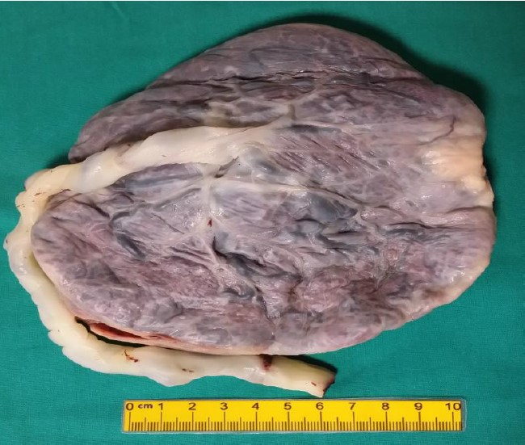
Resim 1: Plasenta makroskopik görünümü

Term bebekte umblikal kord yaklaşık 55-65 cm uzunluktadır (14). Kordon Wharton jölesi olarak bilinen mukoid bağ dokusundan oluşmuştur. İki arter ve bir venden oluşan umblikal vasküler yapılar interstisiyel madde içine gömülmüştür. Umblikal arterlerde internal elastik lamina bulunmaz. Umblikal venin çapı artere göre daha geniştir ve internal elastik laminanın oluşturduğu daha ince bir duvarı vardır. Umblikal kord plasentaya santral veya eksantrik biçimde girebilir. Eğer perferden girmişse buna raket plasenta denir (Resim-2).
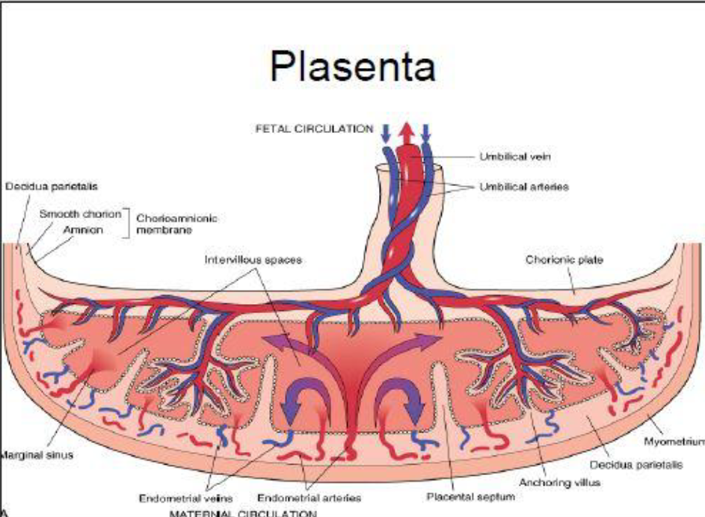
Resim 2: Plasenta yapısı ve dolaşımı
Plasental membranlar amnion ve koryondan oluşur (15,16). Amnion boşluğunun en içteki örtüsü amnion olup, amnion tek katlı yassı epitelden oluşur. Bu tek katlı yassı epitel hücreleri bazal membran üzerine oturmuştur. Koryon ise fetal damarları taşıyan bir bağ doku membranından oluşmuştur. Koryon iç yüzü amnionun dış tabakasıyla sınırlanmıştır. Koryonun membranla birlikte olan bölümüne koryon laeve denir ve asıl plasentanın içinde yerleşmiş olan tabaka koryon frondozumdan ayrılır (17,21).
Trofoblastik villuslar blastokist oluşumunun ardından trofoektodermden gelişmişir ve plasentanın esas işlevsel birimini oluşturur. İlk trimesterda primitif fibroblastlar ve dağınık makrofajları içeren mezenkimal santral bir koru çevreleyen dışta sinsityotrofoblast; içte sitotrofoblast tabakasından oluşmuştur. Sinsityotrofoblast human koryonik gonodotropin (hCG), human plasental laktojen (hPL), plasental benzeri alkalen fosfotaz (PLAP), keratin ve inhibin için güçlü immünreaktif, geniş asidofilik sitoplazmalı multinükleer dev hücrelerden oluşmuştur (22,23). Sitotrofoblastlar sinsityotrofoblastın progenitörü olup, berrak sitoplazmalı momonükleer hücreler olup, hücre membranı belirgindir ve keratin dışında yukarıda belirtilen belirleyicilerden hiçbiri ile tepkime vermez (Resim-3).
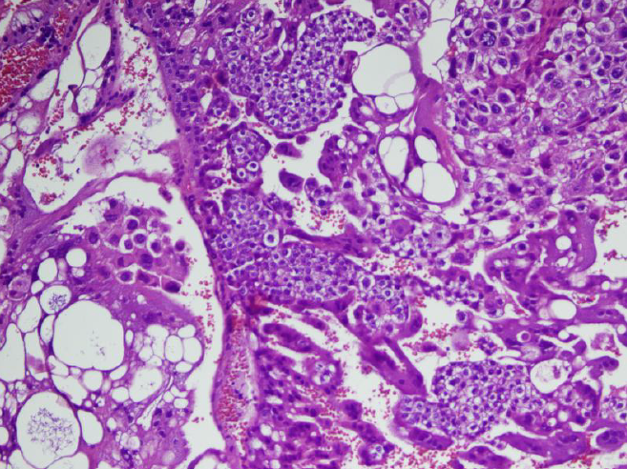
Resim 3: Sitotrofoblastların ve sinsityotfoblastların mikroskobik görüntüsü (Hem&Ex200)
Term bebekteki sinsityotrofoblastlar plasentada kümelenme halinde görülür. Diğer trofoblast tipi ise intermediyer trofoblasttır. Bu tip villuslar ve membranlar, implantasyon yerinin en derin ana komponenti olan ekstravillöz bölgede özellikle çok sayıdadır.
Plasentada villöz damarlar 6. haftada görünürhale gelir ve yaklaşık 8. haftada sadece nükeluslu eritrositleri içerir. 10-12 haftaya kadar çekirdekli eritrosit oranı %10’a düşer ve 12. haftadan sonra bu eritrositler bütünüyle yok olur. Desidua hem membranların koryona bakan yüzünde hem de plasental diskte bulunur. (24)

2.2. GESTASYONEL TROFOBLASTİK HASTALIK
Hidatiform mol ilk kez Hipokrat tarafından MÖ 400’lü yıllarda ‘uterusun şişkinliği’ olarak tanımlanmıştır. O zamandan beri mol gebelikler araştırmalar için ilgi odağı olmuştur. Mol hidatiform gebelikler maternal doku içerisinde trofoblastik hücrelerden köken alan fetal hücrelerden oluşur ve uterusa invaze olup uzak metastaz yapma ihtimali vardır. Gestasyonel trofoblastik dokudan kaynaklanan maternal bir tümör olması nedeniyle GTH patogenezi eşsizdir (1). Hidatiform mol iki farklı gruba ayrılır; komplet ve parsiyel mol hidatiform. Bu iki hastalık kromozom patterni, klinik özellikleri makroskopik ve mikroskopik histopatolojik özellikleri ve prognoz açısından faklılılar gösterir (25,26,27). Molar gebelikler benign olmalarına rağmen, malign hastalıklara dönüşebilme potansiyellerinden dolayı premalign hastalıklar olarak değerlendirilirler. Malign hastalık Gestasyonel Trofoblastik Neoplazi olarak adlandırılır. Bu gruptaki hastalıklar ise şunlardır: koryokarsinom, invaziv mol, epiteloid trofoblastik tümör ve plasental site trofoblastik tümör.

2.2.1. Sınıflandırma ve patogenez

2.2.1.1 Mol Hidatiform:
Mol hidatiform komplet ve parsiyel mol olarak sınıflandırılan premalign bir hastalıktır. Komplet ve parsiyel mol, histopatoloji, morfoloji, karyotip ve malignensi riski ile birbirinden ayrılır (28). Mol hidatiform, non molar gebeliği (spontan ya da medikal abort, ektopik gebelik ve preterm ya da term gebelik) takiben değil; aberran bir fertilizasyonu takiben gelişir. Mol hidatiform paternal genlerin overekspresyonu sonucunda anormal trofoblastik hiperplazi gerçekleşen villöz trofoblastlardan köken alır (29).
Komplet mol hidatiform diploid, parsiyel mol hidatiform ise triploid kromozom sayısına sahiptir. Komplet mol hidatiform tipik olarak daha yüksek titrede Β hCG ile karakterizedir. Malign GTN riski komplet mol hidatiformda parsiyel mol hidatiformdan daha yüksektir. GTN, daha sıklıkla invaziv mol, komplet mol hidatiformu takiben hastaların %15-20’sinde gelişirken, parsiyel mol hidatiformu takiben hastaların %1-5’inde gelişir (30).
GTN hastalarının büyük bir kısmını daha önce mol gebelik öyküsü olan hastalar oluşturur. GTN grubunda olan invaziv mol, koryokarsinoma, plasental site trofoblastik tümör ve epiteloid trofoblastik tümör lokal invazyon ve metastaz potansiyelleri olması nedeniyle malign hastalıklar olarak değerlendirilirler.

Komplet Mol Hidatiform:
Komplet mol hidatiformların yaklaşık %80’i homozigot 46XX kromozoma sahiptir ve fertilizasyon sırasında haploid spermin duplikasyonu ve maternal kromozomların mayoz bölünme sırasında kaybolması sonucu oluşur. Ya da iki sperm ile döllenmeyi takiben diploidizasyon sonucu oluşur (31,32,33). Komplet mol hidatiformların yaklaşık %20’si dispermik fertilizasyon ile oluşur ve 46XX veya 46XY kromozoma sahiptir. Komplet mol hidatiformda nükleer DNA paternal kökenliyken, mitokondrial DNA yine maternal kökenlidir (34). Nadir vakalarda her iki ebeveynden gelen otozomal resesif geçişli mol hidatiform genleri mevcuttur ve bu hastalarda tekrarlayan molar gebelikler görülür. Bu hastalarda sağlıklı gebelik elde edebilmek için oosit donasyonu gerekebilir (35,36,37). Hastada geçirilmiş mol öyküsü 1 sonraki gebeliklerde mol riskini artırmaktadır (38,39,40). Yineleyen mol gebelikler genellikle komplet tipte görülmektedir. Ancak komplet molü parsiyel bir mol de izleyebilir (41). Yüksek serum β hCG seviyeleri hastalığın klinik özelliklerinin bir kısmını oluşturur. Bunlar, teka lutein kistleri ve artmış over boyutları; hiperemesis gravidarum, 20. gebelik haftasından önce gelişen preeklampsi ve hipertiroidizmdir (42-45).

Parsiyel Mol Hidatiform:
Parsiyel mol hidatiform triploid kromozomludur; genellikle normal ovumun iki spermle ya da nadiren diploid kromozoma sahip bir spermle döllenmesi sonucu oluşur ve 69XXX, 69XXY, 69XYY kromozoma sahip olabilir (46,47,48). Diploid parsiyel mol hidatiform olarak bildirilen vakaların çoğu yanlış tanı konmuş komplet moller, hidropik abortlar ya da ikiz gebeliklerdir (49). Fetusun görüldüğü tek gestasyonel trofoblastik hastalık parsiyel mol hidatiformdur. Fetal kardiak aktivite de görülebilir ancak triploidi nedeniyle intrauterin fetal kayıp olasılığı çok yüksektir. Bu da parsiyel mol hidatiformlara sıklıkla missed abort, inkomplet abort olarak tanı konulmasına sebep olur; gerçek tanı ancak uterin boşaltım sonrası küretaj materyalinin patolojik incelenmesi sonucu konulabilir (50).

2.2.1.2. İnvaziv Mol Hidatiform
İnvaziv mol hidatiform terimi derin myometriumu ve/veya kan damarlarını invaze eden malign bir mol hidatiform sınıfıdır (çoğunlukla komplet tip, bazen parsiyel tip) (51,52). Tüm komplet mollerin yaklaşık %16’sında olan invaziv mol formu, normal trofoblastın implantasyon için gerekli olan invazyon kabiliyetinin aşırı bir ekspresyonudur. Normal gebelikten sonra akciğerlerde mikroskopik trofoblastik embolusların gösterilmesi ve plasenta akreata invaziv molün diğer görünümleridir (53). İnvaziv molde myometrial permeabilite yaygın olmasına rağmen seroza genellikle intakttır. Buna bağlı olarak inatçı kanamalara neden olabilir. Bununla birlikte uterin perforasyonu görülebilir. Vasküler invazyon sonucu ekstra uterin yerlerde (vajina, beyin, akciğer ve spinal kord gibi) trofoblastik nodüller görülebilir (54,55). Akciğerde nodüller, β hCG üretmeye devam ederler ve hemorajik komplikasyonlara eğilim gösterirler. Klinik belirtiler tutulan yere bağlıdır. Akciğerde kitle büyük de olsa hiç semptoma yol açmadan kendiliğinden regrese olabilir. Bazen beyinde mortal kanama gelişebilir (56,57).

Bir invaziv mol hidatiformun kendini sınırlama özelliği dışında, malign bir neoplazmın tüm biyolojik özelliklerini gösterdiğine dikkat edilmelidir. Stromayı invaze eder, tümör embolusları oluşturur ve uzak metastaz yapabilirler. İnvaziv mol hidatiform alışılmış mol hidatiformdan invazivliği ile koryokarsinomdan ise ‘metastatik’ odaklarda bile villusların bulunmasıyla ayrılır. İnvaziv mol hidatiformdaki trofoblastik proliferasyon derecesi, sıradan mol hidatifora benzerdir. İnvaziv mol hidatiform olan hastalar temel olarak kemoterapi ile tedavi edilirler, ama histerektomi bazı durumlarda endike olabilir (58,59).

2.2.1.3.Koryokarsinom
Koryokarsinom, tedavi edilmediği sürece, en aggresif seyreden trofoblast hastalığıdır. Çoğu koryokarsinom olgusu, komplet hidatiform mol sonrası ortaya çıkar. Bu sebeple bu malign tümör dünyada mol hidatiformun daha sık olduğu yerlerde görülür. Komplet mol hidatiform hastalarının %1-2’sinin sonradan koryokarsinoma dönüştüğü tahmin edilmektedir (60). Ayrıca gebeliğin ilk trimesterinde kök villusların trofoblastlarından gelişen ‘in situ’ koryokarsinom vakaları da mevcuttur (61). Term gebelikte, non molar bir intrauterin abortus, parsiyel mol veya ektopik gebelikte de koryokarsinom gelişebilir (62,63). Koryokarsinom olgularında latent dönem çoğu zaman 1 yıl olsa da latent dönemin daha uzun olduğu vakalar da mevcuttur. Koryokarsinom görülen vakaların yaş ortalaması 29’ dur. Sonradan koryokarsinom gelişen non molar bir abortusun mikroskopik kesitinde trofoblastik proliferasyon odakları çoğunlukla görülmektedir. Bu odaklar öncül bir lezyonun varlığını düşündürmektedir.
Bagshavve, yaptığı bir çalışmada koryokarsinomun insidansı ve prognozu ile kadının ve eşinin ABO grupları arasındaki çarpıcı ilişkiyi ortaya koymuştur. Aynı gruptaki erkeklerle evli A grubuna sahip kadınlar için en yüksek risk söz konusudur. Kendi kan grubundaki erkeklerle evli kadınlar, bir mol hidatiform hastalığın tedavisinden sonraki en yüksek spontan trofoblast regresyonu insidansı göstermektedir (64).
Gross olarak, koryokarsinoma karakteristik olarak hemorajik, koyu kırmızı, yumuşak, nodüler yuvarlak tümör kitleleri oluşturur. Mikroskopik olarak, tümör karakteristik dimorfik (65) pleksiform patern oluşturan, akıp giden sinsityotrofoblast kitleleriyle ayrılmış sitotrofoblast kümelerinden oluşmuştur (66). Genel olarak spontan abortuslarda da sıklıkla izlendiği için, var olan kanama ve nekrozun reel bir tanısal değeri bulunmamaktadır. Karakteristik olarak koryokarsinomada villuslar yoktur. Villusların var olması, trofoblast hücreleri atipik olsa da olmasa da koryokarsinom tanısını dışladığı söylenmektedir. Bu kriterin mantığını anlamak biraz zordur. Sonuçta, bu tip koryokarsinomlar komplet mollerden sonra oluştuğuna göre, molar dokular ile koryokarsinomatöz dokuların aynı anda bir arada olduğu bir zaman kesitinin olması gerekir. Yine de uygulamada faydalı bir parametre olduğu da yadsınamaz bir gerçektir (66,67).
Tedavi edilmeyen koryokarsinomun doğal gelişimi en sık akciğer, beyin, böbrek, karaciğer ve bağırsağa olmak üzere hematojen metastazlardır (68,69). Klinik olarak solid yapıd olabilir, en alışılmadık yerlerde olabilir ve sıklıkla masif hemoroji ile kendini gösterir. Yayılmış koryokarsinom sebebiyle ex olan hastaların uteruslarında rezidüel tümör önemsiz miktarda olabilir veya hiç bulunmayabilir (70).
Koryokarsinom olan olgularda başka organlarda görülen morfolojik değişikliklerin çoğu, tümör hücrelerinden salınan aşırı hCG ve diğer hormonların artan sekresyonuna bağlıdır. Bu değişiklikler içinde teka-lutein kistleriyle overlerin bilateral büyümesi, desidual reaksiyon, endoservikal glandlarda hiperplazi, Arias-Stella reaksiyonu ve meme lobüllerinde hiperplazi yer alır. Bir koryokarsinom vakasının tedavisinden çok sonra bilateral overde teka-lutein kistlerinin saptanması, genellikle kalıcı hastalığın bir işaretidir (71).
Koryokarsinom tedavisi medikal onkolojideki en büyük başarılardan biridir. Yalnızca cerrahi ile kür sağlandığında, kür oranı uterusa sınırlı tümörlerde yalnızca %40, eğer metastazlar eşlik ediyorsa %20 ’den daha azdır (72).
Metotreksat, klorambusil 15 ve aktinomisin D ve gibi kemoterapi ajanlarının kullanımıyla survive oranı uterusa sınırlı olgularda %100’e yakın iken, metastaz varlığı olan hastalarda yaklaşık %83 olmuştur (73). Koryokarsinom tedavisinde erken tanı, tedavinin hızlı oluşturulması ve β hCG üretiminin seri ölçülerek tedavi sonuçlarının izlenmesi önemlidir. Fakat hCG salgılanması sadece gestasyonel koryokarsinoma özgü bir durum değildir. Non gestasyonel koryokarsinomda, testis ve overin diğer germ hücre tümörlerinde, özofagus, böbrek, pankreas, mide, karaciğer, akciğer, uterus, mesane, sürrenal, malign lenfomada, meme gibi başka yerlerdeki karsinomlarda da hCG salgılanması olabilmektedir. Bu tümörlerdeki ortak özellik, bunların çoğunda immünohistokimyasal tekniklerle hCG içeren tümör hücrelerinin bulunmasıdır (74).
Tümör dokusu DNA’sındaki polimorfizmleri tanımlamak için bölge- spesifik minisatellit problar kullanarak yapılan genetik çalışmalar, tümörün önceki bir komplet molden köken aldığını ortaya koymada ve gestasyonel koryokarsinomu non gestasyonel olan koryokarsinomdan ayırmada ve faydalıdır (75).

2.2.1.4. Epiteloid Trofoblastik Tümör
GTN grubu içerisinde ender görülen bir tümördür. Klinik, patolojik ve prognostik olarak PSST’ye benzer bir formdadır. Morfolojik olarak squamöz hücreli karsinoma benzerlik gösterir. Histolojik olarak koryonik tip ara trofoblastlardan köken alırlar. Kalsifikasyon ve nekrozun genellikle birlikte görüldüğü, çevre dokuları derinlemesine invaze eden nodüller şeklinde izlenirler (76).
2.2.1.5. Plasental Site Trofoblastik Tümör
PSTT mono nükleer intermedier trofoblast hücrelerden köken alan ender bir GTN sınıfıdır. Sıklıkla erken evrede tanı alır ve yavaş büyüyüp geç dönemde metastaz yaparlar. Genellikle fundus veya servikse lokalizedirler (76). Nekroz, hemoraji ve vasküler invazyon çok nadir olup, lenfatik metastaz yapma meyilindedirler.

2.2.2 Epidemiyoloji
Molar gebeliğin sıklığını ortaya koymak, hastalığın nadir görülmesi ve farklı bölgelerde farklı sıklığa sahip olması nedeniyle zordur (76,77). Avrupa ve Kuzey Amerika’da düşük ya da orta sıklıkla (100000 gebelikte 66-121) görülen GTH; Asya ve Orta Doğu ve Latin Amerika’da çok farklı sıklıklarda bildirilmiştir (100000 gebelikte 23-1299 arası) (78). Mol hidatiform insidansıyla ilgili bu bilgiler eski verilere dayanmaktadır; takip eden verilerde Güneydoğu Asya’daki verilerin batı ülkelerine benzer olduğu ortaya çıkmış, bu da batıya benzeyen yaşam tarzı ve beslenme biçimleri nedeniyle olabileceği görüşünü desteklemiştir (79,80,81,82). Türkiye’de mol hidatiform gebelik insidansı bölgeler arasında farklılık göstermektedir. Total insidans her 1000 canlı doğumda 1-24,6 arasında değişmektedir. 2014 yılında 28 merkezde yapılan çalışmada mol hidatiform gebelik insidansı 1000 canlı doğumda 0,38 olarak belirlenmiştir. Histopatolojik olarak doğrulanmış mol hidatiform gebelik insidansı %45,1 olarak tespit edilmiş ve bu hastaların %22,3’ünde Gestasyonel Trofoblastik Neoplazi saptanmıştır. Hastaların %1,9’unda persiste hastalık gelişmiş ve %1,4’ünde mortal seyretmiştir (83).

2.2.3. Risk Faktörleri
Mol hidatiform için önde gelen 2 majör risk faktörü; çok küçük veya ileri anne yaşının olması ve geçirilmiş molar gebeliktir.
Daha önce mol gebelik geçiren bir hastanın, sonraki gebeliğinde mol gebeliğin tekrarlama riski genel popülasyona kıyasla yaklaşık %10-15 artmıştır ve yaklaşık yüzde 1 ile 1,5 arasındadır (84). 1999 yılında Tuncer ve ark. 34 gebelik üzerinde 20 farklı çiftle yaptığı bir çalışmada, daha önce 2 molar gebelik öyküsü olan hastada nüks oranı yüzde 11 ila 25 arasında olduğunu bildirmiştir (85).

Komplet mol hidatiform riski, anne yaşının 15’ten küçük ve 35’ten büyük olduğu durumlarda en yüksektir. Bir vaka-kontrol çalışmasında komplet mol hidatiform gebelik riskinin 35 yaşından büyük kadınlarda 2 kat, 40 yaşından büyük kadınlarda 7,5 kat arttığı bulunmuştur. Bu çalışmalar, ileri yaşla birlikte azalan oosit kalitesinin anormal döllenmeye karşı daha duyarlı olduğunu düşündürmektedir. Ayrıca komplet mol hidatiform gebeliğin anne yaşı ile ilişkisi, parsiyel mol hidatiforma göre daha fazladır ve komplet mol hidatiform gebeliğin anne yaşı ile ilişkisi, parsiyel mole hidatiforma göre daha fazladır (86). Adölesan veya ileri yaş kadınlarda hem komplet hem de parsiyel mol hidatiform insidansı artmış olarak izlenmiştir (87).
Bunların yanı sıra daha önce düşük öyküsü olan ve infertilite öyküsü olan kadınlarda komplet ve parsiyel mol hidatiform gebelik riski artmaktadır. Daha önce düşük öyküsü olmayan kadınlarla, 2 ya da daha fazla düşük öyküsü olan kadınlara kıyasla, komplet ve parsiyel mol hidatiform için risk sırasıyla 3,1 ve 1,9’dur (88).
Gebe kalmada zorluk veya infertilite öyküsü olan kadınlarda, komplet mol hidatiformve parsiyel mol hidatiform riski sırasıyla 2,4 ve 3,2 kat artmaktadır (88,89,90).
Vaka-kontrol çalışmaları, karoten (A vitamini öncüsü) ve hayvansal yağ tüketiminin azalmasıyla birlikte mol hidatiform gebelik riskinin arttığını vurgulamaktadır. Komplet mol hidatiform gebelik sıklığının yüksek olduğu bölgeler, A vitamini eksikliği sıklığının yüksek olduğu bölgelerle korelasyon göstermektedir. Bununla birlikte, parsiyel mol hidatiform diyet faktörleriyle ilişkili değildir (90).

2.2.4. Tanı Yöntemleri
Mol hidatiform gebelik tanısı reprodüktif dönemde anormal vajinal kanama ile başvuran hastada düşünülmesi gereken hastalıklardan birisidir. Bu hastalarda serum β hCG seviyesi görülmeli ve ultrasonografik değerlendirme yapılmalıdır.
Serum β hCG yüksek bulunan hastaların nonmolar gebelik ihtimali (normal intrauterin gebelik, ektopik gebelik, spontan abortus) daha yüksektir. Non molar gebelik tanıları dışlandığında ve özellikle hastada molar gebelik öyküsü varlığında mol gebelik olma ihtimali yüksektir.

2.2.5. Anamnez
Hastanın anamnezi önceki gebelik ve doğum öyküleri; tarih, gebelik süresi ve sonuçlarını içerecek şekilde detaylı alınmalı, varsa mol gebelik öyküsü detaylıca sorgulanmalıdır. Hastanın medikal, jinekolojik ve cerrahi öyküsü de oldukça önemlidir. Hastada mol gebelik semptomları sorgulanmalıdır. Eğer klinik özellikler mol gebeliğe işaret ediyorsa mutlaka GTN dışlanmalıdır. Bu sebeple hastanın metastatik hastalık açısından anamnezi alınmalıdır. En sık metastaz olan organların tutulumları bulguları; pulmoner semptomlar (dispne, göğüs ağrısı, öksürük, hemoptizi), santral sinir sistemi bulguları (baş ağrısı, bulantı, kusma hemiparezi), karaciğer tutulum bulguları (sarılık, epigastrik ağrı), virilizim (teka lutein kistlerinden salgılanan testosteron nedeniyle) sorgulanmalıdır.

2.2.6. Fizik muayene
Pelvik muayene tamamıyla yapılmalıdır. Spekulum ile vajinal direkt bakıda vajen metastaz yönünden değerlendirilmelidir. Bimanual pelvik muayenede komplet mol hidatiformde uterus boyutu gestasyonel haftada beklenilenden daha büyük izlenir. Bu hastalarda β hCG stimülasyonu nedeniyle bilateral teka lutein kistleri gözlenebilir. Tek taraflı adneksiyal kitle başka bir ovaryen kitleye işaret eder.

2.2.7. Laboratuvar
Serum β hCG seviyesi sıklıkla aynı gestasyonel haftadaki, ektopik ya da intrauterin gebelikten daha yüksek izlenir. Çok yüksek hCG seviyeleri (>100,000 mIU/mL), komplet mol hidatiform gebelikte parsiyel mol hidatiform gebeliğe göre daha sıklıkla görülür (91). Hastaya kan grubu tayininin yapılması ve Rh uyuşmazlığı durumunda Anti-D yapılması gereklidir. Kanama en sık görülen semptom olduğundan tam kan sayımı ve hipertiroidizm gelişme ihtimalinden dolayı tiroid fonksiyon testleri bakılması gereken tetkiklerdendir.

2.2.8. Görüntüleme
Komplet mol hidatiform gebelikte ultrasonografide fetus ve amniyotik sıvı gözlenmez. Uterin kavitede çok sayıda anekoik boşluklar içeren heterojen kitle görülür. Bu görüntüye tipik ‘kar manzarası’ denir. Bazen bu hidropik villuslar genişleyerek anembriyonik gebelik ile uyumlu bir görüntü oluşturabilir. Aynı zamanda bilateral ovaryan teka lutein kistleri de görülebilir. Komplet mol hidatiform tanısında ultrasonografinin sensitivitesi %70-90 arasında değişmektedir ve gebelik haftası ile birlikte bu oran artmaktadır (91,92,93,94). Parsiyel mol hidatiform ultrasonografik görüntüsü vakaların %15-60’ında missed abortus ve inkomplet abortus tanısı almaktadır (95,92,96). Parsiyel mol hidatiform gebeliğin ultrasonografik bulguları arasında; fetüs (sıklıkla intrauterin büyüme kısıtlılığı mevcut olarak), amniotik sıvı (oligohidramnios olabilir), plasenta (kistik boşluklar, hiperekojen görünüm normalden büyük plasenta olabilir) gözlenir. Parsiyel mol hidatiformda bilateral teka lutein kistleri genellikle görülmez (97,98,99).
GTN'nin tipik ultrasonografik ve Doppler özellikleri bulunmamaktadır. Ultrasonda çeşitli sonografik görüntüler izlenebilir. Hiperekojenik, hipoekojenik veya heterojen miyometriyal kitle bulunabilir ve genellikle endometriyum ile net bir ayrım yoktur. Doppler ultrasonda yoğun damarlanma izlenebilir (100).
GTN’de en sık olan metastaz organlarıakciğer (%80), vajina (%30), karaciğer (%10) ve santral sinir sistemi (%10)’dir. Vajina ve akciğerde metastaz yoksa diğer alanlarda metastaz daha enderdir (101). Metastazları oldukça vasküler olduğu ve biyopsi almak hayati risk teşkil eden kanamalara neden olabileceği için metastazlardan biyopsi önerilmez. Vajinal metastazlar ön vajen mukozasında yumuşak mavi nodüller şeklinde görülür ve genellikle pelvik muayene ile saptanır. Akciğer metastazı tanısı koymak için göğüs X-ray incelemesi yeterlidir. X-ray filmi negatif tespit edilen hastaların %40’ında akciğer bilgisayarlı tomografi (BT) ile mikrometastazlar saptanabilir; fakat bu mikrometastazlar sonuçları etkilemediği ve risk faktörü olarak değerlendirilmediği için BT gerekli değildir. Beyin metastaz tanısı BT veya manyetik rezonans görüntüleme ile, karaciğer metastaz tanısı ise ultrasonografi veya BT ile konulabilir (102).
İnvaziv mol ve koryokarsinomda yüksek hCG düzeyleri görülürken, ETT’de ve PSST’de düşük hCG düzeyleri mevcuttur. Kütlesel tümörlerde dahi hCG seviyesi genellikle 1000 mIU/ mL’den azdır. Olguların yarısına yakını metastatik hastalığa bağlı gelişen semptomlar ile tanı alır. Tanıda ultrasonografi yardımcıdır. Ultrasonda myometrium ve endometriumu içeren solid veya kistik ekojenik kitle görülebilir. Tümörün vaskülaritesini belirlemek için Doppler ultrasonografi eklenebilir (103).

2.2.9. Klinik özellikler
Mol hidatiform hastaları genellikle Kadın Hastalıkları ve Doğum uzmanına adet rötarı, pozitif gebelik testi, vajinal kanama, pelvik ağrı, hiperemesis gibi erken gebelik semptomları ile başvururlar (30,104,105,106). Olguların çoğunda, özellikle parsiyel mol hidatiformda ön tanı sıklıkla spontan abortustur ve hastalar küretaj sonrası patoloji sonucu ile tanı alırlar. Bazen de hastalar erken dönemde, semptomlar gelişmeden, normalden yüksek serum Β hCG seviyeleri ya da ultrason bulguları ile tanı alırlar (107). 1980li yıllara kadar komplet mol hidatiform hastaların başvuru semptomları geç bulgulardı (hipertiroidizm, preeklampsi gibi). Ultrasonografi ve sensitif kantitatif Β hCG ölçümlerinin kullanımının yaygınlaşması ile birlikte artık daha erken tanı artık mümkün olmaya başladı (108-112).

2.2.10. Tedavi
Mol hidatiform tedavisinde temel basamağı, komplet ya da parsiyel, küretaj ile uterusun evakuasyonu oluşturulmaktadır. Fertilitesini tamamlamış hastada histerektomi de bir tedavi seçeneğidir. Profilaktik kemoterapi, yüksek riskli komplet mol hidatiform hastalarında ya da takibin uygun, ulaşılabilir olmadığı durumlarda faydalı olabilir (91). Profilaktik kemoterapide kullanılan metotreksat ve aktinomisin D hastaların gelecekteki fertilite potansiyelini etkilememektedir (113,114). İki ajan arasında tercih için yeterli data mevcut değildir. Kemoprofilaksi uygulanan merkezlerde yüksek riskli hastalara genelde aktinomisin D tercih edildiği bildirilmiştir. Kemoprofilaksinin takipte gelişebilecek GTN riskini azalttığını ileri süren çalışmalar da mevcuttur. Fakat düşük risk grubunda yer alan hastalar için kemoprofilaksi önerilmemektedir (114-119). Anti-D immunglobulin: Rh (-) kan grubuna sahip hastalar, tedavi zamanında anti-D immunglobulin almalılar. Çünkü Rh faktör trofoblastlar tarafından eksprese edilir

2.2.11. Komplikasyonlar

2.2.11.1. Hipertiroidizm
Mol hidatiform gebelikle ilişkili hipertiroidizm, hastalığın tedavisi ile birlikte gerilemektedir. Bazı hastalar tedavi süreci tamamlanana kadar antitiroid tedaviye ihtiyaç duyabilirler. Anestezi öncesinde tiroid fırtınasının metabolik ve kardiyolojik komplikasyonlarından kaçınmak için β adrenerjik blokörler uygulanabilir (120).

2.2.11.2. Over teka-lutein kistleri
Teka lutein kistleri genellikle, uterin evakuasyonu takiben, β hCG seviyeleri düştükçe; 2-4 ay içinde, regrese olurlar. Nadiren torsiyone veya rüptüre olabilir; böylece cerrahi tedavi ihtiyacı doğabilir (121).

2.2.11.3. Preeklampsi
Mol hidatiform gebelikle ilişkili preeklampsi, mol hidatiform gebelik tedavisini takiben hızlıca çözülür ve genellikle ek tedavi gerektirmez.

2.2.11.4. Kardiopulmoner semptomlar
Birinci trimesterde kardiopulmoner semptomlar çok nadir görülmektedir (122,123). İkinci trimesterde tahliye yapılan komplet hidatiform mol olgularında, hastaların yaklaşık %2’sinde kardiopulmoner semptomlar gelişir. Bunlar göğüs ağrısı, dispne, takipne ve taşikardidir (122). Oskültasyonda genelde raller duyulurken, Akciğer grafisinde bilateral pulmoner infiltrasyonlar görülür. Semptomlar genellikle tahliyeyi takiben 72 saat içinde geriler. Respiratuar distress durumunda trofoblastik embolizasyon mutlaka akla gelmelidir. Fakat bu durum tiroid fırtınasına, sıvı yüklenmesine bağlı da gelişebilir. Bazen pulmoner infiltrasyonlar metastaz olarak da değerlendirilebilir ve hastaya erken kemoterapi uygulanabilir. Ancak infiltrasyonlar 48-72 saat içinde β hCG seviyeleri düştükçe geriler. β hCG seviyelerinin düştüğü durumda mevcut olan pulmoner nodüller tedavi gerektirmez; trofoblastik emboli spontan olarak regrese olur(124).

3. GEREÇ VE YÖNTEM
Bu çalışma 2011-2022 yılları arasında Tepecik Eğitim ve Araştırma Hastanesi Kadın Hastalıkları ve Doğum bölümünde 522 hasta incelenerek yapıldı. İlk başvurularında ultrasonda mol gebelik şüpheli olan bu hastaların dosya bilgisine ulaşıldı ve olgular retrospektif olarak değerlendirildi.
Toplam 522 mol gebelik olgusu kayıtları incelendi. Hastaların dosya bilgilerine hastanenin veri tabanından (Probel, Probel yazılım ve bilişim sistemleri A.Ş- Verusa Holding) ulaşıldı. Mol hidatiform tanısıyle takip edilen; fakat küretaj materyalinin patolojik sonucu olmayan olgular çalışmaya dahil edilmedi. Abortus inkompletus ve abortus insipiens ön tanıları ile tedavi yapılıp histopatoloji sonucu mol hidatiform olan vakalar çalışmaya dahil edilmedi. Ayrıca dosyaları eksik olan, 15 yaşın altında olan hastalar çalışmaya dâhil edilmedi. Mevcut verilerden hastaların yaş, gravida, parite, abortus, β HCG, kan grupları, serum tiroid uyarıcı hormon (TSH), serbest tri-iyodotironin (T3) ve serbest tiroksin (T4), akciğer grafisi ve histopatoloji ile ilgili sonuçları kayıt edildi. Gestasyonel trofoblastik hastalığın histopatolojik tipi, mol gebelik öyküsü, ektopik gebelik öyküsü, gebelik haftası kaydedildi. Nihai histopatolojik sonuç ile ultrason tanıları ve laboratuvar değerleri karşılaştırılarak incelendi. Ultrasonun mol hidatiform tespitindeki doğruluğu hesaplanmaya çalışıldı. Elde edilen veriler hastanemizin arşiv taraması yapılarak kayıt edildi. Çalışma için Tepecik Eğitim ve Araştırma Hastanesi Etik Kurulundan 2023/06-01 etik kurulu onayı alınmıştır.

3.1. ARAŞTIRMA PLANI VE TAKVİMİ
Araştırma plan ve takvimi Tablo 1’de gösterilmektedir.
Tablo 1: Araştırmanın planı ve takvimi
 | Ağustos 2022 | Eylül 2022 | Ekim 2022 | Kasım 2022 | Aralık 2022 | Ocak 2023 | Şubat 2023 | Mart 2023 | Nisan 2023 | Mayus 2023 | Haziran 2023 | Temmuz 2023 | Ağustos 2023
Kaynak Tarama
Planlama
Ön Çalışma
İzinler ve Onaylar
Veri Toplama ve Değerlendirme
İstatiksel Çözümleme
Yazım
Basım
Sunum

3.2. VERİLERİN DEĞERLENDİRİLMESİ
Veriler IBM SPSS Statistics Standard Concurrent User V 24 (IBM Corp, Armonk, New York, ABD) istatistik paket programında değerlendirildi. Elde edilen verilerin tanımlayıcı analizleri yüzde değerleri ve ortalama (standart sapma) şeklinde sunuldu. Toplanan verilerin aritmetik ortalama ile standart sapma değerleri hesaplandı. Normal dağılıma işaret eden parametrik değerler için Student T testi kullanıldı. Kategorik değişkenler için ki-kare testi kullanılmıştır. p <0.05 istatistiksel olarak anlamlı kabul edilmiştir. Güç analizi için G*Power istatistik programı (ver.3.1.9.4; Faul ve Erdfelder, 1998) kullanılarak; Tip-1 hata %5, Etki büyüklüğü 0,5 alınarak 196 hasta için “Testin Gücü” (Power) %80 bulundu.

3.3. ETİK KURUL ONAYI
Bu çalışma Sağlık Bakanlığı Üniversitesi (S.B.Ü) Tepecik Eğitim Araştırma Hastanesi (E.A.H.) Girişimsel Olmayan Klinik Araştırmalar Etik Kurulu tarafından 13/07/2023 tarihi ve 2023/06-01 karar numarası ile onaylanmıştır (Ek 1). Bu çalışma, Helsinki Deklarasyonu (2013) prensipleri doğrultusunda yürütülmüştür.

4. BULGULAR
Çalışmaya 522 hastanın verileri dâhil edildi. Hastalar ultrasonografik olarak mol hidatiform şüpheli olarak değerlendirilmişti. Cerrahi olarak uterin kavitenin boşaltımı sonrası materyalin histopatolojik incelemesinde vakaların 428(%81,9)’i mol hidatiform tanısı almış, 93(%17,82)’ü olağan gebelik kalıntısı olarak değerlendirildi (Tablo 2).
Tablo 2: Ultrasonografik olarak mol hidatiform tanısı konulan hastalarda histopatolojik sonucunun dağılımı
Mol/Normal gebelik | Sıklık(n) | Yüzde (%)
Normal Gebelik Kalıntısı | 93 | 17,82
Mol Hidatiform | 428 | 81,99
Koryokarsinom | 1 | 0,19
Total | 522 | 100,0

Tablo 3: Nihai patoloji sonucu dağılımları
Patoloji sonucu | Sıklık(n) | Yüzde (%)
Gebelik Kalıntısı | 93 | 17,8
Hidropik Villus | 82 | 15,7
Koryokarsinoma | 1 | 0,19
Komplet Mol | 96 | 18,4
Parsiyel Mol | 92 | 17,6
Mol (alt tipi belirtilmemiş) | 158 | 30,31
Toplam | 522 | 100

Histopatolojik incelemede Mol hidatiform olarak değerlendirilen hastaların (428); 92 (%17,6)’sı parsiyel mol, 96(%18,4)’sı komplet mol hidatiform olarak değerlendirildiği, 240 (%46,01)’ında ise mol alt tipi belirtilmediği görüldü. Mol hidatiformunun ultrason tanısı için genel duyarlılığı %82 olarak saptanmıştır (Tablo 2 ve Tablo 3).

Tablo 4: Patoloji sonucu mol bulgusu ile obstetrik öykü arasındaki korelasyon analizi
Obstetrik Öykü | Patolojide Mol Bulgusu |  | p değeri
Obstetrik Öykü | Var n (%) | Yok n (%) | p değeri
Ektopik Gebelik Öyküsüª
0 | 319 (65,2) | 170 (34,8) | 0,031*
1 | 9 (100) | 0 | 0,031*
2 | 3 (100) | 0 | 0,031*
Mol Gebelik Öyküsüª
0 | 319 (65,4) | 169 (34,6) | 0,005*
1 | 12 (100) | 0 | 0,005*
2 | 6 (100) | 0 | 0,005*
3 | 3 (100) | 0 | 0,005*
Gravide^{b}
1 | 77 (73,3) | 28 (26,7) | 0,225
2 | 54 (69,2) | 24 (30,8) | 0,225
3 | 92 (63,9) | 52 (36,1) | 0,225
4+ | 108 (62,10) | 66 (37,90) | 0,225
Parite^{b}
0 | 110 (74,80) | 37 (25,20) | <0,001*
1 | 78 (63,40) | 45 (36,60) | <0,001*
2 | 71 (52,60) | 64 (47,40) | <0,001*
3+ | 72 (75,00) | 24 (25,00) | <0,001*
Abort Öyküsü^{b}
0 | 247 (72,20) | 95 (27,80) | <0,001*
1 | 45 (51,70) | 42(48,30) | <0,001*
2+ | 39 (54,20) | 33 (45,80) | <0,001*
ªFisher’s Exact Test, ^{b}Pearson Ki-Kare, *p<0,05
Patolojide mol bulgusu olmayan hastalarda ektopik gebelik öyküsü de bulunmamıştır. Ektopik gebelik öyküsü olan hastaların tümünde ise mol bulgusu gözlemlenmiştir. Patoloji sonucu mol gebelik olan 9 hastanın 1 ektopik gebelik öyküsü, 3 hastanın 2 kez ektopik gebelik öyküsü olduğu saptanmıştır.
Ektopik gebelik öyküsü ile patolojide mol bulgusu arasındaki ilişki istatistiksel olarak anlamlı olarak saptanmıştır (p=0,031).
Mol gebelik öyküsü olan tüm hastaların patoloji sonucunda mol bulgusu vardır. Patoloji sonucu mol gebelik olduğu görülen toplam 12 hastanın daha önce 1 mol gebelik öyküsü, 6 hastanın 2 mol gebelik öyküsü mevcutken; 3 hastanın da daha önce 3 mol gebelik öyküsü olduğu saptanmıştır. Patoloji sonucu mol bulgusu olmayan hastaların hiçbirinde mol öyküsü de bulunmamıştır. Buna göre mol gebelik öyküsü ile patoloji sonucu mol bulgusu varlığı arasındaki ilişki istatistiksel olarak anlamlıdır (p=0,005).
Gravide ile patoloji sonucu mol bulgusu varlığı istatistiksel olarak anlamlı saptanmamıştır (p>0,05).
Parite ile mol bulgusu arasındaki ilişki istatistiksel olarak anlamlıdır (p<0,001). Paritesi 0 olan hastaların mol bulgusu oranı 1 ve 2 olan hastalara göre anlamlı düzeyde yüksektir. Paritesi 2 olan hastaların mol bulgusu ise 3+ olan hastalara göre anlamlı düzeyde daha düşüktür.
Abort öyküsü ile mol bulgusu arasındaki ilişki istatistiksel olarak anlamlıdır(p<0,001). Abort olmayan hastaların patolojide mol bulgusu oranı abort 1 ve 2 olan hastalara göre istatistiksel olarak daha yüksektir.

Tablo 5: Patoloji sonucu mol tiplerine göre gebelik haftası, anne yaşı ve β hCG ortalama dağılımları
 | Mol Tipi |  |  |  | p değeri
 | Komplet Mol |  | Parsiyel Mol |  | p değeri
 | n | Ortalama±Std. Sapma | n | Ortalama±Std. Sapma | p değeri
Gebelik haftası^{c} | 72 | 5,63±0,911 | 67 | 7,42±2,571 | <0,001*
Anne yaşı^{c} | 96 | 25,26±7,299 | 92 | 28,4±7,263 | 0,004*
β hCG Düzeyi | 96 | 212964,9±194624,5 | 92 | 177787,6±154991,9 | 0,173

^{c}Bağımsız Örneklem T-Testi, *p<0,05
Hastaların tanı anındaki gebelik haftaları; parsiyel molde ortalama 7,42±2,571, komplet molde 5,63±0,911 olarak saptandı. Gebelik haftası ortalamasının mol tipine göre gösterdiği farklılıklar istatistiksel olarak anlamlıdır (p<0,001). Komplet mol tipinde gebelik haftası ortalaması parsiyel mol tipi gebelik haftası ortalamasından istatistiksel olarak anlamlı düzeyde daha düşüktür.
Komplet mol tanısı konulan kadınlarda anne yaşı ortalama 25,26±7,299 iken; parsiyel mol tanılı kadınlarda anne yaşı ortalama 28,4±7,263 olarak saptanmıştır. Anne yaşı ortalamasının mol tipine göre gösterdiği farklılıklar istatistiksel olarak anlamlıdır (p=0,004). Buna göre komplet mol tipi anne yaşı ortalaması parsiyel mol tipi anne yaşı ortalamasından istatistiksel olarak anlamlı düzeyde daha düşüktür.
β hCG düzeyi ile mol tipi (komplet/parsiyel) arasındaki ilişki istatistiksel olarak anlamlı değildir (p=0,173).
Tablo 6: Patoloji sonucu mol bulgusu ile anne yaşı arasındaki korelasyon analizi
Anne Yaşı | Patolojide Mol Bulgusu |  | p değeri
Anne Yaşı | Var | Yok | p değeri
<20 | 68(73,10) | 25(26,90) | 0,303
21-40 | 257(64,90) | 139(35,10) | 0,303
41+ | 21(63,60) | 12(36,40) | 0,303
Patolojide mol bulgusu varlığı anne yaşına göre anlamlı farklılık göstermemektedir (p=0,303).

Tablo 7: Patoloji sonucu mol bulgusuna göre kan grubu dağılımları
Kan Grubu | Patolojide Mol Bulgusu |  | p değeri
Kan Grubu | Var | Yok | p değeri
0 | 88(25,40) | 56(31,30) | 0,403
A | 145(41,90) | 71(39,70) | 0,403
B | 76(21,90) | 35(21,10) | 0,403
AB | 37(10,80) | 14(7,90) | 0,403

Tablo 8: Patoloji sonucu mol alt tipleri ve kan grubu arasındaki korelasyon analizi
Kan grubu^{b} | Mol Tipi |  | p değeri
Kan grubu^{b} | Komplet mol n(%) | Parsiyel mol n(%) | p değeri
0 | 39(40,6) | 16(17,4) | <0,001*
A | 33(34,4) | 40(43,5) | <0,001*
B | 21(21,9) | 17(18,50) | <0,001*
AB | 3(3,1) | 19(20,7) | <0,001*
^{b}Pearson Ki-Kare, *p<0,05
Patolojide mol bulgusu kan grubuna göre istatistiksel olarak anlamlı farklılık göstermemektedir (p=0,403). Fakat mol alt tip olarak parsiyel ve komplet mol saptanmış olan hastalar kıyaslandığında; komplet mol tanısı almış hastalarda en yüksek oranla 0 kan grubu görülürken; parsiyel mol tanısı alan hastalarda A kan grubu görülmektedir. Aradaki fark istatistiksel olarak anlamlıdır (p<0,001).
Tablo 9: Patolojide mol bulgusuna göre TSH, sT3, sT4 ortalamalarının dağılımları
Tiroid Fonksiyon Testi | Patolojide Mol Bulgusu |  |  |  | p değeri
Tiroid Fonksiyon Testi | Var |  | Yok |  | p değeri
Tiroid Fonksiyon Testi | n | Ortalama±Std. Sapma | n | Ortalama±Std. Sapma | p değeri
TSH Düzeyi^{c} | 76 | 1,46±0,99 | 47 | 1,97±2,99 | 0,039*
Serbest T3^{c} | 76 | 3,82±1,84 | 4 | 3,69±1,05 | 0,487
Serbest T4^{c} | 73 | 1,36±0,82 | 4 | 1,24±0,63 | 0,185
^{c}Bağımsız Örneklem T-Testi, *p<0,05
TSH düzeyi patolojide mol bulgusu varlığına göre anlamlı farklılık göstermesine rağmen (p=0,039), serbest T3 ve serbest T4 ortalaması patolojide mol bulgusu varlığına göre anlamlı farklılık göstermemektedir (p>0,05).

Tablo 10: Patoloji sonucu mol gebelik olan hastalarda hipertiroidi ve hipotiroidi dağılımları
TSH | Sıklık (n) | Yüzde (%)
Hipertiroidi mevcut | 95 | 18,2
Hipotiroidi mevcut | 11 | 2,1
Patoloji sonucu mol gebelik olan hastaların %18,2’sinde hipertiroidi, %2,1’inde ise hipotiroidi mevcuttur.
Tablo 11: Patoloji bulgusuna göre GTN bulgusu dağılımı
Patoloji Bulgusu | Sıklık (n) | GTN sayısı (n) | GTN yüzdesi (%)
Gebelik Materyali | 93 | 3 | 3,23
Komplet Mol | 96 | 3 | 3,13
Parsiyel Mol | 92 | 1 | 1,09
Mol Hidatiform | 240 | 10 | 4,17
Koryokarsinom | 1 | 1 | 100,00
Toplam | 522 | 18 | 3,44
Çalışmada incelenen toplam 522 hastanın 18 (%3,44)’inde GTN gelişimi saptanmıştır. Patoloji bulgusu gebelik materyali olarak değerlendirilen 93 hastanın 3’ünde, komplet mol hidatiform olarak değerlendirilen 96 hastanın 3’ünde ve parsiyel mol tanı alan 92 hastanın 1’inde GTN gelişmiştir. Patoloji sonucu mol (alt tipi belirtilmemiş) olarak raporlanan 240 hastanın 10’unda GTN gelişmiştir. Patoloji sonucu 1 hasta koryokarsinom tanısı almıştır.
Tablo 12: GTN tiplerinin dağılımı
GTN sınıflandırması | Sıklık (n)
İnvaziv Mol Hidatiform | 4
Plasental Site Trofoblastik Tümör | 2
Koryokarsinoma | 1
GTN (alt tip belirtilmemiş) | 11
Toplam | 18
Hastaların takip ve tedavi süreçlerinde toplam 4 hasta histerektomi olmuş olup; bu 4 hastanın 3’ünün histerektomi sonrası patoloji sonucu invaziv mol olarak değerlendirilmiş, 1 hasta ise komplet mol hidatiform tanısıyla kanaması olması üzerine histerektomi olmuş ve ameliyat patoloji sonucunda GTN’ ye rastlanmamıştır. Vakum küretaj sonrasında seri β hCG takiplerinde anlamlı düşüş olan ve takiplerinde herhangi bir komplikasyon gelişmeyen hastalar taburcu edilmiş, taburculuk sonrası haftalık β hCG takibine alınmıştır. Taburculuk sonrası takipleri sırasında tanısı konulan olgularla birlikte toplam 18 hasta klinik olarak GTN olarak değerlendirilmiştir. GTN olgularının 2’si Plasental Site Tümör, 4’ü invaziv mol ve 1’i ise Koryokarsinoma olarak tanı almıştır; kalan olgular ise sınıflandırılmamıştır. Sınıflandırılmayan GTN olguları, hastaların taburculuk sonrası seri β hCG düzeylerinde yeterli düşüş görülmediği için klinik olarak GTN tanısı konulan olgulardır. Bu hastalara hastanemiz jinekoloji-onkoloji bölümünde kematerapi protokelleri uygulanmıştır.
Çalışmamızda bakılan tüm hastaların akciğer grafileri normal olarak değerlendirilmiştir.

Tablo 13 : Patoloji bulgusunun GTN varlığına göre korelasyon analizi
Patoloji Bulgusu | GTN Varlığı |  | p değeri
Patoloji Bulgusu | GTN (-)  Sıklık-yüzde (n%) | GTN (+)  Sıklık-yüzde(n%) | p değeri
Gebelik Materyali | 90(17,90) | 3(16,70) | 0,056
Mol Hidatiform | 230(45,50) | 10(55,50) | 0,056
Komplet Mol | 93(18,50) | 3(16,70) | 0,056
Parsiyel Mol | 91(18,10) | 1(5,55) | 0,056
Koryokarsinoma | 0 | 1(5,55) | 0,056
Patoloji bulgusuna göre GTN gelişme durumu arasında istatistiksel anlamlı fark saptanmamıştır (p= 0,056).

Tablo 14: GTN gelişimi ile obstetrik öykü arasında korelasyon analizleri
Obstetrik öyküsü | GTN Varlığı |  | p değeri
Obstetrik öyküsü | GTN + | GTN- | p değeri
Ektopik Gebelik + | 0 | 12(2,40) | 0,989
Ektopik Gebelik - | 18(100) | 492(97,60) | 0,989
Abort öyküsü+ | 9(50,0) | 150(29,8) | 0,067
Abort öyküsü- | 9(50,0) | 354(70,2) | 0,067
Mol Öyküsü + | 2(11,10) | 19(3,80) | 0,16
Mol Öyküsü- | 16(88,90) | 485(96,20) | 0,16
Fisher’s Exact Test, p<0,05
Ektopik gebelik öyküsü (p=0,989), abort öyküsü (p=0,067) ve mol öyküsü (p=0,16) ile GTN varlığı istatistiksel olarak ilişkili değildir.
Tablo 15: GTN gelişimi ile hipertiroidi arasındaki korelasyon analizi
Hipertiroidi varlığı | GTN Varlığı |  | p değeri
Hipertiroidi varlığı | GTN + | GTN- | p değeri
Hipertiroidi + | 4(22,2) | 91(18,1) | 0,754
Hipertiroidi - | 14(77,8) | 413(81,9) | 0,754
Fisher’s Exact Test, p<0,05
Hipertiroidi varlığı ile GTN varlığı istatistiksel olarak ilişkili değildir (p=0,754).

5. TARTIŞMA
Birinci trimesterde yapılan ultrason ile hastaların %82’sine molar gebelik olarak doğru tanı konabilmiştir. Chelli ve ark’nın yaptığı çalışmada mol hidatiform halinde ultrason duyarlılığı %75,86 olarak saptanmıştır (125). Kirk ve ark.’nın yaptığı çalışmaya göre ise tüm molar gebeliklerin ultrason ile tanınma oranı %44 olarak saptanmıştır (126). Bizim çalışmamızda diğer çalışmalara göre duyarlılığın daha yüksek saptanmasının nedeni çalışmamızın daha güncel olması olabilir. Günümüzde kullanılan ultrasonografik cihazların teknolojisinin daha ileri seviyede olması ve görüntü kalitesinin daha iyi olması sayesinde fetal imaj ve trofoblastik dokuyu daha iyi ayırt edebilme avantajı sağlanmış olabilir. Ayrıca diğer neden kliniğimize başvuran hasta sayısının daha çok olması ve gebelerin takiplerinin kliniğimizde daha sık ve düzenli yapılması olabilir.
Çalışmamızda tüm vakalara suction küretaj uygulanmış olup, işlem sırasında ve sonrasında herhangi bir komplikasyon izlenmemiştir. Suction küretaj, gestasyonel trofoblastik hastalıkların tedavisinde dikkate alınan tedavi şekli olup tüm olgularda kesin tanı ve tedavi için uygulanmalıdır.
Çalışmamıza göre abort öyküsü olmayan olgularda abort öyküsü olanlara göre mol gebelik daha yüksek saptanmıştır. Bruce ve ark’nınn yaptığı bir çalışmada spontan abortus, küretaj öyküsü olan kadınların, spontan abortusolmayan kadınlara göre molar gebeliğin 2-3 kat artış olduğu rapor edilmiştir (127). Çalışmamız bu konuda literatürden farklı sonuç elde edilmiştir.
Çalışmamızda mol gebelik öyküsü, mol gebeliği olmayan kadınlarla kıyaslandığında mol hidatiform için risk faktörü olarak saptanmıştır. 1999 yılında Tuncer ve arkadaşlarının 34 gebede yaptığı bir çalışmada, daha önce iki molar gebelik öyküsü olan hastalarda GTH nüks oranı %11-25 arasında olduğunu bildirmiştir (128). Vargas ve arkadaşlarının çalışmasında hastaların %1,5’de rekürren molar gebelik gözlenmiştir (129). Bu konuda çalışmamız literatürle uyumlu olarak sonuçlanmıştır.
Mol gebelik öyküsünün mol hidatiformda risk faktörü olmasının nedeni hastada mevcut genetik bir defekte bağlı tekrarlayan mol olgularının olduğunu da düşündürmektedir. Rekürren mol gebelik olgularında hastalarda genetik mutasyon varlığı ile ilgili araştırmalar hala devam etmektedir. (130)
Çalışmamızda mol gebelik olgularına bakıldığında en sık mol gebelik olgusu 21-40 yaş aralığındadır; fakat patolojide mol bulgusu varlığı anne yaşına göre anlamlı farklılık göstermemektedir. Buna rağmen komplet mol olgularında anne yaşı ortalamasının parsiyel mol olgularına göre daha küçük olduğu tespit edilmiştir. Palmer ve arkadaşlarının yaptığı bir çalışmada 21-35 yaş aralığında kadınlara göre, 35 yaşından büyük ve 21 yaşından küçük kadınlar için mol hidatiform riskini daha yüksek bulmuşlardır (131). Lurain ve ark.’nın yaptığı çalışmada GTH’ın 20 yaş altında görülme riskinin 1,5 kat, 40 yaş üstünde ise 5,2 kat arttığı rapor edilmiştir (132). Sebire ve ark.’nın bir çalışmasında erken yaş ve geç yaş gebeliklerin GTH insidansını arttırdığını rapor edilmiştir (133). Benzer bir şekilde daha erken yaşlarda saptanan mol gebeliklerin GTH insidansını ciddi şekilde arttırdığı rapor edilmiştir (134). Çalışmamız yapılan diğer çalışmalarla uyumlu olmasa da; mevcut saptadığımız bulgular ile 21-40 yaş aralığının reprodüktif dönem içerinde olması sebebiyle, bu yaş aralığındaki gebelik insidansı diğer yaş gruplarına göre yüksektir. Bundan dolayı GTH olgularının daha fazla görüldüğü yorumu yapılabilir.
Çalışmamızda nullipar hastalarda mol gebelik olgularının daha fazla görüldüğü saptanmıştır. Literatüre bakıldığında gravide ve paritenin sayısı arttıkça GTH gelişiminin daha fazla olduğu görülmüştür. Barut ve arkadaşlarının çalışmasında primipar gebelik sayısını %20,2 olarak saptanmış, %51,7 olgunun da gravida sayısını 4 ve üzeri olarak tespit etmişlerdir (135).
Çalışmamızda mol gebelik tespit edilen ortalama gebelik haftası 6 haftadır. Ultrason ile birlikte GTH genellikle birinci trimesterda tanı almaktadır (136). Karateke ve arkadaşlarının çalışmasında mol gebelikte ortalama gebelik haftasını 10 hafta olarak raporlanmıştır (137). Neelakanthi ve arkadaşları ise hastaların mol gebelik tanısı aldıklarında ortalama gebelik yaşını 12 hafta olarak belirtmişlerdir (138).
Bizim çalışmamızda mol gebelik tespit edilen ortalama gebelik haftası diğer çalışmalara göre daha erken tespit edilmiştir. Buna ek olarak komplet molde gebelik haftası ortalaması parsiyel molden daha düşük olarak saptanmıştır. Gebelik haftasının daha erken döneminde GTH tanısı almasının nedeni günümüzdeki güncel ultrason teknolojisinin daha gelişmiş olmasına bağlı olabilir. Ayrıca komplet mol olgularının parsiyel mole göre daha erken gebelik haftasında tespit edilmesinin nedeni, komplet mol olgularında uterus boyutunun gestasyonel yaştan daha büyük saptanması ve fetal dokulara ait doku bulunmaması olarak değerlendirilebilir.
Çalışmamızda komplet mol tanısı almış hastalarda en yüksek oranla 0 kan grubu görülürken; parsiyel mol tanısı alan hastalarda A kan grubu görülmektedir. Bagshwe ve ark.’nın bir çalışmasında mol hidatiform gebeliklerde anne A kan grubunun daha sıklıkla görüldüğünü bildirilmiştir (139).
Çalışmamızda hastaların tiroid fonksiyon testleri incelendiğinde %18,2 ’sinde hipertiroidi tespit edildi. Çalışmada mol gebelik tanısı konulan hastaların TSH ortalama değeri 1,97 mIU/mL iken; serbest T3 ortalama değeri 3.82 ng/dl, serbest T4 değeri ortalama 1,36 ng/dl olarak bulunmuştur. Çalışmamıza göre hastada hipertiroidi varlığı ile GTH arasında anlamlı ilişki mevcuttur. Braga ve ark.’nın yaptığı bir çalışmada GTH’ın önemli komplikasyonlarından; vajinal kanama, hipertiroidizm ve preeklampsi olduğu raporlanmıştır (140). Çalışmamızın bu konuda literatürle uyumlu olduğu görülmüştür. TSH ve β hCG hormonunun alfa alt ünitesi aynı olduğu için bu biyokimyasal benzerlik nedeniyle artan β hCG’nin TSH reseptörlerine bağlanarak hipertiroidizm tablosuna neden olduğu literatürde mevcuttur (141). Buna ek olarak; hipertirodizm tablosu GTH’ta anlamlı olmasına rağmen, çalışmamızda GTN ile ilişkisi bulunamamıştır. Sun ve arkadaşları mol hidatiform tanısı konulan hastalarda saptanan hipertiroidinin post molar GTN riskini değiştirmediğini raporlamışlardır (142). Bu da çalışmamızın literatürle uyumlu sonuçlarından biridir.
Çalışmamızda GTN gelişme oranı %3,44 olarak tespit edilmiştir. Ayrıca patoloji sonucu mol gebelik olarak raporlanan hastalarda %2,68 olarak, patoloji sonucu normal gebelik materyali olan hastaların ise %0,57 olarak hesaplanmıştır.
GTN gelişen hastaların patoloji sonucuna bakıldığında %16,7’si normal gebelik materyali, %77,75’i mol hidatiform, %5,55’i ise koryokarsinom olarak raporlanmıştır. GTN gelişen hasta insidansı literatürde 1/400000 olup, bu hastaların %50’si molar bir gebelik sonrası, %25’i normal gebelik (term gebelik sonrasında gelişen trofoblastik hastalıkların hepsi), %25’i ektopik gebelik ve düşük sonrası oluşmuştur. (143). Çalışmamızda ayrıca komplet mol ve parsiyel mol kıyaslandığında GTN gelişimiyle ilgili anlamlı bir ilişki saptanmamıştır. Parazzini ve arkadaşlarının yaptığı çalışmaya göre komplet ve parsiyel molden sonra postmolar GTN gelişme riski sırasıyla %15-20 ve %0,5-1’dir(144). GTN gelişimde mol tipinin literatürle uyumlu olmamasının sebebi patoloji sonuçlarındaki mol alt tipi belirlenmemiş hasta sayısının fazla olmasından olabilir.
Çalışmamızın güçlü tarafı, diğer çalışmalara göre daha çok hastayla yapılmış olması ve çalışmanın İzmir ilindeki 3. basamak en donanımlı merkez deneyimini yansıtıyor olmasıdır. Ancak çalışmamımızın eksik yönleri; bazı hastaların epikriz bilgilerine ulaşılamaması ve değerlendirmemizin retrospektif elde edilen verilerle yapılmasıdır.

6. SONUÇ
Hastaların ilk başvurularında ultrasonda mol hidatiform olarak tanı alma oranının çalışmamızda diğer yapılan çalışmalara göre daha yüksek olduğu tespit edilmiştir. Mol hidatiform saptanan hastalarda geçirilmiş mol gebelik ve ektopik gebelik öyküsünün risk faktörü olduğu saptanmıştır. Nullipar kadınlarda daha fazla mol gebelik görüldüğü, parite sayısıyla korele olarak mol gebelik insidansının azaldığı saptanmıştır. Abort öyküsü olmayan olgularda abort öyküsü olanlara göre mol gebelik daha yüksek saptanmıştır. Çalışmamızda diğer çalışmalara göre hastalara daha erken gebelik haftalarında mol hidatiform tanısını konulduğu tespit edilmiştir. Komplet mol ve parsiyel mol kıyaslandığında; komplet mol gebelikte daha erken gebelik haftasında mol gebelik tanısı konulduğu saptanmıştır. Komplet mol olguları parsiyel mol olgularına göre daha genç kadınlarda saptanmıştır. Ek olarak; komplet mol gebelikte 0 kan grubu daha sık görülürken, parsiyel mol gebelikte A kan grubuna daha sık rastlanmıştır. Ayrıca mol hidatiform gebelik vakalarında tetkik ve tedavileri göz önüne alındığında hastalarda subklinik hipertirodi bulgularının daha ön planda olduğu gözlenmiştir.
Hastalıkla ilgili daha detaylı tanı ve risk faktörlerinin değerlendirilebilmesi için daha geniş serilerle ile yapılacak prospektif çalışmalara ihtiyaç vardır. Genetik ve moleküler biyoloji alanındaki çalışmalar ile literatüre daha çok katkı sağlanabilir ve hastalık hakkında daha fazla bilgi elde edinilebilir.

KAYNAKLAR
- DiSaia PJ, Creasman WT. Gestational Trophoblastic Neoplasia. In: DiSaia PJ, CreasmanWT, eds. Clinical Gynecologic Oncology. St Louis: Mosby-Yer Book Inc.1997: 180-201.
- Berkowitz RS, Goldstein DP. Current advances in the management of gestational trophoblastic disease. Gynecol Oncol 2013; 128:3.
- Vassilakos P, Riotton G, Kajii T. Hydatidiform mole: two entities. A morphologic and cytogenetic study with some clinical consideration. Am J Obstet Gynecol 1977; 127:167.
- Rustin GJS. Trophoblastic diseases. In: Shaw RW, Soutter WP, Eds. Gynaecology. 2nd Ed., London: Churchill Livingstone; 1997: 605-614.
- Bracken MB, Brinton LA, Hayashi K. Epidemiology of hydatidiform mole and choriocarcinoma. Epidemiol Rev. 1984; 6: 52-75
- McGrath S, Short D, Harvey R, Schmid P, Savage PM, Seckl MJ; The management and outcome of women with post-hydatidiform mole ‘low-risk’ gestational trophoblastic neoplasia, but hCG levels in excess of 100 000 IU l(-1). Br J Cancer. 2010 Mar 2;102(5):810-4
- Dighe M, Cuevas C, Moshiri M, Dubinsky T, Dogra VS. Sonography in fi rst trimester bleeding. J Clin Ultrasound 2008;36(6):352–366.
- Jauniaux E, Nicolaides KH. Early ultrasound diagnosis and follow-up of molar pregnancies. Ultrasound Obstet Gynecol 1997;9:17–21
- E. JauniauxUltrasound diagnosis and follow-up of gestational trophoblastic disease Ultrasound Obstet Gynecol 1998;11:367–377
- Berkowitz RS, Goldstein DP, Bernstein MR. Natural history of partial molar pregnancy. Obstet Gynecol 1985;66: 677-681
- Fox H. Pathology of the placenta, ed. 2. London, 1997, W.B. Saunders.
- Kingdom J, Jauniaux E, O’Brien PM, Royal College of Obstetricians and Gynaecologists Study Group. The placenta: basic science and clinical practice. London, 2000, RCOG Press.
- Lewis SH, Benirschke K. Placenta. In Mills SE (ed.): Histology for pathologists, ed. 3. Philadelphia, 2007, Lippincott Williams and Wilkins, pp. 1095-1128.
- Naeye RL. Umbilical cord length. Clinical significance. J Pediatr 1985, 107: 278-281.
- Danforth DM, Hull RW. The microscopic anatomy of the fetal membranes with particular reference to the detailed structure of the amnion. Am J Obstet Gynecol 1958, 75: 536-550.
- Naeye RL. Disorders of the placenta, fetus, and neonate. Diagnosis and clinical significance. St Louis, 1991, Mosby.,
- Lewis SH, Benirschke K. Placenta. In Mills SE (ed.): Histology for pathologists, ed. 3. Philadelphia, 2007, Lippincott Williams and Wilkins, pp. 1095-1128.
- Naeye RL. Umbilical cord length. Clinical significance. J Pediatr 1985, 107: 278-281.
- Danforth DM, Hull RW. The microscopic anatomy of the fetal membranes with particular reference to the detailed structure of the amnion. Am J Obstet Gynecol 1958, 75: 536-550.
- Naeye RL. Disorders of the placenta, fetus, and neonate. Diagnosis and clinical significance. St Louis, 1991, Mosby.
- Huettner PC, Gersell DJ. Arias-Steila reaction in nonpregnant women. A dinicopathologic study of nine cases. Int I Gynecol Pathol 1994, 13: 241-247.
- Home CH, Rankin R, Bremner RD. Pregnancy- specific proteins as markers for gestational trophoblastic disease. Int J Gynecol Pathol 1984, 3: 27-40.
- Shih IM, Kurman RJ. Immunohistochemical localization of inhibin-alpha in the placenta and gestational trophoblastic lesions. Int I Gynecol Pathol 1999, 18: 144-150.
- Heatley MK, Maxwell P, Toner PG. The immunophénotype of human decidua and extra-uterine decidual reactions. Histopathology 1997, 29: 437-442.
- Vassilakos P, Riotton G, Kajii T. Hydatidiform mole: two entities. A morphologic and cytogenetic study with some clinical consideration. Am J Obstet Gynecol 1977; 127:167.
- Szulman AE, Surti U. The clinicopathologic profile of the partial hydatidiform mole. Obstet Gynecol 1982; 59:597.,
- Szulman AE, Surti U. The syndromes of hydatidiform mole. I. Cytogenetic and morphologic correlations. Am J Obstet Gynecol 1978; 131:665.
- Azuma C, Saji F, Tokugawa Y, et al. Application of gene amplification by polymerase chain reaction to genetic analysis of molar mitochondrial DNA: the detection of anuclear empty ovum as the cause of complete mole. Gynecol Oncol 1991; 40:29.
- Berkowitz RS, Goldstein DP. Current advances in the management of gestational trophoblastic disease. Gynecol Oncol 2013; 128:3.
- Berkowitz RS, Goldstein DP. Chorionic tumors. N Engl J Med 1996; 335:1740.
- Sebire NJ, Fisher RA, Foskett M, et al. Risk of recurrent hydatidiform mole and subsequent pregnancy outcome following complete or partial hydatidiform molar pregnancy. BJOG 2003; 110:22.
- Berkowitz RS, Goldstein DP. Current advances in the management of gestational trophoblastic disease. Gynecol Oncol 2013; 128:3.
- Szulman AE, Surti U. The syndromes of hydatidiform mole. I. Cytogenetic and morphologic correlations. Am J Obstet Gynecol 1978; 131:665.
- Azuma C, Saji F, Tokugawa Y, et al. Application of gene amplification by polymerase chain reactionto genetic analysis of molar mitochondrial DNA: the detection of anuclear empty ovum as the cause of complete mole. Gynecol Oncol 1991; 40:29.
- Fisher RA, Hodges MD. Genomic imprinting in gestational trophoblastic disease--a review. Placenta 2003; 24 Suppl A:S111.
- Fisher RA, Hodges MD, Rees HC, et al. The maternally transcribed gene p57(KIP2) (CDNK1C) is abnormally expressed in both androgenetic and biparental complete hydatidiform moles. Hum Mol Genet 2002; 11:3267.
- Fisher RA, Hodges MD, Newlands ES. Familial recurrent hydatidiform mole: a review. J Reprod Med 2004; 49:595.
- Joint Project for Study of Choriocarcinoma and Hydatidiform Mole in Asia. Geographic variation in the occurrence of hydatidiform mole and choriocarcinoma Ann N Y Acad So 1959, 80: 178-195.
- Sand PK, lurain JU, Brewer JI. Repeat gestational trophoblastic disease. Obstet Cynecol 1984, 63: 140-144.
- Shapter AP, McleHan R. Gestational trophoblastic disease. Obstct Gynecol Clin North Am 2001, 28: 805-817.
- Rice LW, Lage JM, Berkowitz RS, Goldstein DP, Bernstein MR. Repetitive complete and partial hydatidiform mole. Obstet Gynecol J 989, 74: 217-219.
- Osathanondh R, Berkowitz RS, de Cholnoky C, et al. Hormonal measurements in patients with theca lutein cysts and gestational trophoblastic disease. J Reprod Med 1986; 31:179.
- Norman RJ, Green-Thompson RW, Jialal I, et al. Hyperthyroidism in gestational trophoblastic neoplasia. Clin Endocrinol (Oxf) 1981; 15:395.
- Soper JT, Lewis JL Jr, Hammond CB. Gestational trophoblastic disease. In: Principles and practice of gynecologic oncology, 2nd, Hoskins WJ, Perez CA, Young RC (Eds), Lippincott-Raven, Philadelphia 1997. p.1039.
- Schlaerth JB, Morrow CP, Montz FJ, d'Ablaing G. Initial management of hydatidiform mole. Am J Obstet Gynecol 1988; 158:1299.
- Vassilakos P, Riotton G, Kajii T. Hydatidiform mole: two entities. A morphologic and cytogenetic study with some clinical consideration. Am J Obstet Gynecol 1977; 127:167.
- Szulman AE, Surti U. The clinicopathologic profile of the partial hydatidiform mole. Obstet Gynecol 1982; 59:597.
- Szulman AE, Surti U. The syndromes of hydatidiform mole. I. Cytogenetic and morphologic correlations. Am J Obstet Gynecol 1978; 131:665.
- Genest DR, Ruiz RE, Weremowicz S, et al. Do nontriploid partial hydatidiform moles exist? A histologic and flow cytometric reevaluation of nontriploid specimens. J Reprod Med 2002; 47:363.
- Berkowitz RS, Goldstein DP, Bernstein MR. Natural history of partial molar pregnancy. Obstet Gynecol 1985; 66:677.
- Kurman RJ. Pathology of trophoblast. Monogr Pathol 1991, 33: 195-227.
- Lurain IP, Brewer JI, Tonik EE, I lalpem It Gestational trophoblastic disease. Treat ment results at the Brewer Trophoblastic Disease Center, Obstet Gynecol 1982, 60: 354-360.
- Attwood HD, Park WW. Embolism to the lungs by trophoblast. I Obstet Gynaecol Br Commonw 1961, 68: 611-617.
- Haines M. Hydatidiform mole and vaginal nodules. | Obstet Gynaecol Br Emp 1955, 62. 6-11.
- Ring AM. The concept of benign metastasizing hydatidiform moles, Am I Clin Pathol 1972. 58: 111-117.
- Greene RR. Chorioadenoma destruens. Ann N Y Acad Sci 1959, 80: 143-148.
- Wilson RB, Hunter IS Jr, Dockerty MB. Chorioadenoma destruens. Am J Obstel Cynecol 1961, 81: 546-559.
- Lurain JR, Brewer JI. Invasive mole. Semin Oncol 1982, 9: 174-180.
- Takeuchi S. Nature of invasive mole and its rational management. Semin Oncol 1982, 9: 181-186.
- Civantos F, Rywlin AM. Carcinomas with trophoblastic differentiation and secretion of chorionic gonadotrophins. Cancer 1972, 29: 789-798,.
- Berkowitz RS, Goldstein DP, Bernstein MR. Choriocarcinoma Following term gestation. Gynecol Oncol 1984, 17: 52-57.
- Medeiros F, Callahan MJ, Elvin I A, Dorfman DM, Berkowitz RS, Quade BJ. Intraplacental choriocarcinoma arising in a second trimester placenta with partial hydatidiform mole. Int j Gynecol Pathol 2008, 27: 247-251.
- Olive DL, Lurain JR, Brewer JI. Choriocarcinoma associated with term gestation. Am I Obstet Gynecol 1984, 148: 711-716.
- Bagshawe KD. Risk and prognostic Factors in trophoblastic neoplasia. Cancer 1976, 38. 1373-1385.
- Hermonat PL, Kechelava S, Lowery CL, Korourian S. Trophoblasts are the preferential target for human papilloma virus infection in spontaneously aborted products of conception. Hum Pathol 1998, 29: 170-174.
- Redline RW, Abdul-Karim FW. Pathology of gestational trophoblastic disease. Semin Oncol 1995, 22: 96-108.
- Deligdisch L, Driscoll SG, Goldstein P. Gestational trophoblastic neoplasms. Morphologic correlates of therapeutic response. Am j Obstet Gynecol 1978, 130: 801-806.
- Mazur MT, Lurain IP, Brewer JI. Fatal gestational choriocarcinoma. Glinicopathologic study of patients treated at a trophoblastic disease center. Cancer 1982, 50: 1833-1846.
- Soper JT, Mutch DG, Chin N, Clarke-Pearson DL, Hammond CB. Renal métastasés of gestational trophoblastic disease. A report of eight cases. Obstet Gynecol 1988, 72: 796-798.
- Ober WB, Edgcomb JH, Price EB Jr. The pathology of choriocarcinoma. Ann N Y Acad Sci 1971, 172: 299-321.
- Kohorn El. Theca lutein ovarian cyst may be pathognomonic for trophoblastic neoplasia. Obstet Cynecol 1983, 62: 80-81.
- Brewer JI, Smith RY, Pratt GB. Choriocarcinoma. Absolute 5-year survival rates of 122 patients treated by hysterectomy. Am J Obstet Gynecol 1963, 85: 841-843.
- Lurain JR, Brewer JI. Invasive mole. Semin Oncol 1982, 9: 174-180.
- Civantos F, Rywlin AM. Carcinomas with trophoblastic differentiation and secretion of chorionic gonadotrophins. Cancer 1972, 29: 789-798,.
- Fisher RA, Newlands ES, Jeffreys A), Boxer GM, Begent RH, Rustin GJ, Bagshawe KD. Gestational and nongestational trophoblastic tumors distinguished by DNA analysis. Cancer 1992, 69: 839-845.
- Bracken MB. Incidence and aetiology of hydatidiform mole: an epidemiological review. Br J Obstet Gynaecol 1987; 94:1123.
- Palmer JR. Advances in the epidemiology of gestational trophoblastic disease. J Reprod Med 1994;39:155.
- Altieri A, Franceschi S, Ferlay J, et al. Epidemiology and aetiology of gestational trophoblastic diseases. Lancet Oncol 2003; 4:670.
- Smith HO. Gestational trophoblastic disease epidemiology and trends. Clin Obstet Gynecol 2003; 46:541.
- Brinton LA, Bracken MB, Connelly RR. Choriocarcinoma incidence in the United States. Am J Epidemiol 1986; 123:1094.
- Martin BH, Kim JH. Changes in gestational trophoblastic tumors over four decades. A Korean experience. J Reprod Med 1998; 43:60.
- Steigrad SJ. Epidemiology of gestational trophoblastic diseases. Best Pract Res Clin Obstet Gynaecol 2003; 17:837.
- Gestational Trophoblastic diseases in Turkey. Ozalp SS1, Telli E, Oge T, Tulunay G ve ark. Asian Pac J Cancer Prev. 2014;15(8):3625-8.
- Hydatidiform mole in England and Wales 1973-83. Bagshawe KD, Dent J, Webb J Lancet.1986;2(8508):673
- Repetitive hydatidiform mole with different male partners. Tuncer ZS, Bernstein MR, Wang J,Goldstein DP, Berkowitz RS Gynecol Oncol. 1999 Nov;75(2):224-6
- Risk of partial and complete hydatidiform molar pregnancy in relation to maternal age Sebire NJ, Foskett M, Fisher RA, Rees H, Seckl M, Newlands E BJOG. 2002 Jan;109(1):99-102.
- Gockley AA, Melamed A, Joseph NT, Clapp M, Sun SY, Goldstein DP, Horowitz NS, Berkowitz RS Gynecol Oncol. 2016;140(3):470.
- Risk factors for complete molar pregnancy from a case-control study.Berkowitz RS, Cramer DW, Bernstein MR, Cassells S, Driscoll SG, Goldstein DP Am J Obstet Gynecol.
- Increased frequency of complete hydatidiform mole in women with repeated abortion. Acaia B, Parazzini F, La Vecchia C, Ricciardiello O, Fedele L, Battista Candiani G Gynecol Oncol.1988;31(2):310
- Case-control study of risk factors for partial molar pregnancy. Berkowitz RS, Bernstein MR, Harlow BL, et AL Am J Obstet Gynecol. 1995;173:788]
- Berkowitz RS, Goldstein DP. Clinical practice. Molar pregnancy. N Engl J Med 2009; 360:1639.
- Fowler DJ, Lindsay I, Seckl MJ, Sebire NJ. Routine pre-evacuation ultrasounddiagnosis of hydatidiform mole: experience of more than 1000 cases from a regional referral center. Ultrasound Obstet Gynecol 2006; 27:56.
- Johns J, Greenwold N, Buckley S, Jauniaux E. A prospective study of ultrasound screening for molar pregnancies in missed miscarriages. Ultrasound Obstet Gynecol 2005; 25:493.
- Sebire NJ. Histopathological diagnosis of hydatidiform mole: contemporary features and clinicalimplications. Fetal Pediatr Pathol 2010; 29:1.
- Benson CB, Genest DR, Bernstein MR, et al. Sonographic appearance of first trimester complete hydatidiform moles. Ultrasound Obstet Gynecol 2000; 16:188.
- Sebire NJ, Fisher RA, Rees HC. Histopathological diagnosis of partial and complete hydatidiform mole in the first trimester of pregnancy. Pediatr Dev Pathol 2003; 6:69.
- Fine C, Bundy AL, Berkowitz RS, et al. Sonographic diagnosis of partial hydatidiform mole. Obstet Gynecol 1989; 73:414.
- Woo JS, Wong LC, Hsu C, Ma HK. Sonographic appearances of the partial hydatidiform mole. J Ultrasound Med 1983; 2:261.
- Naumoff P, Szulman AE, Weinstein B, et al. Ultrasonography of partial hydatidiform mole. Radiology 1981; 140:467.
- Lin LH, Polizio R, Fushida K, Francisco RPV. Imaging in Gestational Trophoblastic Disease. Semin Ultrasound CT MR. 2019 Aug;40(4):332-349.
- Biscaro A, Braga A, Berkowitz RS. Diagnosis, classification and treatment of gestational trophoblastic neoplasia Rev Bras Ginecol Obstet. 2015 Jan;37(1):42-51.
- Ngan HYS, Seckl MJ, Berkowitz RS, Xiang Y, Golfier F, Sekharan PK, Lurain JR, Massuger L. Update on the diagnosis and management of gestational trophoblastic disease. Int J Gynaecol Obstet. 2018 Oct;143 Suppl 2:79-85.
- Topfedaisi Özkan N, Güngör T. Plasental Site Trofoblastik Tümör. Ayhan A, Özalp SS, Harma M, Harma Mİ, Gestasyonel Trofoblastik Hastalıklara Genel Bakış. 1. Baskı. Ankara, Türkiye. Güneş Tıp Kitabevleri, 2020; 109-117.
- Soto-Wright V, Bernstein M, Goldstein DP, Berkowitz RS. The changing clinical presentation of complete molar pregnancy. Obstet Gynecol 1995; 86:775.
- Mosher R, Goldstein DP, Berkowitz R, et al. Complete hydatidiform mole. Comparison of clinicopathologic features, current and past. J Reprod Med 1998; 43:21.
- Zalel Y, Dgani R. Gestational trophoblastic disease following the evacuation of partial hydatidiform mole: a review of 66 cases. Eur J Obstet Gynecol Reprod Biol 1997; 71:67.
- Joneborg U, Marions L. Current clinical features of complete and partial hydatidiform mole in Sweden. J Reprod Med 2014; 59:51.
- Sebire NJ. The diagnosis of gestational trophoblastic disease in early pregnancy: implications for screening, counseling and management. Ultrasound Obstet Gynecol 2005; 25:421.
- Hou JL, Wan XR, Xiang Y, et al. Changes of clinical features in hydatidiform mole: analysis of 113 cases. J Reprod Med 2008; 53:629.
- Paradinas FJ, Browne P, Fisher RA, et al. A clinical, histopathological and flow cytometric study of 149 complete moles, 146 partial moles and 107 non-molar hydropic abortions. Histopathology 1996; 28:101.
- Felemban AA, Bakri YN, Alkharif HA, et al. Complete molar pregnancy. Clinical trends at King Fahad Hospital, Riyadh, Kingdom of Saudi Arabia. J Reprod Med 1998; 43:11.
- Braga A, Moraes V, Maestá I, et al. Changing Trends in the Clinical Presentation and Management of Complete Hydatidiform Mole Among Brazilian Women. Int J Gynecol Cancer 2016; 26:984.
- Kashimura Y, Kashimura M, Sugimori H, et al. Prophylactic chemotherapy for hydatidiform mole. Five to 15 years follow-up. Cancer 1986; 58:624.
- Berkowitz RS, Goldstein DP, DuBeshter B, Bernstein MR. Management of complete molar pregnancy. J Reprod Med 1987; 32:634.
- Fu J, Fang F, Xie L, et al. Prophylactic chemotherapy for hydatidiform mole to prevent gestational trophoblastic neoplasia. Cochrane Database Syst Rev 2012; 10:CD007289.
- Kim DS, Moon H, Kim KT, et al. Effects of prophylactic chemotherapy for persistent trophoblastic disease in patients with complete hydatidiform mole. Obstet Gynecol 1986; 67:690.
- Uberti EM, Fajardo Mdo C, da Cunha AG, et al. Prevention of postmolar gestational trophoblastic neoplasia using prophylactic single bolus dose of actinomycin D in high-risk hydatidiform mole: a simple, effective, secure and low-cost approach without adverse effects on compliance to general follow-up or subsequent treatment. Gynecol Oncol 2009; 114:299.
- Goldstein DP, Berkowitz RS. Prophylactic chemotherapy of complete molar pregnancy. Semin Oncol 1995; 22:157.
- Limpongsanurak S. Prophylactic actinomycin D for high-risk complete hydatidiform mole. J Reprod Med 2001; 46:110.
- Nagataki S, Mizuno M, Sakamoto S, et al. Thyroid function in molar pregnancy. J Clin Endocrinol Metab 1977; 44:254.
- Berkowitz RS, Goldstein DP, Bernstein MR. Laparoscopy in the management of gestational trophoblastic neoplasms. J Reprod Med 1980; 24:261.
- Soto-Wright V, Bernstein M, Goldstein DP, Berkowitz RS. The changing clinical presentation of complete molar pregnancy. Obstet Gynecol 1995; 86:775.
- Braga A, Moraes V, Maestá I, et al. Changing Trends in the Clinical Presentation and Management of Complete Hydatidiform Mole Among Brazilian Women. Int J Gynecol Cancer 2016; 26:984.
- Twiggs LB, Morrow CP, Schlaerth JB. Acute pulmonary complications of molar pregnancy. Am J Obstet Gynecol 1979; 135:189.
- Chelli D, Dimassi K, Bouaziz M, Ghaffari C, Zouaoui B, Sfar E, Chelli H, Chennoufi MB. Imaging of gestational trophoblastic disease. J Gynecol Obstet Biol Reprod (Paris). 2008 Oct;37(6):559-67
- E. Kırk, Papageorghiout AT, Condous G, Bot¬tomley C, Bourne T. The accuracy of first trimester ultrasound in the diagnosis of hydatidiform mole Ul¬trasound Obstet Gynecol 2007;29:70–75
- Bracken MB, Brinton LA, Hayashi K. Epidemiology of hydatidiform mole and choriocarcinoma. Epidemiol Rev. 1984; 6: 52-75.
- Repetitive hydatidiform mole with different male partners. Tuncer ZS, Bernstein MR, Wang J, Goldstein DP, Berkowitz RS Gynecol Oncol. 1999 Nov;75(2):224-6
- Subsequent pregnancy outcomes after complete and partial molar pregnancy, recurrent molar pregnancy and gestational trophoblastic neoplasia: an update from the New England Trophoblastic Disease Center. Vargas R, Barroilhet LM, Esselen K, Diver E, Bernstein M, Goldstein DP, Berkowitz R S.J Reprod Med. 2014 May;59(5-6):188-94.
- Balci, Mücahit & Kaya, Özge & Gezici, Atakan & Oral, Serkan & Akpak, Yaşam Kemal & Karaduman, Arda & Cetin, Hamit & Gülhan, İbrahim. (2023). Recurrent hydatidiform moles: detection of a new mutation in the NLRP7 gene in the family. International Journal of Reproduction, Contraception, Obstetrics and Gynecology. 12. 2251-2254. 10.18203/2320-1770.ijrcog20231943.
- Palmer JR, Driscoll SG, Rosenberg L, Berkowitz RS, Lurain JR, Soper J. Oral contraceptive use and risk of gestational trophoblastic tumors. J Natl Cancer Inst. 1999; 91: 635- 40.
- Lurain JR. Pharmacotherapy of gestational trophoblastic disease. Expert Opin Pharmacother. 2003; 4: 2005- 17.
- Sand PK, Lurain JR, Brewer JI. Repeat gestational trophoblastic disease. Obstetrics and gynecology. 1984; 63: 140-4.
- Tierney JP, Welsh J, Owen P. Management of early pregnancy loss--a complete audit cycle. Journal of obstetrics and gynaecology: the journal of the Institute of Obstetrics and Gynaecology. 2006; 26: 229-32.
- Barut, M.U, Sak, S, Sak, M.E, Kliniğimize Başvuran Mol Gebelik Olgularının Retrospektif İncelenmesi, Dicle Tıp Dergisi, 2018, 45, 431.
- Hou, J-L, Wan, X-r, Xiang, Y, ve ark., Changes of clinical features in hydatidiform mole: analysis of 113 cases, The Journal of Reproductive Medicine, 2008, 53, 629-633.
- Karateke, A, Kurt, R, Dede, M, ve ark., Kliniğimize Başvuran Mol Gebelik Olgularinin Retrospektif İncelenmesi: 5 Yillik Klinik Deneyim, Mustafa Kemal Üniversitesi Tıp Dergisi, 2014, 5, 18-23.
- Neelakanthi, A, Lokeshchandra, H, Gestational Trophoblastic Disease: A Hospital-Based Prospective Study to Characterize Incidence, Risk Factors, Management and Review of Literature, Indian Journal of Gynecologic Oncology, 2020, 18: 1-8
- Bagshwe KD, Dent J, Webb J: Hydatiform mole in United Kingdom 1973-1983. Lancet. 1986; 2: 673- 7.
- Braga A, Moraes V, Maestá I, Amim Júnior J, Rezende-Filho Jd, Elias K, et al.: Chan ging trends in the clinical presentation and management of complete hydatidiform mole among Brazilian women. Int J Gynecol Cancer. 2016; 26: 984–90.
- Casey BM, Leveno KJ, Thyroid disease in pregnancy. Obstet Gynecol 2006; 108(5):1283-92.
- Sun SY, Melamed A, Goldstein DP, Bernstein MR, Horowitz NS, Moron AF et al. Changing presentation of complete hydatidiform mole at the New England Trophoblastic Disease Center over the past three decades: does early diagnosis alter risk for gestational trophoblastic neoplasia, Gynecol Oncol. 2015 Jul;138(1):46-9.
- Mangilli G, Lorusso D; Pfisterer J, Vaughan M, Nngan, H.Y, Golfier, F; et.al. Tropfoblastic disease review for diagnosis and management: A joint report from the International Society fort he Study of Tropfoblastic Disease, European Organisation for the Treatment of Tropfoblastic disease, and the Gynecologic Cancer Intergroup. Int J. Gynecol. Cancer 2014,24.
- Parazzini F, La Vecchia C, Pampallona S. Parental age and risk of complete and partial hydatiform mole. Br J Obstet Gynaecol 1986;93:582-85.

EKLER

EK.1 ETİK KURUL ONAYI
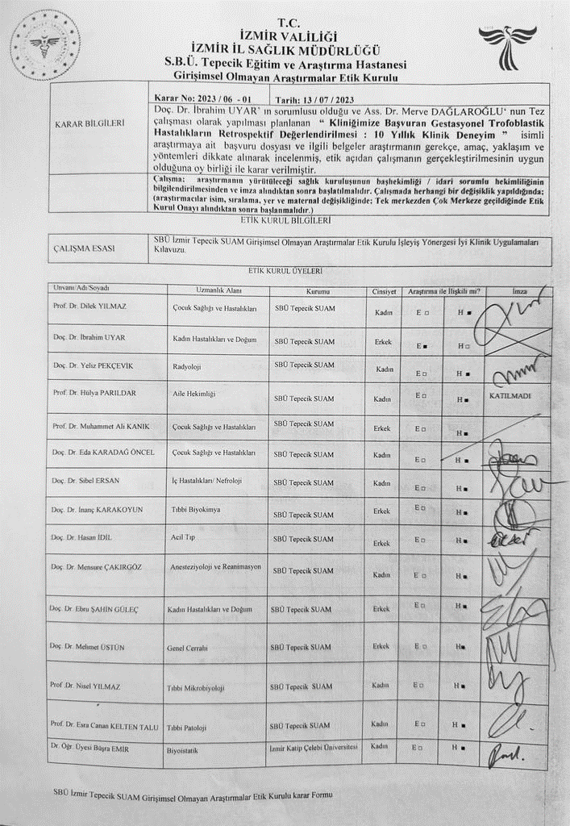
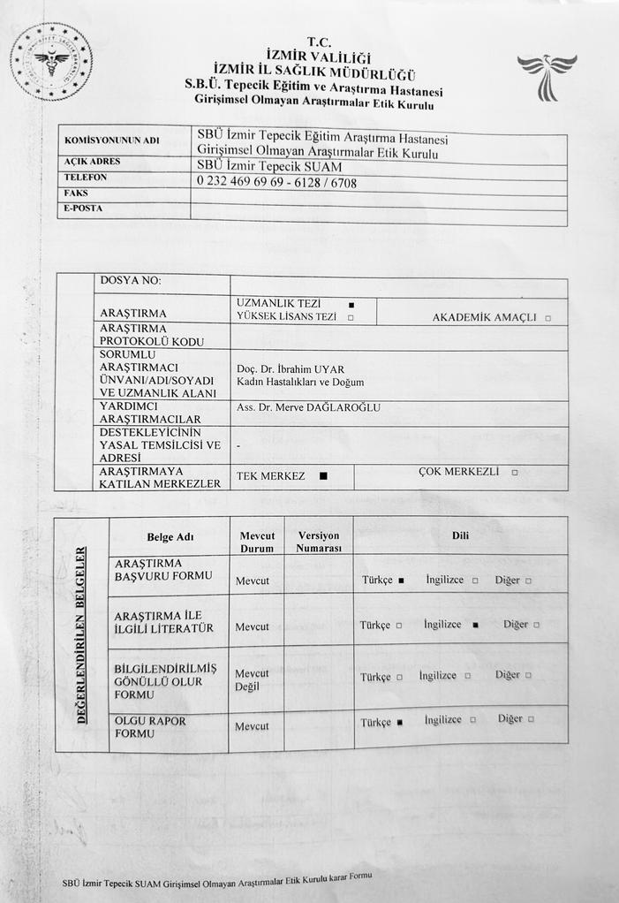

ÇIKAR ÇATIŞMASI
Araştırma ve tez yazımı süresince herhangi bir çıkar çatışması mevcut değildir. Herhangi bir kurum ya da kuruluştan destek alınmamıştır. Tez çalışmasının tasarımı STROBE- kesitsel çalışma kılavuzuna uygun olarak yapılmıştır. Tezin alıntılama oranı lisanslı program ile yapılmış olup % 22 izlenmiştir.

S-55 Approach To Incidentally Detected Unicornuate Uterus Rudimentary Horn Anomaly
Mesut Bala¹
1 S.b.ü. Gazi Yaşargil Eğitim Araştırma Hastanesi

ABSTRACT Unicornuate uterus with rudimentary horn is very rare congenital anatomic anomaly of women genital truct causing many obstetrical and gynecologic complications. The frequency of this pathology is approximately 1/100 000. Here in, we present a case of incidentally detected this congenital anomaly and discus our approach.
Keywords: Uterin Anomally, Unicorn
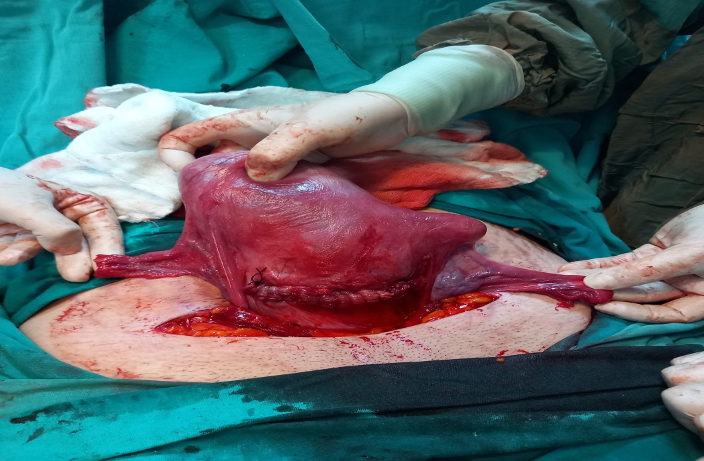
FIGURE.1. PRE-OP

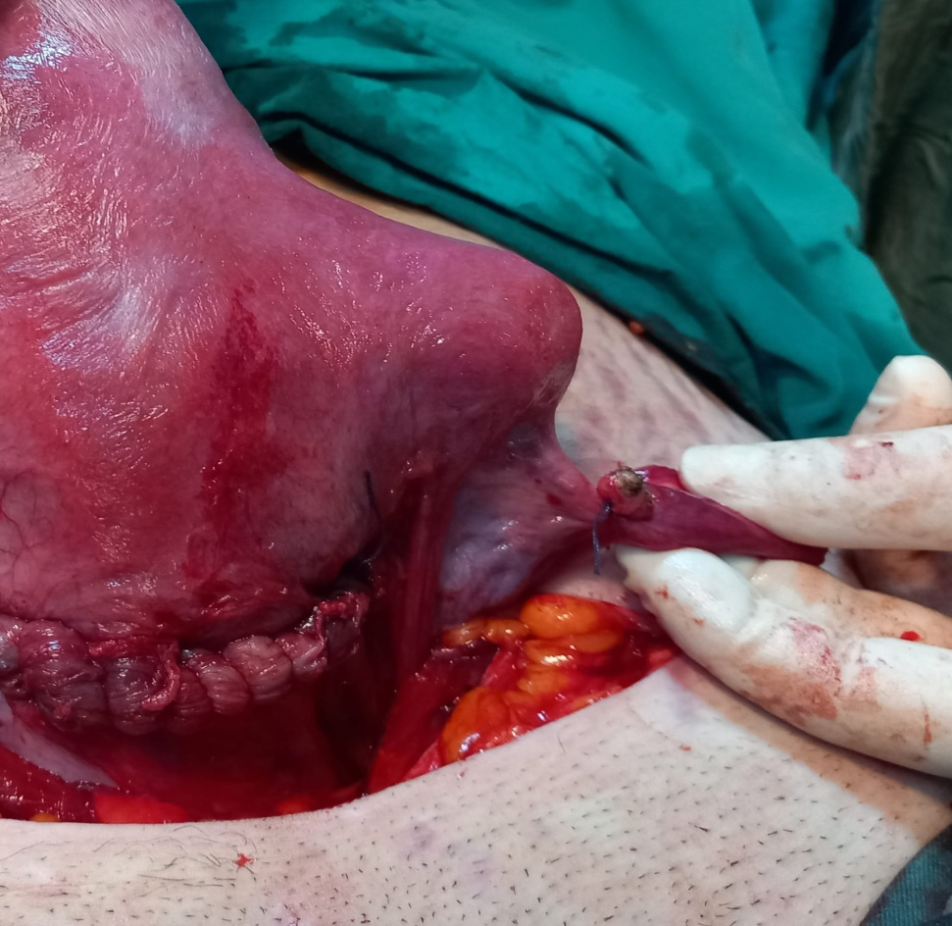
FIGURE.2. POST-OP

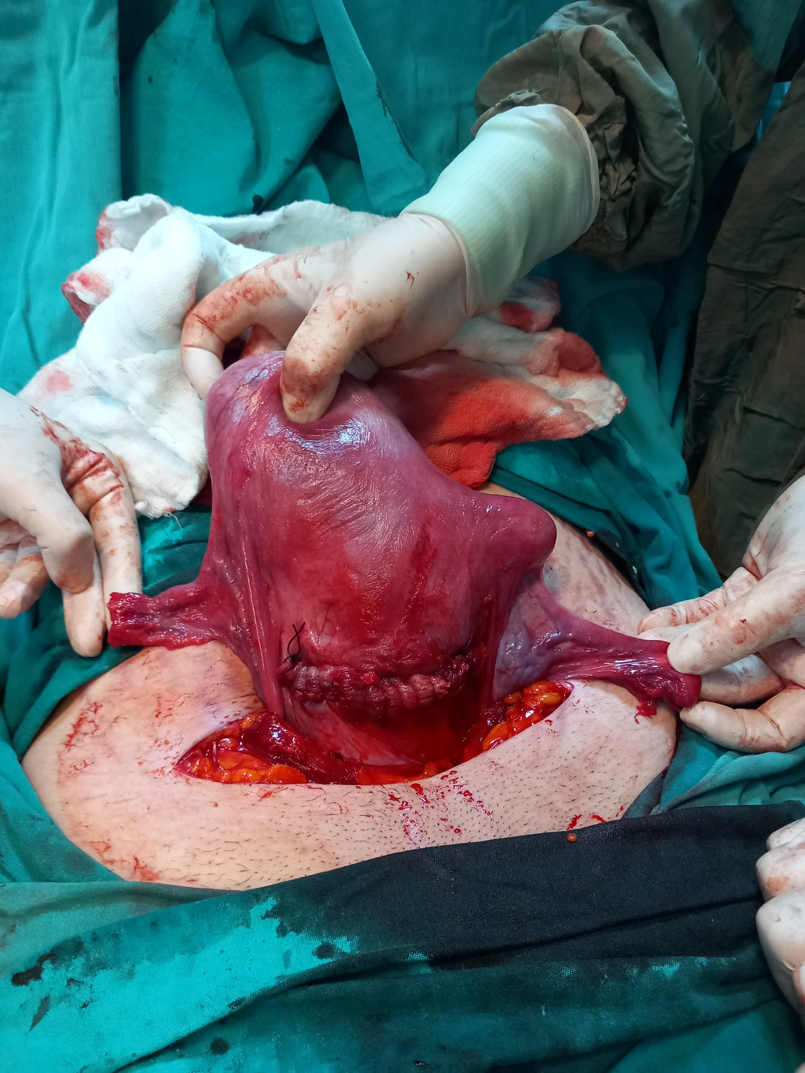

S-56 A Complication Of B-Lynch Uterine Compression Suture Which Is Resulting With Uterus Necrosis, A Case Report
Mesut Bala¹, Berfin Bulut¹, Emine Akkuş¹, Abdullah Acar¹, Sedat Akgöl¹
1 Saglık Bilimleri University Gazi Yaşargil Training And Research Hospital

İntroduction
Postpartum hemorrhage (PPH) is one of the leading causes of maternal mortality and morbidity worldwide, and PPH is responsible for 25-30% of maternal deaths worldwide each year. The most common cause of primary PPH is uterine atony. In postpartum atony cases that do not respond to medical treatment, uterine artery ligations, internal iliac artery ligations and 'uterine compression sutures' which are thought to be the surgical equivalent of uterine tamponade, have been described among conservative surgical procedures. Although uterine compression sutures are effective procedures in reducing bleeding due to atony, complications such as erosion, necrosis, and pyometra rarely occur. In this case, we aimed to emphasize that the possibility of complications after conservative surgical procedures should be considered in postpartum atony cases that do not respond to medical treatment.
Case
31 years old, G2P1Y1, term pregnant giving normal delivery in an external center. On the postpartum 6th day, she applies to another center with bleeding and B-Lynch suture is applied to the patient in order to control the bleeding caused by atony in the patient who does not respond to medical treatment. The patient, who was referred to us 2 days later with postpartum bleeding, was prepared in the lithotomy position under general anesthesia after preoperative blood preparation and hysterectomy consent forms were signed. In the vaginal examination, the episio, skin and vaginal mucosa were intact. The abdomen was entered through the old pfannenstiel incision. Widespread clotted hemorrhagic fluid was observed in the observation. An old b-lynch suture was observed in the uterus. Uterus, tuba and ovaries were edematous, fragile and necrotic. Deformations, bleeding and necrotizing areas were observed in the uterus and hysterectomy was decided. Round ligament, uterine artery, cardinal ligament were involved, cut and ligated. The infundibulopelvic ligament was opened, then the uterus was removed, and the vaginal cuff was created. The ovaries were not taken. Partial omentectomy and bridectomy were performed. Bleeding control was achieved, a drain was placed. Antibiotherapy was applied to the patient for 7 days. He was discharged on the 8th postoperative day.

Discussion
With the introduction of uterine compression sutures by B-Lynch in 1997, the surgical management of uterine atony has changed worldwide. Due to the B-Lynch suture is a uterus preservating surgery and can be applied relatively quickly and easily, it has been applied by many obstetricians until today. Despite its worldwide use, there are very few studies evaluating its success as well as complication rates. Our case report questions the success of the compression suture, and also mentions its rare complications. The case series on the success rate of these sutures is insufficient and more studies are needed.
Keywords:Postpartum Hemorrage, Uterine Atony, B-Lynch Uterine Compression Suture
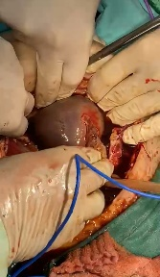
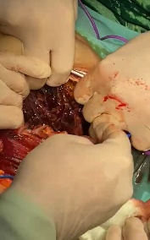
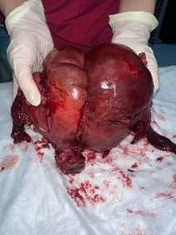
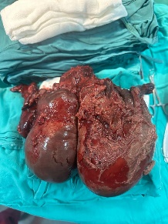
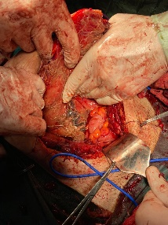

S-57 Obstetric Outcomes Of Pregnancies Diagnosed With Prenatal Hypoplastic Left Heart Syndrome: Experience Of Gazi Yaşargil Training And Research Hospital
Mustafa Fırat Aydın¹
1 S.b.ü Gazi Yaşargil Eğitim ve Araştırma Hastanesi

Abstract Objective: Evaluation of obstetric outcomes of pregnancies with prenatal diagnosis of Hypoplastic Left Heart Syndrome (HLHS). Material and Method: The results of the pregnancies followed up with the diagnosis of fetal HLHS in the Department of Obstetrics and Gynecology of Gazi Yaşargil Training and Research Hospital between 2022 and 2023 were retrospectively scanned. Maternal demographic characteristics and obstetric outcomes were evaluated. Results: 9 fetuses were diagnosed with HLHS in the prenatal period. The mean gestational age was 28 (21-39). The mean birth weight was 2540 (1430-3850) g. One fetus was terminated at the 21st week of pregnancy at the request of the family. Only one of the newborns was operated. The other 7 (87.5%) fetuses died after delivery. Conclusion: Mortality rates may be higher in fetuses diagnosed with Hypoplastic Left Heart Syndrome in the prenatal period compared to the literature. Therefore, care should be taken in the antenatal follow-up of these patients. Families should be informed in detail about the prognosis and births should be planned in tertiary centers. Keywords: Hypoplastic Left Heart Syndrome, obstetric outcomes, prenatal diagnosis,
Keywords: Hypoplastic Left Heart Syndrome, obstetric outcomes, prenatal diagnosis,
Introduction
Hypoplastic left heart syndrome includes different conditions with severe hypoplasia of the left ventricle and decreased left ventricular outflow. Surgery and medical interventions have improved outcomes in HLHS, but mortality and morbidity remain high. HLHS is the most common form of functional single-ventricle heart disease, with a birth prevalence of approximately 2 to 3 cases per 10,000 live births. HLHS accounts for 2 to 3 percent of all congenital heart diseases. HLHS is associated with 25 to 40 percent of all neonatal heart deaths when untreated. In this study, we aimed to evaluate the obstetric outcomes of fetuses with hypoplastic left heart syndrome in our clinic.
Material and Methods
The results of the pregnancies followed up with the diagnosis of fetal HLHS in the Department of Obstetrics and Gynecology of Gazi Yaşargil Training and Research Hospital between 2022 and 2023 were retrospectively scanned. Maternal demographic characteristics and obstetric outcomes were evaluated.
Results: 9 fetuses were diagnosed with HLHS in the prenatal period. The mean gestational age was 28 (21-39). The mean birth weight was 2540 (1430-3850) g. One fetus was terminated at the 21st week of pregnancy at the request of the family. Only one of the newborns was operated. The other 7 (87.5%) fetuses died after delivery. Demographic characteristics and obstetric results of the mother are given in table 1.

Table 1:Maternal demographic characteristics and obstetric outcomes were evaluated.
 | Age | Gravida | Parite | Abortus | Birth week | Birth weight | Route of delivery | Newborn outcome
Case 1 | 34 | 3 | 2 | 0 | 39 | 3850 g | c/s | Ex
Case 2 | 22 | 1 | 0 | 0 | 36 | 2600 g | c/s | Operation
Case 3 | 39 | 4 | 2 | 1 | 30 | 1500 g | c/s | Ex
Case 4 | 25 | 1 | 0 | 0 | 33 | 1430 g | c/s | Ex
Case 5 | 30 | 2 | 1 | 0 | 38 | 2140 g | c/s | Ex
Case 6 | 21 | 1 | 0 | 0 | 37 | 2830 g | c/s | Ex
Case 7 | 34 | 3 | 2 | 0 | 39 | 3750 g | c/s | Ex
Case 8 | 30 | 2 | 1 | 0 | 38 | 2240 g | c/s | Ex
Case 9 | 24 | 1 | 0 | 0 | - | - | - | Termination

Discussion
Despite successful cardiac surgery, HLHS is the congenital heart disease with the highest mortality. In the literature, the survival rate of fetuses diagnosed with HLHS is less than 40%. In a study involving 240 fetuses with HLHS, survival rates were found to be 65-79% in the low-risk group, while 37% in the high-risk group. In our study, the mortality rate of newborns was 87.5%. Only one of the newborns was operated.
In conclusion, mortality rates may be higher in fetuses diagnosed with Hypoplastic Left Heart Syndrome in the prenatal period compared to the literature. Therefore, care should be taken in the antenatal follow-up of these patients. Families should be informed in detail about the prognosis and births should be planned in tertiary centers.

References
1.Gordon BM, Rodriguez S, Lee M, Chang RK. Decreasing number of deaths of infants with hypoplastic left heart syndrome. J Pediatr 2008; 153:354.
2.Reller MD, Strickland MJ, Riehle-Colarusso T, et al. Prevalence of congenital heart defects in metropolitan Atlanta, 1998-2005. J Pediatr 2008; 153:807.
3.Fixler DE, Nembhard WN, Salemi JL, et al. Mortality in first 5 years in infants with functional single ventricle born in Texas, 1996 to 2003. Circulation 2010; 121:644.
4.Karamlou T, Diggs BS, Ungerleider RM, Welke KF. Evolution of treatment options and outcomes for hypoplastic left heart syndrome over an 18-year period. J Thorac Cardiovasc Surg 2010; 139:119.
5.Ohye RG, Sleeper LA, Mahony L, et al. Comparison of shunt types in the Norwood procedure for single-ventricle lesions. N Engl J Med 2010; 362:1980.
6. Rychik J, Szwast A, Natarajan S, Quartermain M, Donaghue DD, Combs J, et al. Perinatal and early surgical outcome for the fetus with hypoplastic left heart syndrome: a 5-year single institutional experience. Ultrasound in obstetrics & gynecology : the official journal of the International Society of Ultrasound in Obstetrics and Gynecology. 2010;36(4):465-70.
7. Galindo A, Nieto O, Villagrá S, Grañeras A, Herraiz I, Mendoza A. Hypoplastic left heart syndrome diagnosed in fetal life: associated findings, pregnancy outcome and results of palliative surgery. Ultrasound in obstetrics & gynecology : the official journal of the International Society of Ultrasound in Obstetrics and Gynecology. 2009;33(5):560-6.

S-58 Evalution Of Ovarian Reserve After Three Months Of İsotretinoin Treatment
Mustafa Şengül¹
1 Izmir Kâtip Çelebi Üniversitesi

ABSTRACT Aim: To investigate the effect of isotretinoin, used in the treatment of women of reproductive age with acne, on functional ovarian reserve by anti-Müllerian hormone (AMH), ovarian volume (OV) measurement and antral follicle count (AFC). Methods: In this prospective cohort study, AMH, ovarian volume (T1) before treatment (T 0 ) and after 3 months of treatment (T 1 ) of 18 premenopausal patients who will use isotretinoin standard dose (0.5-1 mg/kg/day) for acne treatment. Ovarian Volume (OV) measurement and antral follicle count (AFC) were performed. AMH at T 0 and T 1 were compared ultrasonographically and with a series of serum samples from 18 premenopausal women not receiving isotretinoin therapy. Results: When the treatment and study groups were compared in terms of AMH, OV, and AFC at the start (T0) and at the study end (T1) values, no statistical difference was found between T0 and T1 in either the control group or the treatment group (Table 3a). However, the change in AMH and AFC (T1 value-T0 value) was statistically higher in the treatment group than in the control group (p=0.007 and p=0.008, respectively, Table 3b). The change in OV was similar between the two groups (p=0.767) (Figure 1,2,3). Conclusion: Short-term isotretinoin use was not associated with AMH reduction and AFC. Prospective, multicenter studies with longer follow-ups are needed to reach definitive conclusions.
Keywords: Anti-mullerian hormone; İzotretinoin; Ovarian reserve
INTRODUCTION
Acne vulgaris is a self-limiting chronic inflammatory skin disease caused by hypersensitivity of pilosebaceous units (consisting of hair follicle and sebaceous gland) to circulating androgen levels (1). Acne vulgaris, whose prevalence is estimated to be approximately 9.4%(2) in the general population, affects 85% of individuals between the ages of 12-24 and its prevalence gradually decreases with increasing age(3,4). It can cause psychological problems, scarring resulting in post inflammatory pigmentation and disfigurement(5).

Systemic isotretinoin (13-cis retinoic acid) is a retinoid that is widely used in the treatment and acts by reducing the sebum production, follicular keratinization concentration and immunoregulatory properties involved in the pathogenesis of acne (6,7). There are many cumulative dose-dependent side effects such as cutaneous atrophy and erythema, ophthalmic and mucocutaneous dryness, palmoplantar desquamation, itching, bone marrow suppression and hepatotoxicity, and these are temporary(8).

Although there is no definite consensus on whether it has side effects on female fertility, it is one of the most curious subjects in the age population using the drug..
Follicle stimulating hormone (FSH), luteinizing hormone (LH), estradiol, inhibin B, Anti-Müllerian hormone (AMH) levels, Ovarian volume (OV), Antral follicle count (AFC) are used to evaluate functional ovarian reserve(9,10) ).

AMH is a glycoprotein hormone from the superfamily of transforming growth factor-β (TGF-β) secreted by granulosa cells of preantral and small antral follicles with a diameter of ≤8 mm(11). AMH levels in the reproductive period are closely related to the pool of ovulating follicles that have the potential to ovulate, and accordingly, AMH is the ideal marker to evaluate functional ovarian reserve(12).

Although AFC has more efficacy with high-tech ultrasonography and has disadvantages such as being affected by operator variability, it is a reliable method in the evaluation of ovarian reserve(13).
AFC and serum AMH values are the most ideal non-invasive markers of functional ovarian reserve(14).
Studies on the effect of oral isotretinoin, which is the main drug of acne treatment, on functional ovarian reserve are limited; Although the current results seem to affect the ovarian reserve negatively, a definite conclusion could not be reached(15-18). These studies compared the results after 6 months of treatment. As far as we know, it is the first study to compare the effect of isotretinoin on functional ovarian reserve after a short-term treatment of 3 months.
This study aimed to provide clinical evidence for the relationship of systemic isotretinoin and functional ovarian reserve and to evaluate the effects of short-term isotretinoin treatment on serum AMH concentration.

METHOD
Our observational, prospective cohort study was carried out in İzmir Katip Çelebi University Atatürk Training and Research Hospital, Department of Obstetrics and Gynecology, following the principles stated in the Declaration of Helsinki, between 30 July 2022 and 30 MAY 2023.
Acne patient population:
This study included 48 women of reproductive age, aged 18 to 28 years, who were diagnosed with acne for the first time and planned to receive standard dose (0.5-1 mg/kg/day) oral isotretinoin treatment. Thirty-six patients were included in the study after 12 patients were excluded from the study due to not using regular medication. Registered patients, at Izmir Katip Çelebi University Atatürk Training and Research Hospital, obstetrics and gynecology outpatient clinic before (T 0 ) and after 3 months of treatment (T 1 ) on the 2nd and 4th days of the menstrual cycle, evaluated in terms of measurement of ovarian volume (OV) by ultrasonography and antral follicle number (AFC). Venous blood samples were taken from patients with acne for AMH levels in the follicular phase. Patients with chronic disease (eg, diabetes mellitus, thyroid disease, hypertension or autoimmune disease), polycystic ovarian syndrome (PCOS), smoking history, history of ovarian surgery, and using systemic retinoid and hormonal contraceptives in the entire study population were excluded. Sociodemographic characteristics (age, body mass index [BMI], menstrual history) and medical history of the participants were recorded.

Control population:

Eighteen healthy women without acne or infertility were included in the study as a control group. In the group consisting of healthy women, ovarian volume measurement and Antral Follicle count were performed by transabdominal ultrasonography on the 2nd and 4th days of menstruation at T 0 and T 1 at the İzmir Katip Çelebi University Atatürk Training and Research Hospital, obstetrics and gynecology outpatient clinic. Those diagnosed with PCOS were excluded from the study. Blood samples were taken for AMH measurement.

Measurements:

Ultrasound scans were performed by the same physician (Mustafa Şengül) using (Esaote MyLabSeven, Esaote Group, Genova, Italy) with an 8-1 MHz multi-frequency AC2541 abdominal probe. Image analyzes were performed from the inner edges to the outer edges of the ovary in the sagittal and transversal planes(19). OV was calculated for each ovary using the formula Length (L) × Width (W) × Thickness (T) × 0.523 (20). The total number of antral follicles was calculated by measuring the follicles of 2-9 mm in diameter in both ovaries. Total OV (volume of both ovaries) and total AFC (number of follicles in the right + left ovary) were calculated.

Serum samples from both populations were measured in the same laboratory. Serum AMH concentrations were measured by ELISA using a commercial kit (ng/mL, Beckman Coulter, Chaska, MN, USA) suitable for all patients at T 0 or T 1 to reduce interlaboratory variability bias. The mean inter and intra-assay Coefficient of Variability (CVS) were 4.5% and 3.6%, respectively.

Statistical analysis:

Data were entered into the Statistical Package for the Social Sciences (IBM® SPSS Statistics for Windows, Version 23.0, Armonk, NY, USA) software package. Whether the distributions were normal or not was determined by Kolmogorov-Smirnov analysis. Normal distributions were calculated as mean (mean) and standard deviation (SD), non-normal distributions were calculated as median and difference between quartiles (IQR). Student's t-test was used to compare normal distributions. Non-parametric continuous variables that were not normally distributed were compared using Mann-Whitney U tests. p value <0.05 was considered statistically significant.

RESULTS
The mean age of the patients was 22.0±3.0 years and the mean BMI was 23.5±3.9 kg/m2. When baseline (T0) values were examined between the treatment and study groups, it was observed that there was no statistical difference between the two groups in terms of AMH, OV, and AFC (respectively, p=0.08, p=0.214, p=0.501) (Table 1). When the study outcome (T1) values between the treatment and study groups were examined, it was seen that there was no statistical difference between the two groups in terms of AMH, OV, and AFC (p=0.521, p=0.481, p=0.09, respectively) (Table 2). When the treatment and study groups were compared in terms of the values of AMH, OV, and AFC at the start (T0) and at the study end (T1), no statistical difference was found between T0 and T1 in either the control group or the treatment group (Table 3a). However, the change in AMH and AFC (T1 value-T0 value) was statistically higher in the treatment group than in the control group (p=0.007 and p=0.008, respectively, Table 3b). The change in OV was similar between the two groups (p=0.767) (Figure 1,2,3).

Table 1. Comparison of baseline (T0) values of demographic and blood routines of treatment and study group

Variables | Control Group (n=18) | Treatment Group (n=18) | p value
Age, Year, Mean (SD) | 22.6 (3.3) | 21.5 (2.6) | 0.252
BMI, kg/m2 mean (SD) | 24.8 (3.4) | 22.3 (4.0) | 0.06
Menstruel Irregularity Situtation durumu, n / %  No  Yes | 14 / 77.8  4 / 22.2 | 12 / 66.7  6 / 33.3 | 0.457
AMH, ng/mL medyan (IQR) | 2.10 (1.65) | 2.59 (1.97) | 0.08
OV, ml medyan (IQR) | 14.2 (1.7) | 13.7 (0.9) | 0.214
AFC, medyan (IQR) | 14.0 (4.0) | 14.0 (2.0) | 0.501

Table 2. Comparison of the blood routines of the treatment and study group at the study end date (T1)

Variables | Control Group (n=18) | Treatment Group (n=18) | p value
AMH, ng/mL median (IQR) | 2.14 (1.69) | 1.92 (1.92) | 0.521
OV, ml median (IQR) | 13.3 (2.7) | 13.2 (1.0) | 0.481
AFC, median (IQR) | 14.0 (5.0) | 12.5 (3.0) | 0.09

Table 3. a) Comparison of AMH, OV, and AFC values at the start of the study (T0) and at the end of the study (T1) in terms of AMH, OV, and AFC between the treatment and study groups, b) Comparison of the changes in the treatment and study groups in terms of AMH, OV and AFC at the start of the study (T0) and at the study end date (T1)

a) Comparison of the study start (T0) and study end date (T1) values in terms of AMH, OV, and AFC between treatment and study groups
 | Control Group |  |  | Treatment Group
Variables | T0 | T1 | p value | T0 | T1 | p value
AMH, ng/mL median (IQR) | 2.10 (1.65) | 2.14 (1.69) | 0.261 | 2.59 (1.97) | 1.92 (1.92) | 0.531
OV, ml median (IQR) | 14.2 (1.7) | 13.3 (2.7) | 0.765 | 13.7 (0.9) | 13.2 (1.0) | 0.216
AFC, median (IQR) | 14.0 (4.0) | 14.0 (5.0) | 0.461 | 14.0 (2.0) | 12.5 (3.0) | 0.285
b) Comparison of the changes (T1-T0) of the treatment and study groups in terms of AMH, OV and AFC at the start of the study (T0) and at the study end date (T1)
Variables | Control Group |  | Treatment Grouo |  | p value
AMH change, ng/mL median (IQR) | -0.03 (0.29) |  | -0.62 (1.57) |  | 0.007
OV change, ml median (IQR) | -0.35 (0.62) |  | -0.35 (0.62) |  | 0.767
AFC change , median (IQR) | -1.0 (1.0) |  | -2.0 (3) |  | 0.008
Bold p values indicate statistical significance; number, SD; standard deviation, IQR; interquartile range,

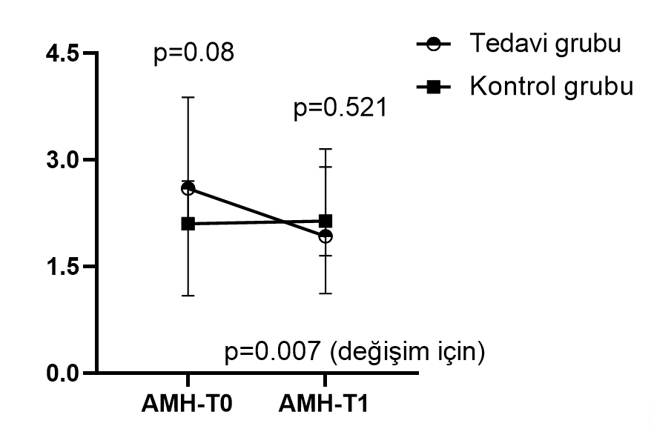

Figure 1: AMH (T0 value-T1 value) between groups

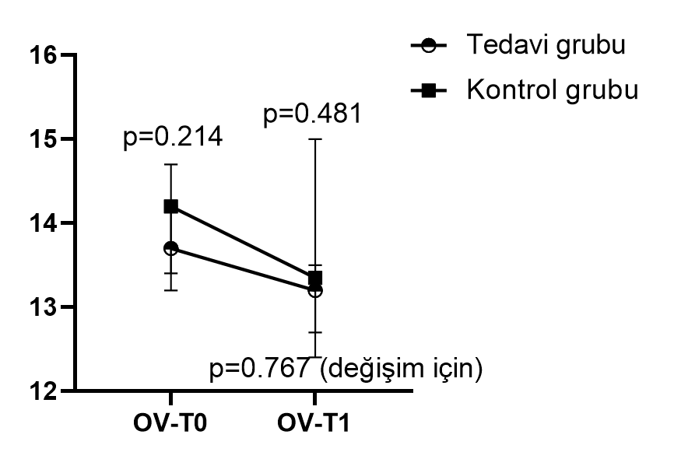
Figure 2: OV between groups (T0 value-T1 value)

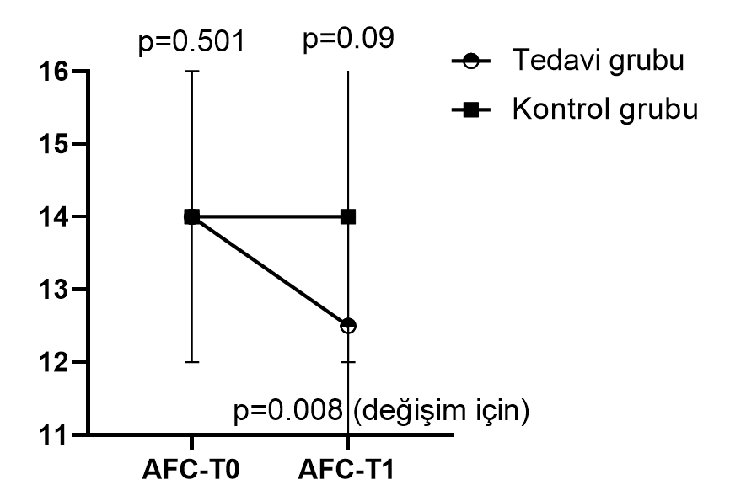
Figure 3: AFC (T0 value-T1 value) between groups

DISCUSSION AND CONCLUSION

Since the introduction of systemic isotretinoin in the treatment of acne, it has been a life-saving treatment option for physicians and patients. However, many side effects have been described. Its effect on female fertility caused anxiety in patients. There are conflicting reports on the effect of retinoic acid in the literature. Aksoy H et al. showed that systemic isotretinoin use has a significant negative effect on ovarian reserve(17). Although decreased, it was found to be statistically similar to the initial values (16,18).

The limitation of this study was the evaluation of OV and AFC using transabdominal ultrasonography, since the patients were virgins. Another limitation was the inability to follow-up the patients for a long time. Besides, its strengths were the prospective design of the study.
In conclusion, our study is one of the comprehensive studies examining the effects of isotretinoin on female fertility and contributes to the literature. Further studies are needed to increase understanding of this issue.

REFERENCES

- Motosko CC, Zakhem GA, Pomeranz MK, Hazen A. Acne: a masculinizing hormonal side effect like trance. BrJ Dermatol. January 2019; 180(1):26-30. 2
- Vos T, Flaxman AD, Naghavi M, et al. Years lived with disability (YLDs) for 1160 sequelae of 289 diseases and injuries 1990–2010: a systematic analysis for the Global Burden of Disease Study 2010. Lancet. 2012;380(9859):2163–2196.
- Tan JK, Bhate K. A global perspective on the epidemiology of acne. Br J Dermatol. 2015;172(Suppl 1):3–12.
- Eichenfield DZ, Sprague J, Eichenfield LF. Management of Acne Vulgaris: A Review. JAMA. 2021 Nov 23;326(20):2055-2067.
- Sutaria AH, Masood S, Schlessinger J. StatPearls [Internet] Treasure Island, FL: StatPearls Publishing; 2021. Acne vulgaris.
- Katsambas A, Papakonstantinou A. Acne: Systemic treatment. Clin Dermatol 2004; 22: 412-418.
- Edileia Bagatin & Caroline Sousa Costa (2020) The use of isotretinoin for acne – an update on optimal dosing, surveillance, and adverse effects, Expert Review of Clinical Pharmacology, 13:8, 885-897.
- Owen C. Oral isotretinoin therapy for acne vulgaris. In: Dellavalle RP, Levy ML, Callen J, Ofori AO, editors. Current. Waltham, MA: [Accessed July 28, 2021]. https://www.uptodate.com/contents/oral-isotretinoin-therapy-for-acne-vulgaris.
- Monniaux D, Clement F, Dalbies Tran R, et al. The ovarian reserve of primordial follicles and the dynamic reserve of antral growing follicles: what is the link? Biol Reprod. 2014;90(4):85.
- Hendriks DJ, Kwee J, Mol BW, et al. Ultrasonography as a tool for the prediction of outcome in IVF patients: a comparative meta-analysis of ovarian volume and antral follicle count. Fertil Steril. 2007;87(4):764–775.
- Broer SL, Broekmans FJ, Laven JS, Fauser BC. Anti-Mullerian hormone: ovarian reserve testing and its potential clinical implications. Hum Reprod Update. 2014;20(5):688–70.
- Moolhuijsen LME, Visser JA. Anti-Müllerian Hormone and Ovarian Reserve: Update on Assessing Ovarian Function. J Clin Endocrinol Metab. 2020 Nov 1;105(11):3361–73.
- La Marca, G. Stabile, A. Carducci Artenisio, and A. Volpe, “Serum anti-Mullerian hormone throughout the human menstrual cycle,” Human Reproduction, vol. 21, no. 12, pp. 3103–3107.
- Scheffer JB, Scheffer BB, Carvalho RF, Vellez LT, Florencio F, Grynberg M. Anti-Mullerian as predictor of reproductive outcome in infertile women: follow up. JBRA Assist Reprod. 2014 Sep 27;18(3):80-84.
- Sikar Aktürk A, Abalı R, Yüksel MA, Güzel EÇ, Güzel S, Kıran R. The effects of isotretinoin on the ovarian reserve of females with acne. Gynecol Endocrinol. 2014 Jan;30(1):30-3.
- Öztürk S, Öztürk T, Ucak H, Erden I, Demir B, Kayalı A, Cicek D. Evaluation of ovarian reserve and function in female patients treated with oral isotretinoin for severe acne: an exploratory study. Cutan Ocul Toxicol. 2015 Mar;34(1):21-4.
- Aksoy H, Cinar L, Acmaz G, Aksoy U, Aydin T, Vurdem UE, Oz L, Idem Karadag O, Kartal D. The effect of isotretinoin on ovarian reserve based on hormonal parameters, ovarian volume, and antral follicle count in women with acne. Gynecol Obstet Invest. 2015;79(2):78-82.
- Cinar SL, Kartal D, Aksoy H, Cinar E, Aydin T, Öz L, İmamoğlu H, Ferahbas A, Borlu M. Long-term effect of systemic isotretinoin on female fertility. Cutan Ocul Toxicol. 2017 Jun;36(2):132-134.
- Sipahi M, Tokgöz VY, Keskin Ö, Atasever M, Menteşe A, Demir S. Is ovarian volume a good predictor to determine metabolic syndrome development in polycystic ovary patients. J Obstet Gynaecol. 2019 Apr;39(3):372-376.
- Leonhardt H, Gull B, Stener-Victorin E, et al. Ovarian volume and antral follicle count assessed by MRI and transvaginal ultrasonography: a methodological study. Acta Radiol. 2014; 55(2): 248–256.

S-59 Uterus Preserving Surgical Management In A Case Of Placenta Percreta
Neslihan Uğur Demirel¹
1 Sağlık Bilimleri Üniversitesi Gazi Yaşargil Eğitim ve Araştırma Hastanesi

Placenta percreata It occurs due to damage to the decidua basalis and its inability to fulfill its barrier function adequately. Chorionic villi adheres to the myometrial surface but does not penetrate the myometrium placenta accreta , the type that does not infiltrate the myometrium placenta increta , the type that infiltrates the entire myometrium The type in which it infiltrates into the serosa and sometimes into neighboring organs is called placenta percreta. These cases are delivered by cesarean section and some of them are delivered postpartum hysterectomy may be required. Lower uterine segment resection may be a suitable option in patients requiring fertility preserving surgery.Placenta accreta , which is the mildest form among placental invasion anomalies , is seen in 60% of the cases, while placenta percreta is the most advanced form, accounting for 20% of the cases. In case of placenta percreata , chorionicvilliIt penetrates completely into the myometrium and, in some cases, can spread to surrounding tissues. Placenta accreta is frequently seen in women with a history of cesarean section, scar tissue in the uterus, women who have had a manual abortion, and pregnant women with high parity. Placental invasion anomalies can cause serious maternal complications and require hysterectomy. Diagnosing placenta percreta antenatally can be difficult, and ultrasonography may not always provide sufficient information. The classic treatment is hysterectomy. Hemodynamically stable cases of placenta percreta can be treated conservatively with methotrexate , uterine artery embolization .It is another method that can be used in cases who want to preserve their fertility. In our case, a method other than other treatment options was used, avoiding hysterectomy in order to preserve fertility. The invaded lower segment of the placenta was removed together with the placenta tissue, and the remaining uterine tissue was repaired.
Keywords: Placenta percreta , placenta previa , cesarean section
Introduction
Placenta percreata It occurs due to damage to the decidua basalis and its inability to fulfill its barrier function adequately. Chorionic villi adheres to the myometrial surface but does not penetrate the myometrium placenta accreta , the type that does not infiltrate the myometrium placenta increta , the type that infiltrates the entire myometrium The type in which it infiltrates into the serosa and sometimes into neighboring organs is called placenta percreta (1). These cases are delivered by cesarean section and some of them are delivered postpartum.hysterectomy may be required. Lower uterine segment resection may be a suitable option in patients requiring fertility preserving surgery.
Case
The 31-year-old mother, who was 38 weeks pregnant according to her enstrual perilast mod, had 3 live births by cesarean section out of 4 pregnancies. The patient applied to our clinic due to pain. In obstetric ultrasonography, it was observed that there was a single live pregnancy compatible with 38 weeks and total placenta percreata . placenta uterus. It invaded the anterior wall and did not cover the cervix. During the preoperative preparation phase, informed consent was obtained from the patient for cesarean section and hysterectomy surgeries. During the observation, placenta percreta was observed in the anterior lower segment of the uterus (Figure

1).
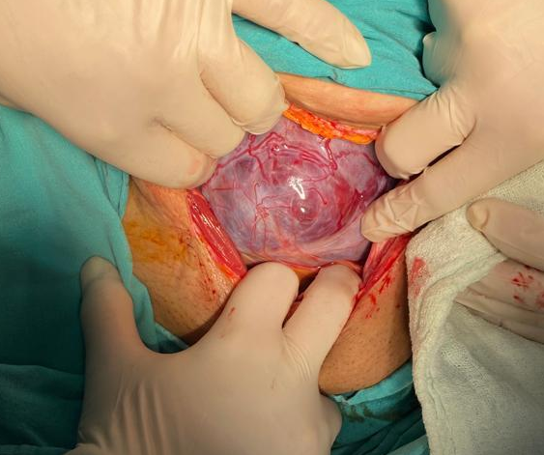

into the uteruskehrAn incision was made and a 3130 g 48 cm A:8/9 male baby was delivered. The area where the placenta invaded was removed together with the lower segment of the uterus . Then, the excised areas were brought closer together and sutured . Approximately 1000 cc of bleeding occurred intraoperatively. (Picture 2).

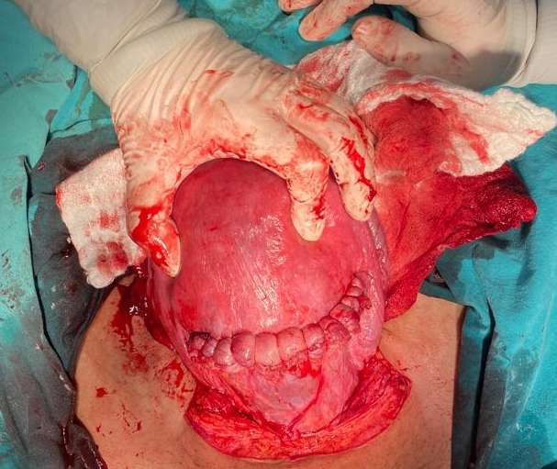
A total of 1 unit of erythrocyte suspension was given to the patient during the intraoperative and postoperative periods. The patient was discharged with surgical recovery on the second postoperative day .
Conclusion
Placenta accreta , which is the mildest form among placental invasion anomalies , is seen in 60% of the cases, while placenta percreta is the most advanced form, accounting for 20% of the cases. In case of placenta percreata , chorionicvilliIt penetrates completely into the myometrium and, in some cases, can spread to surrounding tissues. Placenta accreta is frequently seen in women with a history of cesarean section, scar tissue in the uterus, women who have had a manual abortion, and pregnant women with high parity (2). Placental invasion anomalies can cause serious maternal complications and require hysterectomy. Diagnosing placenta percreta antenatally can be difficult, and ultrasonography may not always provide sufficient information. The classic treatment is hysterectomy. (3). Hemodynamically stable cases of placenta percreta can be treated conservatively with methotrexate , uterine artery embolization .It is another method that can be used in cases who want to preserve their fertility (4). In our case, a method other than other treatment options was used, avoiding hysterectomy in order to preserve fertility. The invaded lower segment of the placenta was removed together with the placenta tissue, and the remaining uterine tissue was repaired.
References
1. Cresswell JA, Ronsmans C, Calvert C, Filippi V. Prevalence of placenta praevia by world region: a systematic review and meta-analysis. Trop Med Int Health. 2013 Jun;18(6):712-24.
2. Wu S, Kocherginsky M, Hibbard JU. Abnormal placentation: twenty-year analysis. Am J Obstet Gynecol. 2005 May;192(5):1458-61.
3. Rabenda-LackaK,Wilezynski J, Radoch Z, Breborowicz GH. Obstetricalhysterectomy. ArchGynecolObstet 2001; 265: 89-90.
4. Butt K, Gagnon A, Delilse MF. Failure of methotrexate and internal iliac balloon catheterization to manage placenta percreta. ObstetGynecol 2002; 99: 981-2.
Key Words: Placenta percreta , placenta previa , cesarean section

S-60 The Evaluation Of The Relationship Between Adnexal Torsion Angle And Necrosis : A Cross-Sectional Study
Onur Yavuz¹, Kadir Alper Mankan¹, Umay Balcı¹, Aslı Akdöner¹
1 Dokuz Eylül Üniversitesi Hastanesi

Objective: The aim of this study is to reveal the relationship between the intraoperative observed adnexal torsion (AT) angle and adnexal necrosis. Materials and methods: This was a cross-sectional study conducted at a tertiary center. Between 2018 and 2023, a total of 64 patients who underwent surgery for AT in our clinic were included in this study. The cases were classified as Group 1 (Torsiyon angle = 360°; n= 27, 42%) and Group 2 (Torsiyon angle > 360°; n:=37, 58%) according to the torsion angle. The macroscopic description of adnexal necrosis was made intraoperatively and observationally. Results: The median preoperative serum white blood cells (WBC) of all participants was 8.8. There was no statistical difference between the groups (p=0.4). The median neutrophil lymphocyte ratio (NLR) of all participants was 4.2 . Although the WBC of Group 2 was higher, the groups were similar (p=0.8). The groups are similar in terms of whirlpool sign, increased pelvic free fluid, diameter of the longest axis of the adnexa and doopler flow (p=0.4, p=0.2, p=0.4 p=0.5; respectively). The evaluation of adnexal appearance differed statistically between groups (p=0.04). The groups are similar in terms of surgical management (p=0.09). Inraoperative necrosis was detected in 25% of all cases (16/64). This rate was 14.8% in Group 1 and 32.4% in Group 2. There was no statistical difference between the groups (p=0.1). Conclusion: Intraoperative necrosis was observed more frequently in cases with a torsion angle greater than 360°. However, it is important to acknowledge that other factors may also contribute to the occurrence of necrosis. Therefore, a comprehensive evaluation, including clinical examination, laboratory tests, and imaging methods, should be conducted. In cases of any uncertainty, laparoscopy, the current standard approach, should be considered.
Keywords: torsion angle, adnexal necrosis, adnexal torsion
INTRODUCTION
Adnexal torsion (AT) refers to the twisting of adnexal structures, which encompass the ovary, fallopian tube, and their associated ligamentous supports. Its occurrence in the emergency department is relatively rare, with a prevalence rate of 2.7%¹. AT is frequently observed in women of reproductive age, although it can also manifest in postmenopausal women². Ovarian cysts (especially >5cm), prior tubal ligation, history of torsion and pregnancy are established predisposing factors for adnexal torsion^{3,4}. The symptoms and clinical manifestations of AT are frequently non-specific, rendering it challenging to distinguish from non-gynecological etiologies. A delayed diagnosis of AT can result in adnexal loss, ovarian necrosis, subfertility, early menopause, and peritonitis². Timely diagnosis and prompt surgical referral are imperative for achieving favorable surgical outcomes, which often involve the preservation of adnexal structures.
Adnexal torsion (AT) frequently disrupts the vascular supply to the ovary and fallopian tube, resulting in varying degrees of tissue ischemia and necrosis. Ultrasonography (US) is the primary imaging modality of choice for the initial evaluation of women suspected of having AT. An accurate sonographic diagnosis of AT has been reported in a range of 23% to 81% of cases in women⁵. The broad spectrum of ratios documented in the literature reflects a controversy regarding the accuracy of US in diagnosing AT. Bardin et al. reported the sensitivity and positive predictive value (PPV) of a preoperative ultrasound diagnosis of AT were 84.4 % (95% CI 0.79–0.88) and 81.4 % (95% CI 0.76–0.86), respectively⁵. In addition, because the clinical presentation of AT is similar to other causes of acute abdominal pain, computed tomography (CT) scan is sometimes performed as part of the routine evaluation of abdominal pain. If the clinical presentation is unclear, CT scan may serve as the initial diagnostic imaging technique. A previous study showed that intraoperatively observed necrosis only occurs when the torsion angle is >360° on CT⁶. It is believed that factors such as the duration between the onset of the patient's symptoms and the surgical intervention, as well as the extent of adnexal twisting, can impact the intraoperative presence of adnexal necrosis.
The aim of this study is to reveal the relationship between the intraoperative observed AT angle and adnexal necrosis.

MATERIAL AND METHODS
This was a cross-sectional study conducted at a tertiary center. The institutional ethical approval was provided. Informed consent of the patients was obtained. The study was conducted in accordance with the Helsinki Declaration Principles. Between 2018 and 2023, a total of 64 patients who underwent surgery for AT in our clinic were included in this study. Pregnant patients and cases with less than one full twist (<360$°)$ of the adnexa around any ligament observed perioperatively were excluded from the study. One full twist of AT around any ligament was recorded as 360$°$. The AT angle of cases with more than one full twist around any ligament was calculated based on intraoperative observations, taking into account the number of twist. The cases were classified as Group 1 (Torsiyon angle = 360°; n= 27, 42%) and Group 2 (Torsiyon angle > 360°; n:=37, 58%) according to the torsion angle. Demographic features, laboratory and imaging findings of the patients were documented. Surgical operation features were recorded. If the pathology material was excised during the operation, it was examined from the records.
The macroscopic definition of adnexal necrosis in intraoperative observation was made as follows (Figure 1): The torsioned organ often exhibits enlargement attributed to engorgement, edema, and ischemia. It typically displays a bluish-black coloration and distinctive hemorrhagic foci. The black-blue appearance of the organ's surface can be attributed to hemorrhagic congestion and necrosis.
Statistical analyses were conducted using IBM SPSS Statistics version 26.0 (IBM Inc., Chicago, IL, USA). The normality of data distribution was assessed using the Kolmogorov-Smirnov test. Non-normally distributed variables were analyzed using the Mann-Whitney U test. Categorical data were analyzed using the Chi-square test and Fisher's exact test. Quantitative data were reported as median (minimum-maximum), whereas categorical data were presented as counts and percentages (%). The p value considered statistically significant was <0.05.

RESULTS
Table 1 presents demographic characteristics of the study groups. The median age of study participants' was 33 years. The median age of Group 1 was 41 and Group 2 was 28 (p=0.007). Out of all participants, 82.8% (53/64) were premenopausal women. In Group 2, 94.6% (35/37) were postmenopausal women, whereas in Group 1, 33.3% (9/27) were premenopausal women. A statistically significant difference was observed between the two groups in terms of menopausal status (p=0.006). The most common symptom was pelvic pain in both groups (81.5% vs 86.5%). In terms of symptoms, the groups are similar (p=0.6). 12.5% (8/64) of all participants had a history of torsion. While this rate was 3.7% (1/27) in Group 1, it was 18.9% (7/37) in Group 2. There was no statistically significant difference between the groups. (p=0.06). The groups are similar in terms of other demographic characteristics (p>0.05).
Laboratory and imaging findings of the patients were shown in Table 2. The median preoperative serum white blood cells (WBC) of all participants was 8.8. There was no statistical difference between the groups (8.8 vs 8.8, p=0.4). The median neutrophil lymphocyte ratio (NLR) of all participants was 4.2 . Although the WBC of Group 2 was higher, the groups were similar (3.5 vs 4.3, p=0.8). Transabdominal US was performed because 14 of 64 patients were virgin. Virgin patients (n=14) were examined with transabdominal US, other patients (n=50) were examined with transvaginal US. The groups are similar in terms of whirlpool sign, increased pelvic free fluid, diameter of the longest axis of the adnexa and doopler flow (p=0.4, p=0.2, p=0.4 p=0.5; respectively). The evaluation of adnexal appearance differed statistically between groups (p=0.04). In group 1, both normal size, edema and cystic features were significantly different (18.5% vs 2.7%, p=0.04; 74.1% vs 73%,p=0.04; respectively).
Table 3 shows surgical operation features of the groups. Only ovarian torsion was detected in 70.3% of all patients, and AT in 29.7%. The ovarian torsion rate was 63% in Group 1 and 75.7% in Group 2 (p=0.2). Participants' median torsion angle was 720$°$. In group 2, the median torsion angle was statistically higher than Group 1 (360$°$ vs 1080$°$, p<0.0001). The groups are similar in terms of surgical management (p=0.09). Detorsion was performed in 42.2% of all participants (27/64). Nine of these operations were performed with laparotomy, while 18 were performed with laparoscopy. In 10 cases, only detorsion operations were performed, whereas in 17 cases, both detorsion and cystectomy procedures were carried out. The pathology results of the cases who underwent detorsion and cystectomy are as follows: mature teratomas (n=5), functional cysts (n=9), benign mucinous cystadenomas (n=2), paratubal cyst (n=1). Detorsion rate was higher in Group 2 than Group 1 (29.6% vs 51.4%). Unilateral salpingooferectomy (USO) was performed in 39.1% of all participants (25/64). Eight of these operations were performed with laparotomy, while 17 were performed with laparoscopy. The pathology results of the cases who underwent USO are as follows: functional cysts (n=12), mature teratomas (n=6), benign mucinous cystadenomas (n=4), paratubal cyst (n=2), benign mucinous cystadenofibroma (n=1). USO rate was higher in Group 1 than Group 2 (40.7 % vs 37.8%). Hysterectomy and bilateral salpingoooferectomy (BSO) was performed in 18.8% of all participants (12/64). Ten of these operations were performed with laparotomy, while 2 were performed with laparoscopy. The pathology results of the cases who underwent hysterectomy and BSO are as follows: functional cysts (n=5), benign mucinous cystadenomas (n=3), benign mucinous cystadenofibroma (n=2), adult type granulous cell tumor (n=1), serous carcinoma (n=1). Hysterectomy and BSO rate was higher in Group 1 than Group 2 (29.6 % vs 10.8%). Ligamentopexy was performed in 6 patients (9.4%), the groups were similar (3.7% vs 13.5%, p=0.1). Inraoperative necrosis was detected in 25% of all cases (16/64). This rate was 14.8% in Group 1 and 32.4% in Group 2. There was no statistical difference between the groups (p=0.1). Groups are similar in terms of torsion region and location (p=0.5; p=0.5, respectively). Time to surgery was determined as 23 hours in Group 1 and 5 hours in Group 2 (p=0.001). Median hospitalization was 3 days in Group 1 and 3 days in Group 2 (p=0.01).

DISCUSSION

In this study, the relationship between torsion angle and necrosis in patients with AT was evaluated. Intraoperative necrosis findings were more common in patients with a torsion angle greater than 360°. However, this difference was not statistically significant. Regardless of torsion, cases with suspected AT in preoperative laboratory and imaging methods are at risk of necrosis and emergency surgery should be performed.
Adnexal torsion (AT) is one of the most common causes of acute pelvic pain in non-pregnant women, preceded by corpus luteum rupture with hemorrhage, and followed by pelvic inflammatory disease, malpositioned intrauterine device, and degenerating fibroids⁷. It is most common in women of reproductive age but it can rarely occur in postmenopausal women⁸. The cases included in our study were predominantly within the reproductive period. Approximately one-fifth of participants were in the postmenopausal period. When evaluating the predisposing factors for AT, such as torsion and tubal ligation, no statistically significant difference was observed between the groups. Most patients with AT are symptomatic and the most common symptom is acute pelvic pain⁹. In our study, acute pelvic pain was the most common complaint in 84.4% of the patients. This symptom was similar between the groups.
The WBC count serves as an indicator of inflammation. Elevated WBC counts have been documented in several studies involving AT cases^{10,11}. However, it's important to note that increased WBC counts were not detected in all AT cases. For instance, Chiou et al. assessed 55 torsion cases in patients aged between 12 and 85 years and found an elevated WBC count in 64% of cases¹⁰. In contrast, Melcer et al. reported a notably lower rate of leukocytosis. Among 111 AT cases involving women of reproductive age, the rate of elevated WBC counts exceeding 11 was 32.4%¹¹. The median WBC of the cases in our study was <11. There was no statistically significant difference between the groups in terms of WBC.
Kinay et al. reported the mean NLR value of AT cases as 5.9¹². The optimal NLR cut-off value for predicting AT was 2.51 with a sensitivity of 72% and a specificity of 78%. Yilmaz et al. reported the results of 136 ovarian cyst cases with lower abdominal pain. They found an NLR cut-off value of 2.44 with a sensitivity of 70.5% and a specificity of 70.4% in the diagnosis of the torsion of an ovarian cyst¹³. In our study, the median NLR value of all cases was 4.2. Although this value was higher in Group 2, this difference was not statistically different.
Moro et. al. evaluated the preoperative US findings of 315 AT cases⁹. The presence/absence of ovarian stromal edema was available in the original US reports in 241/315 patients, and this sign was reported in 167 of them (69.3%). The whirlpool sign was available in 226/315 patients and was reported in 178/226 (78.8%) patients. The absence of doppler signals was available in 269/315 patients and it was reported in 119/269 patients (44.2%). The increased pelvic free fluid was detected in 196/275 patients (71.6%). The whirlpool sign was available in 226/315 patients and was reported in 178/226 (78.8%) patients. The median of the largest diameter of the twisted organ as measured on US was 8.3 cm. In our study, the whirlpool sign rate was found to be 6.3%. In group 2, the whirlpool sign was approximately two times higher. However, there was no statistical difference. Increased pelvic free fluid was present in half of all patients. Although this rate is higher in Group 2, the groups are similar. Diameter of the longest axis of the adnexa was determined as 5 cm in both groups. Interestingly, 21.9% of all patients had an absence doopler flow. The absence doopler flow was higher in the group with higher torsion angle. However, there was no statistical difference. The groups were statistically different in terms of evaluation of adnexal appearance. Normal adnexa was seven times higher in Group 1 and this was statistically different. Although edema was detected at a rate of approximately three times higher in Group 2 and the groups were similar. Remarkably, edema and cystic finding were higher there in Group 1, which is statistically different.
Adnexal masses prone to torsion typically comprise functional ovarian cysts, with dermoid cysts and serous cystadenomas being the most frequently encountered pathologies⁸. Torsion occurrences are uncommon in patients afflicted by endometriosis or malignant lesions, likely owing to an elevated likelihood of local inflammation accompanied by adhesions that anchor the mass in place¹⁴. AT also exhibits a predilection for the right side. One plausible explanation is that the presence of the sigmoid colon in the left pelvic region reduces available space, thus diminishing the risk of torsion on the left side¹⁵. In our study, the right AT and twist around ovarian ligament were highest in both groups. The groups are similar in terms of these characteristics. The time from the onset of clinical findings to the operation was 5.5 times longer in Group 1. However, the rate of intraoperative adnexal necrosis was approximately two times higher in Group 2, which had a higher torsion angle. This difference was not statistically significant.
Adnexal torsion (AT) is considered a surgical emergency, and the most common treatment approach is laparoscopy. There are conservative (detorsion $±$ cystectomy) and definitive options (USO/ hysterectomy + BSO) for treatment. Age, future fertility, menopausal status, and evidence of ovarian disease are all factors considered in the management decision. In our study, there was no difference between the groups in terms of surgical management.

This study has several limitations, with the retrospective design being the first and foremost. The identification of intraoperative necrosis is a subjective criterion. Unfortunately, the torsion angle has been evaluated observationally.
In conclusion, intraoperative necrosis was observed more frequently in cases with a torsion angle greater than 360°. However, it is important to acknowledge that other factors may also contribute to the occurrence of necrosis. Therefore, a comprehensive evaluation, including clinical examination, laboratory tests, and imaging methods, should be conducted. In cases of any uncertainty, laparoscopy, the current standard approach, should be considered.

REFERENCES
1. Hibbard LT. Adnexal torsion. Am J Obstet Gynecol. 1985;152(4):456-461.
2. Wattar B, Rimmer M, Rogozinska, et al. Accuracy of imaging modalities for adnexal torsion: a systematic review and meta-analysis. BJOG. 2021;128(1):37-44.
3. Boswell KMO, Silverberg KM. Recurrence of ovarian torsion in a multiple pregnancy: conservative management via transabdominal ultrasound-guided ovarian cyst aspiration. Fertil Steril. 2010;94(5):1910.e1-3.
4. Li P-C, Chen B-C, Yeh B-H, et al. Hydrosalpinx with Adnexa Torsion Treated with a Salpingostomy in a Virgin Woman. Gynecol Minim invasive Ther. 2018;7(3):136-138.
5. Bardin R, Perl N, Mashiach R, et al. Prediction of Adnexal Torsion by Ultrasound in Women with Acute Abdominal Pain Vorhersage der Adnextorsion mittels Ultraschalls bei Frauen mit akuten Unterbauchschmerzen Authors. 2019.
6. Duan N, Chen X, Rao M, et al. CT predictive model for torsion angle as a marker for risk of necrosis in patients with adnexal torsion. Clin Radiol. 2021;76(7):540-546.
7. Amirbekian S, Hooley RJ. Ultrasound evaluation of pelvic pain. Radiol Clin North Am. 2014;52(6):1215-1235.
8. Ozcan A, Mumusoglu S, Gokcu M, et al. Differentiated therapy in pre- and postmenopausal adnexal torsion based on malignancy rates: A retrospective multicentre study over five years. Int J Surg. 2016;29:95-100.
9. Moro F, Bolomini G, Sibal M, et al. Imaging in gynecological disease (20): clinical and ultrasound characteristics of adnexal torsion. Ultrasound Obstet Gynecol. 2020;56(6):934-943.
10. Chiou S-Y, Lev-Toaff AS, Masuda E, et al. Adnexal torsion: new clinical and imaging observations by sonography, computed tomography, and magnetic resonance imaging. J ultrasound Med Off J Am Inst Ultrasound Med. 2007;26(10):1289-1301.
11. Melcer Y, Maymon R, Pekar-Zlotin M, et al. Does she have adnexal torsion? Prediction of adnexal torsion in reproductive age women. Arch Gynecol Obstet. 2018;297(3):685-690.
12. Kinay T, Akgul MA, Kiykac Altinbas S, et al. Diagnostic value of the neutrophil-to-lymphocyte and platelet-to-lymphocyte ratios in adnexal torsion cases. J Obstet Gynaecol Res. 2021;47(5):1846-1853.
13. Yilmaz M, Cimilli G, Saritemur M, et al. Diagnostic Accuracy of Neutrophil/Lymphocyte Ratio, Red Cell Distribution Width and Platelet Distribution Width in Ovarian Torsion. J Obstet Gynaecol J Inst Obstet Gynaecol. 2016;36(2):218-222.
14. Huchon C, Fauconnier A. Adnexal torsion: a literature review. Eur J Obstet Gynecol Reprod Biol. 2010;150(1):8-12.
15. Warner MA, Fleischer AC, Edell SL, et al. Uterine adnexal torsion: sonographic findings. Radiology. 1985;154(3):773-775.

S-61 Premature Labor In A Patient With Incidentally Detected Bicornuate Uterine Anomaly
Özge Küçükatalay¹, Emrah Töz¹
1 S.b.ü Tepecik Eğitim ve Araştırma Hastanesi

Although uterine anomalies are usually asymptomatic, they may also be associated with symptoms such as preterm labor, abnormal bleeding, recurrent pregnancy loss, pelvic pain, and malpresentation. The fundus of the bicornuate uterus is indented more than 1 cm, and the vagina and cervix are usually normal. It is caused by partial fusion of the Müllerian ducts. Depending on the degree of fusion, separation of the uterine horns will be complete, partial, or minimal. Literature reviews report spontaneous abortion in 36 percent, preterm delivery in 21 to 23 percent, and fetal survival in 50 to 60 percent of patients with bicornuate uterus. Fetal growth restriction and malpresentation during delivery are also increased. In this case report, we will evaluate the preterm labor encountered in the fourth pregnancy of a patient with an incidentally encountered bicornuate uterus, following three term spontaneous vaginal delivery. Uterin anomaliler genellikle asemptomatik seyretmekle beraber preterm eylem , anormal kanama , tekrarlayan gebelik kaybı , pelvik ağrı , malprezentasyon gibi semptomlarla da birliktelik seyredebilir. Bikornuat uterusun fundusu 1 cm’den fazla girintilidir ve vajina ve serviks genellikle normaldir. Müllerian kanalların tam yerine kısmi füzyonundan kaynaklanır. Füzyonun derecesine bağlı olarak uterus hornlarının ayrılması tam, kısmi veya minimal olacaktır. Literatür incelemelerinde bikornuat uterusu olan hastaların yüzde 36'sında spontan düşük, yüzde 21 ila 23'ünde erken doğum ve yüzde 50 ila 60'ında fetal sağkalım bildirilmektedir. Fetal büyüme kısıtlaması ve doğum sırasında malprezentasyon da artmaktadır. Bu olgu sunumunda insidental rastlanan bikornuat uterusa sahip hastanın üç miad spontan vajinal doğumu takiben dördüncü gebeliğinde karşılaşılan preterm eylemi değerlendireceğiz.
Keywords: Bicornuate uterus, Müllerian canal, Preterm labor, Uterine anomaly
INTRODUCTION
Congenital uterine anomalies are usually associated with symptoms such as pelvic pain, abnormal bleeding during the menstrual cycle, abnormal uterine bleeding, recurrent pregnancy loss, preterm labor, preterm birth, premature rupture of membranes, intrauterine growth retardation, fetal malpresentation. Generally, adolescent patients apply to the hospital for such reasons.
Although the etiology underlying abnormal uterine development is not fully known, it is likely to be due to polygenic and multifactorial causes. The karyotype of patients with uterine anomaly is usually normal(1). The three main mechanisms of abnormal uterine development are agenesis/hypoplasia, defective lateral and vertical fusion.
Bicornuate uterus is also often asymptomatic and is detected incidentally in any gynecological or obstetric evaluation. Its incidence varies between 0.16% and 10%(2). The fundus of the bicornuate uterus is more than 1 cm indented, and the vagina and cervix are usually normal(3). It results from partial fusion of the Müllerian ducts. Depending on the degree of fusion, separation of the uterine horns will be complete, partial, or minimal.
Two-dimensional (2D) ultrasound is the first imaging modality of choice because it is widely available, noninvasive, relatively inexpensive, and provides information about relevant extrauterine structures (ovaries, kidneys, pelvic mass). HSG, 3D ultrasonography, and MR imaging are other imaging modalities that can also be used.
There is no universally accepted classification of congenital septal anomalies (4). The classification system accepted in America is the classification system belonging to The American Society for Reproductive Medicine (ASRM). The classification system published by ASRM in 2021 classifies anomalies related to the vagina, cervix, fallopian tubes and kidney using descriptive terminology, unlike other classifications.

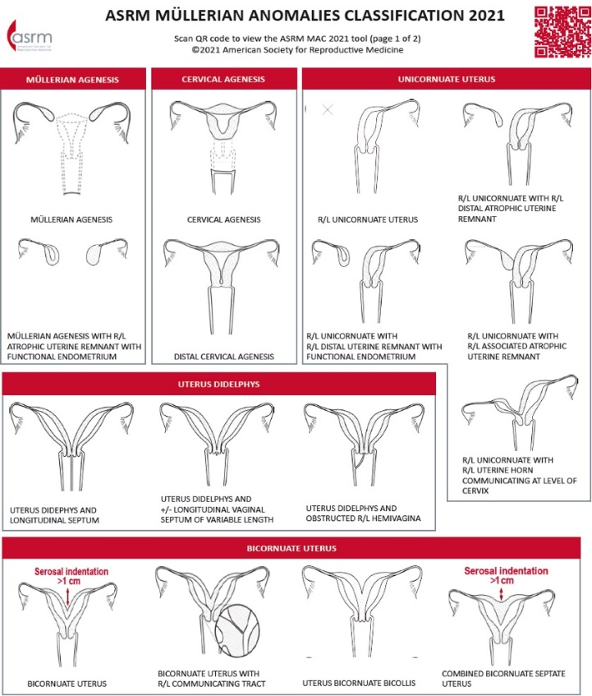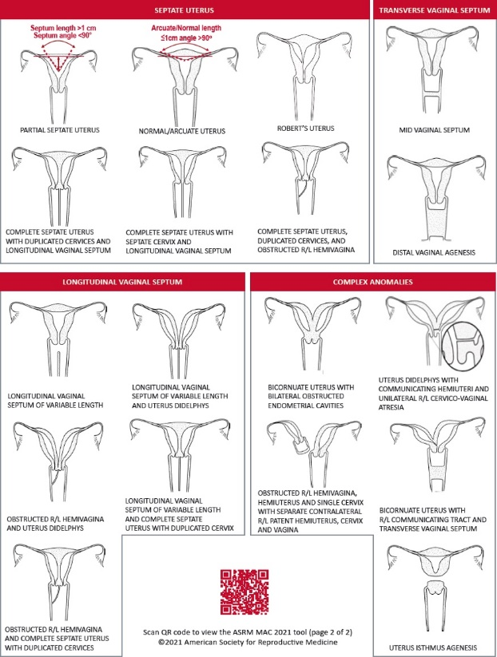
The European Society of Human Reproduction and Embryology (ESHRE) and The European Society of Gynecological Endoscopy (ESGE) also published their own classification in this way(5).

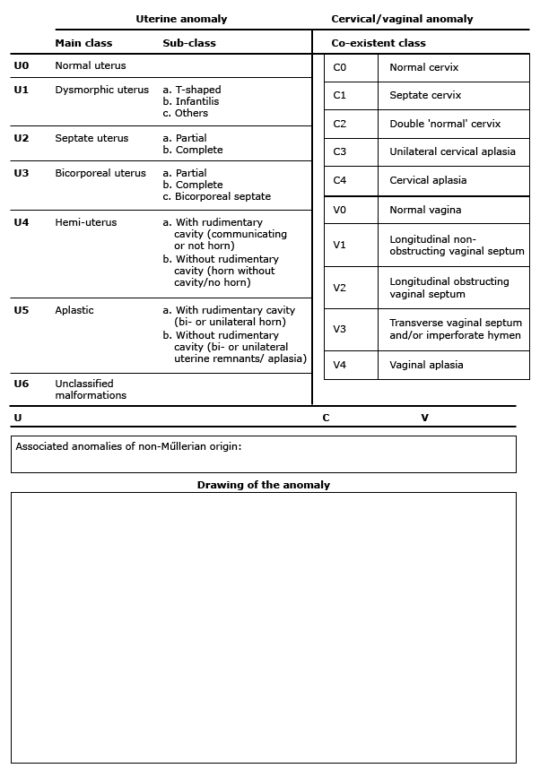

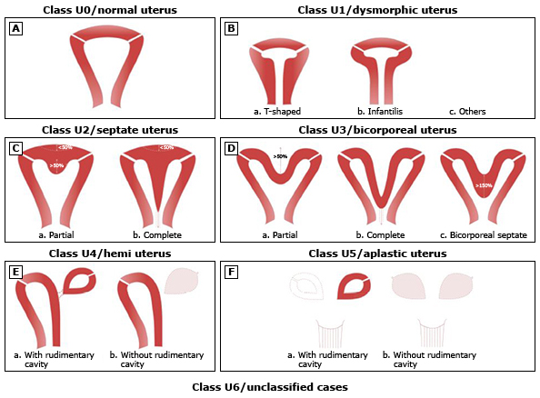
Studies have shown that anomalies seen in infertile and fertile patients with congenital uterine anomalies are 35% septate, 26% bicornuate, 18% arcuate, 10% unicornuate, 8% didelphis, and 3% agenesis (6).

CASE
A 24-year-old gravida 4, parity 3, living 3 patient with a history of vaginal delivery was admitted to the emergency department with the complaint of vaginal bleeding. The measurements of the patient whose last menstrual period was unknown and whose previous ultrasound measurement values were not available at the time of admission were found to be compatible with 30 weeks. There was no history of additional disease in his anamnesis. There is no history of abortion and evacuation abortion. No drug use. The patient's physical examination was normal, active vaginal bleeding was not observed in the vaginal examination, and an old coagulum was observed. The patient was followed up in the delivery room.
During the delivery room follow-ups, the patient did not have active vaginal bleeding. Nst was reactive and no contraction was observed. The patient had moderate anemia and thrombocytopenia in laboratory values, and hematology was consulted. Existing coagulation values were normal, fibrinogen and d-dimer were increased, ldh, bilirubin values were normal, and the patient had iron and B12 deficiency. Peripheral smear of the patient was sent to hematology. During the follow-ups, the patient was taken to emergency cesarean section with the suspicion of ablation due to the onset of active vaginal bleeding and concomitant contractions. The abdomen was entered with a Pfannenstiel incision. After the incision made in the lower uterine segment, a 1550 gram male baby was delivered with the head. Ablation state was observed in the placenta. The material was sent to pathology.
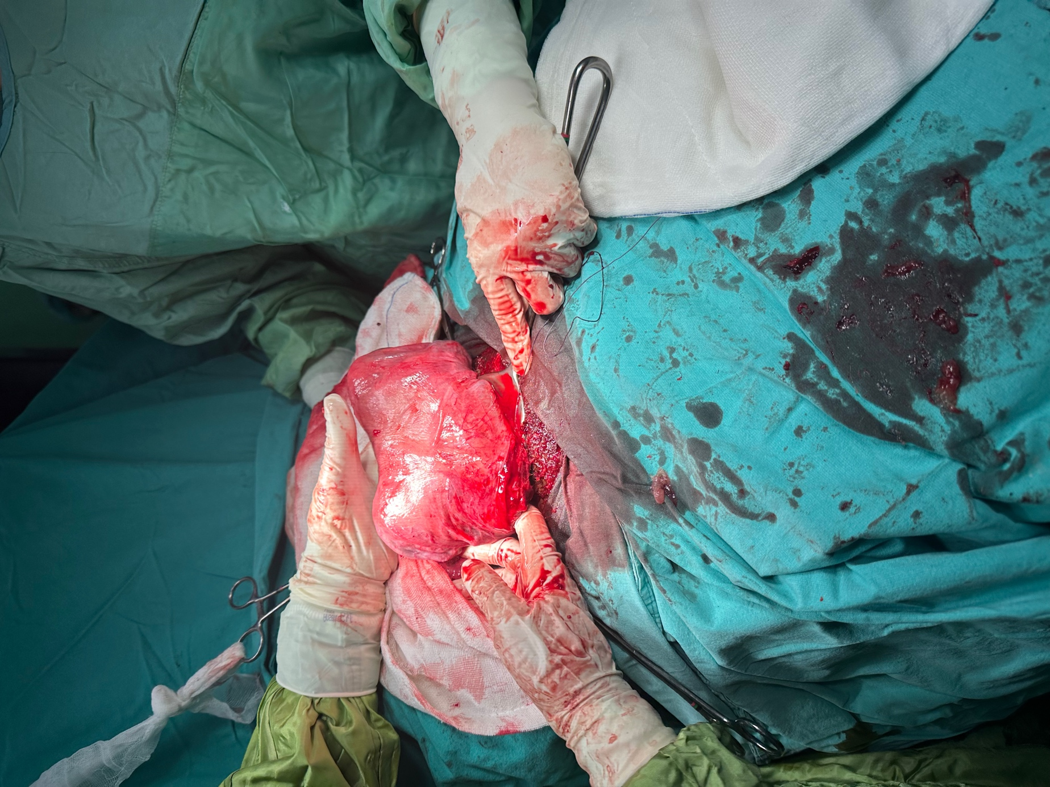
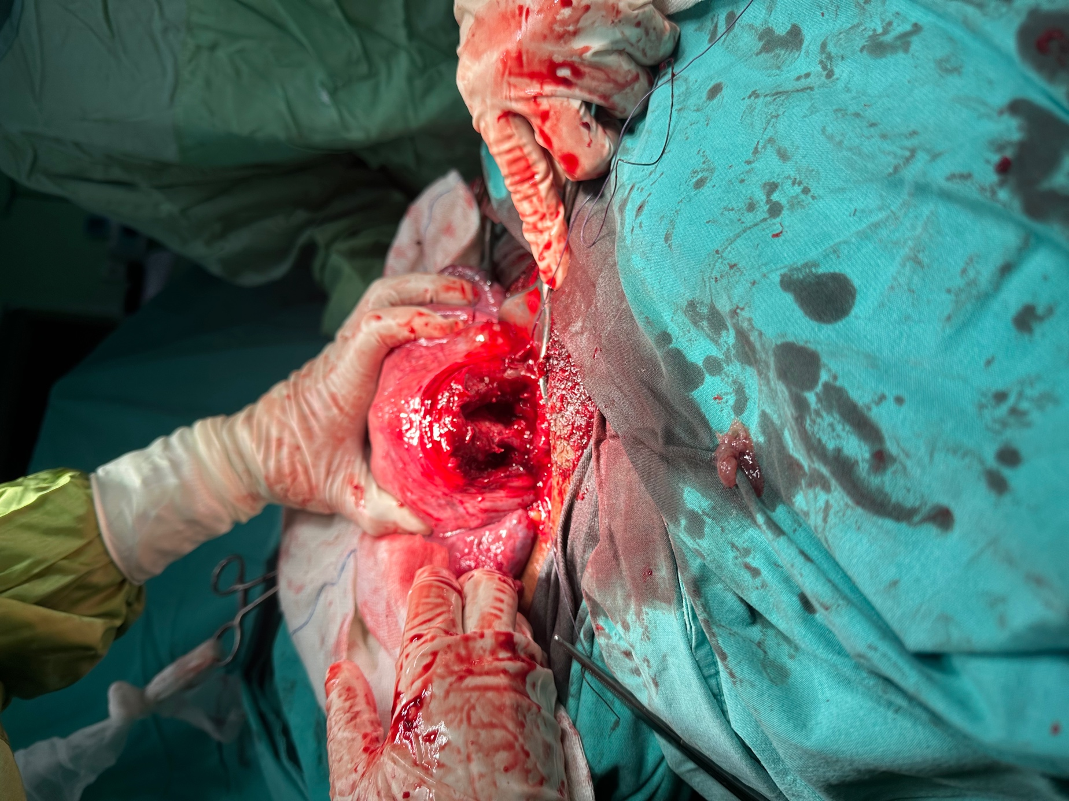

In observation and palpation, the uterine cavity over the Kerr incision was observed in pairs and it was observed that the septum extended completely to the fundus. It was observed that the area under the Kerr incision extended to the os level of two separate cavities in the same way. There was a complete bicornuate uterus. Bilateral tuba and ovaries were normal. After the bleeding control, the patient was followed up in the intensive care unit. As a result of the peripheral smear sent, hematology 'Platelets were consistent with the hemogram, no schistocyte was observed. In the hemogram control, it was observed that the platelets started to increase spontaneously. The patient was advised to control hematology with oroferon and apicobal treatment.'
In the post-operative period, the patient did not have active bleeding during the intensive care follow-up, and laboratory values were observed at normal levels. The patient was mobilized and followed up in the ward. Vaginal septum was not found in the vaginal examination performed again on the 1st day. Single cervix and lochia were normal. The patient was discharged after 48 hours of follow-up with the recommendation of hematology and gynecology and obstetrics outpatient clinic control.

SUMMARY AND CONCLUSION
The underlying etiology of congenital mullerian anomalies has not been fully elucidated, and these patients usually have a normal karyotype.
Its prevalence depends on the population studied and in a systematic study, the prevalence was found to be 5.5% in a randomly selected population, 8% in infertile patients, 12.3% in patients with a history of abortion, and 24.5% in patients with a history of abortion and infertility. In a study conducted on patients with renal anomaly, it was observed that 29% of the patients had mullerian anomalies. Literatür incelemelerinde bikornuat uterusu olan hastaların yüzde 36'sında spontan düşük, yüzde 21 ila 23'ünde erken doğum ve yüzde 50 ila 60'ında fetal sağkalım bildirilmektedir(6,7,8). Fetal büyüme kısıtlaması ve doğum sırasında malprezentasyon da artmaktadır(9).
Many patients are asymptomatic. In some cases, findings such as vaginal septum, double cervix, or pelvic mass in routine physical examination require further evaluation and thus enable diagnosis. Symptomatic patients may present with pain, abnormal vaginal bleeding, or infection. In other cases, the diagnosis of the anomaly may be made as a result of evaluation of a gynecological problem, unfavorable pregnancy outcome, or imaging studies for kidney, skeletal, or abdominal wall abnormalities.
Women with bicornuate uterus have been reported to have an increased incidence of preterm delivery, fetal growth restriction, or malpresentation compared with women with normal uterus. The pathophysiology of this condition may include unhealthy implantation of the fetus due to abnormal uterine cavity, irregularity in uterine blood flow or cervical insufficiency(10). The frequency of spontaneous abortion increases. In a study by Raga et al., they reported that early pregnancy complications were seen in approximately 21% of pregnant women with uterine anomaly. They explained the pathophysiology of this condition not only by the narrowing of the uterine cavity, but also by local effects that disrupt embryo development in the post-implantation period. In the study of Fedele, they argued that the ultrastructural changes in the endometrium tissue close to the septum caused the implantation to not result in a successful outcome(11).
As a result, bicornuate uterus may progress asymptomatically throughout life, and may occur with conditions such as preterm birth, preterm labor, premature rupture of membranes, as well as abnormal uterine bleeding, recurrent pregnancy losses, pelvic pain, and endometrioma.

REFERENCES
- Fontana L, Gentilin B, Fedele L, Gervasini C, Miozzo M. Genetics of Mayer-Rokitansky- Küster-Hauser (MRKH) syndrome. Clin Genet. 2017;91(2):233-246. doi:10.1111/cge.12883
- Byrne J, Nussbaum-Blask A, Taylor WS, et al. Prevalence of Müllerian duct anomalies detected at ultrasound. Am J Med Genet. 2000;94(1):9-12. doi:10.1002/1096-8628(20000904)94:1<9::aid-ajmg3>3.0.co;2-h
- Troiano RN, McCarthy SM. Mullerian duct anomalies: imaging and clinical issues. Radiology. 2004;233(1):19-34. doi:10.1148/radiol.2331020777
- Pfeifer SM, Attaran M, Goldstein J, et al. ASRM müllerian anomalies classification 2021 [published correction appears in Fertil Steril. 2023 Jun;119(6):1088]. Fertil Steril. 2021;116(5):1238-1252. doi:10.1016/j.fertnstert.2021.09.025
- Grimbizis GF, Gordts S, Di Spiezio Sardo A, et al. The ESHRE/ESGE consensus on the classification of female genital tract congenital anomalies. Hum Reprod. 2013;28(8):2032-2044. doi:10.1093/humrep/det098
- Grimbizis GF, Camus M, Tarlatzis BC, Bontis JN, Devroey P. Clinical implications of uterine malformations and hysteroscopic treatment results. Hum Reprod Update. 2001;7(2):161-174. doi:10.1093/humupd/7.2.161
- Ludmir J, Samuels P, Brooks S, Mennuti MT. Pregnancy outcome of patients with uncorrected uterine anomalies managed in a high-risk obstetric setting. Obstet Gynecol. 1990;75(6):906-910.
- Raga F, Bauset C, Remohi J, Bonilla-Musoles F, Simón C, Pellicer A. Reproductive impact of congenital Müllerian anomalies. Hum Reprod. 1997;12(10):2277-2281. doi:10.1093/humrep/ 12.10.2277
- Venetis CA, Papadopoulos SP, Campo R, Gordts S, Tarlatzis BC, Grimbizis GF. Clinical implications of congenital uterine anomalies: a meta-analysis of comparative studies. Reprod Biomed Online. 2014;29(6):665-683. doi:10.1016/j.rbmo.2014.09.006
- 10. Zlopasa G, Skrablin S, Kalafatić D, Banović V, Lesin J. Uterine anomalies and pregnancy outcome following resectoscope metroplasty. Int J Gynaecol Obstet. 2007;98(2):129-133. doi:10.1016/j.ijgo.2007.04.022
- 11. Fedele L, Bianchi S, Marchini M, Franchi D, Tozzi L, Dorta M. Ultrastructural aspects of endometrium in infertile women with septate uterus. Fertil Steril. 1996;65(4):750-752.

S-62 Ailesel Swyer Sendromlu Bir Vaka
Özgür Adıgüzel¹, Süleyman Cemil Oğlak¹, Sedat Akgöl¹
1 Gazi Yaşargil Eğitim ve Araştırma Hastanesi, Diyarbakır

Öz. Giriş: Swyer sendromu, primer amenore ve az gelişmiş sekonder cinsiyet özellikleri ile ortaya çıkan; normal dişi dış genitaller, normal Müllerian yapılar ve çizgi gonadların görüldüğü nadir bir genetik bozukluktur. Yaşla beraber artan malignansi riski mevcuttur. Ailesel Swyer sendromu çok nadirdir ve litaratürde aynı aileden primer amenoresi olan bu sendromun görüldüğü sadece iki olgu sunumu tespit edebildik. Malignansi riski nedeni ile tanı konulur konmaz profilaktik gonadektomi önerilmektedir Olgu sunumu: Swyer sendromu tanısı bulunan 19 yaşında G0P0 primer amenoreli hasta, 6 aydır devam eden karın şişliği ve alt karın ağrısı nedeniyle başka bir merkezden hastanemize yönlendirildi. Fizik muayenede meme gelişiminin Tanner Evre 4, pubik ve aksiller kıllanmanın seyrek olduğu görülmüştür. Yapılan abdominal muayenede batın rahattı ve palpabl sabit abdominopelvik kitle vardı. Ultrason muayenesinde pelvisten başlayan ve göbeğin üst hizasına kadar uzanan 25x20 cm boyutlarında solid kitle lezyonu izlenmiştir. Aile öyküsünde, Swyer sendromu teşhisi konmuş ve akabinde gonadektomi uygulanmış bir kız kardeş olduğu bilgisi alındı. Ablaya gonadal disgenezi tanısı konması üzerine hastamıza karyotip analizi önerilmiş. Hastanın karyotipi 46,XY ile uyumlu bulunuş. Klinisyenler, gonadal malignite riskine dayalı olarak profilaktik gonadektomi geçirmesini tavsiye etmişler, ancak ailesi, gonadektomiyi ihmal etmiş. Yıllar sonnrasında kitle ile başvuran hastaya, total abdominal histerektomi, bilateral gonadektomi, bilateral salpenjektomi, infrakolik omentektomi ve paraaortik lenfadenektomi uygulandı. Histopatolojik rapor sağ adeksial disgerminom olduğunu göstermiştir. Sonuç: Swyer sendromunun erken teşhisi, erken yaşta gelişebilen malign gonadal tümörlerin yüksek riski göz önüne alındığında oldukça önemlidir. Swyer sendromu tanısı alan olguların prepubertal kız kardeşleri taranmalıdır. Erken tanı ve hızlı profilaktik gonadektomi duygusal travmayı azaltacak, hastanın doğurganlığını koruyabilecek ve sağkalımını iyileştirebilecek konservatif bir tedavi planı sağlayacaktır.
Keywords: Swyer sendromu, proflaktik gonadektomi, disgerminom

S-63 Comparison Of Ten-Year Results Of Tension-Free Transvaginal Tape And Transobturator Tape Operations In Terms Of Urinary Incontinence And Quality Of Life
Pakize Özge Karkın¹, Gözde Sezer², Nehir Pişkin¹
1 Sağlık Bilimleri Üniversitesi, İstanbul Kanuni Sultan Süleyman Eğitim ve Araştırma Hastanesi, Kadın Hastalıkları ve Doğum Kliniği
2 Manisa Yunus Emre 9 No’Lu Aile Sağlığı Merkezi 069 No’Lu Aile Hekimliği Birimi

ABSTRACT Objective: This study was conducted to compare the 10-year results of Tension-free Transvaginal Tape and Transobturator Tape operations in terms of urinary incontinence and quality of life. Material and Methods: Women who had undergone Tension-Free Transvaginal Tape (TVT) and Transobturator Tape (TOT) operations at least 10 years ago (before January 2013) in Istanbul Kanuni Sultan Süleyman Training and Research Hospital Urogynecology service were retrospectively screened. The urogenital distress inventory (UDI-6) and King's Health Questionnaire were applied to the volunteers who could be reached via telephone between January 2023 and July 2023, to evaluate urinary incontinence and quality of life. Results: Of the 117 volunteers who were included in the study, it was found that 28 had undergone TVT and 89 had undergone TOT operations. A statistically significant difference in favor of TVT was found between the two groups in terms of postoperative stress urinary incontinence and pelvic pain (p<0,05). When TVT and TOT groups were compared according to Urogenital Distress Inventory and King's Health Questionnaire, no statistically significant difference was found (p>0,05). Although it is not statistically significant, it can be thought that TOT is superior than TVT in terms of quality of life in scoring. Conclusion: Despite the fact that no long-term difference was found in quality of life who had undergone TVT and TOT surgery; subjectively, it was observed that TVT procedure was more successful in the long term in terms of stress urinary incontinence and post-operative pelvic pain. Keywords: TVT, TOT, quality of life, urinary incontinenc
Keywords: TVT, TOT, quality of life, urinary incontinence
INTRODUCTION
Urinary incontinence (UI) is a common involuntary urinary leakage problem that affects mostly elderly people, and is more common in women. While its prevalence is 20% under the age of 20, it rises to 50% in older ages (1).
UI is defined by the International Continence Society (ICS) as involuntary urinary leakage that causes social problems. Urinary incontinence is defined under three headings as stress, urge and mixed urinary incontinence (2,3).
Stress urinary incontinence is the most common type of urinary incontinence due to urethral hypermobility, which can also be seen during coughing, sneezing or other physical activities which cause increased intra-abdominal pressure. Urge urinary incontinence is urination before reaching the toilet with urgent need for micturition, which occurs due to excessive activity of the detrusor muscles. The coexistence of stress incontinence and urge incontinence is called mixed type urinary incontinence. Risk factors for UI include advanced age, short urethral neck in women, hormonal status (hypoestrogenemia), pregnancy, birth trauma (nerve, muscle, connective tissue injury), genetic differences, recurrent resistant urinary infections, obesity, chronic constipation, chronic coughing in lung diseases, antiestrogenic effect, gynecological operations, sedentary lifestyle, diabetes, peripheral vascular insufficiency, neurological diseases and congestive heart failure (4,5,6). Although urinary incontinence is seen in all ages and genders, it is a common problem, especially in elderly women. It affects one-third of women and about one-fifth of men over the age of 60 in the world (2,3).
UI negatively affects physical, social and sexual life (7,8).
UI treatment ranges from lifestyle changes to medical and surgical methods. Determining the type of incontinence may affect the success of the treatment, especially in cases where surgical treatment is considered. Mid-urethral sling procedures, which have gained popularity in the last 10 years, become more prominent, replacing urethral suspension surgeries. Tension-free transvaginal tape (TVT) and transobturator tape (TOT) are mid-urethral sling procedures (1,9).
Since, investigating the long-term success of urinary incontinence surgeries and the quality of life of patients after the operation is important, our study aims to compare the 10-year results of TVT and TOT operations in terms of urinary incontinence and quality of life.

MATERIAL AND METHOD
Women who had been hospitalized in the urogynecology service of Istanbul Kanuni Sultan Süleyman Training and Research Hospital and had undergone Tension-Free Transvaginal Tape and Transobturator Tape Operations at least 10 years ago (before January 2013) were retrospectively screened. Between January 2023 and July 2023, 117 volunteers were included in the study. Approval was obtained from the ethics committee of Istanbul Kanuni Sultan Süleyman Training and Research Hospital and volunteers for the study. Urogenital Distress Inventory (UDI-6) and King's Health Questionnaire (KHQ) were applied to evaluate urinary incontinence and quality of life, and questions including sociodemographic characteristics and obstetric characteristics were asked.
UDI-6 assesses life quality and symptom distress in women suffering from urinary incontinence.
The Urogenital Distress Inventory includes three sub-dimensions: irritative symptoms, stress symptoms, obstructive/disturbing or voiding symptoms, and consists of 6 questions. In the scoring of the scale, there are options from 0 to 3. A minimum of 0 to a maximum of 18 points can be obtained from UDI-6. A rise in the score indicates a deterioration in the quality of life (10).
KHQ is an assessment of health-related quality of life related to a specific condition (bladder problems). 21 items about urinary tract symptoms yield scores in 9 domains (general health perception, incontinence impact, role limitations, physical limitations, social limitations, personal relationships, emotions, sleep/energy & severity of symptoms). Each item is rated using a 4 or 5 points likert scale. Domain scores range from 0 (best) to 100 (worst). There are 2 single-item domains (general health perceptions, and incontinence impact) and the severity of symptoms domain, is scored using a scale from 0 (best) to 30 (worst). As the score increases, the quality of life decreases (11).
Statistical Analysis
SPSS 21.0 was used to evaluate the data. In the analysis of data, numerical and percentage distribution, mean, standard deviation, Kolmogorov-Smirnov test for comparison between groups and t test for independent groups were used when normal distribution was achieved. Chi-square test was used in the analysis of categorical variables. The probability of statistical error was accepted as p<0,05.

RESULTS
Table 1: Sociodemographic characteristics of the patients
 | TVT (n=28) | TOT(n=89) | p
Age | 63,39 | 63,92 | 0,959
BMI (kg/m²) | 26,89 | 26,79 | 0,554
Menopause | 19 (%67,9) | 69 (%77,5) | 0,418
Hormone Replacement Therapy | None  22 (%78,6) | None  59 (%66,3) | 0,160
Urinary incontinence problem | None  18 (%64,3) | None  45 (%50,6) | 0,146
Urinary incontinence in daily activities such as coughing | Exists  8 (%28,6) | Exists  48 (%53,9) | 0,016**
Urgent need and involuntary leakage before going to toilet | None  15 (%53,6) | None  48 (%53,9) | 0,572
POP | None  16 (%57,1) | None  56 (%62,9) | 0,370
Problems during sexual intercourse | None  14 (%50,0) | None  39 (%43,8) | 0,537
Post-operative pelvic pain | Exists  16 (%57,1) | Exists  68 (%76,4) | 0,044**
*Chi-Square Tests -BMI: Body mass index, POP: Pelvic organ prolapse
**p<0,05
When the sociodemographic characteristics of the patients were examined among the patients who had undergone TVT and TOT at least 10 years ago, in terms of age, BMI, menopause, hormone replacement therapy, urinary incontinence problem, sudden incontinence when rushed to toilet, uterine/bladder/intestinal prolapse, and problems during sexual intercourse, no statistically significant difference was found (p>0,05).
When study population were asked about the presence of urinary leakage in daily activities such as coughing, it was determined that 53.9% of the patients who underwent TOT surgery had urinary incontinence, and 71.4% of those who had TVT did not, and a statistically significance was found (p<0,05).
When the pelvic pain that continued intermittently for 10 years after the operation was compared, it was determined that 76.4% of the TOT group had pain and 57.1% of the TVT group had pain, and there was a statistically significant difference between them (p<0,05).

Table 2: Comparison of Urogenital Distress Inventory-6 (UDI-6) between TVT and TOT group
 | TVT (n=28)  ( mean±SD ) | TOT(n=89)  ( mean±SD ) | p
Frequent Urination | 2,39±0,87 | 2,41±0,75 | 0,901
Urine leakage related to urgency | 2,25±0,88 | 2,31±0,82 | 0,734
Urine leakage related to physical activity (walking, running, laughing, sneezing, coughing) | 2,28±0,97 | 2,21±0,87 | 0,728
Small amounts of urine leakage (drops) | 2,21±0,91 | 2,07±0,95 | 0,503
Difficulty emptying your bladder or Difficulty urinating | 2,14±0,80 | 2,03±0,92 | 0,548
Pain or discomfort in your lower abdominal, pelvic, or genital area | 2,25±0,88 | 2,12±0,90 | 0,516
UDI-6 Total Scores | 13,54±5,02 | 13,18±4,83 | 0,743
*Independent Samples Test
The comparison of Urogenital Distress Inventory between TVT and TOT shows no difference statistically in terms of long-term quality of life (p>0,05).

Table 3: Comparison of King’s Health Questionnaire (KHQ) between TVT and TOT groups
 | TVT (n=28)  ( mean±SD ) | TOT(n=89)  ( mean±SD ) | p
General Health Perceptions  Min-Max. Score (25-75) | 41,07±16,96 | 41,29±16,89 | 0,952
Incontinence Impact  Min-Max. Score (0-100) | 58,32±28,14 | 55,42±22,99 | 0,623
Role Limitations  Min-Max. Score (0-100) | 41,66±35,85 | 38,57±29,36 | 0,646
Physical Limitations  Min-Max. Score (0-100) | 42,85±34,96 | 38,38±31,22 | 0,549
Social Limitations  Min-Max. Score (0-100) | 42,85±32,66 | 37,45±29,74 | 0,440
Personal Relationships  Min-Max. Score (0-100) | 39,28±36,06 | 29,96±29,42 | 0,169
Emotions  Min-Max. Score (0-100) | 37,69±27,76 | 32,83±27,05 | 0,420
Sleep/Energy  Min-Max. Score (0-100) | 39,87±32,18 | 32,95±24,61 | 0,232
Severity Measures  Min-Max. Score (0-100) | 54,51±26,17 | 53,47±21,50 | 0,850
Symptom Severity Scale  Min-Max. Score (0-30) | 18,14±5,92 | 16,19±6,48 | 0,144
*Independent Samples Test
In terms of KHQ, there is not statistical significance for long-term quality of life between TVT and TOT surgeries in all domains (p>0,05).

Table 4: Comparison of Urogenital Distress Inventory-6 (UDI-6) and King’s Health Questionnaire (KHQ) total scores between TVT-TOT groups
 | TVT (n=28)  ( mean±SD ) | TOT(n=89)  ( mean±SD ) | p
UDI-6 | 13,54±5,02 | 13,18±4,83 | 0,743*
KHQ | 49,64±15,93 | 46,89±14,00 | 0,417*
*Independent Samples Test
Overall results for quality of life on UDI-6 and KHQ are not different statistically for TVT and TOT patients at long-term (p>0,05). Although there was no statistically significant difference, it was seen that TOT impairs quality of life less than TVT when compared in terms of scores.

DISCUSSION AND CONCLUSION
Although urinary incontinence is a problem with increasing prevalence by age in the society; recently, it is seen as a problem that impairs the quality of life among patients and the search of need for treatment has increased. There is not enough data in the literature regarding the 10-year results of mid-urethral sling operations performed in the treatment of stress urinary incontinence.
In a meta-analysis comparing TVT and TOT operations, the evaluation of pain and quality of life with VAS ve UDI-6 scoring showed the change in VAS score and UDI-6 score before and after the operation were larger in TOT group than in TVT group, but without statistical significance. Similar results were found in our study for UDI-6 ,which TVT group had higher scores than TOT after 10 year follow-up yet the difference was not statistically significant. Additionally, in that meta-analysis there was no significant difference in cure rate and satisfaction rate between the groups (12). After a 4-year comparison of two procedures in another study no significant difference was found between the procedures in terms of continence results and quality of life. But the complication rate was significantly higher with the TVT procedure when compared to TOT procedure (13). In randomized trials comparing two procedures, pelvic pain was greater in TOT in 1 year follow-up but at 5 years, pain in the groin and pelvic pain were reported higher in TVT group (14,15). By contrast, our study found that at 10-year follow-up pelvic pain was greater in patients who have undergone TOT. Also in the trial comparing 5-year results there was no statistical difference according to stress urinary incontinence as our study says , yet results differ in urge urinary incontinence. In 5-year follow-up urge incontinence statistically higher in TVT group (15). Our study which shows 10-year results, revealed no difference according to urge urinary incontinence between TVT and TOT patients. UDI-6 score difference was marginal between TVT and TOT in 5-year follow up (15). Despite in 10-year follow-up UDI-6 and King’s Health Questionnaire results were not statistically different between two groups, total scores slightly higher in TVT group. This may indicate that long-term quality of life of TVT patients may be worse than that of the TOT group.
A strength of our study is that obtaining the long-term results. Yet, several limitations are worth pointing, which are difficulty reaching patients after more than 10 years, small TVT population and one center study.
As a result, although there was no long-term difference in the quality of life due to urinary incontinence in patients who had TVT and TOT surgery; subjectively, the TVT procedure seemed to be more successful with regard to stress urinary incontinence and postoperative pelvic pain in long-term.

REFERENCES
- Mehdiyev M, İtil İM, Şendağ F, Akdemir A, Aşkar N. Stres inkontinans olgularının cerrahi tedavisinde transvaginal tape (TVT) ve transobturator tape (TOT) uygulamalarının etkinliğinin ve yaşam kalitesi üzerine etkilerinin karşılaştırılması. Türk Jinekoloji ve Obstetrik Derneği Dergisi, 2010;7:117- 24.
- Amanak K, Sevil Ü. Üriner inkontinansı olan ve olmayan kadınların yaşam doyumu ve sosyal kaygı düzeylerinin karşılaştırılması. Düzce Üniversitesi Sağlık Bilimleri Enstitüsü Dergisi, 2020; 10(2): 217-222.
- Balcı C, Akçetin Z. Üriner inkontinansın tanımı ve sınıflaması. Turkiye Klinikleri J Urology-Special Topics, 2009;2(1):13-6.
- Wood LN, Anger JT. Urinary incontinence in women. British Medical Journal, 2014;349:g4531.
- Terzi H, Terzi R, Kale A. 18 yaş üstü kadınlarda üriner inkontinans sıklığı ve etkileyen faktörler. Ege Tıp Dergisi, 2013;52(1):15-19.
- Yılmaz E, Muslu A, Özcan E. Üriner inkontinanslı kadınlarda yaşam kalitesi. Erciyes Üniversitesi Sağlık Bilimleri Fakültesi Dergisi, 2014;2(2).
- Kök G, Şenel N, Akyüz A. GATA jinekoloji polikliniğine başvuran 20 yaş üstü kadınların üriner inkontinans açısından farkındalık durumlarının değerlendirilmesi. Gülhane Tıp Dergisi, 2006;48:132-136.
- Demir S, Kızılkaya Beji N. Üriner inkontinanslı kadınlarda yaşam kalitesi ve sağlık arama davranışları. Florence Nightingale Hemşirelik Dergisi, 2015;23(1):23-31.
- Betschart C, Scheiner D, Hess E, Seifert B, Fink D, Perucchini D. Patient satisfaction after retropubic and transobturator slings: first assessment using the Incontinence Outcome Questionnaire (IOQ). International Urogynecology Journal, 2011;22(7):805-12.
- Cam C, Sakalli M, Ay P, Cam M, Karateke A. Validation of the short forms of the Incontinence Impact Questionnaire (IIQ-7) and the Urogenital Distress Inventory (UDI-6) in a Turkish Population. Neurourol Urodynamics Neurourol Urodynam, 2007;26(26):129-133.
- Akkoc Y, Karapolat H, Eyigor S, Yesil H, Yüceyar N. Quality of life in multiple sclerosis patients with urinary disorders: reliability and validity of the Turkish version of King's Health Questionnaire. Neurological Sciences, 2011;32(3):417-21.
- Huang ZM, Xiao H, Ji ZG, Yan WG, Zhang YS. TVT versus TOT in the treatment of female stress urinary incontinence: a systematic review and meta-analysis. Ther Clin Risk Manag, 2018;20(14):2293-2303.
- Zugor V, Labanaris AP, Rezaei-Jafari MR, Hammerer P, Dembowski J, Witt J, Wucherpfennig W. TVT vs. TOT: a comparison in terms of continence results, complications and quality of life after a median follow-up of 48 months. Int Urol Nephrol, 2010;42(4):915-20.
- Ross S, Robert M, Swaby C, Dederer L, Lier D, Tang S, Brasher P, Birch C, Cenaiko D, Mainprize T, Murphy M, Carlson K, Baverstock R, Jacobs P, Williamson T. Transobturator tape compared with tension-free vaginal tape for stress incontinence: a randomized controlled trial. Obstet Gynecol, 2009;114(6):1287-1294.
- Ross S, Tang S, Eliasziw M, Lier D, Girard I, Brennand E, Dederer L, Jacobs P, Robert M. Transobturator tape versus retropubic tension-free vaginal tape for stress urinary incontinence: 5-year safety and effectiveness outcomes following a randomised trial. Int Urogynecol J, 2016;27(6):879-86.

S-64 The Surgıcal And Subjectıve Outcomes Of High Uterosacral Ligament Suspension With Vnotes Technique: A Medıan Follow-Up Of 17 Months
Pınar Birol İlter¹, Murat Yassa², Cihan Kaya ³
1 Kartal Dr. Lütfi Kırdar City Hospital
2 Bahcesehir University Medical Faculty, Vm Maltepe Medical Park Hospital
3 Acibadem Bakirkoy Hospital
Objectives
Vaginally Assisted Natural Orifice Transluminal Endoscopic Surgery (vNOTES) is one of the most innovative surgical techniques which is currently under the spotlight(1). vNOTES is improving its usage areas day by day towards gynecology, pelvic floor and prolapse surgeries including hysterectomy, adnexial procedures, sacrocolpopexy, meshless anterior repair, posterior rectus fascia prolapse repair surgeries and high uterosacral ligament suspension (HUSLS)(2-6)
Methods
This multi-centred prospective study investigated the postoperative objective and subjective outcomes of vNOTES high uterosacral ligament suspension (vNOTES-HUSLS) technique.
Results
A total of 102 patients with various benign gynecologic indications underwent vNOTES-HUSLS following vNOTES hysterectomy between 1 January 2021 and 1 January 2022. All procedures were performed by or under the direct supervision of surgeons (M.Y. or C.K.) with an adequate experience in vNOTES. The median follow-up was 17.07 months with range of 12–27.5 months (IQR=4). Duration of total surgery was found 76.64±29.13 minutes.
vNOTES-HUSLS was performed in 56 (54.9%) patients due to apical prolapse. The prolapse level in apical, anterior and posterior compartments were found to be improved (p=<0.001). İn addition, apical prolapse was not detected in the follow-up of patients who perfoming prophylactic vNOTES-HUSLP after hysterectomy performed without the purpose of prolapse. The satisfaction rate was 98% at 1st year of follow-up in the all patients.
Intraoperative complications were detected in 3 (2.9%) patients, including bladder injury in 2 patients and hemorrhage from the colpotomy line in 1 patient. The bladder injury was repaired intraoperatively without a long-term complications. There was not any conversion to laparoscopy or laparotomy. Recurrence in apical prolapse was not detected in any patient. Colporrhaphy anterior was performed concomitantly in 2 (1.9%) patients due to anterior compartment prolapse and denovo urge incontinence was detected in 2 (1.9%) patients during the postoperative follow-up period. Sexual pain/dyscomfort was found to be improved at 1st year(FSFI pain subdomain score,p<0.001).
Conclusions
vNOTES has the potential to provide faster recovery and higher patient satisfaction(4,7). In recent years, some scholars have reported the advantages of vNOTES-HUSLS, which include no incisional pain and a better cosmetic outcome, as well as direct visualization of key structures, such as the ureters and rectum(8,9) Hence, vNOTES-HUSLS is associated with a reduced risk of ureteral obstruction, less incidence of intraoperative complications(10). Long-term results of vNOTES-HUSLS are unknown, but short-term results did not detect serious complications and prolapse recurrences(11)
vNOTES-HUSLS resulted in marked improvement in both anatomical prolapse without cases of conversion or severe complications. İn addition, vNOTES-HUSLP is safely performed to support the vaginal apex prophylactically after a hysteroctomy.
During the ‘minimal mesh’ era, vNOTES-HUSLS may be the first choice in either native tissue repair of apical prolapse for whom uterus needs to be removed, or as a prophylaxis technique following vaginal or vNOTES hysterectomy.

Keywords: vaginally assisted natural orifice transluminal endoscopic surgery, vNOTES, high uterosacral ligament suspension

References
1. Buzzaccarini, G., et al., Surgical approach for enlarged uteri: further tailoring of vNOTES hysterectomy. Journal of Investigative Surgery, 2022. 35(4): p. 924-925.
2. Lu, Z., et al., Mesh exposure and prolapse recurrence following transvaginal natural orifice transluminal endoscopic surgery for sacrocolpopexy: over 24 months of follow-up data. Journal of Minimally Invasive Gynecology, 2022. 29(12): p. 1317-1322.
3. Yang, C.-Y., et al., Surgical outcomes of hysterectomy by transvaginal natural orifice transluminal endoscopic surgery (vNOTES) compared with laparoscopic total hysterectomy (LTH) in women with non-prolapsed and benign uterine diseases. Taiwanese Journal of Obstetrics and Gynecology, 2020. 59(4): p. 565-569.
4. Badiglian‐Filho, L., et al., Vaginally assisted NOTES hysterectomy with adnexectomy (vNOTES) compared with conventional laparoscopy. A retrospective observational cohort study. International Journal of Gynecology & Obstetrics, 2021. 153(2): p. 351-356.
5. Baekelandt, J., Matak, L., Merckx, M., Housmans, S., Deprest, J., & Tollens, T. (2023). Posterior rectus fascia prolapse (PREFAP) repair: a new native tissue approach to pelvic organ prolapse via vaginal natural orifice transluminal endoscopic surgery. Archives of Gynecology and Obstetrics, 1-5.
6. Dubuisson, J., & Alec, M. (2022). Transvaginal Natural Orifice Transluminal Endoscopic Surgery Meshless Anterior Repair for the Treatment of Pelvic Organ Prolapse. Journal of Minimally Invasive Gynecology, 29(6), 705-706.
7. Karkia, R., et al., Hysterectomy and Adenextomy via transvaginal natural orifice transluminal endoscopic surgery (vNOTES): a UK perspective with a case series of 33 patients. European Journal of Obstetrics & Gynecology and Reproductive Biology, 2019. 242: p. 29-32.
8. Lowenstein, L., et al., Transvaginal natural orifice transluminal endoscopic hysterectomy and apical suspension of the vaginal cuff to the uterosacral ligament. Journal of Minimally Invasive Gynecology, 2019. 26(6): p. 1015.
9. Liu, J., et al., Management of Pelvic Organ Prolapse with or without Hysterectomy Via Transvaginal Robotic Notes High Uterosacral Ligament. Journal of Minimally Invasive Gynecology, 2022. 29(11): p. S68.
10. Aharoni, S., et al., Transvaginal natural orifice transluminal endoscopic versus conventional vaginal hysterectomy with uterosacral ligament suspension for apical compartment prolapse. European Journal of Obstetrics & Gynecology and Reproductive Biology, 2021. 260: p. 203-207.
11. Lu, Z., et al., Transvaginal natural orifice transluminal endoscopic surgery for uterosacral ligament suspension: pilot study of 35 cases of severe pelvic organ prolapse. BMC surgery, 2021. 21(1): p. 1-8.

S-65 Split Hand Malformation Diagnosed In The Prenatal Period
Raziye Torun¹
1 S.b.u. Tepecik Eğitim ve Araştırma Hastanesi

Objective:
Ectrodactyly; It is a rare limb malformation manifested by medial clefts, syndactyly and phalanx, metacarpal and metatarsal hypoplasia and/or aplasia in the affected extremity. It can be unilateral or bilateral and can involve hands and feet. It can be an isolated anomaly or it can be a part of a syndrome by showing association with various anomalies. It is possible to diagnose with ultrasonographic examination of the extremities in the prenatal period. We aimed to emphasize the importance of evaluating the extremities in the ultrasonographic examination of the fetus through our case.
Method: 24 years, G1P0, 22 weeks pregnant was referred to our perinatology center due to fetal extremity anomaly. There was no comorbidity or medicine use. There was no consanguinity between the spouses. Ultrasonography showed a single bone in the right forearm, and two bones in the left forearm, one camptomelic and the other hypoplasic. Only two-fingered structure and deep cleft in the middle of both hands were seen, it was evaluated in favor of ectrodactyly(Picture 1, 2). Cordocentesis was performed in the patient who did not find any additional anomaly. The karyotype of the fetus was 46,XY, no pathology was detected in the chromosomal array examination. The patient was consulted with the Department of Medical Genetics, and the family was informed about the negative prognosis and it was decided to offer the option of termination of pregnancy. Family didn’t want termination option.
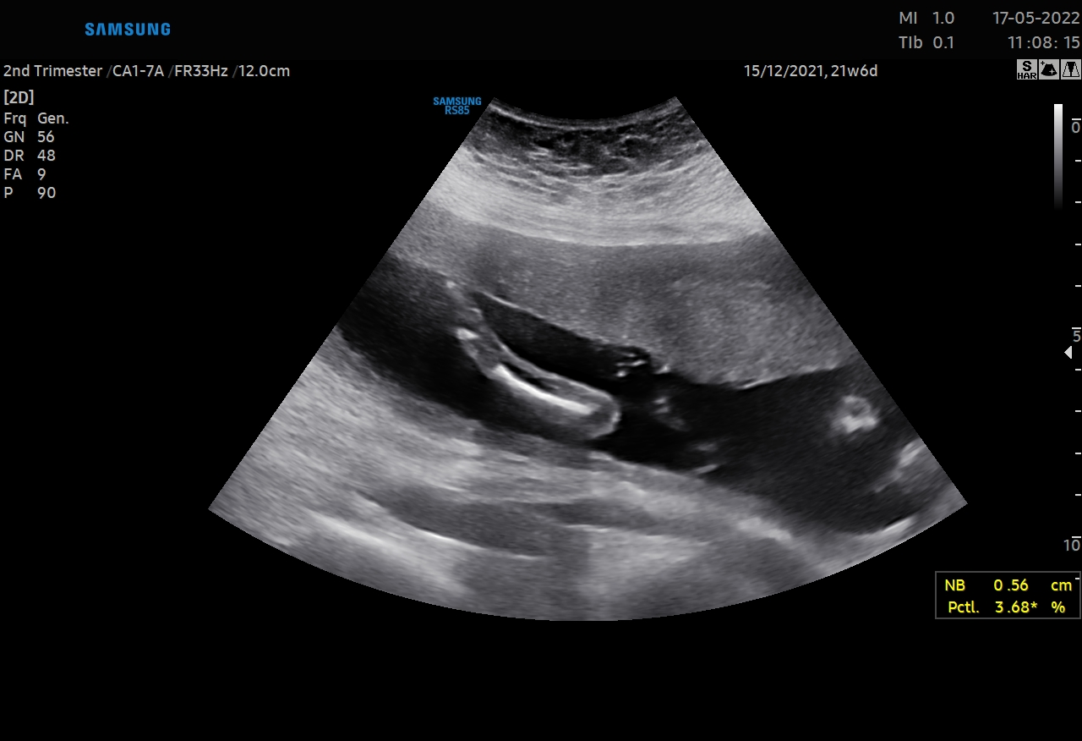
Picture 1: In the USG image of the case, a single bone in the right forearm and 2 finger-like structures are observed in the hand.

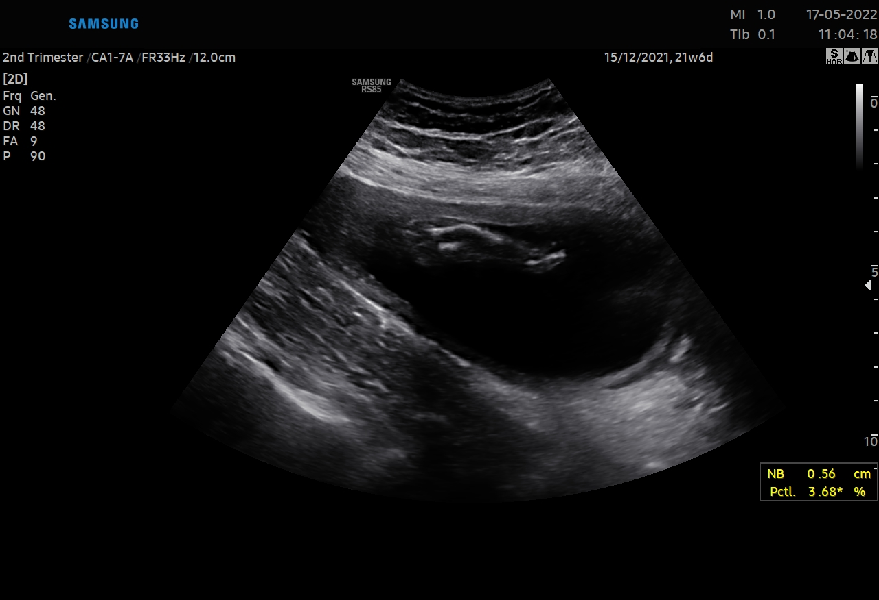
Picture 2: In the USG image of the case, two bones, one camptomelic (upper) and the other hypoplasic (lower), appear in the left forearm.
Results: A 3200 gr single live male baby with an APGAR score of 8 at the 1st minute was delivered by cesarean section at the 39th week of the pregnant woman who started labor. No problems developed in postnatal follow-ups. The case was transferred to plastic and reconstructive surgery for further examination and treatment.
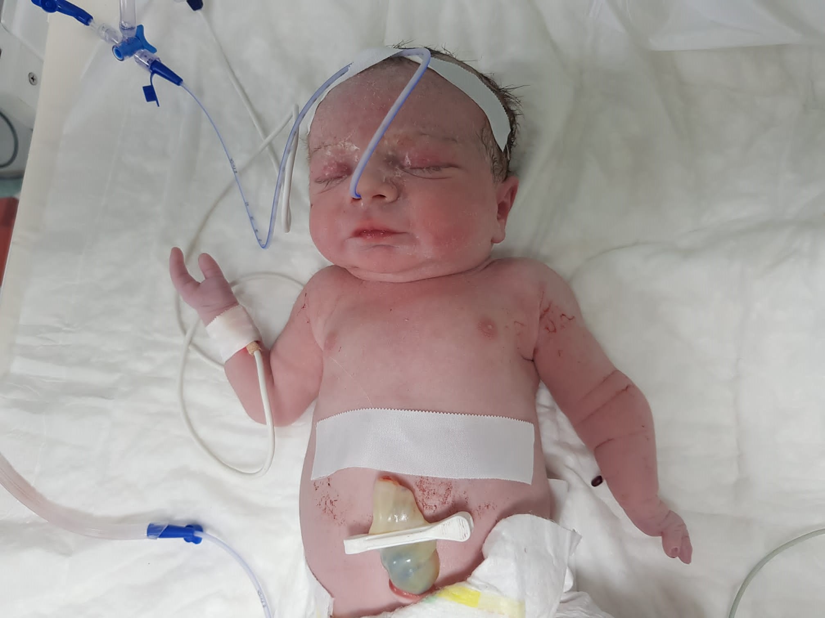
Picture 3: postpartum photo of the case
Conclusion: If ectrodactyly is suspected in the ultrasonographic evaluation, a detailed evaluation of the fetus should be performed in terms of additional anomalies, especially cleft palate-lip. With 3D ultrasonography, the severity of the anomaly can be better determined and better quality counseling can be given to the family about the prognosis. Cases diagnosed prenatally should be evaluated with a multidisciplinary approach.
Keywords: split hand, ectrodactyly, prenatal diagnosis, fetal anomaly

S-66 Clinical Outcomes Of Sacrospinous Ligament Fixation In The Treatment Of Pelvic Organ Prolapse And Evaluation Of Recurrent Cases
Reyyan Gökçen İşcan¹, Aysel Öcal¹, Defne Sayıcı¹, Sultan Seren Karakuş¹, Resul Karakuş¹, Çetin Kılıççı¹, Pınar Kumru¹
1 Zeynep Kâmil Kadın Ve Çocuk Hastalıkları Eğitim Ve Araştırma Hastanesi

Sacrospinous Ligament Fixation (SSLF) is a safe and effective procedure in the surgical treatment of Pelvic Organ Prolapse (POP). We aimed to present the subjective and objective outcomes of SSLF procedure, performed by four surgeons and to evaluate the recurrent and reoperated cases. 44 of 89 patients who were diagnosed with POP and underwent SSLF in our clinic between January 2019 and March 2022 were included in the study. Objective success was evaluated using POP-Q (Pelvic Organ Prolapse Quantification) system. Patients who answered the PGI-I (Patient Global Impression of Improvement) as 'better' or 'much better' were considered subjectively successful. Postoperative stage III or IV and reoperated stage II POP cases were considered as recurrence.The average age of the patients was 58.34± 8.9 (min-max; 34-74), the average BMI was 28.2± 3.92 kg/m² (min-max; 19.7-36.3), gravida and parity average was found to be 3.7± 1.67 (min-max; 1-8) and 2.8 ± 1.07 (min-max; 1-5), respectively. Vaginal hysterectomy was performed in 95.5% (n=42) of the patients, colporrhaphy anterior in 86.4% (n=38), and colporrhaphy posterior in 52.3% (n=23) simultaneously. The median follow-up period was found 32±11 months (min-max; 6-44). In the preoperative period, 68% (n=30) of the patients were found to have stage III POP, and 32% (n=14) had stage IV POP. At 32 months follow-up period, 91% (n=40) of the patients were objectively cured and subjectively succesful. Significant improvement was found in all cases at point C. All quality of life surveys showed significant improvement in the postoperative period compared to the preoperative period (Table 1). Recurrence was observed in the anterior compartment in all cases (n = 4). Three of the patients were reoperated; One was due to stage III Ba prolapse at the 6th postoperative month, and the other two were due to the development of complications and stage II Ba prolapse and accompanying stress urinary incontinence, respectively. In conclusion, SSLF is an effective and safe surgical method for the treatment of apical prolapse. Since the risk of recurrence is higher in cases accompanied by anterior compartment prolapse, the addition of reconstruction procedures of the tissues that provide anterior wall support should be considered to reduce the risk of recurrence.
Anahtar Kelimeler: Sacrospinous ligament fixation, pelvic organ prolapse, anterior compartment prolapse

Table 1
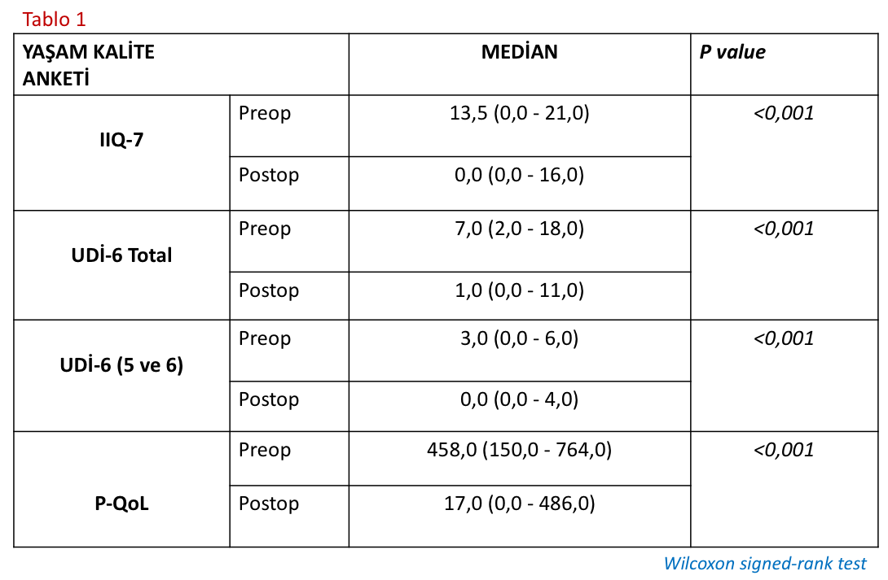

S-67 A Case Of Acute Abdomen And Simultaneous Fetal Distress That Developed Spontaneously At The Beginning Of The Latent Phase In A Mid-Term Pregnant Woman Diagnosed With Primigravid And Small For Gestational Age (Sga)
Sadettin Oğuzhan Tutar¹, Deniz Taşkıran²

1 Giresun Üniversitesi Tıp Fakültesi Kadın Hastalıkları ve Doğum Anabilim Dalı,
2 Giresun Kadın Doğum ve Çocuk Hastalıkları Eğitim ve Araştırma Hastanesi,

Adnexal torsion is a rare pathology and is very important because it is the cause of acute abdomen that is difficult to diagnose in the late stages of pregnancy. A 28-year-old, g1 p0, mid-term pregnant woman, who was within 40 weeks of mid-term gestational age according to her last menstrual period, was being followed up in the delivery room upon detection of an unreliable fetal heartbeat trace in her nst, and spontaneously developed both an acute abdomen clinic and a late-developing deceleration. Upon diagnosis of fetal distress, an emergency cesarean delivery decision was made for the pregnant woman. In the abdominal exploration performed on the patient during cesarean delivery; Both the left and right ovaries were observed in a torsional appearance for 2 rounds. A cystic structure of 10 x 10 cm in size was observed in the left ovary and a cystic structure of 8 x 8 cm in size was observed in the right ovary. The left and right ovaries were first detorsioned for 2 rounds, then a cystectomy was performed without compromising the integrity of the cyst, and primary suturing was performed on the left and right ovaries, and the detorsion and cystectomy procedures were completed without any problems. A live male baby weighing 2830 grams was delivered head-on, with an Apgar score of 8 at the 1st minute and an Apgar score of 8 at the 5th minute, with thick meconium. One true node structure was observed in the umbilical cord structure. As a result of the final pathology, it was reported that the cystic structure removed from the left and right ovaries as a whole was a mature cystic teratoma. The primary cesarean section operation was completed smoothly and without complications from both maternal and fetal perspectives.
Keywords: Pregnancy, acute abdomen, adnexal torsion, mature cystic teratoma, fetal distress
INTRODUCTION

The incidence of acute abdomen during pregnancy has been reported as 1 in 500-635 cases (1). Acute appendicitis is the most common cause of acute abdomen during pregnancy, excluding obstetric reasons (1). 25-30% of the cases who underwent surgery due to acute abdomen are pregnant women diagnosed with acute appendicitis (1).
Non-obstetric causes of acute abdomen include; Acute cholecystitis and intestinal obstruction are also the most common clinical conditions after acute appendicitis (2). The frequency of non-obsteric intra-abdominal surgery has been reported as 1 in every 451-635 births (2).
As a picture of acute abdomen; Adnexal torsion is a rare clinical condition and occurs in 2.7% of all gynecological emergencies (3). Adnexal torsion is more common in women of reproductive age; It is an emergency gynecological clinical condition that is difficult to diagnose preoperatively and involves the tuba, ovary and adjacent structures separately or together.
Its incidence during pregnancy is 1/5000 and it is frequently seen in the 1st trimester (3).
Cases usually present with sudden onset of dull-persistent or intermittent, sharp lower quadrant pain. In differential diagnosis; ovarian cyst rupture, acute appendicitis, ectopic pregnancy rupture, pelvic inflammatory disease, intestinal surgical pathologies, urolithiasis and acute cystitis should be considered (4). In preoperative diagnosis; Doppler ultrasonography is the gold standard and the diagnosis is usually made during exploratory laparotomy/laparoscopy performed due to acute abdomen (5).
In diagnosis and treatment, the pregnancy should not be harmed and the fetus should not be negatively affected. In addition, women in reproductive age should not be harmed in terms of fertility (6).

METHOD

This case is presented as a case report due to the development of a sudden onset acute abdomen clinic and fetal distress in the non-stres test (nst) in a pregnant woman at 40 weeks of mid-term gestation who was followed in the latent phase.

CASE

A 28-year-old, g1 p0, mid-term pregnant woman, who was within 40 weeks of mid-term gestational age according to her last menstrual period, was being followed up in the delivery room upon detection of an unreliable fetal heartbeat trace in her nst, and spontaneously developed both an acute abdomen clinic and a late-developing deceleration. Upon diagnosis of fetal distress, an emergency cesarean delivery decision was made for the pregnant woman. In the last vaginal examination findings of the pregnant woman before cesarean delivery; There was 2 cm cervical dilation, 50% cervical effacement, fetal head level -3, pouch positive and no amniotic fluid drainage. In the abdominal exploration performed on the patient during cesarean delivery; Both the left and right ovaries were observed in a torsional appearance for 2 rounds. A cystic structure of 10 x 10 cm in size was observed in the left ovary and a cystic structure of 8 x 8 cm in size was observed in the right ovary. The left and right ovaries were first detorsioned for 2 rounds, then a cystectomy was performed without compromising the integrity of the cyst, and primary suturing was performed on the left and right ovaries, and the detorsion and cystectomy procedures were completed without any problems. A live male baby weighing 2830 grams was delivered head-on, with an Apgar score of 8 at the 1st minute and an Apgar score of 8 at the 5th minute, with thick meconium. One true node structure was observed in the umbilical cord structure.

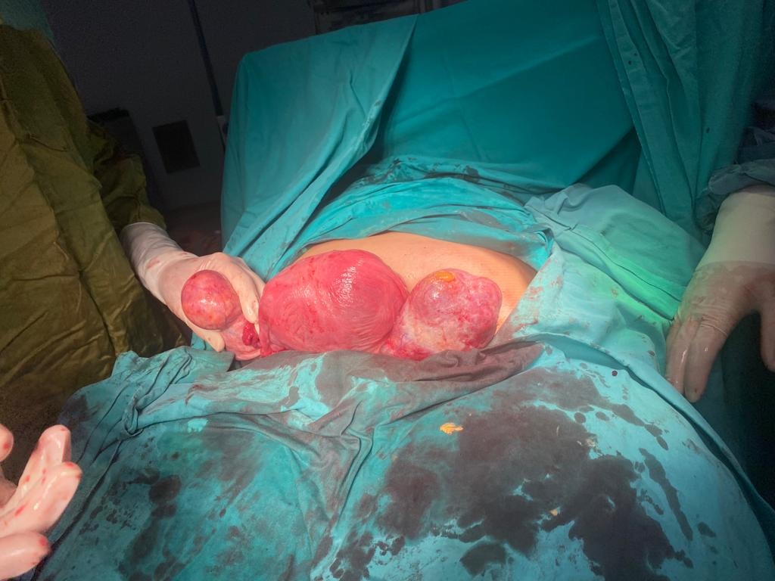

Figure 1: The first image of the dermoid cysts in the left and right ovary after detorsion

The postpartum patient was discharged from the hospital on the second postoperative day with good general condition, normal laboratory findings, and stable vital signs.
As a result of the final pathology; The pathologist reported that the cystic structure removed as a whole from the left and right ovaries was a mature cystic teratoma.

DISCUSSION and CONCLUSION

Adnexal torsion is an acute gynecological emergency that can be seen in 70-80% of women in the reproductive period (3).
Since ovarian torsion is usually accompanied by tubal torsion, it is more commonly defined as adnexal torsion in the literature (4). Approximately 20% of patients with adnexal torsion are pregnant. Although it is more common in the 1st trimester and early 2nd trimester of pregnancy, adnexal torsion can occur at any time during pregnancy.

It is very rare to see adnexal torsion during the 3rd trimester (6). Torsion of the right adnexal is more common (7). Our case; It was the development of torsion in the left and right ovaries in a full-term pregnant woman. The presenting complaints of the patients are groin and lower quadrant pain, and nausea and vomiting may accompany the condition. Physical examination reveals tenderness, guarding and rebound, which are signs of localized peritonitis (8). In our case, there was a sudden onset of defense and rebound in the left and right lower quadrants. Although adnexal torsion does not occur very frequently, a delay in diagnosis and treatment can lead to serious clinical problems such as ovarian necrosis, abscess, peritonitis and sepsis. Therefore, this possibility should be taken into consideration in the differential diagnosis of acute abdomen associated with pregnancy (9).
Nowadays, the laparoscopic approach is the primarily preferred method in the surgical intervention of acute abdomen in pregnant women. There are studies showing that laparoscopy is safe even in the 3rd trimester (3).
It is obvious that there will be difficulties in laparoscopy as the pregnancy progresses (10).
In our case, laparotomy operation was preferred because the diagnosis of adnexal torsion could not be made directly in the preoperative period and a simultaneous emergency cesarean delivery decision was made. Detorsion is a form of treatment (4). Oophorectomy is required in necrosed ovaries where blood flow does not improve after detorsion of the adnexal (11).
In our case, the left and right ovaries were first detorsioned for 2 rounds, and since the improvement in blood flow and color change in the tissue occurred very quickly and the ovarian tissue returned to normal, cystectomy was performed after detorsion, followed by primary suturing, and protective surgery was performed on the left and right ovaries.
In conclusion; Despite all technological developments, it is very difficult to diagnose adnexal torsion, especially in pregnant women in the last trimester. Adnexal torsion, which is difficult to diagnose, is one of the gynecological emergency diagnoses that should be kept in mind because it can cause fetal loss in addition to organ loss.

REFERENCES

- Augustin G, Majerovic M. Non obstetrical acute abdomen during pregnancy. Eur J Obstet Gynecol Reprod Biol 2007; 131(1): 4-1.
- Tarraza HM, Moore RD. Gynecologic causes of the acute abdomen and the acute abdomen in pregnancy. Surg Clin North Am 1997; 77(6): 1371-92.
- Silja A, Gowri V. Torsion of a normal ovary in the third trimester of pregnancy: a case report. J Med Case Rep. 2008;2:378. doi: 10.1186/1752-1947-2-378.
- Hoover K, Jenkins TR. Evaluation and management of adnexal mass in pregnancy. Am J Obstet Gynecol. 2011;205(2):97-102.
- Kumari I, Kaur S, Mohan H, et al. Adnexal masses in pregnancy: a 5-year review. Aust N Z J Obstet Gynaecol. 2006;46(1):52?4.
- Born C, et al. Diagnosis of adnexal torsion in the third trimester of pregnancy: a case report. Abdom Imaging. 2004;29:123?7. doi:10.1007/s00261-003-0079-x.
- Chang SD, et al. Surgical intervention for maternal ovarian torsion in pregnancy. Taiwan J Obstet Gynecol. 2011 ;50(4):458-62. doi: 10.1016/j.tjog.2011.10.010.
- Huchon C, Fauconnier A. Adnexal torsion: a literature review. Eur J Obstet Gynecol eprod Biol 2010;150(1):8-12.
- Smorgick N, et al. Torsion of normal adnexa in postmenarcheal women: can ultrasound indicate an ischemic process? Ultrasound Obstet Gynecol. 2008 31:338?41. doi:10.1002/uog.5194.
- Yoldemir T. Succesfull management of ovarian torsion during ART pregnancies: First and second trimester approaches. Causapedia. 2012;1:126-34.
- Leiserowitz G. Managing ovarian masses during pregnancy. Obstet Gynecol Surv. 2006;61(7):463-70.

S-68 The Investigation Of Motor Imagery Ability In High-Risk Pregnant Women: A Case-Controlled Pilot Study
Seda Yakıt Yeşilyurt¹, Tansu Birinci², Seda Ayaz Taş³, Gökhan Tosun⁴
1 İzmir Ekonomi Üniversitesi
2 İstanbul Medeniyet Üniversitesi
3 Bolu Abant İzzet Baysal Üniversitesi
4 Sağlık Bilimleri Üniversitesi İzmir Tepecik Eğitim ve Araştırma Hastanesi

Introduction: The ability to perform motor imagery has been shown to influence the acquisition of motor skills. This study aimed to investigate motor imagery ability in high-risk pregnant women. Methods: High-risk pregnant women (n=44; mean age: 27.89±5.63 years; mean body mass index: 30.58±6.49 kg/m2) and age and sex-matched healthy controls (n=44; mean age: 27.12±4.19 years; mean body mass index: 23.66±2.84 kg/m2) were included in the study. Turkish version of Vividness of Movement Imagery Questionnaire-2 (VMIQ-2) (Cronbach α=0.94 and ICC=0.74 for external imagery; ICC=0.77 for internal imagery; ICC=0.82 for kinesthetic imagery) was used to assess motor imagery ability. The total score of VMIQ-2 subscales ranges from 12 to 60, lower scores indicate better motor imagery ability. Results: The mean external imagery score was 29.68±15.35 in high-risk pregnant women and 25.86±8.56 in age and sex-matched healthy, without a significant difference (p=0.15). The mean internal imagery score was 29.43±14.28 in high-risk pregnant women, and 24.82±8.81 in age and sex-matched healthy, without a significant difference (p=0.07). The mean kinesthetic imagery score was 33.23±14.28 in high-risk pregnant women, and 27.02±10.94 in age and sex-matched healthy, with a significant difference (p=0.02). There is no statistically significant correlation between pregnancy week and external imagery, internal imagery, and kinesthetic imagery subscale scores (r=0.02, p=0.85; r=0.008, p=0.95, and r=-0.17, p=0.25, respectively). Conclusion: Physical activity may be restricted in high-risk pregnancies, sometimes by the obstetrician and gynecologist, and sometimes because of "fear of something will happen". The thought of "I should not move" may negatively affect motor imagery ability in terms of kinesthetic perception of movement in high-risk pregnant women. Motor imagery, which is the mental execution of a movement without any overt movement or any muscle activation, has shown that motor imagery leads to the activation of the same brain areas as an actual movement. Thus, motor imagery has the potential to be a therapeutic method to decrease the detrimental effect of inactivity with an imagery scenario that mainly consists of internal and external imagery elements for pregnant women with restricted activity.
Keywords: High-risk pregnancy, Motor imagery, Physical activity

S-69 Psychometric Properties Of The Turkish Version Of The Cervical Cancer Knowledge Scale
Selcan Zeynep Ergöz Aksoy¹, Dilek Bilgiç²
1 İzmir Ekonomi Üniversitesi Sağlık Bilimleri Fakültesi Hemşirelik Bölümü
2 Dokuz Eylül Üniversitesi Hemşirelik Fakültesi

Objective: The aim of this study was to examine the psychometric properties of "The Cervical Cancer Knowledge Scale", which was developed to measure the level of cervical cancer knowledge of women in the cervical cancer screening period, and to determine its suitability for Turkish women. Materials and Methods: A descriptive, methodological and cross-sectional design was used. Data were collected by online survey method between July and August 2023 using the "Data Collection Form" prepared by the researchers and the Turkish version of the "Cervical Cancer Knowledge Scale" measurement tool. The sample of the study consisted of women aged 21-65 years (n=307) who met the inclusion criteria and agreed to participate in the study. Language and content validity and confirmatory factor analysis were used to assess the validity of the scale. The reliability of the scale was assessed using Cronbach's alpha, item-total correlations and test-retest. Results: The content validity index of the Cervical Cancer Knowledge Scale was found to be 1.0 with excellent sensitivity. Confirmatory factor analysis showed that the model had a good fit (x2/df=2.200; GFI=0.96; CFI=0.96; RMSEA=0.063). Cronbach's alpha value of the Turkish version of the scale was found to be 0.80. Conclusion:The Cervical Cancer Knowledge Scale is a valid and reliable tool for measuring the knowledge level of Turkish women about cervical cancer. This scale can be used to determine women's level of knowledge about cervical cancer and their educational needs.In addition, it can be useful as a pre-test and post-test in evaluating the effectiveness of educations on cervical cancer. Thus, this scale may help to identify women who lack knowledge about cervical cancer prevention at an early stage. Keywords:Cervical cancer, gynaecological cancer, validity, reliability, psychometric measurement.
Keywords: Cervical cancer, gynaecological cancer, validity, reliability, psychometric measurement

S-70 Gebelikte Guillain-Barre Sendromu: Vaka Sunumu
Sena Özcan¹, Fadime Türe ²
1 T.c. Sağlık Bilimleri Üniversitesi İzmir Tepecik Eğitim ve Araştırma Hastanesi
2 İzmir Demokrasi Üniversitesi Buca Seyfi Demirsoy Eğitim ve Araştırma Hastanesi

GİRİŞ Guillain-Barré Sendromu (GBS), akut gelişen inflamatuar demiyelinizan nadir bir polinöropatidir. Genel popülasyonda sıklığı 1-2/100.000 ve erkeklerde kadınlardan daha sık görülür. GBS’ nin gebelik sırasında arttığı ve komplike olmayan hastalığın gebeliği ve doğumu etkilediği gösterilmemiştir. GBS için ilerleyici ve simetrik kas zayıflığı ve derin tendon reflekslerinin yokluğu karakteristiktir. Parestezi ve otonom fonksiyon bozukluğu eşlik edebilir. Enfeksiyon, aşılama ya da cerrahi ile tetiklendiği bilinmekle birlikte etiyopatogenezi hala belirsizdir. VAKA 28 yaşında, nullipar ve son adet tarihine göre 35 haftalık hamile kadın hasta, çocukluk çağında koroziv madde içme ve özofajektomi öyküsü bulunmaktadır. Hasta gebelik takiplerinde patoloji saptanmadığını bildiriyor. Acil servise abondan vajinal kanama ile başvuran hasta ultrasonda bradikardi görülmesi üzerine ablasyo plesanta endikasyonuyla acil sezaryana alındı. 2900-gram erkek bebek APGAR 6 ile dünyaya geldi ve pediatristlere teslim edildi. Postoperatif hastane takiplerinde hastanın son bir aydır olan bacaklarındaki güçsüzlüğün arttığı ve yürüyediği izlenmiştir. Hasta mobilize edilememiştir. Son dört haftadır herhangi bir enfeksiyon hastalığı öyküsü yok, Toxoplazma, CMV, Rubella, Herpes IgM sonuçları negatif çıktı. Rutin biyokimya tetkikleri, tam kan sayımı ve B12 vitamini değerleri normal sınırlardaydı. Nörolojiye konsülte edilen hastanın alt ekstremite proksimal kas gücü 3/5 (0-5 Tıbbi Araştırma Konseyi [MRC] ölçeğine göre) ve distal kas gücü 5/5 (0-5 Tıbbi Araştırma Konseyi [MRC] ölçeğine göre). Üst ekstremite derin tendon refleksleri normoaktif, oysa alt ekstremite derin tendon refleksleri hipoaktifti. Klinik, MRI ve EMG bulguları ile hastaya GBS tanısı konuldu. IVIG tedavisi ve plasmaferez başlandı. Hasta ilerleyen solunum fonksiyon bozukluğu ile yoğun bakım ünitesine alındı ve entübe edildi. Postoperastif 9. günde yoğun bakım ünitesinde otonom disfonsiyon ile kardiyak arrest gelişen hastaya kardiyopulmoner resüsitasyon protokolü başlandı. Ancak hasta exitus oldu. SONUÇ VE TARTIŞMA Guillain-Barré Sendromu (GBS) etyopatogenezinde gebeliğin rolü olmadığına inanılmaktadır ve prognozu önemli ölçüde etkilemez. Gebelikte GBS ile nadiren karşılaşılır. Kuadripleji gelişen ve hareket edemeyen gebeler için sezaryan doğum önerilmektedir. Ayrıca GBS’ nin enfeksiyon, aşılama ya da cerrahi ile tetiklendiği bilinmektedir. Ancak vaka sayılarının yetersiz olması nedeniyle obstetrik yaklaşım için standart protokol oluşturulamamıştır.
Anahtar Kelimeler: Gebelik, Guillain-Barré Sendromu, Sezaryan

S-71 Ovarian Germ Cell Tumor Dysgerminom
Serap Mutlu Özçelik Otçu¹
1 S.b.ü. Gazi Yaşargil Eğitim Araştırma Hastanesi

ABSTRACT Germ cell tumors arise from the primordial germ cells of the ovary. They can also arise from undifferentiated germ cells of the gonad, and from extragonadal regions such as the mediastinum and retroperitoneum. Germ cell tumors are a model of curable cancers. Most of the management experience has been derived from the management of testicular germ cell tumor men. The most common cellular type is dysgerminoma. Serial LDH (lactate dehydrogenase), PLAP (Placental alkaline phosphatase) were elevated in 95% of patients. Up to 3% of dysgerminomas have elevated HCG levels, typically less than 100 IU. Approximately 70% of ovarian tumors in the first two decades of life are of germ cell origin, and one-third of them are malignant. Since our patient was young and had fertility requests, limited surgical staging and unilateral salpingoopherectomy were performed. Since it was stage 1c3, chemotherapy was started with the BEP regimen. Karyotype analysis is awaited. Since the tumor diameter is greater than 10 cm and younger than 20 years of age, the patient has a tendency to recurrence, and close follow-up with tumor markers and imaging will be performed. Germ cell ovarian tumor should be considered in young patients with solid masses and surgical planning should be performed with diagnostic tests.
Keywords: Ovarian Tumor, Dysgermınom
INTRODUCTION
Germ cell tumors arise from the primordial germ cells of the ovary. They can also arise from undifferentiated germ cells of the gonad, and from extragonadal regions such as the mediastinum and retroperitoneum. Germ cell tumors are a model of curable cancers. Most of the management experience has been derived from the management of testicular germ cell tumor men. The most common cellular type is dysgerminoma. Serial LDH (lactate dehydrogenase), PLAP (Placental alkaline phosphatase) were elevated in 95% of patients. Up to 3% of dysgerminomas have elevated HCG levels, typically less than 100 IU. Approximately 70% of ovarian tumors in the first two decades of life are of germ cell origin, and one-third of them are malignant.

A CASE
The patient was 19 years old, single, and on ultrasonography performed for abdominal pain, a 20 cm solid mass extending to the umbilicus was observed in the abdomen. In magnetic resonance imaging: Intense heterogeneous contrast enhancement in the solid component after contrast injection, which fills the pelvic region, and which is selected separately from the uterus, with a size of 16x14x11 cm at its widest point, hypointense in the lobulated contoured T1W images, hypointense, slightly hyperintense in T2W, and showing cystic degeneration in the central part. A mass lesion is present. Minimal free fluid was observed in the abdomen. Distant metastasis and lymphadenopathy were not observed. Tumor markers bHCG: 112 , CA125:59, other tumor markers (AFP, CEA,CA 19-9) were measured as normal. Pathology result: It came as stage 1C3 (limited, malignant ascites fluid in the left ovary). 5% of dysgerminomas occur in individuals with abnormal gonads who are phenotypically females. Since the patient had pain, an operation plan was made without waiting for the result of the karyotic analysis. Left salpingoopherectomy, omental biopsy, abdominal fluid sampling, peritoneal surfaces and retroperitoneal lymph nodes were carefully palpated and peritoneal biopsy was taken. The contralateral ovary was carefully examined and no implant or metastasis was observed. Dysgerminoma is a single germ cell ovarian tumor that tends to be bilateral. In 5-10% of patients with dysgerminoma with preserved one ovary, dysgerminoma will develop in the other ovary within the next 2 years. Although sensitive to radiotherapy, it is used in selective patients with recurrent disease because of the risks of loss of fertility and secondary malignancy. It is very sensitive to platinum and has a high cure rate. The most commonly used chemotherapy regimen is BEP (Bleomycin, Etoposide, Cisplatin).

RESULTS
Since our patient was young and had fertility requests, limited surgical staging and unilateral salpingoopherectomy were performed. Since it was stage 1c3, chemotherapy was started with the BEP regimen. Karyotype analysis is awaited. Since the tumor diameter is greater than 10 cm and younger than 20 years of age, the patient has a tendency to recurrence, and close follow-up with tumor markers and imaging will be performed. Germ cell ovarian tumor should be considered in young patients with solid masses and surgical planning should be performed with diagnostic tests.

S-72 Gold Standard Surgery For Pelvic Organ Prolapse: Laparoscopic Sacrohysteropexy
Erdoğan Gül¹, Sertaç Ayçiçek¹
1 Sağlık Bilimleri Üniversitesi Diyarbakır Gazi Yaşargil Eah

INTRODUCTION: Sacrohysteropexy/sacrocolpopexy is still the gold standard surgical method in pelvic organ prolapse (POP) surgery, especially in apical prolapse surgery. CASE: The 47-year-old patient has no previous history of surgery. She has 5 normal vaginal deliveries. In the gynecological examination; According to the POP-Q classification, stage 3 anterior, apical and posterior prolapse was observed. There is no significant finding in USG and the smear result is benign. L/S Sacrohysteropexy+Colpography anterior+Colpography posterior was performed to the patient in GAA. The mesh was fixed from the posterior to the promontorium of the uterus. While 2.0 prolene sutures were used during fixation, 2.0 vicryl sutures were used for peritoneal closure. 1 suture was used for the promontorium and 3 sutures were used for the uterus posterior. The patient was discharged without any complications after the operation. The aim of this case-poster study is to show that performing laparoscopic sacrohysteropexy by preserving the uterus is still a frequently used and gold standard surgical method in POP surgery within the appropriate patient and indications. CONCLUSION: The most common apical prolapse surgery performed laparoscopically is sacrohysteropexy, and there are not as many studies in the literature as this technique about other POP surgical methods.
Keywords: Laparoscopic sacrohysteropexy, Minimally Invasive Surgery, Pelvic Organ Prolapse
INTRODUCTION: Pelvic organ prolapse (POP) is defined as pelvic organs descending from their normal position due to pelvic floor dysfunction (1). A woman's lifetime risk of undergoing POP surgery is 11% (2). Laparoscopic sacrohysteropexy is an effective, safe and conservative procedure in the treatment of uterine prolapse (3).

CASE: The 47-year-old patient had a history of five normal vaginal deliveries. The patient came to our clinic with the complaint of uterine prolapse. In the gynecological examination, stage-3 apical prolapse, stage-3 anterior and stage-3 posterior POP were observed according to POP-Q staging (figure-1). The patient has no SUI complaint. There is no significant pathology in USG. There is no pathology in the patient's smear.
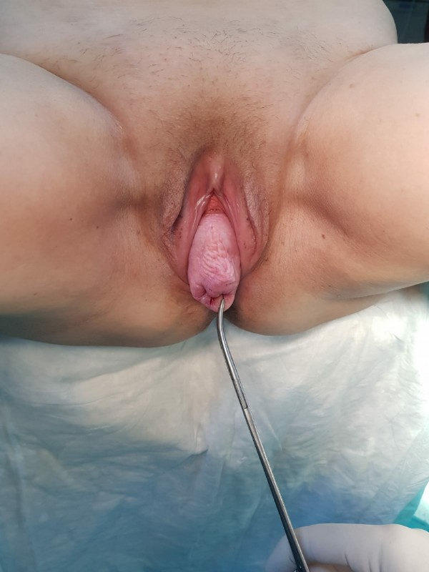
Figure-1: Preoperative gynecological examination image.

The patient was entered into the abdomen with a 10-gauge trochear directly under general anesthesia and three 5th auxiliary trochears were inserted. Pneumoperitoneum was created with 12-14 mmHg throughout the operation. The peritoneum was dissected from the uterus posterior to the sacrum pneumontorium, and the retroperitoneum was exposed by paying attention to the right ureter (figure-2). The promontorium and uterus were fixed posteriorly with 2.0 prolene suture with prolene mesh.

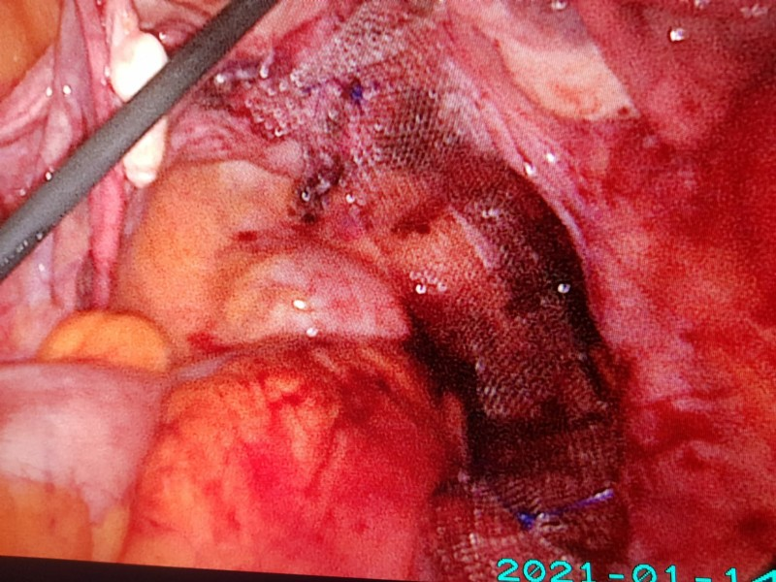
Figure-2 : Revealing the retroperitome from the right lateral and fixing the uterus posteriorly with the sacrum promontorium with prolene mesh.

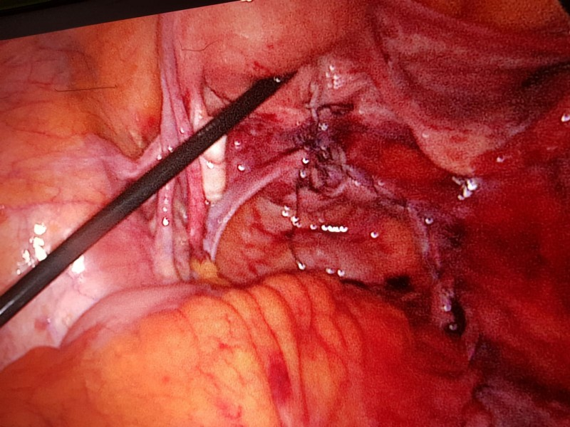
Figure-3: 2.0 vicryl closure of the retroperitoneum.
Later, anterior and posterior colpography was performed vaginally (figure-4).
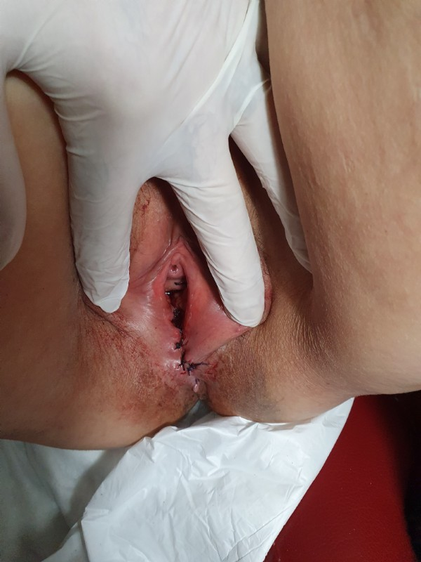
Figure-4: Colpography anterior and posterior.

The operation was terminated after bleeding control and the gynecological examination was normal on the 1st and 10th days post-op.

DISCUSSION AND CONCLUSION: Laparoscopic sacrohysteropexy is a variant of the abdominal method in which the uterus is suspended over a mesh to the sacral promontory (4). It has been reported that laparoscopic sacrohysteropexy has a high success rate (5,6). In a prospective observational study of 51 women who underwent laparoscopic sacrohysteropexy, the procedure had an objective success rate of 98% without resorting to hysterectomy (7,8). In addition, subjective improvement in prolapse symptoms and sexual health was noted. In this study, two patients reported abdominal discomfort and colic pain, and a second laparoscopy was performed. intraoperatively; adhesions were found between the bowel and the theme in both patients (9,10,11). After this finding, the authors performed complete peritonization of the mesh to prevent adhesions (12). In our case, we performed complete peritonization of the mesh.

RESOURCES :
1. M. F. Fialkow, K. M. Newton, G. M. Lentz, N. S. Weiss. Lifetime risk of surgical management for pelvic organprolapse or urinary incontinence. Int Urogynecol J 2008;19:437-4402.
2. Olsen AL, Smith VJ, Bergstrom JO, Colling JC, Clark AL. Epidemiology of surgically managed pelvic organ pro-lapse and urinary incontinence. Obstet Gynecol 1997;89:501-6.3.
3. Baden WF, Walker T. Genesis of vaginal profile: a corre-lated classification of vaginal relaxation. Clin Obstet Gynecol 1972;15:1048-544.
4. Mohamed Hefni, Tarek El-Toucky. Uterine prolapse inyoung women. Best Practice & Research ClinicalObstetrics and Gynaecology 2011;25:157-655.
5. Elisabetta Costantinia, Luigi Mearinia, Vittorio Binib, Alessandro Zucchia, Ettore Mearinia, Massimo Porenaa. Uterus Preservation in Surgical Correction of UrogenitalProlapse. European Urology 2005;48:642-96.
6. Christine C. Skiadas, Donald P. Goldstei n, Marc R.Laufer.The Manchester-Fothergill Procedure as a FertilitySparing Alternative for Pelvic Organ Prolapse in YoungWomen. Journal of Pediatric and Adolescent GynecologyVolume 19, Issue 2, Pages 89-93, April 20067.
7. O’Brien PM, Ibrahim J. Failure of laparoscopic uterine suspension to provide a lasting cure for uterovaginal pro-lapse. Br J Obstet Gynaecol 1994;101:707-8.8.
8. Maher C, FCarey MP,Murray CJ Laparoscopic suture hys-teropexy for uterine prolapse. Obstet Gynecol 2001;97:1010-4.9.
9. N Price, A Slack, SR Jackson. Laparoscopic hysteropexy: the initial results of a uterine suspension procedure for uterovaginal prolapse. An International Journal of Obstetrics and Gynaecology DOI: 10.1111/j.1471-0528.2009.02396.x10.
10. L. Mouritsen and J. P. Larsen, “Symptoms, bother andPOPQ in women referred with pelvic organ prolapse,”International Urogynecology Journal and Pelvic FloorDysfunction, vol. 14, no.2, pp. 2003;122-7 11.
11. B. Bojahr, G. Tchartchian, M. Waldschmidt, R. Ohlinger, and R. L. DeWilde. Laparoscopic Sacropexy: A Retrospective Analysis of the Subjective Outcome in 310 Cases.Obstetrics and Gynecology International Volume 2012,Article ID 538426, doi:10.1155/2012/53842612.
12. G. Busby, J. Broome. Successful pregnancy outcome following laparoscopic sacrohysteropexy for second degreeuterine prolapse. Gynecol Surg DOI 10.1007/s10397-008-0460-4

S-73 Serous Borderline Ovarian Tumors Analysis
Sevgi Ayhan¹
1 Ankara Şehir Hastanesi

Background: The aim of this study was to evaluate the characteristics of serous borderline ovarian tumours (BOT), the recurrence rates and the factors affecting recurrence. Methods: A retrospective evaluation was made of 165 patients diagnosed with BOT between 2004 and 2019 in a single centre. The patients were evaluated in respect of age, parity, preoperative CA-125 level, tumour histological type, FIGO grade, bilaterality of the tumour, tumour size, largest tumour diameter, the presence of stromal micro-invasion, desire of the patient for fertility, surgical procedures applied, the number of lymph nodes removed, follow-up duration, recurrence rates, and the prognostic risk factors affecting disease-free survival (DFS). Results: Early stage BOT (Grade 1-2) were determined in 149 patients (90.3%) and late stage (Grade 3-4) in 16 (9.7%). The mean follow-up period was 120 months, and recurrence was observed in 8 (4.8%) patients. Conservative surgery was applied to 57 (34.5%) patients, non-invasive implant in 19 (11.5%) patients, and micro-invasion was determined in 31 (18.8%) patients. Non-invasive implants, advanced stage, and a high preoperative CA-125 level were determined at a statistically significantly higher rate in the group with micro-invasion (p<0.001 for all). The risk of recurrence was determined at a statistically significantly high level in patients with stromal micro-invasion, nulliparity, and who had undergone a second operation (re-staging). The 5-year DFS of serous BOT was 95.2% and the 10-year DFS was also 95.2%. The results of the univariate analysis showed that preoperative elevated CA-125 level and the presence of micro-invasion were associated with poor DFS results. In the multivariate analysis, the presence of micro-invasion was determined to be the only independent poor prognostic factor for DFS. Conclusion: The risk of recurrence is high in patients with serous BOT determined with micro-invasion. The presence of micro-invasion was found to be the only poor prognostic factor affecting DFS.
Keywords: Serous borderline ovarian tumour, recurrence, micro-invasion
Background: The aim of this study was to evaluate the characteristics of serous borderline ovarian tumours (BOT), the recurrence rates and the factors affecting recurrence.
Methods: A retrospective evaluation was made of 165 patients diagnosed with BOT between 2004 and 2019 in a single centre. The patients were evaluated in respect of age, parity, preoperative CA-125 level, tumour histological type, FIGO grade, bilaterality of the tumour, tumour size, largest tumour diameter, the presence of stromal micro-invasion, desire of the patient for fertility, surgical procedures applied, the number of lymph nodes removed, follow-up duration, recurrence rates, and the prognostic risk factors affecting disease-free survival (DFS).
Results: Early stage BOT (Grade 1-2) were determined in 149 patients (90.3%) and late stage (Grade 3-4) in 16 (9.7%). The mean follow-up period was 120 months, and recurrence was observed in 8 (4.8%) patients. Conservative surgery was applied to 57 (34.5%) patients, non-invasive implant in 19 (11.5%) patients, and micro-invasion was determined in 31 (18.8%) patients.
Non-invasive implants, advanced stage, and a high preoperative CA-125 level were determined at a statistically significantly higher rate in the group with micro-invasion (p<0.001 for all). The risk of recurrence was determined at a statistically significantly high level in patients with stromal micro-invasion, nulliparity, and who had undergone a second operation (re-staging). The 5-year DFS of serous BOT was 95.2% and the 10-year DFS was also 95.2%. The results of the univariate analysis showed that preoperative elevated CA-125 level and the presence of micro-invasion were associated with poor DFS results. In the multivariate analysis, the presence of micro-invasion was determined to be the only independent poor prognostic factor.
Conclusion: The risk of recurrence is high in patients with serous BOT determined with micro-invasion. The presence of micro-invasion was found to be the only poor prognostic factor affecting DFS.

S-74 Recurrent Neural Tube Defects
Sevim Tuncer Can¹
1 Sağlık Bilimleri Üniversitesi, İzmir Tepecik Eğitim ve Araştırma Hastanesi, Kadın Hastalıkları ve Doğum Ana Bilim Dalı, Perinatoloji Bölümü

OBJEKTIVE Most isolated neural tube defects (NTDs) appear to result from folate deficiency, possibly with genetic or other environmental risk factors. NTDs have also been associated with certain genetic syndromes, amniotic band sequence, hyperthermia in early pregnancy, pregestational diabetes (including type 2), and obesity. The recurrence risk of isolated NTDs is 2-4% if there is a history of an affected sibling. METHODS The patient who was referred to Izmir Tepecik Training and Research Hospital Perinatology Clinic due to her poor obstetric history was evaluated in detail. RESULTS The patient, who was 29 years old, G5P4Y2, 19 weeks and 1 day pregnant according to the last menstrual period, was referred to our clinic for further examination and treatment. There was no history of additional disease or teratogenic drug use. There was no history of febrile illness during pregnancy. Body mass index was 22.1 kg/m2. She had a consanguineous marriage. Since there were unplanned pregnancies, the patient did not have a history of regular folic acid use. Her first pregnancy was in 2010, female fetus, healthy. 2nd pregnancyş in 2012, male fetus, encephalocele, no additional anatomical abnormality, normal karyotype for chromosome analysis, terminated. 3rd pregnancy, in 2016, male fetus, healthy. 4th pregnancy in 2018, male fetus, encephalocele, chromosomal analysis normal karyotype, no additional anatomical abnormality. When the patient was admitted to our clinic in her 5th pregnancy, a detailed ultrasonographic examination was performed. The gender was female. The bilateral ventricles were 11 mm and the brain parenchyma was thinned. Thalamic nuclei were discrete and the third ventricle was dilated. Toxoplasma, rubella, cytolomegalivirus infection panel was negative. Chromosome analysis result showed normal karyotype. CONCLUSİON Isolated encephalocele is not familial; If there are associated anomalies, it may be part of specific genetic syndromes. High-dose folic acid (4 mg) is a safe and effective treatment for the prevention of NTDs. Since partial trisomy 2p22-pter and 20p resulting from maternal derived-translocation may be responsible for recurrent NTDs, genetic counseling should be given to parents in this direction.
Keywords: encephalocele, neural tube defects, folic supplementation

S-75 3. Trimester Gebelerde D Vitamini Eksikliği ile Üriner İnkontinans İlişkisinin Belirlenmesi
Sezer Gül¹
1 Erzurum Hınıs Şehit Yavuz Yürekseven Devlet Hastanesi

Amaç: Üriner inkontinans, hastaların yaşam kalitesini önemli ölçüde olumsuz etkileyen bir sağlık sorunudur. D vitamini pelvik taban fonksiyonları açısından kritik bir öneme sahiptir. Bu çalışmanın amacı; 3. trimester gebelerde D vitamini eksikliği ile üriner inkontinans ilişkisini araştırılmasıdır. Gereç ve Yöntem: Araştırmamıza İzmir Kâtip Çelebi Üniversitesi Atatürk Eğitim ve Araştırma Hastanesi gebe polikliniğine Ocak 2021-Kasım 2021 tarihleri arasında başvuran 28 hafta üzeri gebe kadınlar dâhil edildi. Gebeler rutin izlem sırasında inkontinans açısından sorgulandı. İnkontinans tanımlayan gebelere Uluslararası İnkontinans Şiddet İndeksi uygulandı. Tüm katılımcılardan 5 cc venöz kan alınarak -80 °C de saklandı. Olgu sayısı tamamlandığında alınan kan örneklerinde D vitamini düzeyi çalışıldı. D vitamini eksikliği olan 210 olgu çalışma grubu, D vitamini düzeyi normal olan 40 olgu kontrol grubu olarak belirlendi. Çalışma ve kontrol grupları uygulanan inkontinans ölçeğinde aldıkları ortalama puan açısından karşılaştırıldı. Gruplar arası karşılaştırmalar normal dağılım gösteren değişkenlerde bağımsız iki örneklem t testi, normal dağılım göstermeyen değişkenlerde Mann-Whitney U testi ile yapıldı. p<0.05 anlamlı olarak kabul edildi. Bulgular: Çalışmamıza dahil edilen gebelerin %40’ında Üİ öyküsü olduğu ve %84’ünde D vitamini eksikliği olduğu belirlendi. D vitamini eksikliği olan ve D vitamini düzeyi normal olan gebeler Üİ deneyimi açısından karşılaştırıldığında gruplar arasında anlamlı bir fark olmadığı belirlendi. Çalışma grubu (D vit. eksikliği olanlar) ve kontrol (D vit. normal) grubundaki nullipar hastalardan inkontinans tanımlayanlara inkontinans şiddet indeksi uygulandı. D vitamini eksikliği olan nullipar gebelerde üriner inkontinans sıklığı ve şiddetinin anlamlı düzeyde yüksek olduğu belirlendi. Sonuç: Çalışmamızda nullipar gebelerde D vitamini eksikliğinin Üİ gelişimi ile anlamlı biçimde ilişkili olduğu sonucuna varıldı. Anahtar kelimeler: Vitamin D, Gebelik, Üriner İnkontinans
Anahtar Kelimeler: Vitamin D, Gebelik, Üriner İnkontinans

S-76 Subcutaneous Immunoglobulin Therapy During Pregnancy In A Woman With Hyper-Igm Syndrome
Sinem İnan¹, Papatya Bayrak Değirmenci¹
1 İzmir Tepecik Eğitim ve Araştırma Hastanesi

RATIONALE: The hyperimmunoglobulin M (HIGM) syndromes which is a subtype of primary immunodeficiencies(PID) include a heterogeneous group of conditions characterized by defective class-switch recombination, resulting in normal or increased levels of serum IgM associated with deficiency of IgG, IgA, IgE and poor antibody function.
IGRT strategies should be developed during pregnancy, taking into account physiological factors such as maternal placental transfer of IgG, fetal gestational age, increased plasma volume and catabolism. Subcutaneous immunoglobulin (SCIG) and intravenous immunoglobulin (IVIG) are similarly effective at preventing infections. Advantages of SCIG compared with IVIG include fewer systemic reactions, more consistent serum IgG levels, and ease of home infusion.
We present a successful management strategy for SCIG maintenance therapy during two consecutive pregnancies in a patient with HIGM.
METHODS: A 34-year-old woman had a 3-4/year history of lower respiratory tract infections and sinusitis since childhood. In her family history, her parents were third degree relatives and one of her siblings had died at the age of 7 years due to infection. Her tests revealed low IgG(0.34 mg/L) and A(0.26g/L) levels and high IgM(7.33g/L) levels. Activation-induced cytidine deaminase (AID) gene mutation was found in genetic analysis and the patient was diagnosed as HIGM syndrome.Beginning in the first month of pregnancy, total serum IgG levels were monitored monthly and weekly. SCIG doses were increased as clinically indicated and adjusted to approximately 700 mg/dL.
RESULTS: Incremental dosage increases of 3 to 5 grams of SCIG were required beginning in the second trimester of both pregnancies. She gave birth twice at the ages of 30 and 32. The first was born by cesarean section(C/S) at 32. week due to fetal distress, and the other was born by C/S at term. She continued the final SCIG dose for 4 weeks post-partum and then resumed the ante-partum dose.
The first child has fetal cardiac anomaly, which we do not attribute to IGRT; the second child has no discernible development defects
CONCLUSIONS: Pregnancy with PID involves careful consideration of IGRT dosage. Both IV and SC IGRT is generally considered safe during pregnancy. Follow-up of these patients should be multidisciplinary with allergy-immunology physicians.
KEY WORDS: Hyperimmunglobulin M syndrome, SCIG, pregnancy

S-77 Onarılmış Maternal Fallot Tetrolojisi Olan Gebe Doğum Süreci Olgu Bildirimi
Tuğkan Duran¹, Alper İleri¹
1 Tepecik Eğitim ve Araştırma Hastanesi

Fallot Tetralojisi (ToF) ventriküler septal defekt, desktrapoze aorta, pulmoner stenoz ve sağ ventrül hipertrofisi görülen; sağdan sola şantlı konjenital kalp defektleri arasında en sık rastlanılan patolojilerden biridir ve toplam konjenital kalp hastalıkları içinde %5-8 oranında görülmektedir. Yapılan çalışmalarla gösterilmiştir ki erken yapılan cerrahi düzeltmelerle beraber yaklaşık 20’ li yaşlarda hastalarda oluşan kardiak yetmezlik, pulmoner regürjitasyon ve supraventriküler aritmi gibi durumlar azalmıştır. Çalışmamızda amacımız daha önceden 2 kez düzeltme cerrahisi geçirmiş TOF’u bulunan G1P0A0 bir annenin sezaryen olarak gerçekleştirilen doğum sürecini olgu olarak sunmaktır. 23 yaşında gravida1 parite 0 abort 0, son adet tarihine göre 38+3 haftalık, dating 15+3 haftaya göre 37+3 olup vajinal muayenesi 3 cm açıklık ve %30 effasman ile hastanemize başvurdu. Özgeçmişinde hastamız 2004 yılında (4 yaşında) vsd açısından 2017 yılında (17 yaşında) pulmoner kapak değişimi açısından opere olmuş. Kardiyoloji tarafından hipovolemiden kaçınılarak sezaryen önerilen hastamız postoperatif 2. Gününde hemodinamik ve klinik olarak stabil olarak 1 hafta sonra kardiyoloji ve 6 hafta içinde jinekolojik kontrol önerilerek taburcu edildi. Yapılan çalışmalarda gösterilmektedir ki TOF’lu annelerde erken gebelik kaybı ile triküspit regürjitasyonu ve semptomatik kalp yetmezliği gibi kardiyolojik komplikasyonlar artış göstermektedir. Sunduğumuz olguda gebeliği süresince bahsedilen komplikasyonlar gelişmemiştir. Doğum kardiyoloji önerisine uyularak çok daha fazla komplikasyon içermesine karşın sezaryen olarak uygulanmıştır. Çünkü sezaryen doğumun dakikalık volüm yüklenmesi normal doğuma oranla daha azdır. (%30◊%50) Bu olgumuzda da olduğu gibi kardiyolojik durumu kontrol altında olan gebeliği planlı olarak geçekleştirilen ve perinatoloji-kardiyoloji tarafından takip edilen anne adaylarında gebelik süreci sorunsuz geçebilmektedir.
Anahtar Kelimeler: Fallot Tetroloji, gebelik, konjenital kalp defekti.
CASE
Our patient was 23 years old, gravida 1, parity 0, abortion 0, 38+3 weeks according to the last menstrual date, 37+3 weeks according to dating 15+3 weeks and presented to our hospital with a vaginal examination of 3 cm cervical dilation and 30% effacement. Our patient, who had 80 Montevideo unity 2 contractions in 10 minutes in NST follow-up, was followed up by perinatology and had regular follow-ups by cardiology before Patient had no complaint, her blood pressure, pulse rate and temperature were 125/78 mm/hg, 81/minutes and 36.70 C respectively. The ultrasonographic assessment showed intrauterine single fetus, fetal heartbeat +, head presentation, placenta anterior right lateral, and amniotic fluid index (AFI) 158 mm. Antenatal measurements were observed as it follows: BiParietal Diameter (BPD): 37+4 weeks AC(abdominal circumference) 37+2 weeks, FL(femur lenght) 37+3 weeks, estimated fetal weight: 3200 grams, Umbilical arterial s/d ratio: 2.68 and pulsatile index: 0.77. Laboratory findings were Hb 12.9 g/dL leucocyte 11200/uL thrombocytes 174000/uL fibrinogen 505 mg/dL d-dimer 1990ug/L +2 leucocyte +1 erythrocyte +1 protein in the urine. In her detailed anamnesis we found 2 cardiac surgeries, first was in 2004 due to ventricular septal defect (VSD), second was in 2007 due to pulmonary valve replacement. The patient who had no symptoms was followed up closely by cardiology during regular follow-up. The patient was consulted by cardiology after a prenatal ECG. Cardiology consultation was observed as: "Electrocardiogram (ECG) sinus rhythm right bundle branch block 85 beats/minute no symptoms of failure. The patient with moderate right ventricular dilatation and pulmonary stenosis is recommended to be checked 1 month after delivery. A cesarean section is recommended. It is important to avoid hypotension in cesarean delivery." In the echo report of our patient, it was stated that ejection fraction was 66%, right cavities were slightly wide, Ao had mild regurgitation jet flow and moderate pulmonary stenosis, and it was recommended that the delivery should be performed by c/s. After a cesarean section, the Male newborn’s weight was 3158 g with APGAR 8 in the first minute and APGAR 9 in the 5th minute. On examination performed by pediatrics, height was 50 cm and head circumference was 35 cm. CVS examination revealed s1+s2+ rhythmic murmur. Femoral and brachial pulses were equal. The newborn with neonatal transient tachypnoea was transferred to the mother after 1 hour of noninvasive ventilation and clinical improvement. Postoperative laboratory values: hb 10.2 g/dL leucocytes 10700/uL thrombocytes 137000/uL. Our patient, who became hemodynamically and clinically stable on the 2nd postoperative day, was discharged with the recommendation of cardiology control after 1 week and gynecological control in 6 weeks.
DISCUSSION
Studies have shown that cardiological complications such as tricuspid regurgitation and symptomatic heart failure increase with early pregnancy loss in mothers with TOF. In the present case, these complications did not develop during pregnancy. In addition, the patient did not use any extra medication. The delivery was performed by cesarean section in accordance with the cardiological recommendation although it involves more complications. Because the cardiac minute volume loading of cesarean delivery is less than normal delivery. (30%-→ 50%) As in our case, the pregnancy process can go smoothly in expectant mothers whose cardiological status is under control, and whose pregnancy is planned and followed up by perinatology-cardiology. In multicentric retrospective studies, supraventricular and ventricular arrhythmias may develop in mothers with repaired TOF. The most common obstetric complications are early pregnancy loss and postpartum hemorrhage due to PPROM. Neonatal outcomes include high mortality due to prematurity and low birth weight. This condition is frequently associated with negative cardiovascular status during pregnancy and subsequent placental insufficiency.
In conclusion, the incidence of these complications decreases when expectant mothers with repaired TOF undergo a planned pregnancy process with close multidisciplinary follow-up.
REFERENCES
1. Cerovac, A., Ljuca, D., Khodary, B., & Grgic, G. (2018). Pregnacy and delivery in a patient after tetralogy of fallot surgery being undergone. Medical Archives, 72(1), 71.
2. SolmAz, F. A., & Cuhruk, H. (2015). The application of epidural anesthesıa in pregnant woman with uncorrected tetralogy of Fallot: a case report. Agri: Agri (Algoloji) Dernegi'nin Yayin organidir= The journal of the Turkish Society of Algology, 27(4), 215-218.
3. Wang, K., Xin, J., Wang, X., Yu, H., & Liu, X. (2019). Pregnancy outcomes among 31 patients with tetralogy of Fallot, a retrospective study. BMC Pregnancy and Childbirth, 19(1), 1-8.

S-78 Management Of Borderline Ovarian Tumors: A Single Tertiary Center Experience
Caner Köse¹, Büşra Körpe¹, Uğur Kemal Öztürk², Mustafa Erkin Sarsu³
1 Etlik Zübeyde Hanım Kadın Sağlığı Eğitim ve Araştırma Hastanesi
2 Zeynep Kâmil Kadın ve Çocuk Hastalıkları Eğitim ve Araştırma Hastanesi
3 Özel Çağsu Hastanesi

İntroduction: Borderline ovarian tumours (BOT) account for 10-15% of epithelial ovarian neoplasms and the incidence is 1.4-4.8 per 100,000 women. The treatment protocols of BOT are controversial in the literature, and many single-center studies have been conducted to examine this issue. This study aimed to analyze the management protocols, surgical approaches, and outcomes of women with BOTs in a tertiary center. Method: This retrospective study includes 177 patients diagnosed with serous and mucinous BOT, who were operated on at the Etlik Zubeyde Hanım Women's Health Training and Research Hospital Gynecological Oncology Clinic between 2014-2021. Demographic, clinical, and pathological data were retrospectively reviewed from medical records. The patients were divided into two groups according to the surgical interventions, as laparoscopy and laparotomy. Outcomes were assessed and compared between the groups. Statistical analysis was performed using IBM SPSS for Windows, Version 26.0. Results: Laparoscopy was performed in 57 (32.2%) patients, while laparotomy was initially chosen for 120 (67.8%) patients. Conservative treatment was administered to 107 (60.5%) patients (Table 1). The laparotomy group had a higher mean age at diagnosis (48.69±12.52 vs. 41.1±11.66, p < 0.001), larger tumor size (84.13±51.85 mm vs. 67.1±34.78 mm, p = 0.013), and a greater number of postmenopausal patients (55 vs. 9, p = 0.002). Rates of recurrence (8% vs. 7.1%, p = 0.76) did not differ significantly between the two groups. Disease-free survival was also similar between the groups (Table 2). Recurrence occurred in 13 patients and the recurrence rate was 0.7% (Table 3). Conclusion: This study presents the experiences and treatment modalities of borderline ovarian tumors in a tertiary center. There were no significant differences observed between radical and conservative surgery or between laparotomy and laparoscopy in terms of recurrence rates.
Keywords: Borderline ovarian tumor; laparoscopy; laparotomy

S-80 A Rare Cause Of Persistent Constipation In Pregnancy; A Case Of Ovarian Mucinous Cystadenoma
Zercan Kalı¹, Serhat Öcal¹, Pelin Öcal¹
1 Gözde Hospital

Introduction: GIS (gastrointestinal system) problems are quite common during pregnancy. The most common complaint is nausea and vomiting, and the second most common complaint is constipation (1). Since constipation is defined among physiological changes, there is little information in the literature about its differential diagnosis. Ovarian cysts during pregnancy are generally asymptomatic (4). Although very rare, it can be detected in emergency situations such as acute abdomen and torsion. This is the first case in the literature in which the clinical presentation of ovarian cyst during pregnancy is persistent constipation. If constipation during pregnancy does not improve despite treatment recommendations, ovarian masses should be considered in the differential diagnosis.
Case report :Our case was admitted to our clinic at the 36th week due to her third pregnancy. It was pregnancy, her previous pregnancy was delivered by cesarean section as a live birth weighing 3200 g, and there was a history of 1 abortion in her past history. She stated that she had painful and hard stools every 3 days, which started for about 10 days. There was no feature in the patient's medical history other than previous cesarean section. First of all, his diet was adjusted, fluid intake was increased and exercise was recommended. Laxative treatments were recommended to the patient whose complaints did not go away, but despite all suggestions and treatments, her complaints did not go away and gradually increased. The patient was consulted to the internal medicine department with persistent constipation. Abdominal ultrasonography (USG) was requested. A cyst was detected for the first time in our patient, who had no previous history of cysts, on USG. The cyst was thought to be of possible ovarian origin and was reported as having anechogenic bilobed cystic appearance. In the abdominal USG performed 2 weeks later, the cyst was monitored as having grown to 75x82 mm. During the follow-up, the effect of the enlarged uterus could not be visualized more clearly by cyst sonography after the size of 14-15cm. When her gestational age was 38 weeks and 3 days, she underwent elective cesarean section due to a previous cesarean section. A 3500g healthy baby was delivered. During the cesarean section, a giant cyst, approximately 21x19x5 cm in size, with a smooth surface and jelly-like content, was observed originating from the left adnexa (Figure 1). The ovary also could not be visualized. A left salpingo-oophorectomy was performed. Pathological examination reported a corpus luteum in the fibrotic ovarian stroma and a cystic structure with single-layered mucous columnar epithelium on the inner surface, with nuclei located at the base. The appearance of the cyst removed during cesarean section and persistent constipation has an important place among the gastrointestinal problems frequently seen during pregnancy. 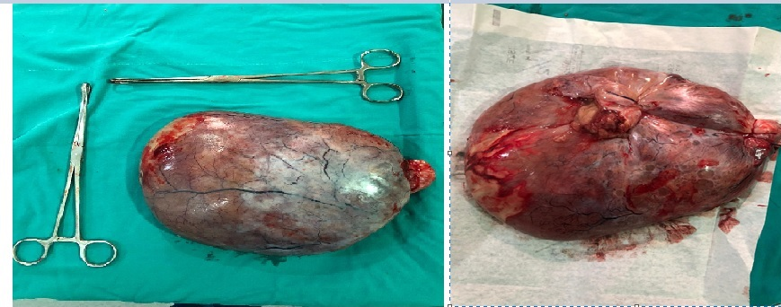 In our country, the incidence of constipation during pregnancy has been found to be 13-38% (1). It is thought to be secondary to the relaxing effect of progesterone on smooth muscles during pregnancy and the slowing down of intestinal peristalsis by the growing uterus putting pressure on the GIS (2). Although there is no clear definition of constipation; a system consisting of simple criteria has been created to define constipation during pregnancy. According to this system; constipation is defined as a pregnant woman defecating less than three times a week, along with hard stools and/or the feeling of incomplete evacuation (3). When the causes of constipation are examined; It is stated in the literature that the most common cause is the use of iron supplements, with a rate of 85.3%. Later, in 32.9% of the cases, history of surgery, fluid consumption, diet, and stress-related situations can be considered among the reasons (4). In treatment, preventive measures such as a high-fiber diet, exercise, and fluid intake are recommended for pregnant women. Education on nutrition and exercise has an important place in treatment. However, in case of persistent constipation, laxative treatments should also be recommended. The incidence of ovarian tumors detected during pregnancy and complicating pregnancy is known to be 1% to 2%. Most commonly with benign ovarian neoplasm; serous or mucinous cystadenomas and mature cystic teratomas (5). It has been observed that this incidence is gradually increasing; the most important reason for this is thought to be the increase in imaging techniques. Ovarian cysts during pregnancy generally remain asymptomatic and most of them regress spontaneously (6). Those that do not show regression may present with complications such as rupture and torsion. Fetal complications are; ıt may present as premature birth triggered by fetal growth restriction and high intra-abdominal pressure. Cases of permanent supine hypotension secondary to the size of the mass in the presence of mucinous cystadenoma during pregnancy have also been reported (7). Our case did not cause hypotension in the clinical sense, but it is the first case in the literature that raises suspicion and is detected due to constipation. Risk factors for adnexal masses include previous surgical history. Adhesions may occur due to abdominal or pelvic surgery or inflammation. The possible mechanism is the formation of a dead space secondary to these adhesions and the formation of adnexal masses due to the filling of the fluid content secreted from the ovarian surface. However, this is more common with inclusion cysts and hormone receptor-negative mucinous cystadenoma.
Mucinous cystadenomas usually originate from the ovary. However, mucinous cystadenomas arising from ectopic ovarian tissue in organs such as omentum, appendix or pancreas have also been reported (8,9). Therefore, in case of doubt, these cysts should be consulted with the relevant branches regarding their gastrointestinal origin.
Risk factors for adnexal masses include previous surgical history. Adhesions may occur due to abdominal or pelvic surgery or inflammation. The possible mechanism is the formation of a dead space secondary to these adhesions and the formation of adnexal masses due to the filling of the fluid content secreted from the ovarian surface. However, this is a theory that is mostly valid for inclusion cysts and hormone receptor negative mucinous cystadenomas. It is clearly known that mucinous cystadenomas show a growth pattern during pregnancy. In our case, it showed a gradual growth pattern in line with the literature and reached 21x9x5 cm in size at term. Although we primarily thought of a cystic structure due to adhesions secondary to previous cesarean section, we moved away from this diagnosis with the increasing growth pattern and the possibility that it was a hormone-sensitive cyst became certain with the pathology report (10,11).
Conclusıons: Although obstetricians' perspective on constipation during pregnancy is considered as physiological findings of pregnancy, an abdominal mass should be considered in the differential diagnosis in the management of persistent constipation, especially in the early weeks of pregnancy, and abdominal ultrasonography should be requested.
References
1. Özçelik G, Karaçam Z. Gebelikte Sık Karşılaşılan Yakınmalar, Fiziksel, Ruhsal ve Cinsel Sağlık Sorunları, Risk Faktörleri ve Yaşam Kalitesi İle İlişkileri. Ege Üniversitesi Hemşirelik Fakültesi Dergisi 2014;30(30)3:1-18.
2 Derbyshire E, Davies J, Costarelli V, Dettmar P. Diet, Physical İnactivity And The Prevalence of Constipation Throughout And After Pregnancy. Maternal and Child Nutrition, 2006; 2(1):127-34.
3. Verghese TS, Futaba K, Latthe P. Constipation in Pregnancy. The Obstetrician and Gynaecologist 2015;17:111-5.
4. Bradley CS, Kennedy CM, Turcea AM, Rao SC, Nygaard IE. Constipation in Pregnancy Prevalence, Symptoms, And Risk Factors. American Collage Obstetrics and Gynecology 2007;110(6):1351-57
5. A huge ovarian mucinous cystadenoma causing virilization, preterm labor, and persistent supine hypotensive syndrome during pregnancy. Kucur SK, Acar C, Temizkan O, Ozagari A, Gozukara I, Akyol A. Autops Case Rep. 2016;6:39–43
6. Qublan HS, Al-Ghoweri AS, Al-Kaisi NS, Abu-Khait SA. Benign mucinous cystadenoma with stromal luteinization during pregnancy: a hormonally responsive tumor and a rare cause of fetal intrauterine growth restriction. J Obstet Gynaecol Res. 2002;28:2
7. Repeated pregnancy with concomitant presence of ovarian teratoma: a case report and literature review. Chen LH, Chang SD, Huang HY, Wang HS, Soong YK, Wu HM. Taiwan J Obstet Gynecol. 2017;56:694–96.
8.Cohen I, Altaras M, Lew S, Jaffe R, Ben-Aderet N. Huge mesenteric mucinous cystadenoma in normal pregnancy. Obstet Gynecol. 1988;71:1030-32.
9. Tica AA, Tica OS, Saftoiu A, Camen D, Tica VI. Large pancreatic mucinous cystic neoplasm during pregnancy : what should be done? Gynecol Obstet Invest. 2013;75(2):132-38

10. Antoniou N, Varras M, Akrivis C, Demou A, Bellou A, Stefanaki S. Mucinous cystadenoma of the ovary with functioning stroma and virilization in pregnancy: a case report and review of the literature. Clin Exp Obstet Gynecol. 2003;30: 248-52.
11. Kalkunte S, Nevers T, Norris W, Banerjee P, Fazleabas A, Kuhn C, Jeschke U, Sharma S. Presence of non-functional hCG in preeclampsia and rescue of normal pregnancy by recombinant hCG. Placenta. 2010;31: 126.

S-82 Bladder Exstrophy: A Case Report
Ece Öcal¹, İhsan Bağlı²
1 Perinatoloji Özel Klinik
2 Gazi Yaşargil Eğitim Araştırma Hastanesi Kadın Hastalıkları ve Doğum Kliniği

Abstract: Bladder exstrophy is a rare complex congenital malformation. Its frequency is reported as one case per 30,000 live births. The rate of prenatal diagnosis is approximately 15%. We are presented a case of bladder exstrophy which diagnosed at 20 th week of pregnancy by us. Amniocentesis and termination of fetus were recommended to the patient who did not undergo screening tests, but the patient refused. Cesarean delivery was performed at 37 weeks of gestation, a 2900 gram baby boy was admitted to the neonatal intensive care unit with 8-9 apgars and bladder exstrophy external sexual organ abnormalities. Despite postnatal repeated reconstructive surgeries, urinary continence problems persisted. Antenatal diagnosis is important in order to provide early information about the situations that will occur in the future child of the family and to offer a termination option.
Keywords: Bladder Exstrophy, Antenatal Diagnosis
Intorduction: Bladder exstrophy is a rare complex congenital malformation. It is seen equally in male and female fetuses. Its frequency is reported as one case per 30,000 live births. Although it is thought that both environmental and genetic factors play a role in the pathogenesis, the underlying cause is not fully known.
It mostly occurs as an isolated malformation without other major anomalies. The most important and only reported risk factor is advanced maternal age. Due to various difficulties in diagnosis, the rate of prenatal diagnosis is approximately 15%. The diagnosis can be made before the 20th gestational week if the bladder fullness is not observed along with the lower abdominal wall defect in the ultrasonographic examination. However, this finding may be overlooked during sonographic examination, since the appearance of a full bladder is not always visible due to limited fetal urine production during early pregnancy. Other USG findings are lower abdominal protrusion, anteriorly displaced scrotum with small phallus in male fetuses, low-lying umbilical cord and increased angulation of the iliac bone. The amniotic fluid level is usually normal, as the fetal kidneys and urine production are normal.
Case: Gravida 1 parity 0, 32 years old, 21 weeks pregnant was referred to us from an external center with a preliminary diagnosis of fetal abdominal anomaly. In the ultrasonography performed, a single live fetus for 20 weeks and 6 days was observed, a well-defined solid area of ​​20x19 mm in size just inferior to the umbilical insertion and protruding into the amniotic fluid (Figures). Since bladder fullness could not be observed during the 40-minute sonographic evaluation, the existing pathology was evaluated as bladder exstrophy. Epispadias and phallus size in external genitalia were observed in a small state. Concomitant fetal anatomical pathology was not observed. Amniocentesis was recommended to the patient who did not undergo screening tests, but the patient refused. After consultation with pediatric surgery, postnatal evaluation and operation were recommended. There was no decrease in amniotic mai levels in antenatal follow-ups. Cesarean delivery was performed at 37 weeks of gestation due to premature rupture of membranes and breech presentation. A 2900 gram male baby was admitted to the neonatal intensive care unit with 8-9 apgars. Small phallus with bladder exstrophy and epispadias in the initial evaluation of the newborn (figures)

Discussion: Bladder exstrophy is usually diagnosed on ultrasound examination in the second trimester of pregnancy. Despite postnatal repeated reconstructive surgeries, it can cause urinary continence problems, reproductive and sexual problems in advanced ages. Antenatal diagnosis is important in order to provide early information about the situations that will occur in the future child of the family and to offer a termination option.

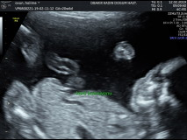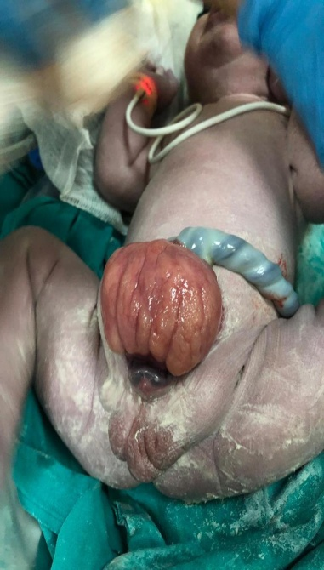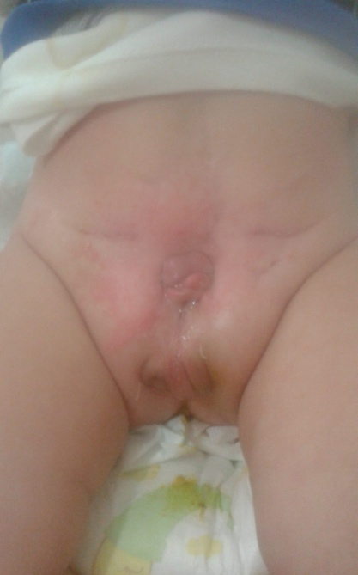

S-83 Hyperthermic Intraperitoneal Chemotherapy (Hipec) Administration In A Case With Recurrent Epithelial Ovarian Cancer
İnci Baran Malgaz¹, Behzat Can ¹, Süleyman Cemil Oğlak¹, Sedat Akgöl¹
1 Gazi Yaşargil Eğitim ve Araştırma Hastanesi Kadın Hastalıkları ve Doğum

Hyperthermic intraperitoneal chemotherapy (HIPEC) administration in a case with recurrent epithelial ovarian cancer İnci Baran Malgaz,Behzat Can,Süleyman Cemil Oğlak,Sedat Akgöl Gazi Yaşargil Training and Research Hospital, Gynecology and Obstetrics Clinic İntroduction: Epithelial ovarian cancer is the seventh most common cancer in women and the eighth cause of cancer death. Ovarian cancer is the cancer with the highest mortality among all gynecological cancers. Since there is a lack of effective screening methods and nonspecific initial symptoms of these patients, approximately 2/3 of cases admit in the advanced stages at the diagnosis time, with a five-year survival rate under 45%. It includes platinum-based combination chemotherapy after optimal cytoreductive surgery (no visible tumor). Intraperitoneal administration of chemotherapy improves the distribution of the drug to the peritoneal surface and can more effectively eliminate residual microscopic peritoneal disease, increasing patient survival. In the treatment of ovarian cancer, HIPEC application can be applied together with interval cytoreductive surgery after neoadjuvant chemotherapy, but there is insufficient information in the literature about the effect of this treatment. Case report: 41-year-old patient was operated in an external center for acute abdomen.. Widespread tumoral lesions were observed in the abdomen. Total abdominal hysterectomy and bilateral salpingooopherectomy was performed. Histopathological examination revealed high grade serous ovarian carcinoma.. Postoperative 6 cycles of carboplatin + paclitaxel adjuvant chemotherapy was administered. The patient who underwent PET-CT 11. months after chemotherapy was admitted to the Gazi Yaşargil Training and Research Hospital Gynecological Oncology clinic after widespread residual disease was detected. After optimal secondary cytoreductive surgery, HIPEC was applied simultaneously to the patient. The follow-up process of the patient, who did not have any postoperative complications, continues. Conclusion : It is known that HIPEC application together with interval cytoreductive surgery performed after neoadjuvant chemotherapy increases the overall survival and disease-free survival of the patient. In this case, we aimed to increase the survival of the patient with HIPEC after interval cytoreduction.
Keywords: hıpec,over ca

S-84 Sinir Koruyucu Radikal Histerektomi (Nerve Sparing Radical Hysterectomy)
Hümeyra Elif Ateş Eminoğlu¹
1 S.b.ü. Gazi Yaşargil Eğitim Araştırma Hastanesi

ABSTRACT Cervical cancer is the most common gynecological malignancy in underdeveloped countries. An average of 2500 new cervical cancer diagnoses are diagnosed annually in Turkey and it is accepted that approximately 1250 of these women die from cervical cancer. Cervical cancer occurs after a period of high-risk HPV infection and preinvasive disease. Screening and treatment of preinvasive lesions reduce the disease rate. With the routine vaccination program started in developed countries in recent years, the World Health Organization plans to eradicate cancer in the next century. Pelvic floor dysfunctions such as bladder, sexual dysfunction, colorectal motility disorders may develop in the postoperative period in patients who underwent traditional radical hysterectomy in the treatment of early-stage cervical cancer (Stage IA1-Stage IIA). Nerve-sparing radical hysterectomy has been defined to reduce the frequency of these complications. In this study, we aim to explain our clinical experience with a patient who underwent nerve-sparing radical hysterectomy, who was diagnosed with at least Stage 1B1 cervical cancer in Diyarbakır Gazi Yaşargil Training and Research Hospital, Gynecology and Obstetrics Clinic. We wanted to point out that it does. We wanted to emphasize the importance of this surgery.
Keywords: Serviks Kanseri, Sinir Koruyucu Radikal Histerektomi

A CASE
The patient was 32 years old, Gravida 2, Parity 2, and cervical smear result was HSIL and HPV 16 (+).In the physical examination, the perineum, vulva, and vagina (pvv) were normal and the collum was clear.No space-occupying formation was observed in the cervical canal and uterine cavity in ultrasonography.Uterus was normal, endometrium was regular, right ovary was not observed, left ovary was observed in natural appearance.When extensive acetowhite areas and atypical vascularization were observed in colposcopic examination, SEE and TREAT protocol was applied to the patient.Loop Electrosurgical Excision Procedure (LEEP) and Endocervical Curettage (ECC) were deemed appropriate.Pathology result was reported as moderately differentiated squamous cell carcinoma with positive surgical margin.The tumor is approximately 1.2×0.8 cm in size and the depth of invasion is 8 mm at its deepest point.Horizontal width is about 5 mm.The tumor is accompanied by a diffuse high-grade squamous intraepithelial lesion (CIN3) and the tumor is continuous at the 10 o'clock position at the endocervical and ectocervical surgical margin.No lymphovascular invasion was observed.The clinical stage was found to be at least stage 1B1.PET-CT and full abdominal MRI were planned for the patient after LEEP for radiological staging.Nerve-sparing radical hysterectomy was recommended to the patient who did not have distant or local metastases.Since the patient was fit, nerve-sparing radical hysterectomy with Pfannenstiel incision was performed, bilateral pelvic, level 3 paraaortic lymph node dissection was performed.Residual urine was measured as 50 cc on the 3rd postoperative day.Bladder dysfunction was not detected.The patient was discharged on the 4th postoperative day.

RESULTS
In this study, it is aimed to demonstrate the bilateral superior and inferior hypogastric nerves formed by the sympathetic nervous system emerging from the T10-L2 level and the splanchnic nerves that provide parasympathetic innervation originating from S2-S4, to perform a nerve-sparing radical hysterectomy, to protect these nerves during surgery functionally without affecting the surgical success of the patient. We have prepared our report in order to indicate that it provides a good postoperative surgery and to present the surgical technique we routinely apply to our patients with a video.

S-85 Are There Immunohistochemical Changes Occurred In Microsatellite Instability, Er/pr, And P53 Expression In Recurrent Endometrial Carcinomas
Zeliha Güzelöz ¹, Özce Kutlu², Özgür Erdoğan ³
1 University Of Health Science Turkey, Tepecik Training And Research Hospital, Department Of Radiation Oncology
2 University Of Health Science Turkey, Tepecik Training And Research Hospital, Department Of Pathology
3 University Of Health Science Turkey, Tepecik Training And Research Hospital, Department Of Gynecologic Oncology

Objective: The aim of this study is to determine the microsatellite instability and immunohistochemical changes in cases of recurrent endometrial cancer following primary surgery and assess the impact of these changes on prognosis. Patients and Methods: Thirty-one patients who underwent surgery for endometrial cancer between 2009 and 2023 and whose recurrences were pathologically verified were evaluated. Paraffin blocks containing tumor tissue samples obtained after primary surgery and recurrence from these patients were evaluated for mismatch repair proteins (MMR) including MLH1, PMS2, MSH2, and MSH6; Estrogen receptor (ER)/Progesterone receptor (PR); and p53 expression using the immunohistochemical staining method. MMR proteins were categorized as proficient MMR (pMMR) and deficient MMR (dMMR). Results:The mean age was 62.2±9.8. Among the patients, 81% (n=25) were in Stage I. Adjuvant external radiotherapy was administered to 52% of the patients. After primary surgery, the positivity rates for MLH1, PMS2, MSH2, and MSH6 staining were 54% (n=17), 51.5% (n=16), 100% (n=31), and 100% (n=31), respectively. In the evaluations of recurrence materials, there were four cases where MLH1 staining changed from positive to negative, and four cases where it changed from negative to positive. For PMS2 assessment, four cases changed from positive to negative, and seven cases changed from negative to positive. There were two cases where MSH2 staining changed from positive to negative, and no changes were observed in MSH6 staining. Staining after primary surgery, the rates of pMMR and dMMR were 61% (n=19) and 39% (n=12), respectively. Four cases transitioned from pMMR to dMMR, and two cases transitioned from dMMR to pMMR (p=0.687). Following recurrence, changes in ER were observed in seven patients, changes in PR in three patients, and changes in P53 status in three patients (p=0.125, p=0.250, p=0.250). There was no significance observed between cases showing MMR changes and prognostic factors. The median overall survival is 80 months. No difference was observed in terms of MMR changes in recurrence-free survival(p=0.072). Conclusion: While individual variations were observed, statistical significance was not detected due to the small number of cases. Recurrences should be pathologically verified to evaluate immunohistochemical changes and salvage treatment should be adjusted accordingly.
Keywords: Endometrial cancer, radiotherapy, microsatellite instability, ER/PR, p53, recurrence

S-86 Doğum İndüksiyonu Uygulanan Gebelerde Trans-Labial Ultrasonografi ile Vajinal Muayenenin Vajinal Doğumun Başarısı Göstermedeki Etkinliği
Emine Öztürk¹
1 Özel Muayenehane

Giriş: Bu çalışma, doğum indüksiyonu yapılan gebelerde trans-labial ultrason ile vajinal muayene kullanarak vajinal doğum başarı oranını karşılaştırmayı amaçlamaktadır. Yöntem: Bu çalışma, Nisan 2021 ile Haziran 2023 tarihleri arasında gerçekleştirildi. Çalışmaya tekil gebelik olan gebelik haftası 37 ila 42 hafta arasında olan gebeler alındı. Gebelerin tamamında fetus baş presentasyonda ve ultrasonografik görüntülemede normal morfolojide idi.4000gr üzerinde olan fetüsler, daha önce sezeryan öyküsü bulunan gebeler ve çalışmaya katılmak istemeyen gebeler çalışmadan çıkarıldı. Doğum İndüksiyon başlanan gebeler trans-labial ultrasonografi ve vajinal muayene grubu olarak ikiye ayrıldı. Bulgular: Çalışmaya toplamda 80 hasta dahil edildi ve bu kadınlar rastgele iki gruba ayrıldı. "Trans-labial plus vajinal muayene" grubundaki katılımcıların yaş ortalaması 27.8 ±7.1 yıl iken vajinal muayene grubunda 27.1±6.6 yıl idi. İki grup arasında yaş açısından anlamlı bir fark yoktu. Ayrıca, annelerin eğitimi (P=0.7), gebelik haftaları (P=0.7) ve gravida (P=0.4) açısından da iki grup arasında anlamlı bir fark saptanmadı Analizi sonuçları, vajinal muayene ile vajinal doğumun tahmininde sensivitenin %69.5 ve trans-labial ultrasonografi ile %87.6 olduğunu göstermektedir. Son olarak, trans-labial ultrason grubunda ilerleme açısı ölçüldüğündeilerleme Angle of Progression (AoP) açısı 130 derecede fazla olan kadınlar için vajinal doğumun gerçekleştiği Ayrıca, vajinal doğum grubundaki kadınların çoğunluğunun (%62.5) fetal başın final dönüş açısının 60 ila 90 derece arasında olduğu, sezaryen grubundaki kadınların çoğunluğunun ise (%45.1) final açının 0 ila 30 derece arasında olduğu gösterilmiştir. Sonuç: Genel olarak, bulgular, trans-labial ultrasonun doğum sürecinde doğru kararlar alınmasına yardımcı olduğunu göstermektedir. Bu nedenle, trans-labial ultrason ile ölçülen İlerleme Açısı (AoP) ve Rotasyon Açısı (RA), doğum sürecinde vajinal doğumu veya sezaryen doğumu tahmin etmek için etkili faktörlerdir.
Anahtar Kelimeler: Trans-Labial Ultrasonografi
Yöntem:
Bu çalışma, Nisan 2021 ile Haziran 2023 tarihleri arasında gerçekleştirildi. Çalışmaya tekil gebelik olan gebelik haftası 37 ila 42 hafta arasında olan gebeler alındı. Gebelerin tamamında fetus baş presentasyonda ve ultrasonografik görüntülemede normal morfolojide idi.4000gr üzerinde olan fetüsler, daha önce sezeryan öyküsü bulunan gebeler ve çalışmaya katılmak istemeyen gebeler çalışmadan çıkarıldı. Doğum İndüksiyon başlanan gebeler trans-labial ultrasonografi ve vajinal muayene grubu olarak ikiye ayrıldı.

Bulgular:
Çalışmaya toplamda 80 hasta dahil edildi ve bu kadınlar rastgele iki gruba ayrıldı. "Trans-labial plus vajinal muayene" grubundaki katılımcıların yaş ortalaması 27.8 ±7.1 yıl iken vajinal muayene grubunda 27.1±6.6 yıl idi.
İki grup arasında yaş açısından anlamlı bir fark yoktu. Ayrıca, annelerin eğitimi (P=0.7), gebelik haftaları (P=0.7) ve gravida (P=0.4) açısından da iki grup arasında anlamlı bir fark saptanmadı
Analizi sonuçları, vajinal muayene ile vajinal doğumun tahmininde sensivitenin %69.5 ve trans-labial ultrasonografi ile %87.6 olduğunu göstermektedir.
Son olarak, trans-labial ultrason grubunda ilerleme açısı ölçüldüğündeilerleme Angle of Progression (AoP) açısı 130 derecede fazla olan kadınlar için vajinal doğumun gerçekleştiği
Ayrıca, vajinal doğum grubundaki kadınların çoğunluğunun (%62.5) fetal başın final dönüş açısının 60 ila 90 derece arasında olduğu, sezaryen grubundaki kadınların çoğunluğunun ise (%45.1) final açının 0 ila 30 derece arasında olduğu gösterilmiştir.

Sonuç:
Genel olarak, bulgular, trans-labial ultrasonun doğum sürecinde doğru kararlar alınmasına yardımcı olduğunu göstermektedir. Bu nedenle, trans-labial ultrason ile ölçülen İlerleme Açısı (AoP) ve Rotasyon Açısı (RA), doğum sürecinde vajinal doğumu veya sezaryen doğumu tahmin etmek için etkili faktörlerdir.

S-87 A Case Of Fibrothecoma In A Woman Without Ovary : A Rare Case
Hayriye Varnalı¹, Özgür Erdoğan¹, Göksever Akpınar¹
1 Sbü İzmir Tepecik Eğitim ve Araştırma Hastanesi

Sex cord-stromal tumors are always found in ovary, but the occurrence of this kind of tumor at extraovarian locations is extremely rare . Fibrothecomas are benign sex cord-stromal tumors which rarely originate outside of the ovary. The etiology of how a fibrothecoma develops in an extraovarian location is unknown and its histogenesis remains speculative.Regardless of their origin, these extraovarian fibrothecomas are histologically indistinguishable from their ovarian counterparts. A fifty eight-year-old female patient, who had undergone total abdominal hysterectomy and bilateral salpingo-oophorectomy 15 years ago,was referred to our department with intermittent lower abdominal pain for about 4 years. On examination, both ultrasonography and magnetic resonance imaging revealed she had a left pelvic mass.Surgical exploration was decided.Histopathological examination revealed a spindle cell proliferation typical of a fibrothecoma and the cells had oval to round nuclei and large amphophilic cytoplasm In this study, we emphasize that fibrothecoma should be considered as a differential diagnosis in patients diagnosed with a pelvic mass after total abdominal hysterectomy and bilateral salpingo-oophorectomy.
Keywords: Sex cord–stromal tumor; extraovarian fibrothecoma ; pelvic mass
Introduction
Sex cord stromal tumors (SCST) are rare heterogeneous tumors of the ovary that exhibit different clinical findings and behaviors and may have different morphological features.
It is a group of non-epithelial tumors that can show different characteristics. SCST is the fifth most common ovarian tumor, with an incidence of approximately 5% to 8%.[1]
While in most cases tumors tend to grow slowly, in some cases aggressive tumors that grow very quickly may be encountered. Even within a single tumor type, morphology can be highly variable. Additionally, the tumor may have mixed morphological and immunohistochemical features of other SCST subtypes. This situation causes difficulties in diagnosis. [2]
According to WHO, in the most current SCST classification, there are 3 major groups according to cell origin. These are pure stromal tumors originating from ovarian stromal cells, pure sex cord tumors originating from the sex cord, and mixed tumors originating from both sex cord and stromal cells. Microcystic stromal tumor and sclerosing tumors were added to this classification in 2014.
Two new tumors in the form of luteinizing thecoma associated with peritonitis have been added. Gynandroblastoma has been removed from this classification. [3]
Sex cord-stromal tumors are always found in ovary, but the occurrence of this kind of tumor at extraovarian locations is extremely rare [4]
Fibrothecomas are benign sex cord-stromal tumors which rarely originate outside of the ovary.
The etiology of how a fibrothecoma develops in an extraovarian location is unknown and its histogenesis remains speculative.Regardless of their origin, these extraovarian fibrothecomas are histologically indistinguishable from their ovarian counterparts. [5]
Case Report
A fifty eight-year-old female patient, who had undergone total abdominal hysterectomy and bilateral salpingo-oophorectomy 15 years ago,was referred to our department with intermittent lower abdominal pain for about 4 years. On examination, both ultrasonography and magnetic resonance imaging revealed she had a left pelvic mass. Medical background and family history were unremarkable. Serum concentrations of the tumor marker cancer antigen (CA)-125 was elevated.A other laboratory parameters were normal. On physical examination, there was a palpable mass of approximately 10 centimeters in the abdomen.Magnetic resonance imaging (MRI) finding;in the form of hypointense mass lesion with cystic components thought to be pelvic origin ,approximately 9 * 12 * 6 cm in size in the low T2-weighted signal (Figure 1,2).Surgical exploration was decided.During the surgical exploration,a 25 centimeters solid mass lesion adhered to the surrounding tissues was observed adjacent to the left side of the bladder.Laparotomy was performed for transabdominal approach.There were no complications after operation and the patient was discharged on the 5th postoperative day. Histopathological examination revealed a spindle cell proliferation typical of a fibrothecoma and the cells had oval to round nuclei and large amphophilic cytoplasm (Figure 3). Cytologic atypia and tumor necrosis were not identified. No ovarian tissue was identified in association with the tumor. The neoplastic cells were diffusely positive for vimentin, calretinin , CD99 and BCL2 .The neoplastic cells were negative for the following markers: pankeratin and cytokeratin ; CD34 and DOG1 (a panel used to rule out gastrointestinal stromal tumor); desmin, smooth muscle actin a (panel used to rule out smooth muscle proliferation); S-100 (a marker of neural and melanocytic differentiation); Phosphohistone H3 (PHH 3 ).Ki67 proliferative index was <%1.

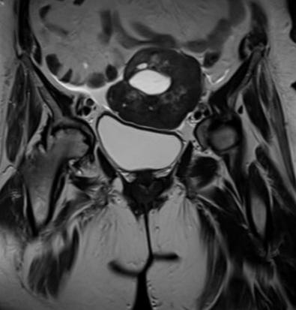

Figure 1. Coronal MRI image of a 58-year-old female patient. Solid white arrows show a hypointense solid mass with cystic components in the upper part of the bladder.

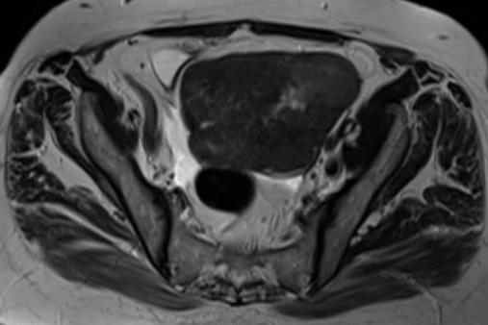
Figure 2.Axial T2-weighted magnetic resonance image.

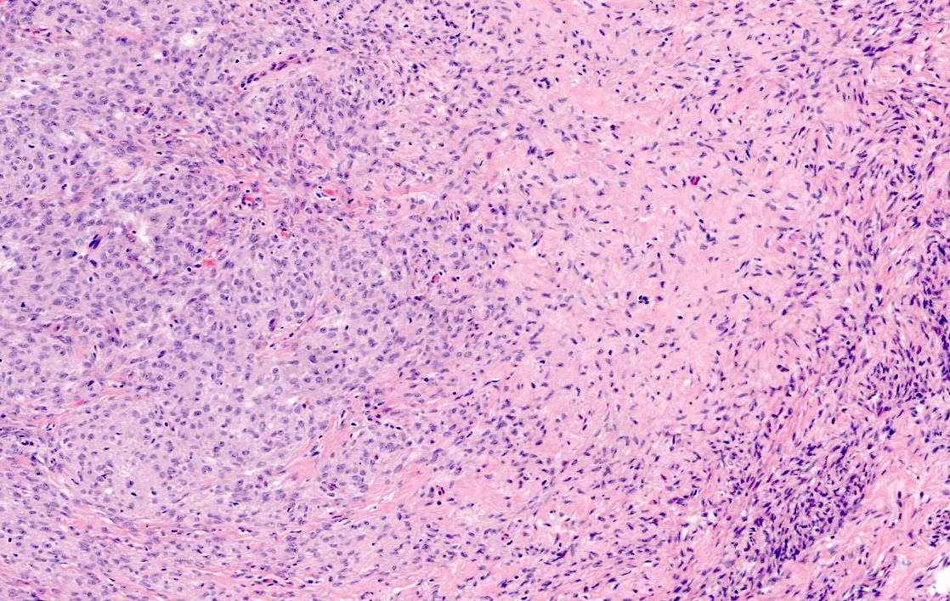

Figure 3

Discussion
There are a few studies showing that fibrothecomas, which are generally known to originate from the ovary, rarely originate from outside the ovary.
In the study conducted by Yanjun Chen et al., it was observed that there was fibrothecoma of the broad ligament with minor sex cord elements, and it was said that the natural course of this tumor was unclear. Long-term follow-up was thought to be extremely important in all patients diagnosed with broad ligament and minor sex cord fibrothecoma.
In the study of retroperitoneal extraovarian fibrothecoma mimicking malignant epithelial ovarian carcinoma by Patrick Roberts et al, the importance of obtaining histological evidence of malignancy before initiating neoadjuvant chemotherapy for presumed ovarian cancer was emphasized.
In this study, we emphasize that fibrothecoma should be considered as a differential diagnosis in patients diagnosed with a pelvic mass after total abdominal hysterectomy and bilateral salpingo-oophorectomy.

References
[1] Selvaggi SM. Tumors of the ovary, maldeveloped gonads, fallopian tube, and broad ligament. Arch Pathol Lab Med. 2000 Mar;124(3):477. PMID: 10705419. [Pubmed]
[2] Prat J.Pathology of the ovary.2004.SaundersPhiladelphia

[3] Hanley KZ, Mosunjac MB. Practical Review of Ovarian Sex Cord-Stromal Tumors. Surg Pathol Clin. 2019 Jun;12(2):587-620. doi: 10.1016/j.path.2019.02.005. PMID: 31097116. [Pubmed]
[4] Chen Y, Zhou P, Chen J. Fibrothecoma of broad ligament with minor sex cord elements: Case report and brief literature review. Medicine (Baltimore). 2023 Mar 3;102(9):e33127. doi: 10.1097/MD.0000000000033127. PMID: 36862914; PMCID: PMC9981358. [Pubmed]

[5] Roberts P, Nofech-Mozes S, Coburn N, Hamilton P, Gien LT. Retroperitoneal extraovarian fibrothecoma mimicking a malignant epithelial ovarian carcinoma. Case Rep Obstet Gynecol. 2012;2012:281745. doi: 10.1155/2012/281745. Epub 2012 Aug 15. PMID: 22928131; PMCID: PMC3426186. [Pubmed]

S-88 Adnexal Torsions During Pregnancy ; A Rare Case Ovarian Torsion And Management In Second Trimester Pregnancy
Burak Demirdelen¹
1 İstanbul Kanuni Sultan Süleyman Eğitim Araştırma Hastanesi

Ovarian torsion is a gynecological emergency that develops when the support structures of the ovary rotate around itself, suppressing the arterial, venous and lymphatic flow to the ovary. This situation may also occur during pregnancy. Case management becomes stronger in correlation with the week of pregnancy. Limitations in the use of imaging methods, surgical method preference, ensuring the continuation of the current pregnancy and routine post-operative complications are the main difficulties. While most adnexal torsions occur in the first trimester, they can rarely be seen in the second and third trimesters, as in this case. Management in accordance with the principles of minimally invasive approach, organ-preserving surgical approach and post-operative enhanced recovery after surgery (ERAS) are emphasized in this case.
Keywords: Adnexial torsions, over torsion, detorsion, pregnancy and torsion
GİRİŞ
Adneksiyal torsiyonlar tüm yaş gruplarında jinekolojik acil vakaların büyük kısmını oluşturmaktadır (1). Gebe ve gebe olmayan hastalarda insidans benzer olup %3.5-5 oranlarında görülür. Bu torsiyonlar izole tuba kaynaklı olabileceği gibi tubaovaryan kompleks, ovarian kitle torsiyonu ve broad ligament torsiyonu gibi farklı varyasyonlarla karşımıza çıkabilir. Genellikle spesifik olmayan belirtiler vermesinden dolayı tanı koymak zor olabilir. Gebelikte hastalığın yönetimi daha zordur. Zorluk tanıyı koyma ile başlar. İlk trimesterde abortus imminens, 2. ve 3. trimesterlerde preterm eylem gibi durumlar ile benzer semptomları göstereceği için adneksiyal torsiyon tanısı klinik süreci uzatacaktır. Aynı zamanda gebe olmayan hastalarda bilgisayarlı tomografi (BT) gibi yardımcı görüntüleme yönteminin gebe hastalarda kullanılmaması da tanıdaki diğer zorluk sebebidir. Cerrahi müdahele, anne ve bebek için ciddi risk oluşturabilmektedir. Konservatif tedavilerde ise torsiyone dokunun nekrozu veya tümör gelişimi de obstetrik komplikasyonlara yol açabilir (2).
VAKA ve YÖNETİMİ
Yirmisekiz yaş, G1P0, son adet tarihine göre 17.1 haftalık canlı gebeliği olan hasta kasık ve karın ağrısı ile acil kadın doğum polikliniğine başvurdu. Spekulum muayenesinde serviks, vulva ve vajen doğal izlendi, herhangi bir kanama görülmedi. Transvaginal ultrasonografide (TVUSG) servikal kanal uzunluğu 42 mm ölçüldü. Kollum hareketleri minimal ağrılı idi. Transabdominal USG'de fetusta belirgin bir anomali saptanmadı. Sağ adneksiyal bölgeden douglasa uzanım gösteren yaklaşık 7 cm boyutlarında konglamere kitle izlendi. Laboratuar değerlerinde hafif lökositoz (16.200) dışındaki değerleri ve tam idrar tahlili (TİT) normal izlenmedi. Vajen ve idrar kültürleri alındı.
Intermittan ağrı tarifleyen hastada ilk etapta erken doğum tehdidi açısından müşaadeye alındı. Hidrasyon tedavisine başlandı, toko monitorizasyonunde kontraksiyon izlenmedi ancak ğrıları devam etti. Gebelik öncesi jinekoloji takibi yoktu. İki saatlik izlem sonrası servikal uzunluk değişmedi. Adneksial bölgedeki kitlenin jinekolojik onkoloji tarafından değerlendirmesinde net bening-malign ayırımı yapılamadı.
Kitlenin Doppler ultrasonunda şüpheli kanlanma olması nedeniyle over torsiyonu ön tanısı düşünerek operasyona karar verildi ve gebelik nedeniyle laparatomi yapıldı. Phannesteil insizyonla batına girildi ve yaygın koagülüm ile beraber kan ile dolu olarak izlendi. Sağ adneksin 3 tam tur torsiyone over dokusu douglasa kadar uzandığı görüldü (Fotoğraf 1). Oldukça koyu renkli alanlar görüldü ve over detorsiyona edildi (Fotoğraf 2).

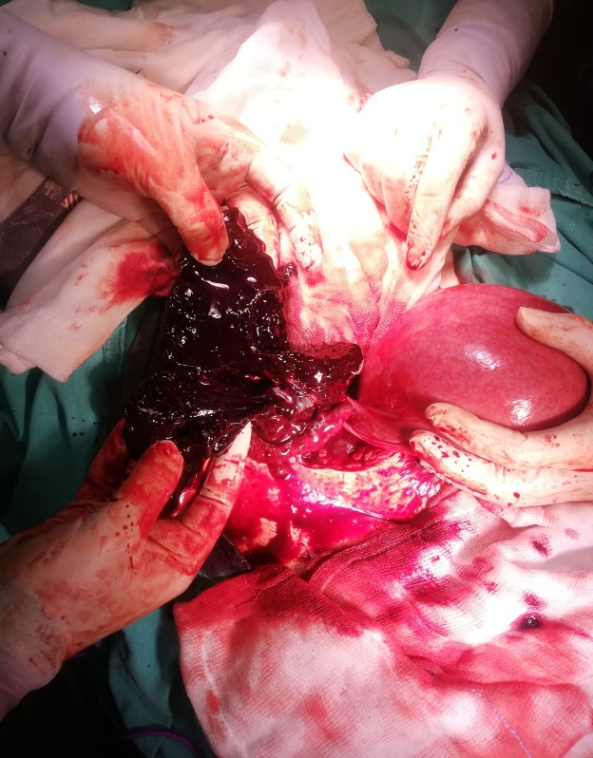
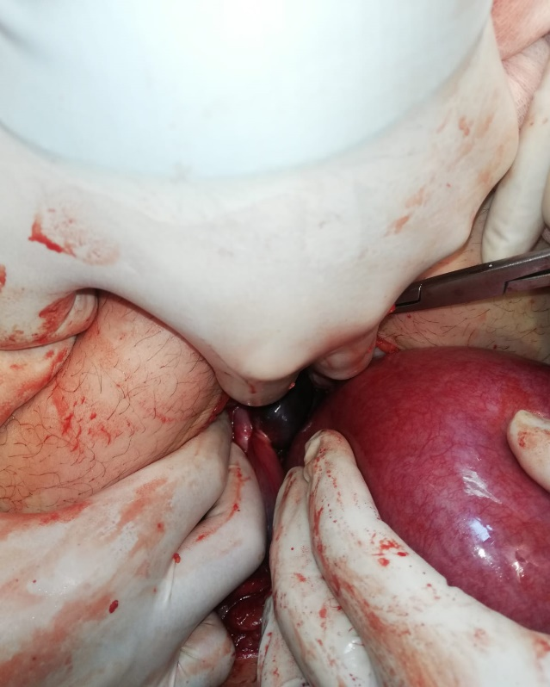
Fotoğraf 1: Üç tam tur torsiyone olmuş adneks
Fotoğraf 2: Bol nekroz ve kanama alanları izlenen over

Detorsiyone ettikten sonra over dokusu kanlanma nedeniyle koyu renkten pembe renge döndü. Over dokusu, kanamalar nedeniyle yapışık olduğu alalardan keskin ve künt diseksiyonlarla ayrıldı, 2-0 vcyrl sütürlerle over üzerindeki kanamalar durduruldu. İnraoperatif komplikasyon gelişmeyen hasta servise alındı, 4x100 mg indometazin supozituar tedavisi başlandı. Hızlı bir şekilde enhanced recovery after surgery (ERAS) protokollerine uygun mobilizasyonu tamamlandı. Takipte servikal uzunluk değişmedi. Ameliyat sonrası 12. saatte düşük molekül ağırlıklı heparin başlandı ve üçüncü günde hasta taburcu edildi, komplikasyonsuz bir şekilde kliniğimizde takibi yapılan hasta 38. haftasında canlı bir doğum gerçekleştirdi.
TARTIŞMA
Adneksiyal torsiyona sebep en önemli faktör adneksiyal kitleler olup gebelikte çoğu zaman rastlantı sonucu tanı almaktadır (3). Çoğu, hiçbir klinik bulgu vermemektedir. Bu vakalarda patofizyolojiyi iyi bilmek gerekir. Torsiyon ile birlikte öncelikle infindibulopelvik ligament çevresinde venöz ve lenfatik akım ilk önce kaybolur. Geri dönüşün tıkandığı bu ilk aşamada adneksial alandaki yapılarda renk ve ödematöz değişiklikler izlenir. Over çapları arasında belirgin farklılaşma USG’de tanınabilir. Bu aşamada spontan detorsiyon olabilir, ancak birkaç tur torsiyon olması durumunda arterial akım bozulur, over ve tubalara giden kanın azalması ya da kesilmesi nedeniyle nekroz ve lokal hemorajileler meydana gelebilir. Sağ overin sola göre torsiyona maruz kalma olasılığı daha yüksektir; muhtemelen sağ utero-ovaryan ligamentin soldan daha uzun olması ya da sol pelviste sigmoid kolon nedeniyle o tarafta torsiyon olmasına izin vermemesi neden olabilir (4,5).
Risk faktörlerine bakıldığında, torsiyonda adneksiyal kitleler en sık sebeptir (3). Ovarian kitlelerin de bazı karakteristik özellikleri torsiyona yatkınlık göstermektedir. Beş cm’den büyük kitleler genelde torsiyona daha sık sebep olmaktadır (6-8). Bir çalışmada 84 over torsiyonunda overyan kitleler ortalama 9.5 cm ölçülmüştür (8). Ovariyan kitlelerin natürü torsiyone olmasını etkiler. Örneğin bir endometrioma kitlesi seröz kist adenoma göre daha zor torsiyone olur. Ayırıcı tanı yaparken kistin natürüne incelemek önemlidir. En önemli diğer risk faktörü daha önce adneksial torsiyon öyküsüdür. Bir çalışmada 216 ovarian torsiyon vakasının yaklaşık %11’inde (n<0.23) tekrar torsiyon izlemişlerdir (9).
Adneks torsiyonu olan hastalar kliniğe en sık pelvik ağrı ile başvurur. Gebelikte pelvik ağrı etyolojisine bakıldığında ilk trimesterda abortuslar akla gelir. İkinci ve 3. trimesterlerinde ise erken doğum eylemi ilk düşünülen ön tanıdır. Bu sebeplerden dolayı gebe hastalarda tanıyı koyma süresi uzayabilir. Çünkü öncelikle bu ön tanıları dışlamak gerekir. Fizik muayene her hastalığın tanısında olduğu gibi adneksiyal torsiyonu olan hastalarda da çok önemlidir. Ancak gebe hastalarda batın muayanesi gebe olmayan hastalara göre çok daha zordur. Çünkü gravid bir uterus derin palpasyona izin vermeyebilir. Kitleler süperpoze olup gerek palpasyonda gerekse görüntülemede gizlenebilir. Gravid bir uterus ve fizyolojik olarak gerilen ligamanlar istemli defansa sebep olabilir. Görüntülemede USG çok yardımcıdır. Akım kaybına bağlı değişiklikler, asimetri, torsiyon olan over boyutlarının artması tanıya yardımcı olabilir.
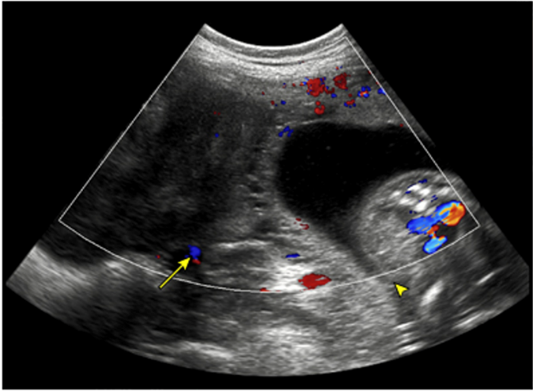

Fotoğraf 3: Torsiyone ve ovarian akım kaybı olan gebe hastanın over Doppler USG görüntüsü
*Courtesy of Charles C Kilpatrick MD, and Francisco J Orejula MD

USG’de periferal dizilim göstermiş folikullerin bir dizi sıra ile izlenmesi bilinen bir torsiyon bulgusu olsa da retrospektif bir çalışmada 153 over torsiyonu olan hastaların 139’unda girdap işareti adı verilen vasküler pediküllerin bükülmesini temsil eden ovaryen damarların hipoekoik şeritlenme gösterdiği boru şeklindeki whirlpool sign izlenmesi de tanıda önemli olabilir (10). Ancak vakamızda olduğu gibi 2. trimester bir hastada veya son trimester hastada USG incelemesi, adneksler açısından suboptimal olabilir. İyi bir ultrason muayenesi gravid bir uterus nedeniyle güçtür. Gebe olmayan ve teknik nedenlerden dolayı efektif USG yapılamayan hastalarda kullandığımız BT gibi görüntüleme cihazlarını gebelikte kullanılamadığından tanı güçleşmektedir.
Torsiyon tanısı konmuş reproduktif çağdaki hastaların primer tedavisi cerrahidir. Cerrahi laparatomi, laparoskopi ve natürel orofis transluminal endoskopik cerrahi (vNote) tercih edilebilir. vNote, gebe hastlalarda kolpotomiyi imkansız kıldığından tercih edilmez ancak laparoskopi tercih edilebilir. Laparoskopinin gebelikte potansiyel riskleri vardır. Batına girişte kullanılan veress iğnesi veya direkt trokar uterusu tramvatize edebilir, perfore edebilir ve durumda fetal etkilenme kaçınılmazdır (11). Pnömoperitonum sırasında intraabdominal basınçtaki artış, utero-plasental kan akışını azaltabilir ve fetal hipoksiye neden olabilir (11). Bu riskler gebelik haftası ile orantılı olarak artar. Cerrahın laparoskopi tecrübesi bu potansiyel riskleri minimize etmede önemlidir. Alternatif tedavi seçenekleri iyi değerlendirmeli ve bunlar hasta ile paylaşılmalıdır.
Cerrahi esnasında uterusa minimum temas birincil kuraldır. Uterin travmaların kontraksiyonu tetiklediği bilinen bir gerçektir. Vakamızda batına girdikten sonra ıslak batın kompres ile uterus sarılmış minimum traksiyonla cerrahi gerçekleştirilmiştir. Torsiyonlarda eskiden süregelen yönetimden farklı olarak reprodüktif çağda organ koruyucu yaklaşım ön plana geçmiştir. Torsiyon olan organ ne kadar nekroze olmuş gibi gözükse de öncelikle detorsiyon işlemi yapılmalıdır. Bu bölgedeki olası hemorajik alanların koagülasyonu şarttır. Tablo 1’de adneksial torsiyon algoritması özetlenmişdir. Bizim vakamızdan da örnek verecek olursak hem organ kaybının hastaya vereceği morbiditeden kaçınmak hem de minimal invaziv yaklaşım gereği sadece detorsiyone edilip kanlanan over üzerindeki kanama alanların koagulasyonu yapılmıştır (Fotoğraf 2).
Hasta premenapozal mı?

Overde kanlanma var mı ?
evet
hayır

hayır
evet

Herhangi bir malignite var mı?

hayır
evet

Bening karakterde kitle veya büyük kist

hayır
evet
Sadece detorsiyone et
Kistektomi ve/ya kist drenajı
Salpingo-ooferektomi

Tablo1: Yetişkin hastada konturlateral overin doğal olduğu durumlarda takip edilecek algoritma
Graphic 130487 Version 1.0
© 2023 UpToDate, Inc. and/or its affiliates. All Rights Reserved.

Gebelik haftasıyla ilişkili olarak viabilite sınırını geçen gebelere batın cerrahisi öncesi kortikosteroid profilaksisi önerilir. Post operatif cerrahi venöz tromboemboli profilaksi sağlık bakanlığı rehberine göre hasta değerlendirilir ve düşük molekül ağırlıklı heparin başlanılabilir (12). Gebeliğin 32. haftasından sonra non steroid anti inflamatuar ilaçların uzun süre kullanılmaması önerilmektedir. Duktus arteriozusun kapanması potansiyel risktir. Son trimesterde analjezi amaçlı opioid kullanımı önerilmektedir (11). Ancak 2. trimesterde olan bu hastamızda doz günde ikiye düşürülerek bir hafta boyunca non steroid antiinflamatuar ajan verildi.
Batın cerrahisi geçirmiş gebelerin diğer sezaryen sebepleri dışlandığında sezaryen endikasyonu yoktur. Normal vajinal doğum yapabilir. Bizim vakamızda doğum eylemine girmesiyle birlite takip ettik ve vajinal yoldan doğum gerçekleşti.
SONUÇ
Adneksiyal torsiyonlar kadın doğum pratiğinin akut batın sebepleri arasında önde gelen nedenlerinden biridir. Bu duruma gebelik eklendiğinde ise süreç zorludur. Tanıda gecikme morbiditeyi artırabilir. Bu durum hem anne hem de bebek için risk teşkil edebilir. Tanı sonrası hasta bazlı değerlendirme ve cerrahi yöntem tercihi önemlidir. Optimum bir operasyon sonrası ilk günler gerek erken doğum gerekse abortus açısından kritik günlerdir. Uygun medikal destek ve postoperatif bakımla bunlar minimize edilebilir. Tek bir cerrahi seçeneğin olmadığı ve bunların içinde güncel literatürün de desteklediği minimal invaziv yöntemler tercih edilmelidir. Multidisipliner yaklaşımla, bu vakaların yönetiminde anne ve bebek ölümlerinin azalması hedeflenmelidir.
KAYNAKÇA
1. Sanfilippo JS, Rock JA. Surgery for benign disease of the ovary. In: TeLinde's Operative Gynecology, 11th ed., Jones HW, Rock JA (Eds), Wolters Kluwer, 2015.
2. Zou G, Xu P, Zhu L, Ding S, Zhang X. Comparison of subsequent pregnancy outcomes after surgery for adnexal masses performed in the first and second trimester of pregnancy. Int J Gynaecol Obstet. 2020 ve 305-309, 148(3):.
3. Naqvi M, Kaimal A. Adnexal masses in pregnancy. Clin Obstet Gynecol. 2015 ve 93-101, 58(1):.
4. Beaunoyer M, Chapdelaine J, Bouchard S, Ouimet A. Asynchronous bilateral ovarian torsion. J Pediatr Surg 2004 ve 39:746.
5. Huchon C, Fauconnier A. Adnexal torsion: a literature review. Eur J Obstet Gynecol Reprod Biol 2010 ve 150:8.
6. Oltmann SC, Fischer A, Barber R, et al. Cannot exclude torsion--a 15-year review. J Pediatr Surg 2009 ve 44:1212.
7. Varras M, Tsikini A, Polyzos D, et al. Uterine adnexal torsion: pathologic and gray-scale ultrasonographic findings. Clin Exp Obstet Gynecol 2004 ve 31:34.
8. Houry D, Abbott JT. Ovarian torsion: a fifteen-year review. Ann Emerg Med 2001 ve 38:156.
9. Tsafrir Z, Hasson J, Levin I, et al. Adnexal torsion: cystectomy and ovarian fixation are equally important in preventing recurrence. Eur J Obstet Gynecol Reprod Biol 2012 ve 162:203.
10. Moro F, Bolomini G, Sibal M, et al. Imaging in gynecological disease (20): clinical and ultrasound characteristics of adnexal torsion. Ultrasound Obstet Gynecol 2020 ve 56:934.
11. https://www.uptodate.com/contents/laparoscopic-surgery-in-pregnancy?topicRef=3305&source=see_link.
12.https://dosyamerkez.saglik.gov.tr/Eklenti/28085/0/dogumoncesibakimyonetimrehberipdf.pdf.

S-89 Comparison Of Continuous And Separe (3 Suture) Techniques For Subcutaneous Fascia Closure In Cesarean Section Operation
Önder Ercan¹
1 Özel Sular Akademi Hastanesi

Comparison of continuous and separe (3 suture) techniques for subcutaneous fascia closure in cesarean section operation Objective: In cesarean section, the subcutaneous fascia is often closed separately with 3 sutures because of its fast closure. We aimed to compare the closure of the subcutaneous fascia continuously and separately (3 sutures) in cesarean section operation. Methods: A total of 199 cesarean section patients were randomized into 2 groups: 100 patients with continuous technique and 99 patients with separated technique (only 3 sutures). Pregnancy complications such as preeclampsia, DM, preterm labor, preterm member rupture were excluded from the study. Mean age, parity, body mass index (BMI) and wound site complications were evaluated between both groups. Wound site complications were evaluated as both major and minor complications (seroma, minor wound dehiscence, wound infection, hematoma). Mann Whitney-U and Chi-square tests were used for statistical analysis. Results: There was no significant difference in mean age, BMI and parity in both groups (table 1). All complications were 8 (8%) in the continuous group and 22 (22%) in the separated group with a statistically significant difference between the two groups (p= 0.005). Conclusion: In cesarean section, subcutaneous fascia closure is often performed separately with 3 sutures because of its rapidity. However, in our study, we found that continuous closure of the subcutaneous fascia resulted in a decrease in minor wound complications. Therefore, we recommend more effective continuous closure of the subcutaneous fascia.
Keywords: cesarian section, subcutaneous fascia,
Comparison of continuous and separe (3 suture) techniques for subcutaneous fascia closure in cesarean section operation
Objective: In cesarean section, the subcutaneous fascia is often closed separately with 3 sutures because of its fast closure. We aimed to compare the closure of the subcutaneous fascia continuously and separately (3 sutures) in cesarean section operation.
Methods: A total of 199 cesarean section patients were randomized into 2 groups: 100 patients with continuous technique and 99 patients with separated technique (only 3 sutures). Pregnancy complications such as preeclampsia, DM, preterm labor, preterm member rupture were excluded from the study. Mean age, parity, body mass index (BMI) and wound site complications were evaluated between both groups. Wound site complications were evaluated as both major and minor complications (seroma, minor wound dehiscence, wound infection, hematoma). Mann Whitney-U and Chi-square tests were used for statistical analysis.
Results: There was no significant difference in mean age, BMI and parity in both groups (table 1). All complications were 8 (8%) in the continuous group and 22 (22%) in the separated group with a statistically significant difference between the two groups (p= 0.005).

Table 1: Comparison of continuous and separated techniques for subcutaneous fascia closure in cesarean section
 | Continue | Separe  (3 sutures) | P
n | 100 | 99
age (average) | 28,5±5,9 | 29,4±6,6 | 0,396
BMİ (average) | 31±3,4 | 30,7±4,2 | 0,435
parity (average) | 1,2±1 | 1,2±1,1 | 0,707
complications (n/%)* | 8 (% 8) | 22 (% 22) | 0,005
* Complications: Seroma, minor wound dehiscence, hematoma, infection
Conclusion: In cesarean section, subcutaneous fascia closure is often performed separately with 3 sutures because of its rapidity. However, in our study, we found that continuous closure of the subcutaneous fascia resulted in a decrease in minor wound complications. Therefore, we recommend more effective continuous closure of the subcutaneous fascia.

S-90 Uterine Didelphys Undiagnosed Despite Two Deliveries With C-Section In A Somali Woman
Adil Barut¹
1 Mogadishu Somali Turkey, Recep Tayyip Erdogan Training And Research Hospital

A 31-year-old pregnant woman (gravida 5, para 4) was referred because of suspected abdominal pregnancy and a 2-day history of severe lower abdominal pain. She did not remember her last menstrual bleeding and did not report any problem about her prior full-term pregnancies, which ended up with normal vaginal deliveries for the first two, and with cesarean section for the latter two. Physical examination was unremarkable except for abdominal pain on palpation and a nonstress test. Pelvic examination showed a soft and 2-cm dilated cervix. Transabdominal ultrasonography revealed two adjacent uteri, one of which was empty (Panel A, arrow), and the other bearing a fetus of approximately 1,100 grams at 28 weeks and 1 day of gestational age, with cephalic presentation and severe oligohydramnios (Panel A). Magnetic resonance imaging substantiated ultrasonographic findings of two uteri, with a single fetus in the left one having cephalic presentation, findings consistent with intrauterine pregnancy (Panel B). A diagnosis of uterine didelphys was made, a congenital disorder in which a female develops two uteri instead of one. The patient underwent cesarean section under general anesthesia and the newborn was transferred to the newborn intensive care unit. The mother had an uneventful postoperative course and was discharged home in very good condition.
Keywords: Uterine didelphys,C-section
A 31-year-old pregnant woman (gravida 5, para 4) was referred because of suspected abdominal pregnancy and a 2-day history of severe lower abdominal pain. She did not remember her last menstrual bleeding and did not report any problem about her prior full-term pregnancies, which ended up with normal vaginal deliveries for the first two, and with cesarean section for the latter two. Physical examination was unremarkable except for abdominal pain on palpation and a nonstress test. Pelvic examination showed a soft and 2-cm dilated cervix. Transabdominal ultrasonography revealed two adjacent uteri, one of which was empty (Panel A, arrow), and the other bearing a fetus of approximately 1,100 grams at 28 weeks and 1 day of gestational age, with cephalic presentation and severe oligohydramnios (Panel A). Magnetic resonance imaging substantiated ultrasonographic findings of two uteri, with a single fetus in the left one having cephalic presentation, findings consistent with intrauterine pregnancy (Panel B). A diagnosis of uterine didelphys was made, a congenital disorder in which a female develops two uteri instead of one. The patient underwent cesarean section under general anesthesia and the newborn was transferred to the newborn intensive care unit. The mother had an uneventful postoperative course and was discharged home in very good condition.

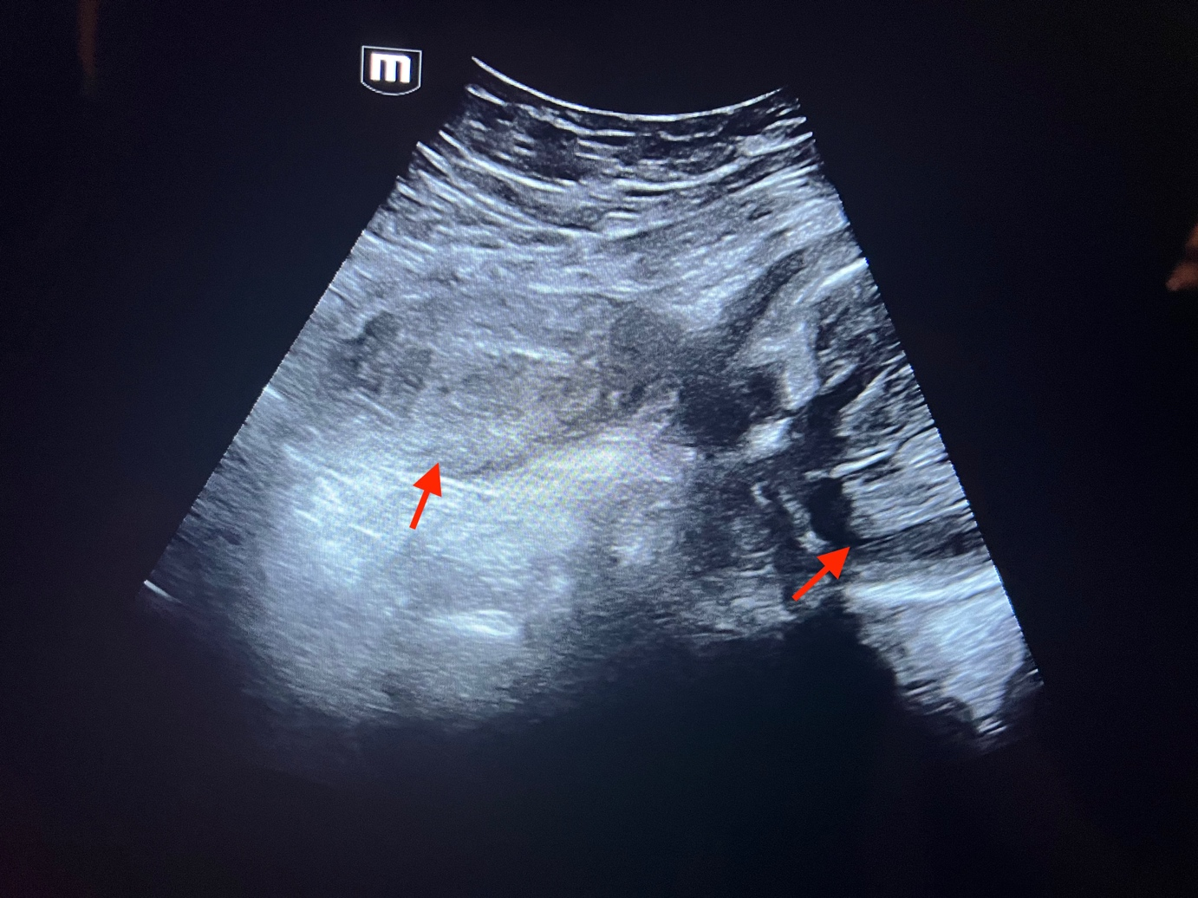
Panel A
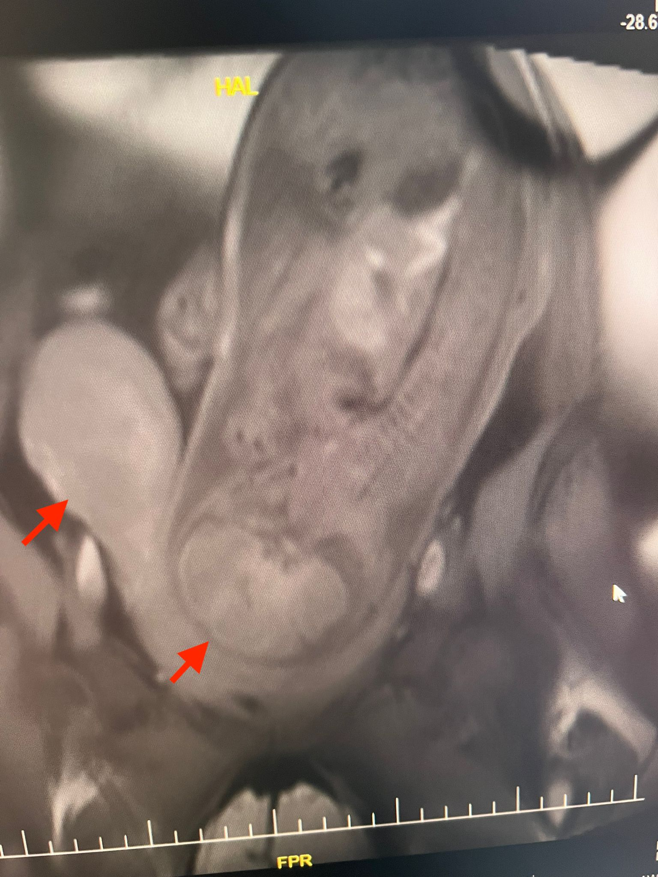
Panel B

POSTER BİLDİRİLER

P-04 Sentinel Lymph Node Sampling Experience Of Our Clinic In Endometrial Ca Patients (A Tertiary Hospital Experience)
Emine Akkuş¹, Abdullah Acar¹, Mustafa Fırat Aydın¹, Behzat Can¹, Sedat Akgöl¹
1 Saglık Bilimleri University Gazi Yaşargil Training And Research Hospital

Introduction
Endometrium ca is the most common gynecological cancer in developed countries and in our country. After appropriate staging, radiotherapy to intermediate and high-risk patients or chemotherapy in advanced disease increases disease-free time and overall survival. Due to the comorbidities of the patients, sentinel lymph node sampling instead of systemic lymphadenectomy provides the same survival and staging success in both low and high risk patients, and it is a more minimally invasive approach. Sentinel lymph node sampling is performed with indocyanine green as standard. Methylene blue is an alternative method that can be used when indocyanine green is not available. In our clinic, sentinel lymph node sampling is performed using methylene blue via laparoscopy or laparotomy for patients who are evaluated radiologically (with pet-CT or MRI) to be non-metastatic.
Results
The data of our patients who were operated for endometrial ca and sentinel lymph node dissection in the last 1 year in our clinic were analyzed retrospectively and compared with the literature data. Sentinel lymph node dissection protocol was applied to 15 patients in the last 1 year. The mean age of our patients was 59.73 years, and they ranged from 47 to 69 years old. 13% of the patients were operated in the premenopausal period and 87% in the postmenopausal periodLaparoscopy and laparotomy were used as surgical methods and laparotomy was preferred in 70% and laparoscopy in 30%. Methylene blue was used for sentinel lymph node mapping. Lymph node dissection was successfully performed in 13 patients. Lymph node dissection could not be performed in one patient due to the presence of widespread adhesions in the pelvis and fragile and bleeding tissues. In another patient, sentinel lymph node was not observed because there was no staining with metilen blue. Histopathological examination resulted in 80% of the patients as endometrioid adenocarcinoma, 6.6% as serous carcinoma, and 13.3% as endometrial hyperplasia with atypia. Myometrial invasion was <50% in 69.2% of 13 patients who had successfully sentinel lymph node dissection, myometrial invasion was >50% in 23.07%, and no myometrial invasion was detected in 7.6%.
Conclusion
Especially in the last 5 years, many studies show that sentinel lymph node applications can be performed successfully in cases of endometrial ca. As a result of these studies, new techniques for detecting sentinel lymph nodes are defined, and it has been shown that the sensitivity is over 90% in patients with bilateral sentinel lymph nodes. The procedures performed in our clinic have proven to us that we are in same line with these data and demonstrated that sentinel lymph node dissection using methylene blue is acceptable as a viable method in patients with endometrial ca.

Keywords: Endometrium Ca, Sentinel lymph node dissection, Metilen blue

P-06 Burch Colposuspension Surgery In The Treatment Of Stress Urinary Incontinence
Erdoğan Gül¹, Sertaç Ayçiçek¹
1 Sağlık Bilimleri Üniversitesi Diyarbakır Gazi Yaşargil Eah

SUMMARY : INTRODUCTION: Burch Colposuspension was a surgical procedure that was successfully applied in the treatment of Stress Urinary Incontinence before the Transobstructive Type operation. CASE: Our patient is 42 years old and has a history of 3 vaginal deliveries. The patient has a history of urinary incontinence with physical activity and coughing for about 4 years. In the physical and gynecological examination of the patient; Stage 1 anterior prolapse was observed according to POP-Q classification. It was observed that the patient had urinary incontinence from his half-full bladder by coughing. The patient did not have any co-morbid disease and routine examinations were normal. The patient underwent Laparoscopic Burch Colposuspension operation and did not have incontinence symptoms afterwards. CONCLUSION: With the spread of Minimally Invasive Surgery, this procedure can also be performed more comfortably Laparoscopically.
CASE: Our patient is 42 years old and has a history of 3 vaginal deliveries. The patient has a history of urinary incontinence with physical activity and coughing for about 4 years. In the physical and gynecological examination of the patient; Stage 1 anterior prolapse was observed according to POP-Q classification. It was observed that the patient had urinary incontinence from his half-full bladder by coughing. The patient did not have any co-morbid disease and routine examinations were normal. The patient underwent Laparoscopic Burch Colposuspension operation and did not have incontinence symptoms afterwards.
CONCLUSION: With the spread of Minimally Invasive Surgery, this procedure can also be performed more comfortably Laparoscopically.

Keywords: Stress Urinary Incontinence, Burch Colposuspension, Minimally Invasive Surgery

INTRODUCTION: Stress Urinary Incontinence (SUI) is a common clinical entity that affects 35% of women in the United States (USA) (1).
The Burch procedure was first introduced laparoscopically in 1991 (2). While the long operation time and higher complications were disadvantageous at first, the rates and advantages of laparoscopic buch colposuspension started to increase due to the increase in the learning curve and the decrease in the post-op discharge time, the decrease in blood loss and the shorter recovery period (3,4).

CASE: The 42-year-old patient has a history of 3 vaginal deliveries. He had a history of urinary incontinence with physical activity and coughing for about 4 years. No significant pelvic organ prolapse was observed in the gynecological and physical examination of the patient. In the cough test performed on the patient, urinary incontinence was observed with a half-full bladder detected by ultrasonography (USG). The patient did not have any additional co-morbid disease. The patient had no pathology in the laboratory and USG.
After the premedication of the patient was completed, the operation was started under general anesthesia. Direct trochear access was preferred as the entrance to the abdomen. Entered from the umbilicus to the west. Then, 3 auxiliary 5-gauge trochears were inserted. The bladder was then inflated approximately 300 cc (figure-1).
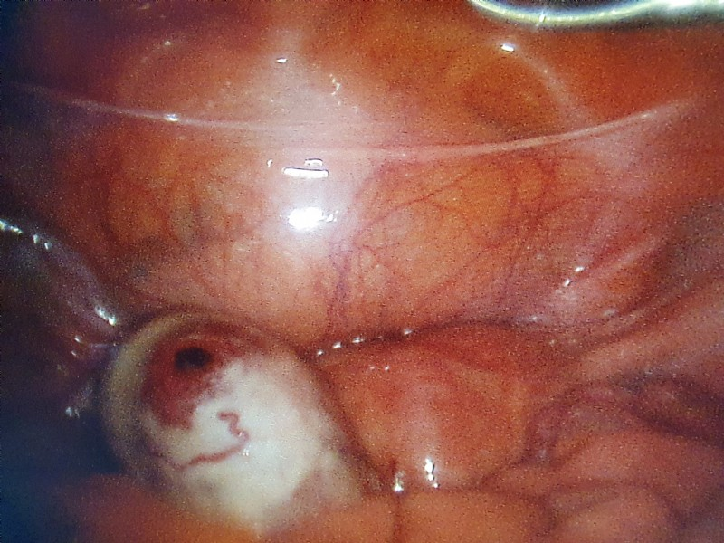
Figure-1 : Inflating the bladder with 300 cc isotonic.

Then, as seen in figure-2, the peritoneum of the anterior abdominal wall was dissected with the inflated bladder border becoming prominent, and the ileopectineal ligament was exposed. The muscle tissue over the pubic arch and bladder was exposed.
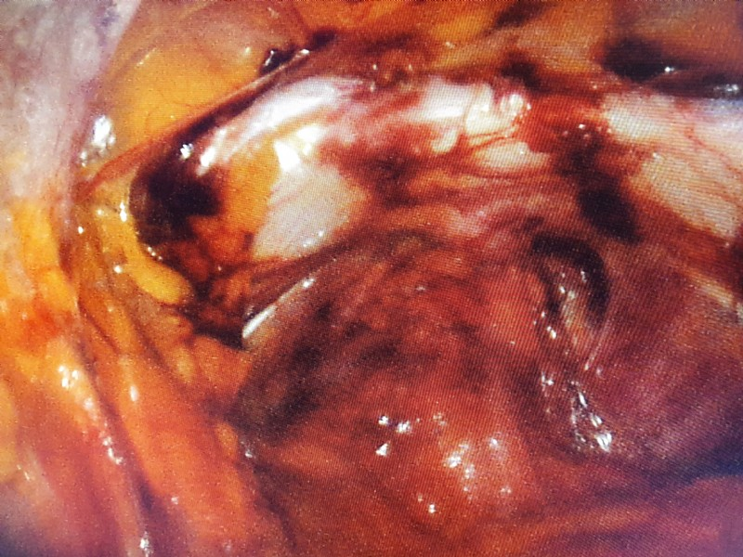
Figure-2: Revealing the ileopectineal ligament and anterior bladder.
Then, an assistant's hand was placed on the right and left lateral parts of the vagina to expose the lateral parts of the bladder, and the bladder was suspended from both laterals to the pectineal ligament with 2.0 prolene sutures (figure-3).
The peritoneum was closed with 2.0 vicyl. The bipolar Ligasure instrument was used as the energy modality. Intraperitoneal pressure was adjusted as 12-14 mmHg throughout the operation.
In the first, tenth, and first months post-operative examination and questioning of the patient, it was observed that there were no complaints of incontinence.
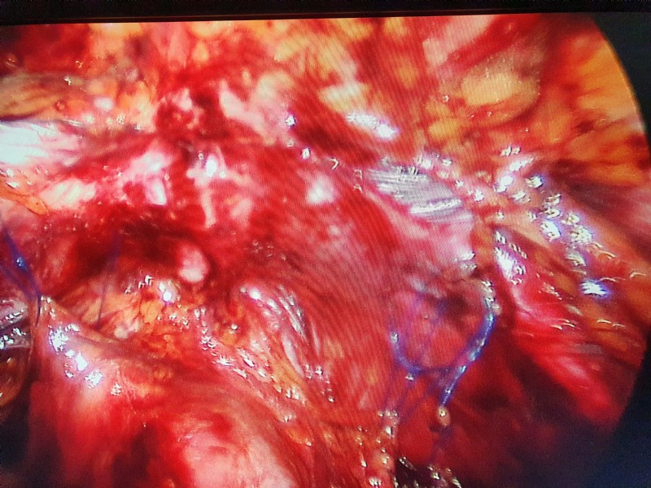
Figure-3 : Two prolene sutures placed laterally on the bladder neck.

DISCUSSION AND CONCLUSION: In two recent large randomized controlled studies, no difference was found between laparotomy and Burch procedures performed with laparoscopy (5). In a cohort study with 200 patients diagnosed with SUI, no difference was observed in terms of laparotomy and laparoscopy in follow-up up to 5 years (6).

RESOURCES :
1. Hampel C, Artibani W, Espuna Pons M, et al. Understanding the burden of stress urinary incontinence in Europe: a qualitative review of the literature. Eur Urol 2004;46(1):15–27.
2. 0. Vancaillie TG, Schuessler W. Laparoscopic bladderneck suspension. J Laparoendosc Surg 1991;1:169–73.
3. Moehrer B, Ellis G, Carey M, et al. Laparoscopic colposuspension for urinary incontinence in women. Cochrane Database Syst Rev 2002;(1): CD002239.
4. Dean NM, Ellis G, Wilson PD, et al. Laparoscopic colposuspension for urinary incontinence in women. Cochrane Database Syst Rev 2006;(3):CD002239.
5. Carey M, Goh JT, Rosamilia A, et al. Laparoscopic versus open Burch colposuspension: a randomized controlled trial. BJOG 2006;113:999–1006.
6. Kitchener HC, Dunn G, Lawton V, et al. Laparoscopic versus open colposuspension-results of a prospective randomized controlled trial. BJOG 2006;113:1007–13.

P-07 Extraperitoneal Laparoscopic Burch Colposuspension
Ayse Betul Ozturk¹, Selcuk Erkilinc², Ilker Cakir², Sena Ozcan¹
1 Izmir Tepecik Training And Research Hospital, Izmir, Turkey
2 Izmir Democracy University Buca Seyfi Demirsoy Training And Research Hospital, Izmir, Turkey

The case of a 42-year-old female patient with a history of difficult birth, gravida 2, para 2, and Vaginal Birth 2. She had no surgery or any significant medical history. After urodynamic tests, she was diagnosed with stress urinary incontinence (SUI), and it was decided to perform an extraperitoneal laparoscopic Burch colposuspension. Burch colposuspension is a widely accepted technique for the treatment of stress urinary incontinence. Laparoscopic Burch Colposuspension offers advantages over others open Burch colposuspension. The laparoscopic Burch colposuspension is a minimally invasive technique compared to the laparotomic Burch colposuspension, there is less blood loss in the patient, the patient is quickly mobilized after the operation and the patient will be discharged quickly. However, the operation time can be longer. In our patient, we performed the Extraperitoneal Burch colposuspension technique, and total surgical time was 37 minutes. Skipping the steps of opening and closing the peritoneum and directly entering the space of Retzius allow to save significant time. An appropriate dissection strategy allows to clearly visualize anatomical landmarks. The patient was operated in the low lithotomy position. The bladder catheter was inflated. A 10 mm bladeless trocar was inserted into the hub. After that Dissection was started by creating a space between the peritoneum with pressure by using the camera. Since there was sufficient space, two 5 mm trocars were placed on each side. Bladder tissues were dissected until the pubocervical fascia was reached. The urinary catheter balloon was held with the fingers. Fingers are also used dissection in the paraurethral region was checked. Cooper's ligaments run along the pectineal line and fuse with the lacunar ligament. The important thing at this stage is not to pass through the periosteum as this can cause post-operative pain. It is important that the seams are tension-free. During the process, The vagina was evaluated using the fingers. After adequate dissection By obtaining strong tissues in desired anatomical structures procedure completed. Post-operative results The operation time was 24 minutes and there was no blood loss. She was discharged on the 1st postoperative day.
Keywords: stress urinary incontinence, laparoscopy, Burch Colposuspension

P-12 Undifferentiated Endometrial Carcinoma: An Extremely Rare Case Presentation

Murat Api¹, Sahra Sultan Kara², Esra Keleş¹, Gizem Elif Dizdaroğulları³, Hatice Kübra Can²
1 Department Of Gynecologiconcology,university Of Health Sciences Turkey, Kartal Lütfi Kırdar City Hospital, Istanbul 34668, Turkey
2 Department Of Obstetrics And Gynecology, University Of Health Sciencesturkey, Kartal Lütfi Kırdar City Hospital, Istanbul 34668, Turkey
3 Department Of Maternal Fetal Medicine, University Of Health Sciencesturkey, Kartal Lütfi Kırdar City Hospital, Istanbul 34668, Turkey

Introduction: Undifferentiated endometrial carcinoma of the uterus is a rare, highly aggressive, and under-recognized subtype of endometrial cancer. The prognosis is often poor, with approximately 50% of patients presenting with advanced stage disease and 75% of patients dying of their disease. Herein, we present a rare case of undifferentiated endometrial carcinoma. Case: A 49-year-old female, gravida 0, was referred to the department of gynecologic oncology with the complaint of abnormal uterine bleeding. The fractional curettage result was resulted in FIGO grade III endometrial carcinoma. She had an elevated cancer antigen (CA) 125 and CA 15-3 levels with normal complete blood count values. Magnetic Resonans Imaging revealed solid mass lesions with a diameter of approximately 6 cm filling the supravesical area and the midline-left half of the pelvis, approximately 8 x 5 cm in size including the corpus anterior and cervix level, and approximately 4.5 cm in diameter in the paracervical area with an atypical signal pattern, showing peripheral postcontrast enhancement. Gastrointestinal endoscopy and colonoscopy were normal. The decision for surgical debulking was made. During abdominal exploration, a mass lesion with a diameter of approximately 10 cm was detected on the anterior surface of the bladder and the bladder dome (Figure 1). The tumor was removed with a partial cystectomy, total abdominal hysterectomy, bilateral salpingo oophorectomy with bilateral double J stenting were performed. Bilateral pelvic and paraaortic lymphadenectomy was performed. The specimen was submitted to frozen section. Frozen was reported that no malignant lesion was observed in the bladder, the solid mass originated from the uterus and was of epithelial origin. Situreductive surgery was performed. R0 resection was achieved. The final histopathology resulted in undifferentiated endometrial carcinoma. The postoperative course was uneventful. The patient had administered chemotheraphy and radiation therapy. Discussion: The undifferentiated e endometrial carcinoma is high-grade epithelial endometrial carcinomas and are aggressive cancers. Considering the highly invasive nature of the disease, timely detection of this cancer using characteristic imaging and pathology findings is of extreme importance to improve the patient’s survival.
Keywords: Endometrium, FIGO Grade 3, High grade, Undifferentiated endometrial carcinoma
Introduction: Undifferentiated endometrial carcinoma of the uterus is a rare, highly aggressive, and under-recognized subtype of endometrial cancer. The prognosis is often poor, with approximately 50% of patients presenting with advanced stage disease and 75% of patients dying of their disease. Herein, we present a rare case of undifferentiated endometrial carcinoma.
Case: A 49-year-old female, gravida 0, was referred to the department of gynecologic oncology with the complaint of abnormal uterine bleeding. The fractional curettage result was resulted in FIGO grade III endometrial carcinoma. She had an elevated cancer antigen (CA) 125 and CA 15-3 levels with normal complete blood count values. Magnetic Resonans Imaging revealed solid mass lesions with a diameter of approximately 6 cm filling the supravesical area and the midline-left half of the pelvis, approximately 8 x 5 cm in size including the corpus anterior and cervix level, and approximately 4.5 cm in diameter in the paracervical area with an atypical signal pattern, showing peripheral postcontrast enhancement. Gastrointestinal endoscopy and colonoscopy were normal. The decision for surgical debulking was made. During abdominal exploration, a mass lesion with a diameter of approximately 10 cm was detected on the anterior surface of the bladder and the bladder dome (Figure 1). The tumor was removed with a partial cystectomy, total abdominal hysterectomy, bilateral salpingo oophorectomy with bilateral double J stenting were performed. Bilateral pelvic and paraaortic lymphadenectomy was performed. The specimen was submitted to frozen section. Frozen was reported that no malignant lesion was observed in the bladder, the solid mass originated from the uterus and was of epithelial origin. Situreductive surgery was performed. R0 resection was achieved. The final histopathology resulted in undifferentiated endometrial carcinoma. The postoperative course was uneventful. The patient had administered chemotheraphy and radiation therapy.
Discussion: The undifferentiated e endometrial carcinoma is high-grade epithelial endometrial carcinomas and are aggressive cancers. Considering the highly invasive nature of the disease, timely detection of this cancer using characteristic imaging and pathology findings is of extreme importance to improve the patient’s survival.
Keywords: Endometrium, FIGO Grade 3, High grade, Undifferentiated endometrial carcinoma
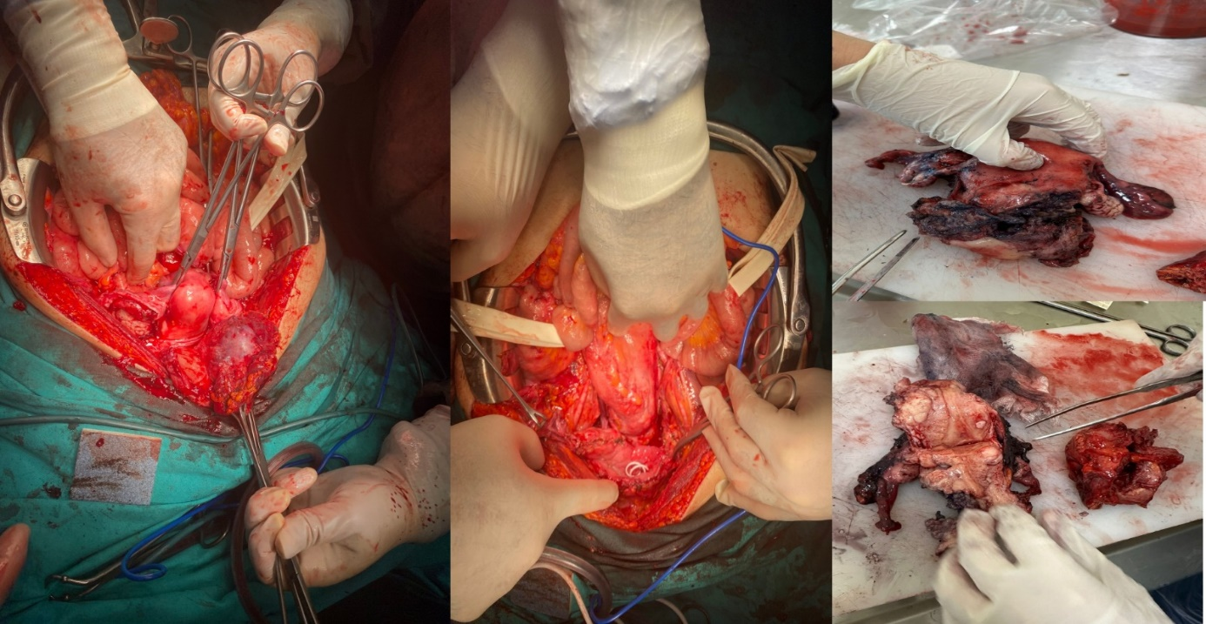
Figure 1

P-13 Giant Ovarian Tumor Serous Cystadenoma Case Report
Özlem Yerlioğlu¹
1 Tepecik Eğitim ve Araştırma Hastanesi

72 year old patient[G9P6A3Y3Ex3 (NSD *3)] came to us with abdominal distension and a widespread palpable mass. On physical examination, there was a pelvic mass that reached above the umbilicus and filled the entire abdomen . Pelvic MRI evaluation: It is 29x26x16 cm in size, densely proteinaceous , and fills the entire abdomen. A giant, thin-walled cystic mass was observed. Irregular, protruding from the mass walls into the wall , with no obvious contrast papillary areas and incomplete septa were present. Normal ovarian tissue could not be selected. Malignancy could not be ruled out, the patient was evaluated in council by the gynecology oncology team. Anesthesia consultation, L/T decision was made with ASA 2 risk. Total abdominal hysterectomy , bilateral Salpingo-oophorectomy and appendectomy were planned. It was decided to take an omentum and parietal peritoneal biopsy and send the removed mass for frozen examination. The abdomen was entered through subumbilical and supraumbilical incisions . There was an approximately 30 cm mass thought to originate from the left adnexa . The mass was excised and sent for review frozen . Total abdominal hysterectomy bilateral salpingoophorectomy performed. Hysterectomy material Frozen was sent for examination. The frozen result was reported as benign . Appendectomy was performed with general surgery included in the operation . Inside the right ureter a mass of approximately 2 cm in the location where it crosses the vaginal cuff was observed.Approximately 2.5 cm of stone was removed from the ureter through an incision . Including per -op urology team was placed a double j catheter in the ureter. The last operation was terminated due to the absence of of early bleeding and complications. Post-op 6th Hour Blood Pressure:121/ 67 Pulse :86 Fever:36.4 Diuresis : 55cc/ h Drain:50cc Follow-up was taken at the service on the 1st post-op day The patient applied to the urology clinic 3 weeks later to have the double j catheter removed.. Final pathology result; atrophic endometrium , right tube and ovary normal, left ovary serous cystadenoma , obliterated reported as appendix .
Keywords: OVARIAN TUMOR SEROUS CYSTADENOMA HYSTERECTOMY

P-16 An Unique Presentation Of Pseudomyxoma Peritonei In Stump Appendectomy
Hatice Kübra Can¹, Beyzanur Kahyaoğlu¹, Esra Keleş¹, Murat Api¹
1 İstanbul Kartal Dr. Lütfi Kırdar Şehir Hatanesi

Pseudomyxoma peritonei (PMP) is an uncommon disease with a relatively low incidence of 1 to 2 per million individuals. Low-grade appendiceal mucinous neoplasm (LAMN) is a rare malignancy accounting for 1% of gastrointestinal neoplasms and is found in less than 0.3% of appendectomy specimens. A 56-year-old women, gravida 4, reported to gynecological oncology outpatient department with a clinical history of pain in the abdomen, with abdominal distension. She had a history of appendectomy. Pelvic ultrasonography revealed the presence of abdominal free fluid suggestive of massive ascites. MRI consisted with diffuse peritoneal carcinomatous. She had elevated cancer antigen (CA) 125 level of 80.1 U/mL and CA 15-3 level of 12.7 U/mL with normal (CA)19-9 levels. Peroperative examination revealed ruptured cystic mass with a diameter of 25x20 cm in size with adherent mucus material, attached to the peritoneal cavity. Surgical debulking, excision of the subserosal appendicular stump of about 2 cm, and extensive removal of gelatinous material was taken up. Low-grade mucinous neoplasm is very rare in stump appendectomy with a very few reported cases previously. Treatment varies based on the cellularity of mucin ranging from hemicolectomy to close follow-up as advised as in our case. Further studies and prolonged follow-up will add to the management of LAMN. Patient education about the case and the follow-up plan is crucial in high-risk patients for pseudomyxoma peritonei.
Keywords: Pseudomyxoma peritonei, low grade mucinous neoplasm, Appendix, Mucinous neoplasm, LAMN
Introduction: Pseudomyxoma peritonei (PMP) is an uncommon disease with a relatively low incidence of 1 to 2 per million individuals. Low-grade appendiceal mucinous neoplasm (LAMN) is a rare malignancy accounting for 1% of gastrointestinal neoplasms and is found in less than 0.3% of appendectomy specimens. LAMN differs from other gastrointestinal neoplasms in that it can cause pseudomyxoma peritonei (PMP) without significant invasion of the appendix wall. We present an unusual case of a postmenapousal women found to have LAMN status post appendectomy 25 years ago.
Case: A 56-year-old women, gravida 4, reported to gynecological oncology outpatient department with a clinical history of pain in the abdomen, with abdominal distension. She had a history of appendectomy. Pelvic ultrasonography revealed the presence of abdominal free fluid suggestive of massive ascites. MRI consisted with diffuse peritoneal carcinomatous. She had elevated cancer antigen (CA) 125 level of 80.1 U/mL and CA 15-3 level of 12.7 U/mL with normal (CA)19-9 levels. Peroperative examination revealed ruptured cystic mass with a diameter of 25x20 cm in size with adherent mucus material, attached to the peritoneal cavity. Pools of mucin were seen within the peritoneal fat and on the serosal surface of the viscera (Figure 1). Frozen was reported that mucinous cystadenoma. No gross abnormality was visualized in the retroperitoneal organs. Surgical debulking, excision of the subserosal appendicular stump of about 2 cm, and extensive removal of gelatinous material was taken up. Subsequently, the peritoneal washing with normal saline was done. The final pathology resulted low grade mucinous neoplasia in both right ovary and the appendix. Extensive mucinous pools and implants containing mucinous neoplasia were identified pseudomyxoma peritonei. The patient was discharged on the 4th postoperative day in a satisfactory condition.
Discussion: Low-grade mucinous neoplasm is very rare in stump appendectomy with a very few reported cases previously. Treatment varies based on the cellularity of mucin ranging from hemicolectomy to close follow-up as advised as in our case. Further studies and prolonged follow-up will add to the management of LAMN. Patient education about the case and the follow-up plan is crucial in high-risk patients for pseudomyxoma peritonei.

